
Are you interested in COLOUR?
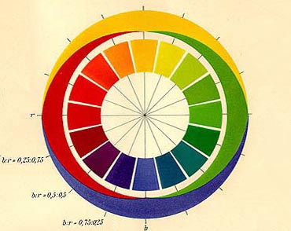
Have you ever wondered whether you see colours the same way as other people?

Observers wanted for a study investigating Colour Appearance

We are looking for people who:

Have normal colour vision
Are able to visit the University for Experiment of 1.5 hours

You will have:
FREE Colour Vision Test
Payment of £20

If you are interested please contact Chenyang Fu
on 0151 794 2174 or email: fuchenyang2004@yahoo.co.uk
or come to the lab (ERB Room 1.58)

