# How to setup University Printing on macOS Ventura

1. Check if you have a previous UoL printer installed and delete it. Navigate to System Setting > Printer & Scanners > Select the UoL Print Queue

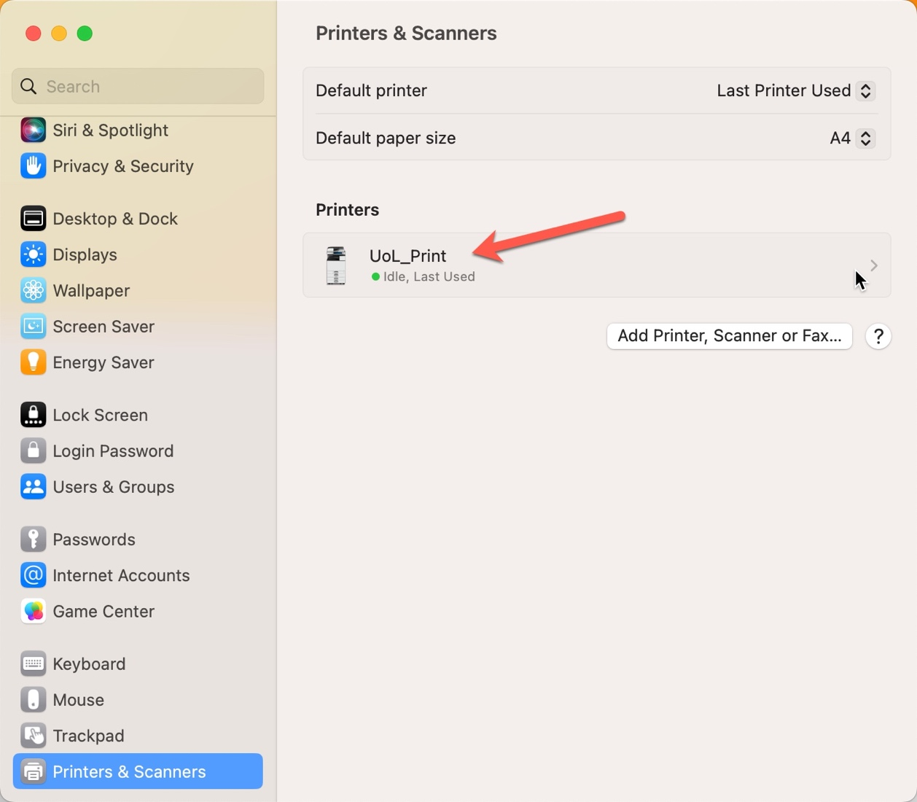

1. Select Remove Printer

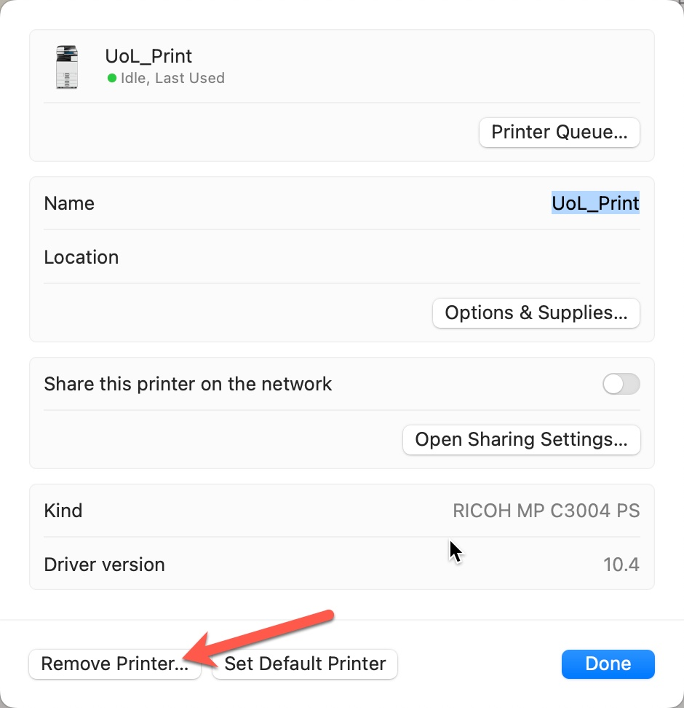

1. Remove Printer

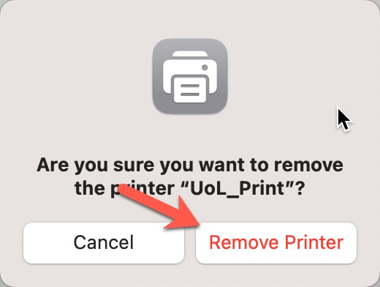

1. Carefully enter (or cut and paste) of the following in an Internet browser: <http://pcwww.liv.ac.uk/csd/macprinting/Ricoh_PS_Printers_Vol4_EXP_LIO_4.0.0.0.dmg>

Download and install the latest print drivers

1. Navigate to Go > Utilities > Terminal

* Enter the following text:
* **cupsctl WebInterface=yes**
* Press **Enter**

Note: You might be prompted to enter your local Admin password

1. Open Safari > in the URL type.

* localhost:631

**Note: You might be prompted to authenticate your Mac using your local account**

1. Click **Administration** > **Add Printer**

1. Select **Internet Printing Protocol (https)** >click **Continue**

1. In the **Connection** box carefully enter (or cut and paste) of the following: <https://webprint.liverpool.ac.uk/printers/UOL-PS-Queue/.printer>

1. Give the printer a name. It is good practice to name the printer after the queue name you are connecting to **UOL-PS-Queue** you can leave the other 2 fields blank Click **Continue.**

1. Select **RICOH** > Select **Continue**

1. In the list select **Ricoh MP C4504ex PS** > **Add Printer**

1. Select the **Options Installed** > **Finisher SR3210**

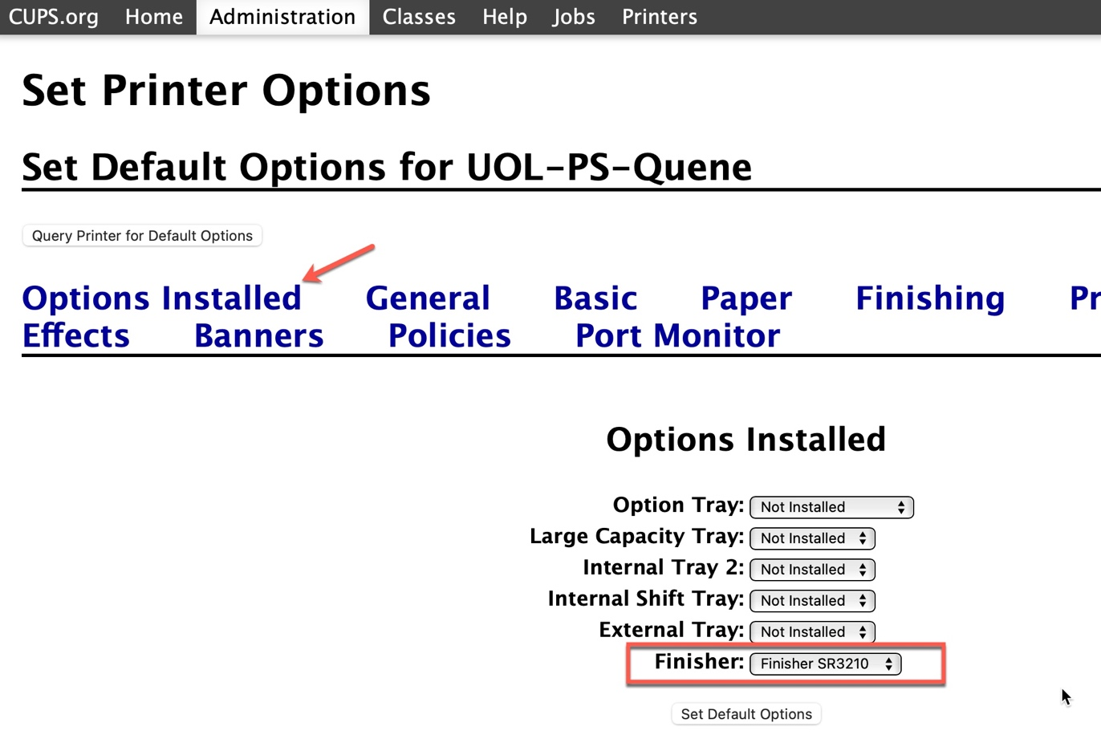

1. Select the **General** tab > **Media Size** Change to **A4 (210 x 297 mm) > Duplex** to **Long Edge**

1. Select the **Basic** tab > **Color Mode >** Set to **Color**
2. **Set Defaults Options**

1. Print set successfully
2. Open your document and click print. You should see the printer appear at the bottom of your screen > Click the Printer icon

1. The print will be “Hold for Authentication” > Click the circular arrow

1. Enter your MWS username and Password as

Swipe your staff card or log in to your nearest printer.