# VITAL User Interface

Overview

The buttons, icons, links and dialogue boxes which make up the standard interactions of the VITAL interface are the ways in which you access menus of options, save and confirm actions that you carry out and generally work with the system. The elements of the interface described here are those which are common across all tools and pages.

# Double downward arrow icons

Wherever you see the double downward arrow icon there will be a pop-up menu of options relevant to the item to which the icon is attached:



Highlighted below are examples of the main parts of the VITAL interface where these double downward arrows appear.

In the first example (1) below, where the double arrow is part of a text button, the pop-up menu will appear when the button is hovered over by the mouse. In the other examples (2) the double arrow is a small button by itself and this means that you click the double arrow button to show its menu of options.

**1. Hover to reveal menu of options - t**hese menu buttons appear on content creation pages in your module e.g. a Learning/resources section. The pop-up menus contain many of the tools for adding content to the module.



For example, hover over the Create Assessment menu and the following list of options will be displayed:

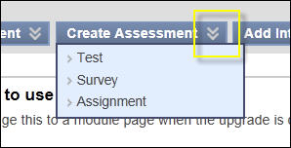

**2. Click to reveal menu of options - b**elow is an example of the module menu with **double downward arrow** buttons highlighted. Typically the pop-up menus allow you to rename, hide and delete the section, and allow or deny guest access to the module section:

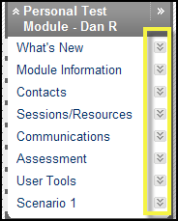

An example, below, of a double arrow button next to a module section heading. The pop- up menu allows you to rename the section and switch between a text and icon view of the content items:



Below is an example of a double arrow button next to a content item in a module. The pop-up menu will typically allow you to edit, rename, copy, delete, set adaptive release rules, tracking functionality and other item-specific management functions:



The Control Panel menu is controlled by double downward arrows, highlighted below. Click on these to expand and hide the menus of options that are listed under each section heading. In this example the ‘Users and Groups’ double arrow has been clicked to show he associated menu of options.

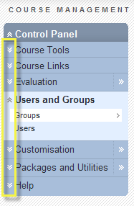

# Double right arrow icons

Also on the Control Panel are several double right-pointing arrows, as shown below. When clicked, the menu of options that would appear for that section, by clicking on the double down arrows to expand the menu, will instead display on the main area of the page as an alternative method for accessing these options:

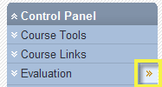

# More Help links

The screenshot below firstly shows the ‘More Help’ link (1) which appears by default whenever you are creating or editing content, next to a short description at the top of the page of the tool you are using to create/edit module content. When you click on this ‘More Help’ link you will open in a new window a detailed description of the options and settings available for that tool to help you set it up. This help page focuses on the technical aspect rather than a contextual description of potential uses for the tool.

**Show/Hide help button**

Also highlighted (2) on this screen shot is the show/hide help button (the question mark). This allows you to turn off the appearance of the description and the More Help link. If you have turned off the More Help link this button will appear with a red line through it. Click it again to restore the More Help link.

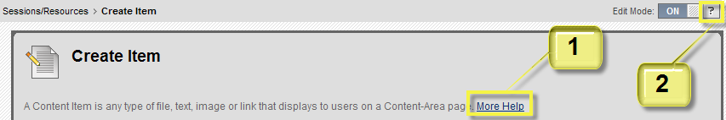

# Cancel and Submit buttons

These buttons appear at the top and bottom right of most pages on which you are making a change to the module. Click Submit to confirm and save your changes. Click Cancel if you do not want to go ahead with any changes or new items that you have started making (or have navigated to this point in error):



# Edit Mode button

The Edit Mode button (at the top right of the page) controls your view of your module pages. The state you switch it to will persist across pages and also when you log in your pages will be in the Edit Mode state you had set when you last logged out.

1. **Edit mode** ‘**ON’** – allows you to create and edit content, work with module management tools and to modify the structure of your module



1. **Edit Mode** ‘**OFF**’ – you see the module pages as the student will see them (all editing functionality is turned off)



# Drag and Drop

Any item in a list which has the double headed arrow, as highlighted below, can be dragged and dropped to a new position in the list. The first example shows two items in a list of content items and the second example shows part of the module menu, the elements of which can be dragged and dropped to re-order the structure of your module.

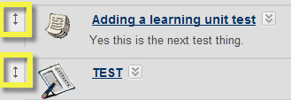

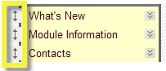

The information panels on your VITAL home page can also be rearranged by dragging and dropping them to the available areas of the page.

# Hide/Reveal side menus button

Always available is this ‘hide/reveal side menus’ button which when clicked will expand the area of the main page to conceal the module menu and Control Panel menus. This might be particularly useful when working with a tool such as the Grade Center, where there can be a lot of data to view in a spreadsheet format:

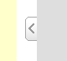

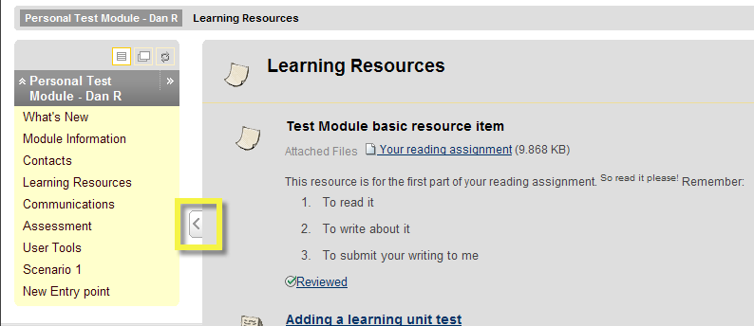

# Name Colour Swatch selector

If you want to change the colour of the name of a content item, for instance you want to colour code items that belong together, then click on the double downward arrow colour button below the ‘Name’ text box. This will bring up the colour selector as shown below from which you can choose the colour you require and click ‘Apply’.

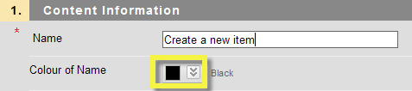

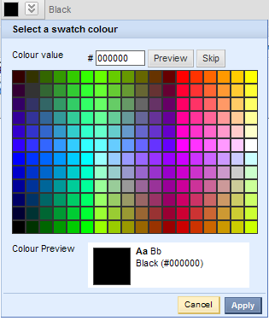

# Date/Time Selectors

Wherever you can enter a date in VITAL there is a useful calendar tool which is accessed by clicking the calendar icon (1). Find the date you need on the calendar that appears and click on it to see it automatically entered into the text box. There is also a time entry tool which you access by clicking the clock icon (2) and selecting a time from the dropdown list that appears:

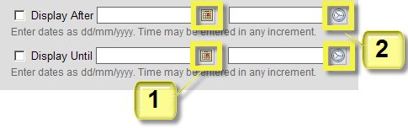

# Visual Text Editor

Standard to the set-up/editing of most tools in VITAL is the Visual Text Editor which is a What You See Is What You Get (WYSIWYG) text editor. You can use this editor to create text in the format (fonts, colours, layouts) as you want it to appear to the students. If you hover your mouse over the icons in the toolbars of the text editor you will see that these are standard functions. There are also some specialised tools described below.

Whilst this tool creates HTML code for you to make the text appear how you want on the VITAL module pages, you can also choose to edit the HTML yourself using the toggle icon (described below):

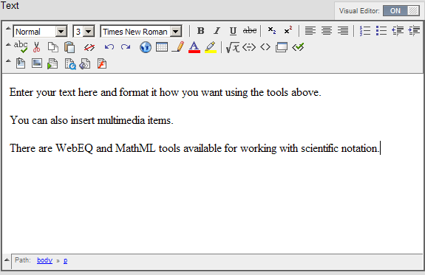

The specialised tools include:

|  |  |
| --- | --- |
| Icon | Description |
|  | Insert a hyperlink. |
|  | Access the WebEQ equation editor for working with scientific notation. |
|  | Access the MathML equation editor for working with scientific notation. |
|  | Switch to HTML code view – allows you to work with the HTML tags created by the Visual Editor. |
|  | Preview item button. |
| *The following tools (found in the third row of icons) have specialised set-up options for the way they appear in the text box which you will see when you click the icon.* | |
|  | Attach file |
|  | Attach image |
|  | Attach video (MPEG/AVI) |
|  | Attach QuickTime file |
|  | Attach sound clip |
|  | Attach Flash file |

The Visual Editor can also be turned off and you can code in your own HTML or insert javascript, for example. As a word of caution, text entered with the Visual Editor on will be lost if you switch it off.

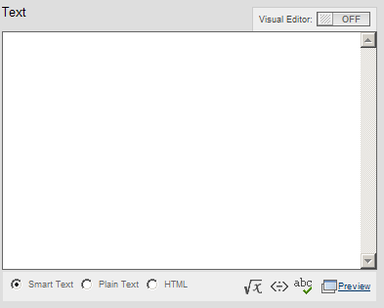

Smart Text mode converts any URLs you enter into links and recognises a limited number of HTML tags for simple formatting purposes.

In the Plain Text mode anything you enter in the text box will be displayed as you write it – this mode does not recognise HTML tags.

In HTML mode you can code the item page in your own HTML.

As when the Visual Editor is on, you can also use WebEQ and MathML equation tools for working with mathematical/scientific symbols (highlighted - 2).