**Student enrolment on VITAL**

Process of student enrolment on VITAL modules

What to do when a student reports difficulties in accessing your VITAL module?

A) Checking student enrolment, the student’s SPIDER record, on TULIP

Further support on TULIP

Checking VITAL to see whether the student is enrolled on module

**Overview**

This guide explains the process of enrolment so that you can identify what action to take to when students report problems in accessing VITAL modules.

# Process of student enrolment on VITAL modules

SPIDER:

Contains student module enrolment data

VITAL:

Takes student module enrolment data from SPIDER

Students are not enrolled directly in VITAL

Overnightly   
update

1. SPIDER student record system contains all student module enrolments.
2. VITAL module enrolments are taken automatically from SPIDER records. (Student VITAL enrolments are never entered directly into VITAL.)
3. VITAL updates itself with SPIDER data every night. Changes to the SPIDER records will appear in VITAL the day after they are made.[do we need this now?]

# What to do when a student reports difficulties in accessing your VITAL module?

Please refer to the *Troubleshooting flowchart on student enrolment guide* for more details*.* The rest of this guide details two steps that you can take to check student enrolment data:

1. check the student’s Spider record via Tulip to see whether they are registered on your module (see section ‘’);
2. check your VITAL module to see whether the student is registered on it (see section ‘’).

## Checking student enrolment, the student’s SPIDER record, on TULIP

1. Log in to <http://tulip.liv.ac.uk/> and click on the **Teaching** menu on the left:

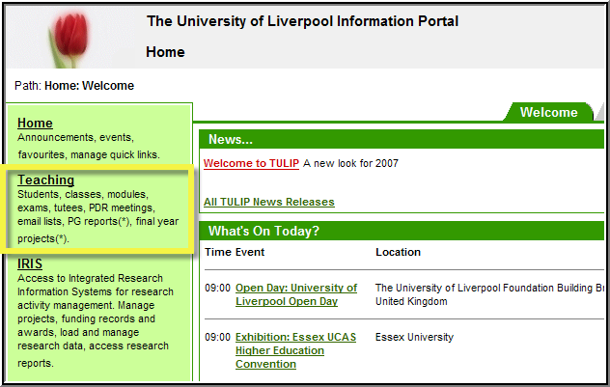

1. Click on the **Spider Student Enquiries** link:

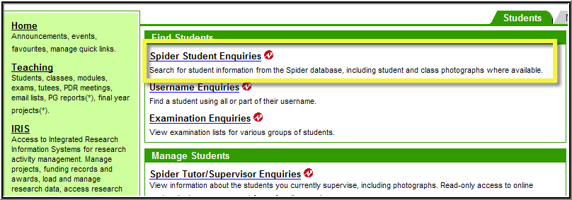

1. On the search page, fill in the student’s ID number or name details. Make sure you select student type as ‘Current, pending and past students’.



1. Click on the **Search.**
2. Click on **Select** next to the student’s name at the bottom left side of the page to search for a particular student. For example:

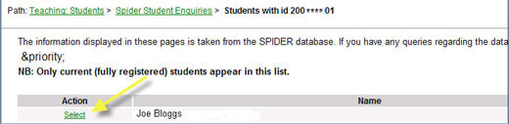

1. Click on the Current **Modules** link from the top of the page:

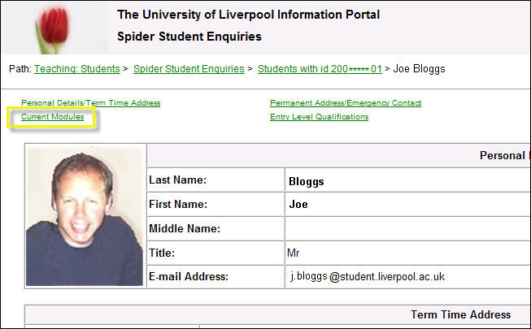

This will open a full list of modules that the student is currently enrolled onto.

1. If the module in question is **not** listed on the student’s record, **the student’s SPIDER record needs updating**. Please ask the student to resolve it with the SPIDER team ([spider@liv.ac.uk](mailto:spider@liv.ac.uk)). Once the student is enrolled on the module in SPIDER, VITAL will automatically take this information during the overnight upgrade. The student will be able to access their VITAL module the next day.
2. If the module in question is listed here, please go on to section ‘Checking VITAL to see whether the student is enrolled on module’, page 3.

## Further support on TULIP

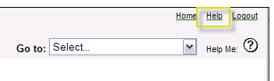If you need help within TULIP, please consult the TULIP help files from within TULIP using the Help button at the top of the screen:

If you need further assistance, please contact the TULIP team at [tulip@liv.ac.uk](mailto:tulip@liv.ac.uk)

## Checking VITAL to see whether the student is enrolled on module

1. Go to the module on which you would like to check student enrolment.
2. From the Control Panel, click **Users and Groups**.
3. Then click on **Users**:

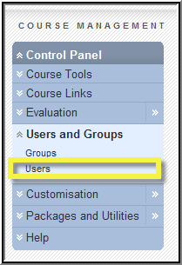

1. To list all users/students on the module, click in the search box and put a **%** (percentage) sign in it, the click **Go**:

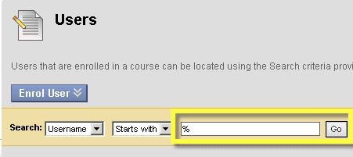

The students enrolled on the module will be listed:

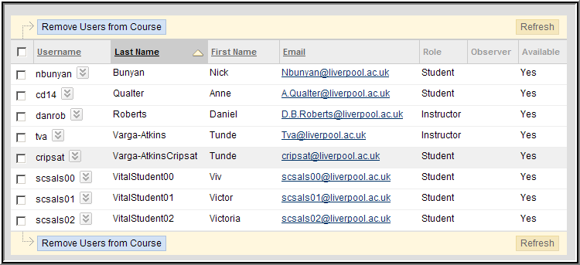

1. If your student is listed here and the block icon  does NOT appear against their name, then the student *should be able to access* their VITAL module. You can confirm this or ask the student whether they may have hidden this module on their home page (see the Managing your home page > Modify your homepage list of modules section of the How to guide).
2. If your student is **not listed** here but is enrolled in SPIDER on the module, please email [helpdesk@liv.ac.uk](mailto:helpdesk@liv.ac.uk) *FAO: VITAL technical team*, stating:

* your module code and year (e.g. MODU101 2010/11),
* the student’s name (and username if you know it)

and that the student seems to be enrolled on your module in Spider but does not show up as enrolled on the module in VITAL.