**Staff enrolment on VITAL**

Process of staff enrolment on VITAL modules

What to do when you want to enrol or remove a staff member on a VITAL module

Step 1: Contacting helpdesk to issue a staff member with a University username and password

Step 2: Check TULIP for the module specification

Step 3: Changing the TULIP electronic module specification (adding or deleting a staff member)

Further support on TULIP

Step 4: Adding (or deleting) a postgraduate assistant or other administrative staff on VITAL

Step 5: Removing staff from a VITAL module

Step 6 Requesting administrator access to all the VITAL modules in the department

**Overview**

* This guide describes the process of staff enrolment on VITAL modules and explains what to do to enrol staff members on VITAL modules if required.
* Staff members with teaching responsibility for a module automatically get enrolled on the VITAL module as an *instructor*.
* Departmental TULIP administrators and heads of departments are automatically added to each module as a *course builder*. A process also exists for requesting access for administrators to all the modules in the department.
* Postgraduate students and other administrative staff can be enrolled to VITAL manually.
* There is also a separate process for enrolling external examiners and temporary teaching staff.

# Process of staff enrolment on VITAL modules

1. Staff gain automatic enrolment to VITAL modules as ‘Instructors’ via the electronic module specifications in TULIP.
2. Staff information from the electronic module specifications are automatically added to VITAL.
3. Changes made to electronic module specifications in TULIP will come through into VITAL the next day.
4. Electronic module specifications in TULIP can be modified by the module coordinator or your departmental TULIP administrator.

# What to do when you want to enrol or remove a staff member on a VITAL module

The flow diagram below shows the steps and actions to resolve issues of enrolment, such as:

* How can I enrol a staff member who is not on the VITAL module?
* How can I enrol a graduate assistant?
* How can I enrol an administrator to the VITAL module?
* How can I allow our external examiner access to the module?
* How can I allow an external lecturer/visiting lecturer access to the module?
* How can I give an administrator access to all the VITAL modules in the department? [this needs adding to diagram!]

Please see the relevant steps below.

## 

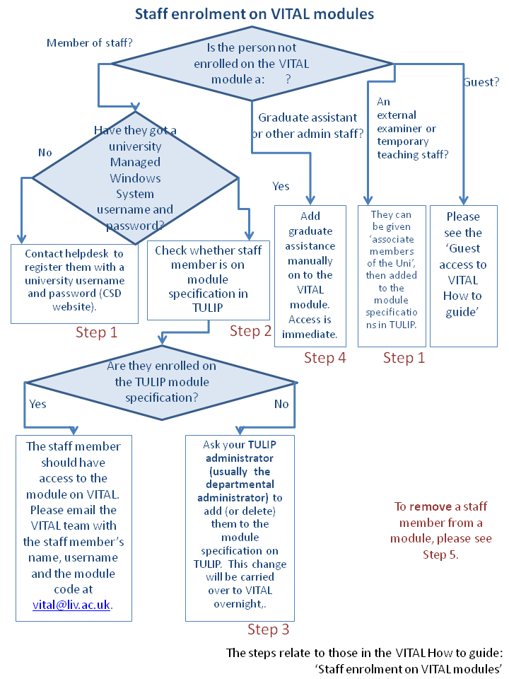

## Step 1: Contacting helpdesk to issue a staff member with a University username and password

Staff, honoraries and postgraduate students can self-register with their staff / student ID. External examiners and temporary teaching staff can be given ‘Associate members of the University’ status and then added to the electronic module specifications in TULIP to gain access to VITAL modules. Associate members of the university need a supporting letter from their Head of Department and complete a registration form available at CSD’s registration page: <http://www.liv.ac.uk/csd/registration/index.htm>.

## Step 2: Check TULIP for the module specification

1. 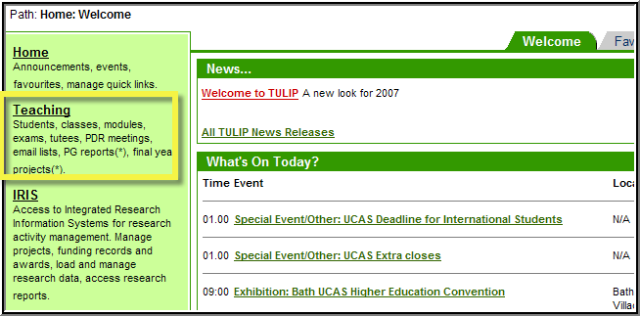Login to TULIP (<http://www.liv.ac.uk/tulip/>)
2. Click on ‘**Teaching’** in the left menu, then on the **Modules** (tab):

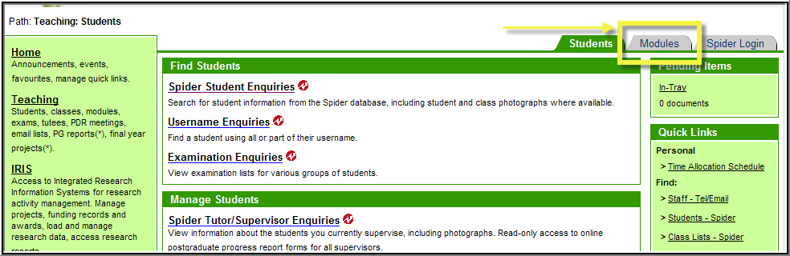

1. Click on the **Module specifications** link, and it will open a list of your modules.

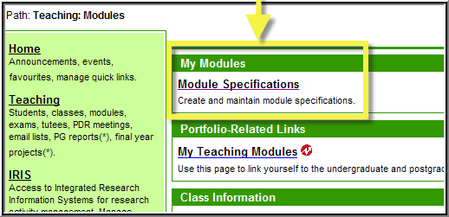

1. To search for a particular module, enter the module code (e.g. EDEV404) in the **Find** box. (You can also customise which modules you want listing using the user preferences link.)

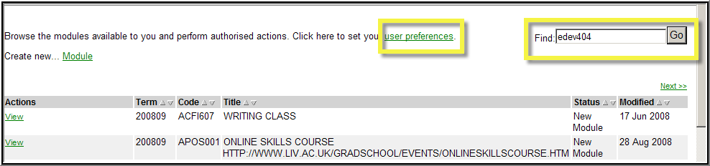

1. Click **View** next to the title of the module specification (eg EDEV404):

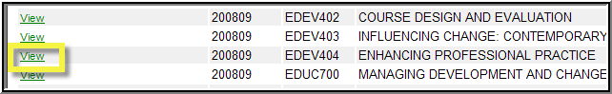

See the staff listed under points 10 (module coordinator) and 13 (other staff associated with the module). These staff members get enrolled on a VITAL module automatically. To amend any of these detail, please see Step 3.

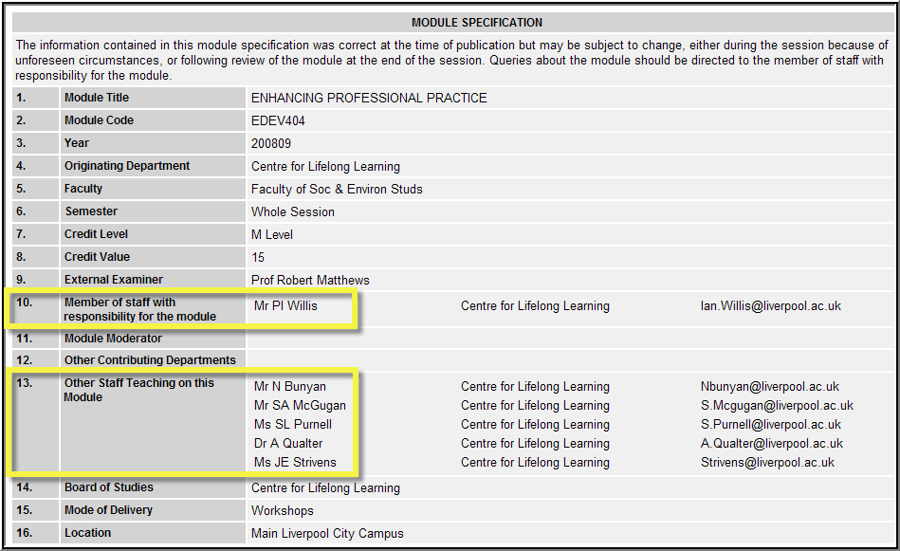

## Step 3: Changing the TULIP electronic module specification (adding or deleting a staff member)

1. Changes to a module specification can be made by the module coordinator or by your departmental TULIP administrator (who is likely to be an administrator for your department – you can also contact [tulip@liv.ac.uk](mailto:tulip@liv.ac.uk) to find out who this may be).

*Please note: Any changes made in TULIP will not result in any changes in VITAL until the next day!*

## Further support on TULIP

If you need help within TULIP, please consult the TULIP help files:[check with TULIP team this, I think it is on VOCAL now]

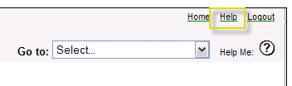

If you need further assistance, please contact the TULIP team at [tulip@liv.ac.uk](mailto:browna@liverpool.ac.uk).

## Step 4: Adding (or deleting) a postgraduate assistant or other administrative staff on VITAL

To enrol main teaching staff on VITAL, please see Step 2.

|  |  |
| --- | --- |
| 1. To enrol postgraduate assistants or other administrative staff on a VITAL module, login to VITAL and your module (e.g. ENGL101). | |
| 1. Click on **Control Panel** and then click on **Users** in the ‘Users and Groups’ menu: |  |
| 1. To list all users on the course, select ‘Not blank’ from the pop-down box and click **Go**. |  |
| 1. To enrol a user, click on the **Enrol user** button and the **‘Enrol Users’** link. This will open an enrolment page. |  |

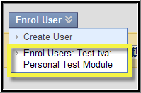[change this image to a ‘normal’ staff one, they don’t have the two options!

1. Type in the username for the staff member to be added (or click **Browse** to find him/her) and select their role (e.g. instructor or teaching assistant), then click **Submit**.

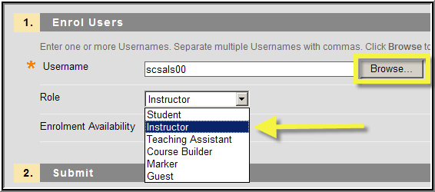

Staff roles (in order of increasing privileges):

* **Guest** – has access to some or all of the content areas as specified by the instructor and does not have access to the Control Panel.
* **Student** – has access to all the tools, content areas, assessments and assignments that have been made available by the tutor. Students do not have access to the Control Panel.
* **Course Builder** – can add content to Content Areas, but cannot access the modules Gradebook tool and therefore any assignment or assessment information.
* **Grader** – can access all the assessment and assignment tools via the Gradebook tool. Graders cannot add, just view, content.
* **Teaching Assistant** – has similar status to an Instructor, but cannot add users or change their status within a module.
* **Instructor** (the highest access privilege) - has full control over all tools, content areas, assessment and enrolments within a module.

## Step 5: Removing staff from a VITAL module

**Main staff members** need to be deleted (de-enrolled) from a VITAL module amending the electronic module specification in TULIP (please see steps 2 and 3). This is because VITAL takes the staff information from TULIP so even though if you de-enrol or remove a staff member from the module in VITAL, they will be reinstated overnight if their details are still on TULIP.

Please also note that the **course builders** (TULIP administrators are given this access status to all departmental VITAL modules) on the module are also automatically added, so even if you delete them, they will be re-instated the next day.

You can remove or delete **graduate assistants** or **temporary staff** directly in VITAL:

|  |
| --- |
| 1. Click on **Control Panel**, then click on **Users** in the ‘Users and Groups’ menu. |
| 1. To list all users on the course, enter % in the search box and click **Go**. |

1. Next to the user to be removed, click on the downward pointing double-arrow and select ‘**Remove Users from Course**’.

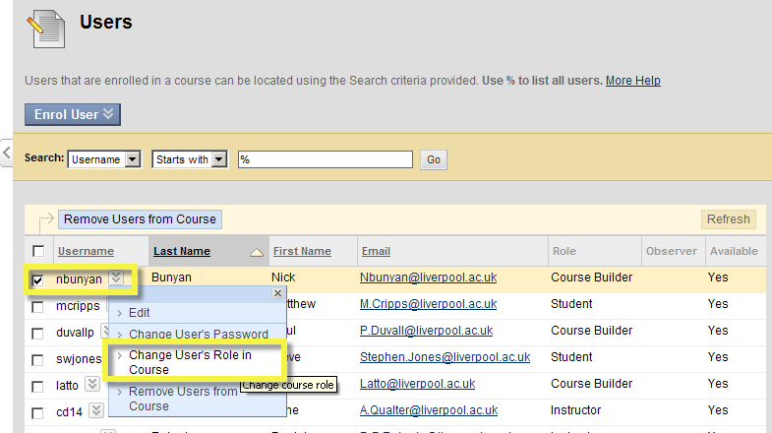[image needs changing to highlight ‘remove users from course’ which is currently not available in the archive server]

## Step 6 Requesting administrator access to all the VITAL modules in the department

Administrators who need access to *all* VITAL modules in the department can be given automatic access to the modules as ‘course builders’ by becoming a TULIP administrator. The process for this is:

**Request to be a TULIP administrator**

1. The Head of Department needs to email [tulip@liv.ac.uk](mailto:tulip@liv.ac.uk) to request the administrator’s access to all the departmental VITAL modules from the Tulip team.

*TULIP is the system which provides VITAL with all information regarding students, instructors and module enrolments which is why the e-mail should be sent to the TULIP Technical Team rather than the VITAL Technical Team.*

1. Once this is done by the Tulip team, the administrator should have access to all modules after an overnightly update process in VITAL. They will be able to see the modules under ‘Courses you are building’ as they have course builder access to the modules by default.

Note: **Course builders** have access to upload content. They do not have access to the Grade Center or other submission and marking data. If this is needed, administrators need to be upgraded as instructors on the modules.

**Request to be upgraded to ‘instructor’ status on all departmental VITAL modules**

‘Instructor’ status can be requested if the administrator needs get into to the Grade Center to access grades or assessment data across the department’s modules.

1. If the staff member to be given department-wide instructor status on VITAL modules, they should already have TULIP administrator status (if they have not, follow the steps above-or REF).
2. The Head of Department should send an email to [helpdesk@liv.ac.uk](mailto:helpdesk@liv.ac.uk) for the attention of the VITAL technical team and ask for the administrator’s upgrade to ‘instructor’ on all modules. [is this right?can the two not be done in one go?]
3. After this is done by the VITAL technical team, the administrator should have access as instructor after an overnightly update process.

See also the How to guides on:

* Annual module rollover;
* Guest access;
* Student enrolment.