# Modifying your module menu structure

Overview

All modules in VITAL are set up with a basic structure which you can modify to:

* add new sections for content to the module
* re-order the module menu and add dividers and sub-headers
* add tool, course and external links to the module menu.

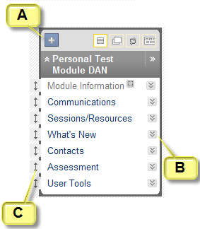

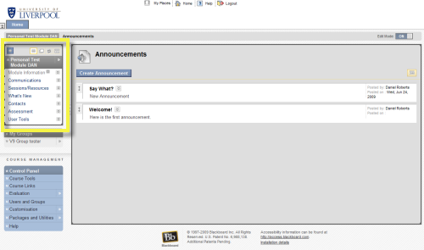

All of these modifications are carried out directly on the module menu (highlighted above left). The enlargement above right shows three main aspects of the module menu:

Hovering over this blue and white cross reveals a drop down menu with the options you need for creating new structural items in your module menu.

each of these double downward arrow icons, when clicked, reveals a dropdown menu with top-level actions directly related to that section.

these two-way arrows indicate that the item can be dragged and dropped to reorder the module menu.

Modifying the module menu structure is done on a module by module basis. You cannot make your own templates to re-use. Students will see the module menu exactly as you create it (without the editing functionality). However, they will not see menu links when there is no content in that section, indicated to you by the link title being greyed-out and an icon next to the link as shown below:

 

You can also choose to hide the link and its associated content from the students and if this is the case you will see this icon next to the link title.

Creating new menu items in a VITAL module menu

1. Hovering the mouse over the blue and white cross icon will expand the ‘Create’ menu of options for creating new structural items in your module menu, as shown below:

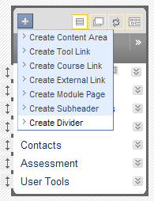

1. For each of these new menu items you create you will be asked whether to make it available to view by students. The default setting is **no** and you need to check the **‘Available to Users’** box to make it visible at this point. You can choose to Show the link at a later point .

**Create Content Area** – every module has a ready-made Content Area called ‘Learning resources’ which you should use in the first instance for adding content items to the module for your students.

1. If it would suit the organisation of your module you can add more content area pages using this **Create Content Area** link:

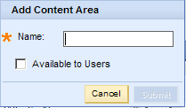

1. You will be prompted for a name. Click **Submit** to add the menu link to your module menu and page where you can add learning content items.

**Create Tool Link** – you can create a direct link from the module menu to a specific VITAL tool, so that your students can quickly access it, if it is a major part of your module, for example.

1. You are prompted to give the tool link a title and to choose one tool from the complete list which appears in a drop down menu:

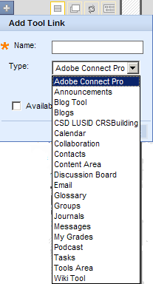

**Create Course Link** – you can create a link from the module menu to a specific section or content item within your module. You might use this to have a quick link for your students to an important module assessment for example.

1. You will be prompted for name for the link and the location of where you want to link to in your module. Click on the **Browse** button to open new window (as shown in the example below) which lists in directory format all of the sections and items within those sections in your module.
2. Click on one of these and click **Submit** to create your link.

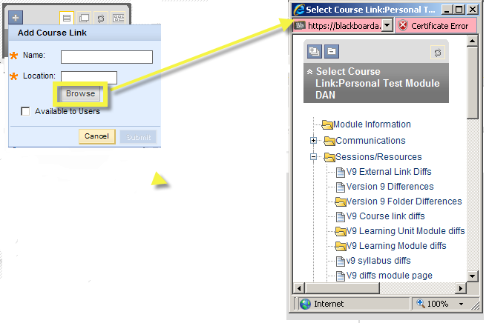

**Create External link** – this creates a direct link from the module menu to an external web site, which might be departmental web pages about the module, for instance.

1. You will be prompted for a name for the link and you will also need to know the URL (copy and paste the address from your browser’s address bar) as there is no browse facility here.

**Create Module Page** – this will create a module information page for the student, summarising (on information panels similar to those on your home page) any relevant information, such as outstanding tasks, recent assessment grades and module announcements.

**Create Subheader** – create a logical divide in the layout of your module menu with this link. You will be asked for a name for your subheader and this will then appear under a line in the module menu as shown on the screenshot on the right. You can then add and order menu items to appear under this subheader:

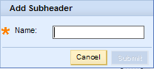 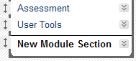

**Create Divider** – creates a logical line divider in the layout of your module which does not have a subheader text attached to it. This can be dragged and dropped up and down the module menu.

Editing menu items in a VITAL module menu

The dropdown menu for each module menu item (accessed through the double-arrow icon) relates specifically to that item so the content of the menu will differ from item to item. These are top-level functions which will generally include an option to **Rename** the module menu link, **Hide** or **Show** the link to the students, **Permit** or **Deny** guests to have external access to that module area, or **Delete** the item and its content altogether.

Exercise caution with this Delete function as it will permanently remove the module menu link and its associated content. It is probably better just to Hide item from students in case you want to re-use content at a later point:

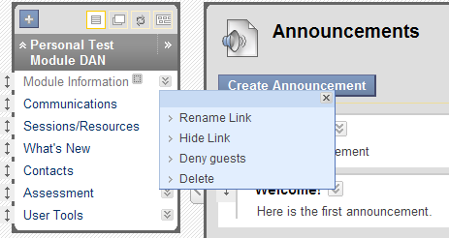

Re-ordering items in a VITAL module menu

Module menu items can be dragged and dropped to rearrange the order of the module menu (including subheaders and dividers) by clicking on the double headed-arrow of the item you want to move and drag and drop it in the new position on the menu, as shown below:

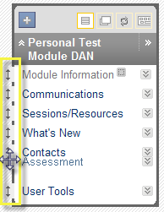

***Accessibility note.*** You can reorder module menu items through your keyboard by clicking the icon highlighted below to access the facility shown here. Select the item you want to move and use the up/down arrows to move it. (Note: you might find that this doesn’t work on computers running Windows 7 & Internet Explorer 8. Switch to a different browser such as Firefox.)

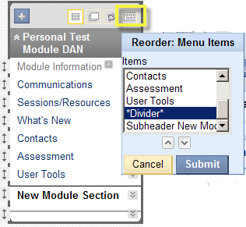

The VITAL module page

Note – This page did not work fully with version 9 of Blackboard (2009/10 academic year). This tool is currently being tested – please contact VITAL support if you would like to use this tool: [vital@liv.ac.uk](mailto:vital@liv.ac.uk) )

1. Clicking on **Create Module Page** prompts you for a name for the section and after submitting you will see a blank page with an **Add Course Module** button as shown below, which you click to see a page where you select which module information panels you want to display to your students on this module:

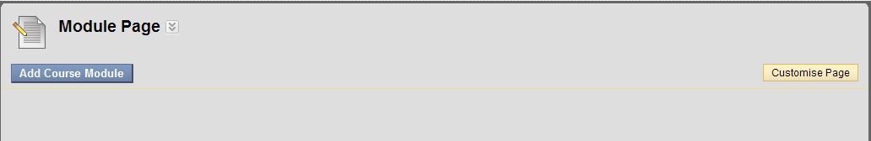

1. Choose the information panels you want your students to see (there is a short description of each on the Add Module page – they are very similar to the home page panels).
2. Click **Submit**.

A Module Page with all module information panels selected will look similar to this screenshot below to the student:

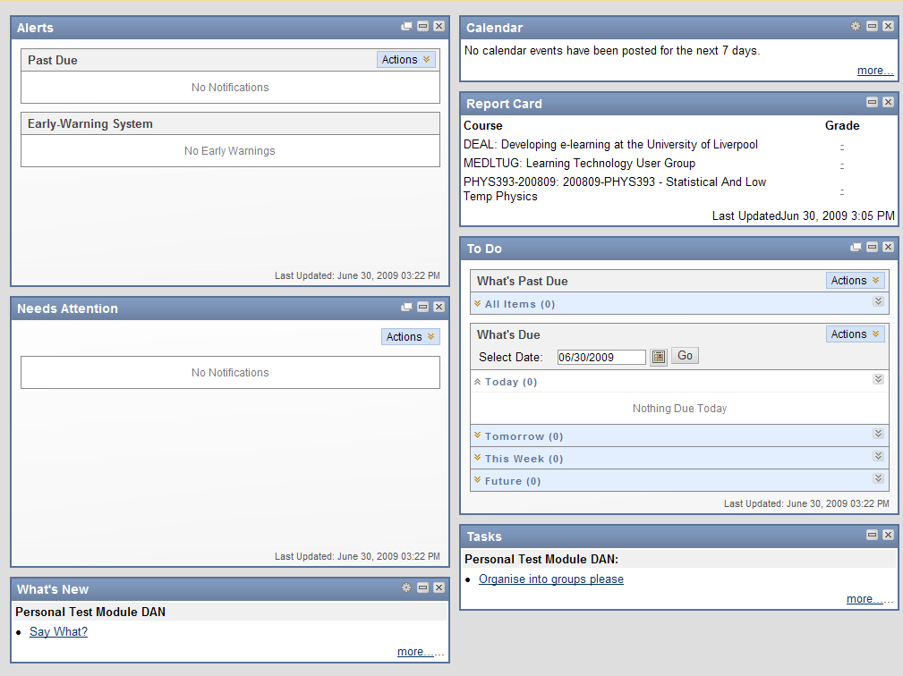

1. You can further modify the module page through the **Customise Page** button (see right hand side of step 9 diagram) to change the colour scheme. There is also a **double-arrow dropdown menu** next to the title of this page where you can add a module banner and allow the students to customise this page.
2. To make this page the entry point for the module (the first page the student sees when they click on the module link from the home page) then you click on **Customisation** in the **Control Panel** menu, then click the **Style** option menu. In section 4 of this page there is a drop-down list to change the entry point. Select your module page’s title and then **Submit**. This page should now also be your module entry point.