# Mashup tool

Overview

This tool lets you easily search and add content form externals sources. Currently this tool enables you to add:

* Youtube videos
* SlideShare presentations.
* Flickr phtotos.

‘Mashup’ is a bit of IT jargon which in this context just means content from another system. It also has more technical meanings such as combining information from 2 databases to produce a new resource. An example of this would be combining houses for sale in an area with Google Maps. This tool within VITAL will possibly be developed and you will be able to access additional external & internal resources.

To add a Youtube video

1. Go to any **content area** (E.g. Sessions/ Resources) and make sure the edit button is set to ‘**On**.’
2. Click on the **Build Content** button and the link to **YouTube Video** from the right of the pop up menu:

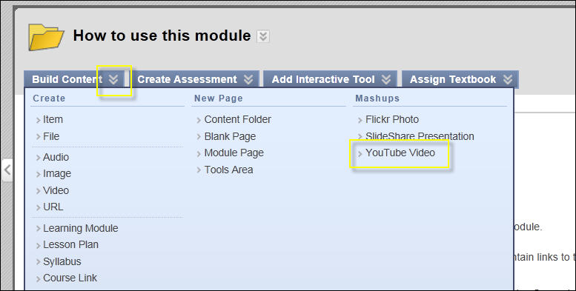

1. This will open the following YouTube search box:

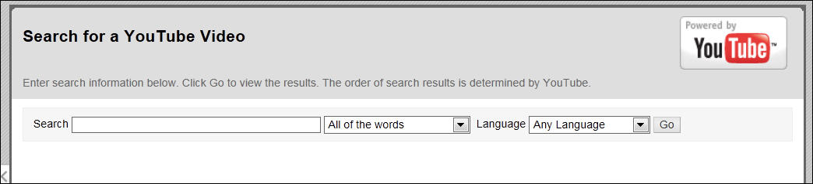

At this point you may want to go directly to YouTube.com in a new browser tab and make sure you know which specific video clip you may want to link to so you can check its title etc. This search box is fine if you know the resource you are looking for.

1. Type in the title of the video you want to link to. Notice the second drop down menu box:

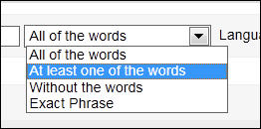

1. Enter your search terms and click on the **Go** button. This will bring up a list of videos. For example:

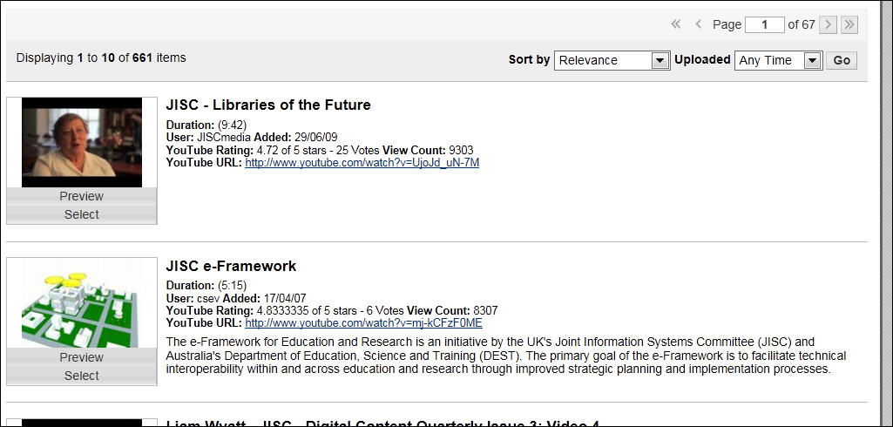

1. Scroll down the list of videos and either click on the **Preview** button to check it is the right on, or click on the **Select** link to add it to your module.

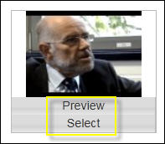

Notice at the top of the page that there are options to sort the list of videos by relevance to your search term, and by date they where uploaded.

1. Once you have selected the video you want to add, the **Create Mash-up Item** page will open:

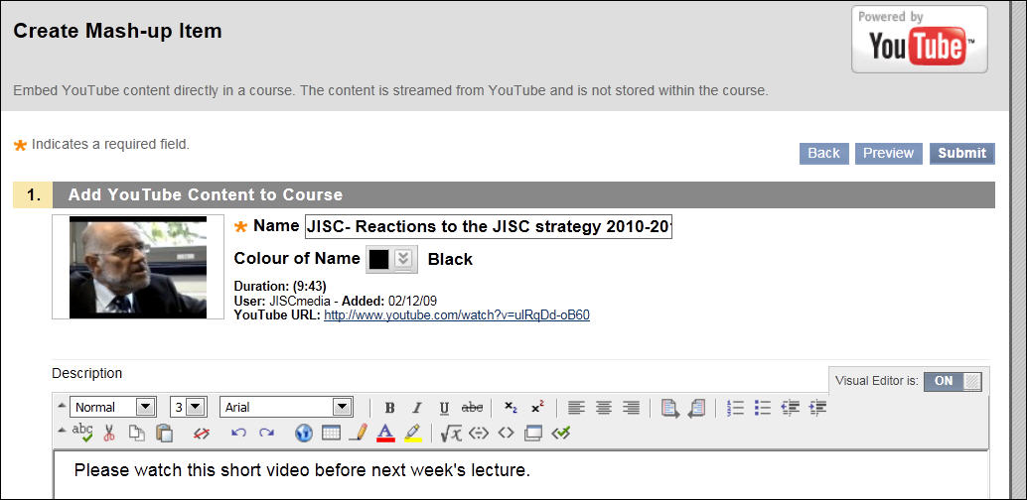

Within this page you can:

* Change the title of the video
* Add additional information or description about the video.
* How the video will be displayed on the page.
* Other options to control the availability etc. which are available in the normal Item tool in VITAL.

1. Select from the **Mash-up Options** section how you want the video to be displayed and any additional information from YouTube you want students to see:

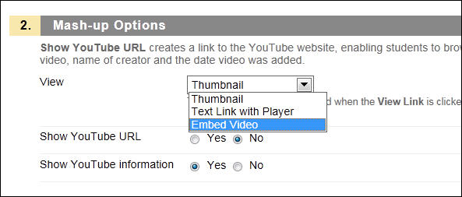

1. Scroll to the base of the page and click on the **Preview** button to check how the video will appear to students – this is an imporatn step as it is easier to change settings at this stage rather than the normal process of using ‘edit’ once ht3 video has been added. Once the settings are the way you want, click on the **Submit** button.

An image of the preview and submit buttons

1. Switch the Edit mode button to ‘**Off’** to check how the video will appear to students. For example:

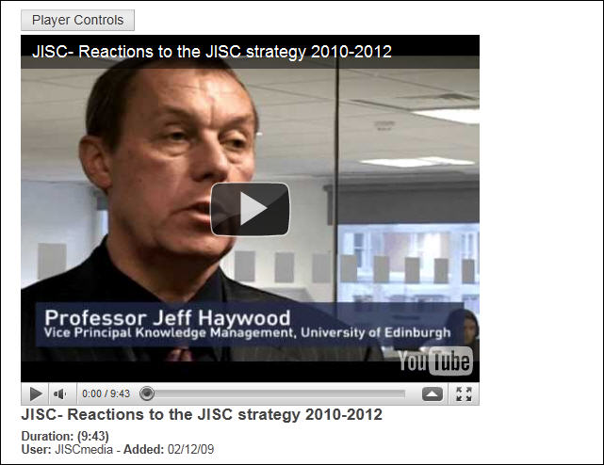

To a SlideShare presentation

This Mashup process works in a similar way to the process described previously for adding a YouTube video.

1. From the **Build Content** button, click on the **SlideShare Presentation** link:

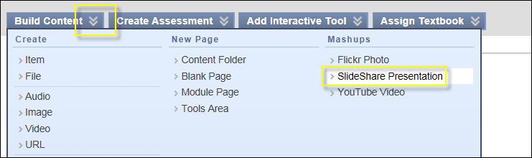

This will open the following page:

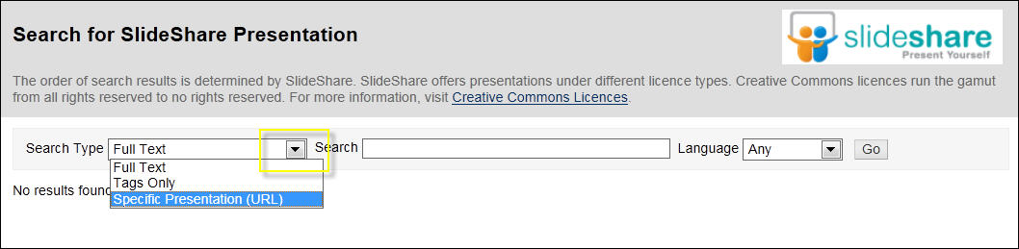

You can search by full text within the presentation, tags or from the presentations URL.

1. Add your search terms and click on the **Go** button.
2. Scroll down and find the presentation you want to add. Click on the **Preview** button and the presentation will open in SlideShare in a new window.
3. Click on the **Select** button to add the presentation.

This will open the **Create Mashup Item** for SlideShare:

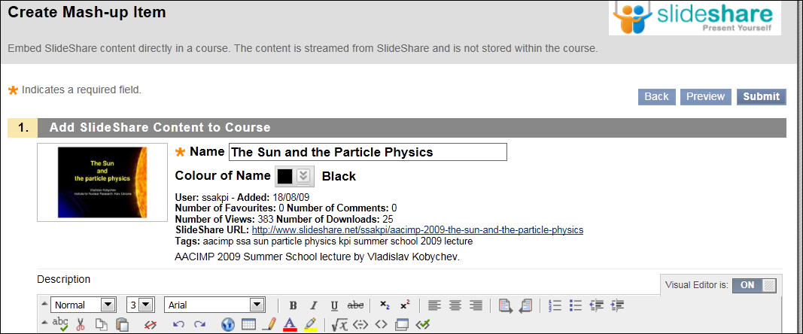

1. Change the title, add any description as required.
2. Scroll down the page and check the **View** settings:

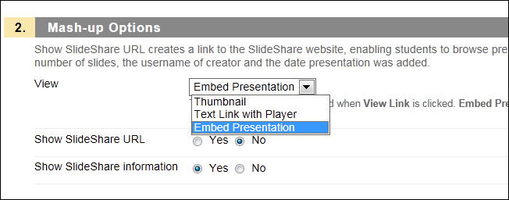

Note – at the time of writing this guide there seems to be a problem using the ‘Embed Presentation’ option with Internet Explorer 8. The presentation will load, but will not display. This option works OK in other browsers such as Firefox.

1. Click on the **Preview** button at the base of the page to check how the presentation will appear – make any adjustments before clicking on the **Submit** button.
2. Switch off the Edit mode button to ‘Off’ to check how the presentation will display to students. For example:

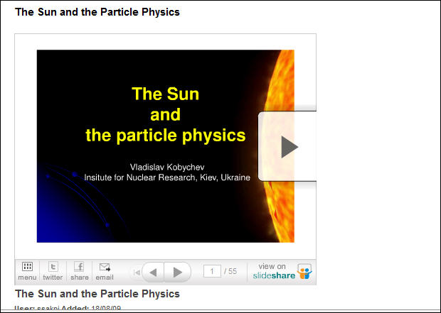

To add a Flickr photo

This Mashup process works in a similar way to the process described previously for adding a YouTube video.

1. From the **Build Content** button, click on the **Flickr Photo** link:

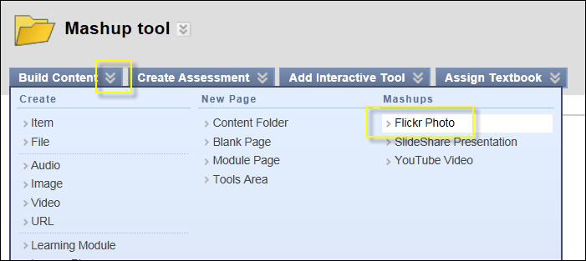

This will open the following page:

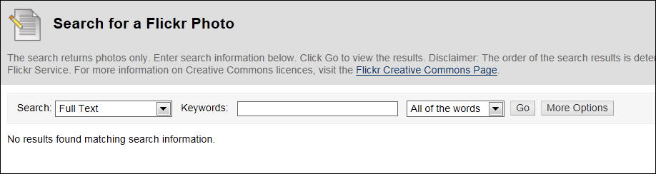

1. Click on the first search box – this will let you search for photos either as full text, tags or the URL. Also notice the **More Options** button – this will give you additional options to find specific photos added to Flickr between defined dates, those that are free to use under creative commons licence etc.

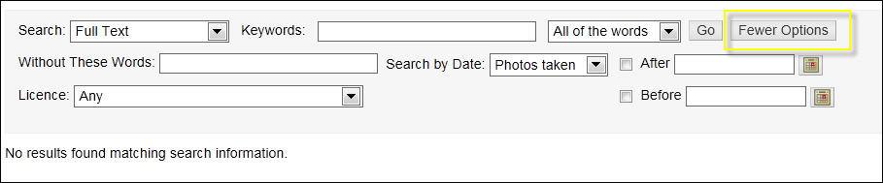

1. Enter your search terms and click on the **Go** button.
2. Scroll through the list of photos and click on either the **Preview** or **Select** buttons:

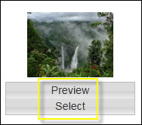

1. Change the title, and add any description.
2. Scroll down the page to the **Mash-up Options** section. This will enable to add the photo as a link, or display it directly in VITAL:

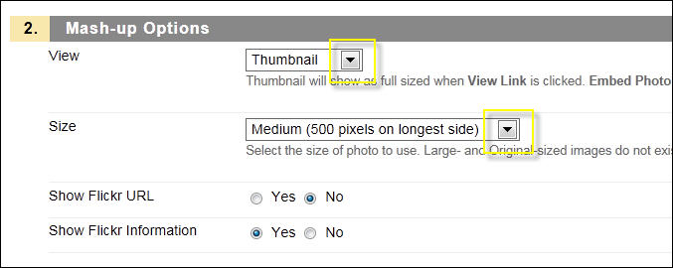

1. With some Flickr photos you may not want to display information imported from Flickr such as lists of tags etc. Click on the **No** option for the **Show Flickr Information** option:

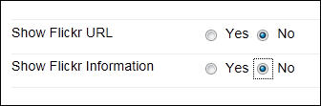

1. Scroll down to the bottom of the page and click on the **Preview** button to check how the photo will displayed. Adjust any settings as necessary and then click on the **Submit** button.
2. Click on the **Edit mode** button to ‘**Off’** to view how the photo will appear to students.