# Managing your homepage

Overview

The main area of your VITAL homepage consists of a number of information boxes, or panels containing information and links which can to a certain degree be customised.

1. Clicking the ‘**Home**’ tab from anywhere in VITAL brings you back to this home page.
2. The ‘**modules’** box is the most important section of the homepage as this lists all the modules you will have access to in VITAL.
3. Your homepage will also include a number of other boxes which will display different information such as announcements from different VITAL modules etc. These boxes can be changed using the (G) ‘**Add Module**’ button and the (F) ‘**Personalise Page**’ button.
4. This box will display a range of links to different tools that can be accessed outside of a VITAL module. These include links to ‘**My Grades**,’ ‘**Campus Pack**’ software (student personal learning spaces/ eportfolio software etc.) and the ‘**Facebook/ iPhone**’ link.
5. The top of the page contains a series of icons which link the Help for staff and students and a ‘**Logout’** of VITAL icon.
6. The ‘**Personalize’** button enables you to change the colour scheme for the homepage.

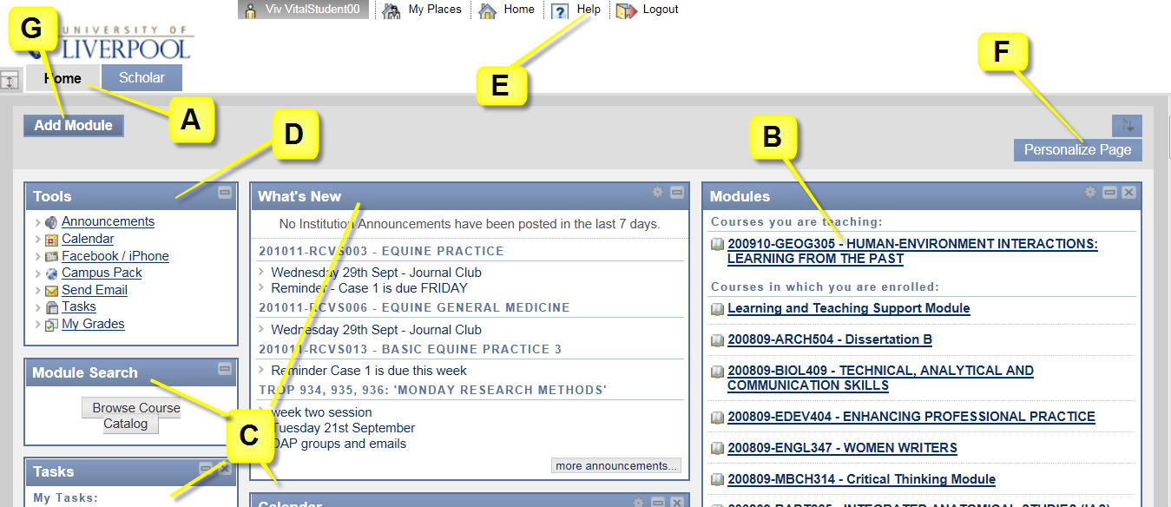

Customise your homepage layout

Each of the panels can be moved into a different position on the page. The home page is organised into three columns.

1. Click on the **blue square icon** just above the ‘Personalize Page’ button. This will open a new window where you can move the position of each box between columns of the homepage etc. For example:

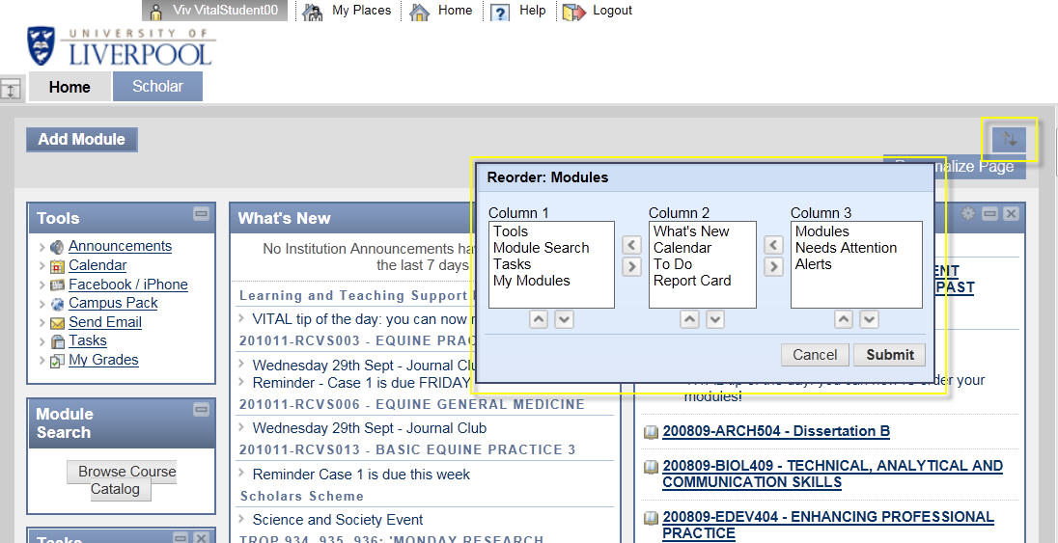

1. Use the arrows on the window to move different boxes around the screen. Click on the ‘Submit’ button to save any changes.

Customise your homepage module list

Within the ‘Modules’ box you can change which modules are displayed, and the order in which they appear. This can be changed at any point – useful if you need to work on a limited number of modules for a period of time. This facility doesn’t affect your enrolments to specific modules.

1. Click the small **cog icon** in the blue title bar of the ‘**Modules**’ panel.

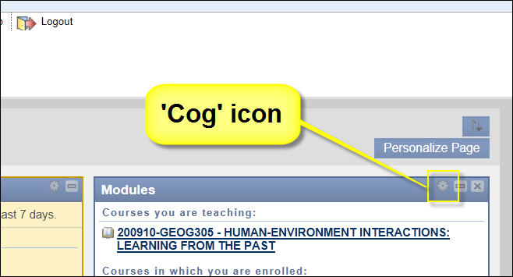

A page where you can edit your list of modules appears.

1. In the column ‘Course Name’ (highlighted below) uncheck all of the modules you do not want to see on your home page list. Click **Submit** to save the changes.

You are not deleting the modules themselves or removing yourself from the module (see **Annual Rollover** process guide) and you can come back to this page to re-display them.

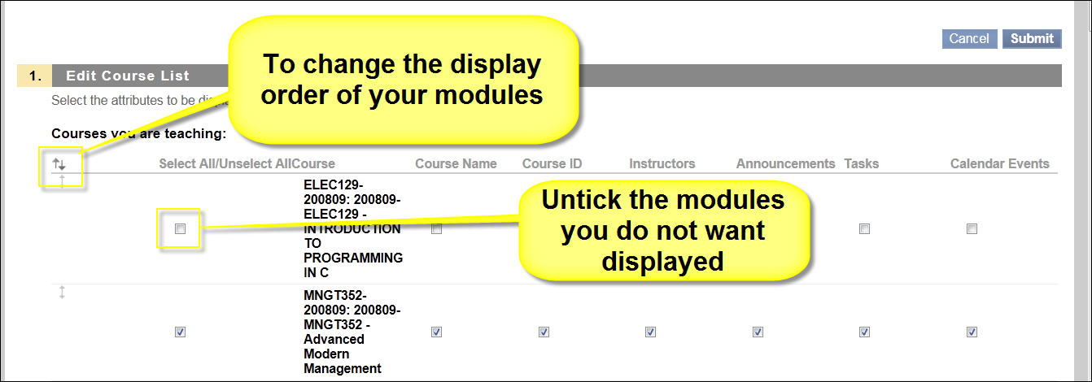

1. There are further display options that can be set on a module-by-module basis for your module list, namely display the: Course ID, Instructors, Announcements, Tasks and Calendar Events.
2. To re-order the list of modules, click on the small **double arrow icon** to the left side of the screen:

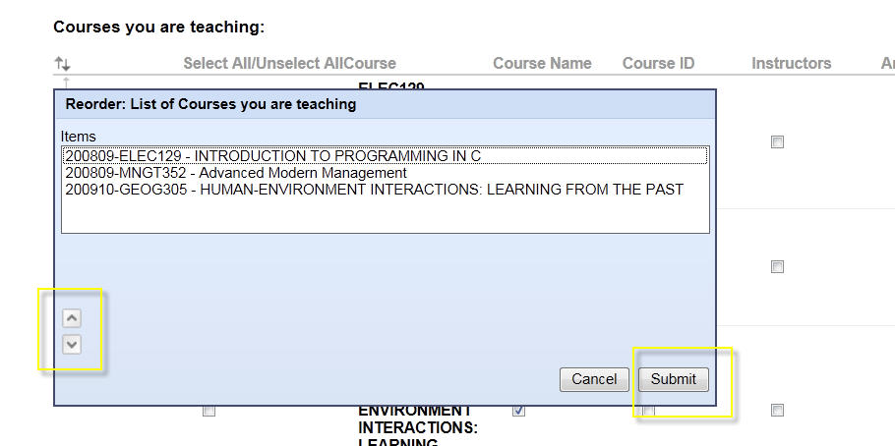

1. Highlight the module you want to move and use the **up & down arrows t**o change its location in the list.
2. Click on the **‘submit’** button to save any changes.
3. Finally click on the ‘**Submit’** button to return to the homepage:

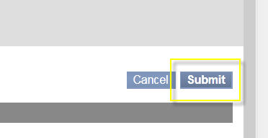

Customise your homepage content – ‘Personalise’

1. To quickly ‘hide’ any panels you don’t want to appear, click the ‘**x**’ icon at the top right of the blue title bar of the panel (where this is available) as you would for closing a Word document:

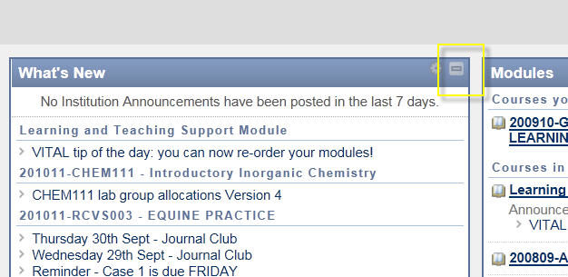

This will minimise the box:

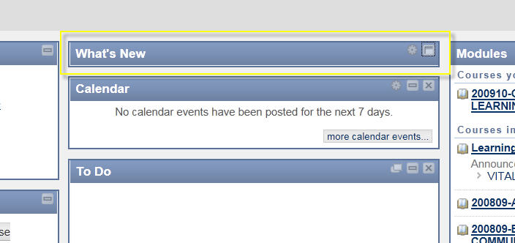

To remove panels & boxes from the homepage

1. The main method for adding and removing panels is to click the **Add Module button. C**heck/uncheck the relevant panels.

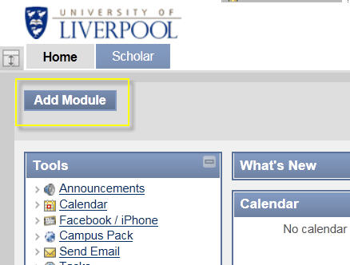

1. Click the **Submit** button to save your changes. (notes some boxes and panels are not removable.)

‘What’s New’, ‘Calendar’ and ‘Tasks’ give a top-level view of this information across all your modules.

‘Alerts’, ‘Needs Attention’, ‘Report Card’ and ‘To Do’ are only relevant to the home pages of VITAL modules for students or if you are enrolled on a module as a learner yourself.

The Tools panel

This panel cannot be completely hidden on the Homepage, only minimised.

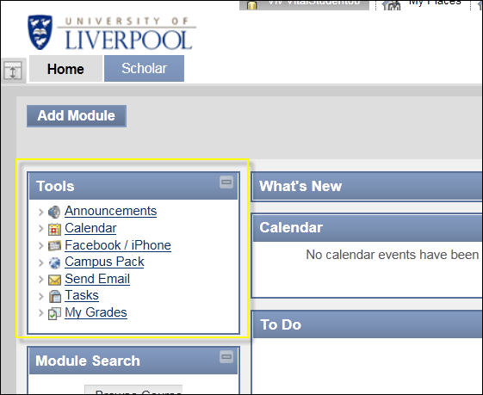

The links on this panel include:

* **Announcements,** by defaultis a list of all announcements on all your modules – view can be modified by time, type and module;
* **View Grades** is where students can check their grades in all their modules;
* **Send Email** is quick way of emailing specific groups without going into individual modules;
* **Facebook/iPhone** is where students can set up their Facebook account or iPhone to get updates and alerts from their VITAL modules;
* Campus Pack is a personal website builder and community space that operates outside of the modules in VITAL.

To customise the colour scheme – ‘Change Theme’

1. Click the **‘Personalise’** button (F) and click on a colour scheme displayed.

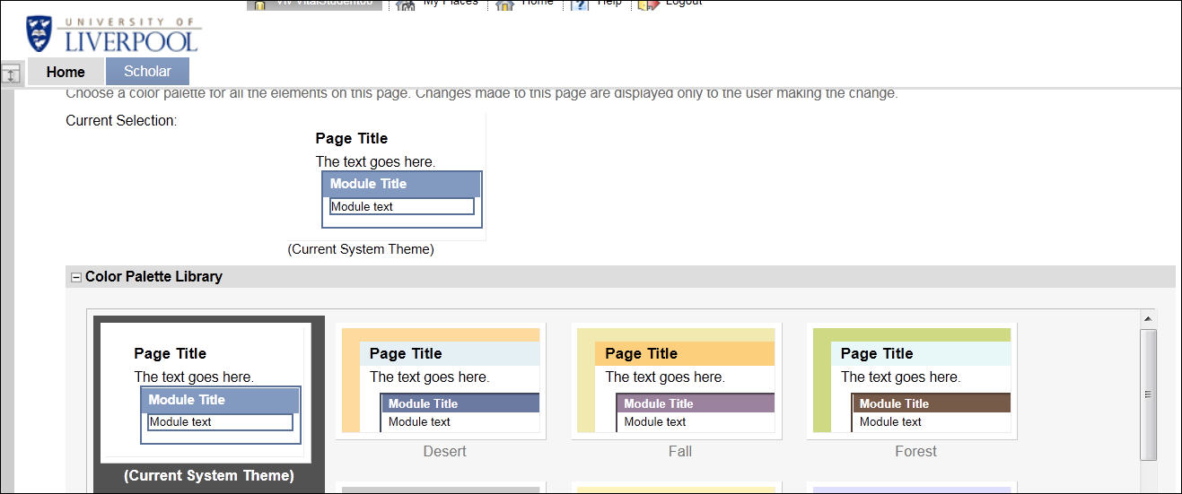

1. Click ‘S**ubmit’** to save your changes. This change will only apply to your view of VITAL and will not affect the student view. For example (some of the options can be a little garish!):

