# VITAL navigation basics

Overview

The basic navigation shown in this guide is:

* how to get from your VITAL home page and into the module with which you want to work
* how to use the main navigation points within a module
* how to find the main elements of a content area (create/edit content tools)
* how to return to the home page or log out of VITAL.
* Navigating from the homepage to a module (and around the options menus of a module) and then back is one of the foundation skills of effective VITAL use.

VITAL homepage navigation

1. Once you have logged-in to VITAL the first page you see is **your home page**. There are three key navigational elements on your home page.

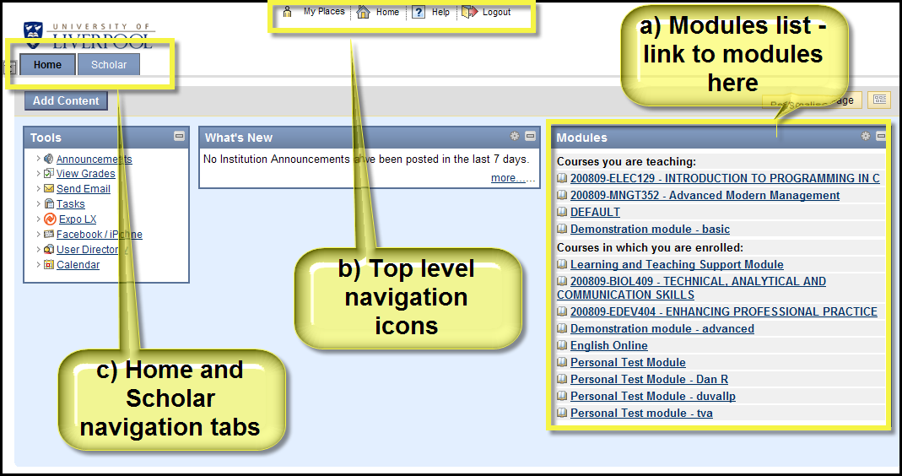

a) Modules list. This is the main point from which you access your modules and is a list of links to all of the modules on which you are enrolled, grouping them by your status on the module. As well as all of your teaching modules there are four modules to which you have automatic access to:

1. **Personal Test Module**. Your own, private module which you can use as a ‘workshop’ to try things out and experiment.(‘**Unavailable**’ means it is unavailable to other users within VITAL but not you!)
2. **Learning and Teaching Support Module**. Will contain materials for the CPS programme and contains a link to the VITAL help resources, and online resources so you can develop your use of VITAL.
3. **Demonstation module:** **tools & facilities**. Examples of the different tools and facilities within VITAL.
4. **Demonstration module**: effective practice. Examples and ideas for laying out your modules, making your module look visually interesting, ideas for structuring learning resources & activities, case studies illustrating the pedagogy of blended learning.

(Note: modules 2,3,4 are under re-development will be available within the 2010/ 11 academic year.)

b) Top level navigation icons. These four icons appear at the very top of every page in VITAL and when clicked can be used to navigate VITAL as follows:

* **My Places** – displays a window with a complete list of links to all your current modules; this navigation method could be used when working in one module to quickly access another module, rather than returning to the home page and then out again
* **Home** – returns you to your VITAL home page
* **Help** – links to the staff and student ‘How to’ guides and FAQs in a separate window
* **Logout** – ends your VITAL session, logs you out of the VITAL system and returns you to the login page.

c) Home and Scholar navigation tabs. These tabs appear in this position across all pages in VITAL. Clicking on the **Home** tab is another way to navigate back to your VITAL home page. The **Scholar** tab accesses VITAL’s social bookmarking system.

1. The homepage is customisable - you can drag and drop the information panels around, add to or remove panels, and change colour schemes. See ‘Managing your homepage’ for details.

Accessing a VITAL module

1. From the homepage, the main way to access a module is to click on a module title link from the **Modules** panel:

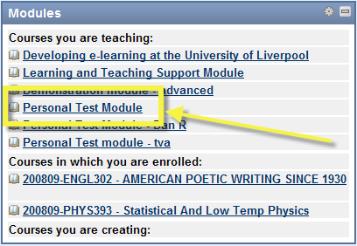

The ‘*Unavailable*’ in the module title means that it is accessible only to you not other staff or students

Navigating around a VITAL module

1. All VITAL modules have a similar structure before content and learning and teaching tools have been added. There are three principal areas of the page from which you navigate around individual modules.

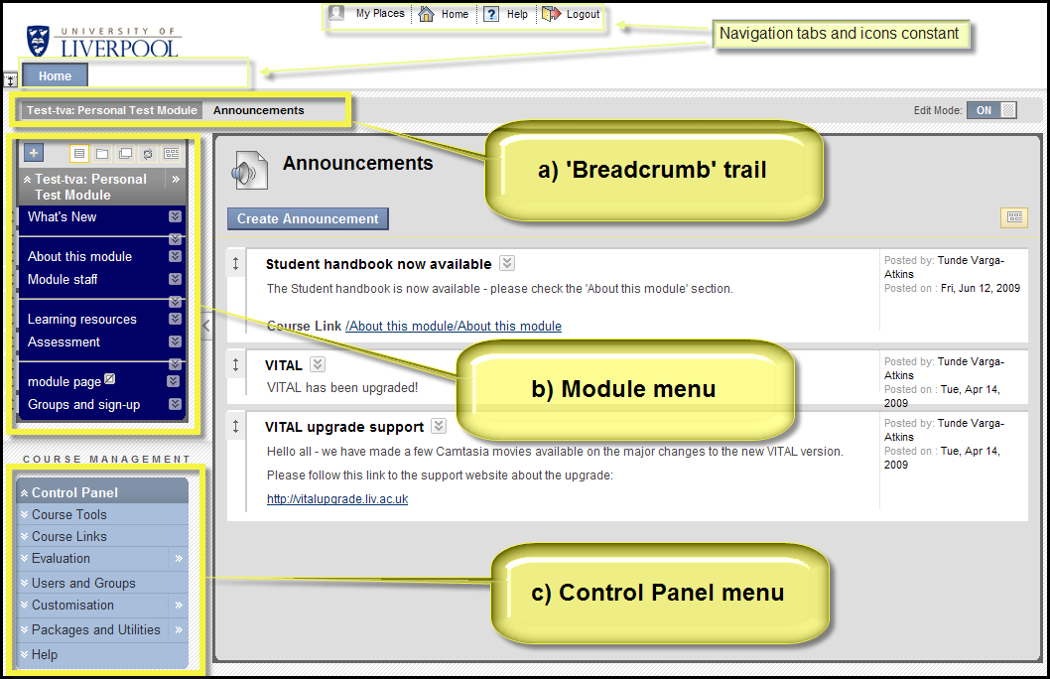

1. ‘**Breadcrumb’ trail**. This trail menu grows and shrinks as you navigate up and down the levels of the module, showing the path you took to get to your current page. Each element of the trail is clickable to navigate back to that page. Clicking on the module title at the start of the trail returns you to the module entry point (usually the ‘What’s New’ page).
2. **Module menu**. This menu shows the structure of your module and is fully editable from here, i.e. add/remove sections, rename sections and reorganise the order. Each link in this menu is a section in your module to which you add your module content. Click through the links to access the sections of the module. See the guide ‘Customising your module menu’ for more detail.
3. **Control Panel menu**. The Control Panel contains the tools you use for managing many aspects of a module as well as some of the content creation tools. It is an expanding/collapsing menu system - each section of the Control Panel contains a submenu which is expanded by clicking the submenu title. The example below shows the Control Panel after the Customization submenu has been clicked. Re-click the submenu title to close the submenu.

Note - students never see the Control Panel.

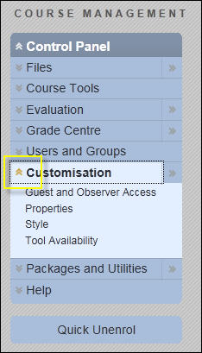

If you cannot see the full Control Panel, as in the example below, just click on the Control Panel title.

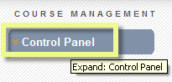

The purpose of many of the options within the Control Panel will become apparent as you learn to use the different tools and facilities within the software.

1. Also highlighted on the main screen shot above are the two always-available navigation methods, the tabs and the top-level icons (see step 1 above).

Navigating around a content area

1. When you click a link from the module menu to access that section of your module, the main area of the page you see lists the content items in that module section in the order in which they will appear to students. The most important of these generally will be your Learning Resources (or Sessions/Resources) and Assessment sections. It is here that (with the **Edit Mode** set **ON)** you create new content items, assignments and tests, and re-order and edit them. With the **Edit Mode** set **OFF** you see the module content from the student view.
2. The screenshot below shows the two main points on a content area page from which you either create and add new content items to the module (a) or from which you edit and manage the content items that are already part of the module content area (b).

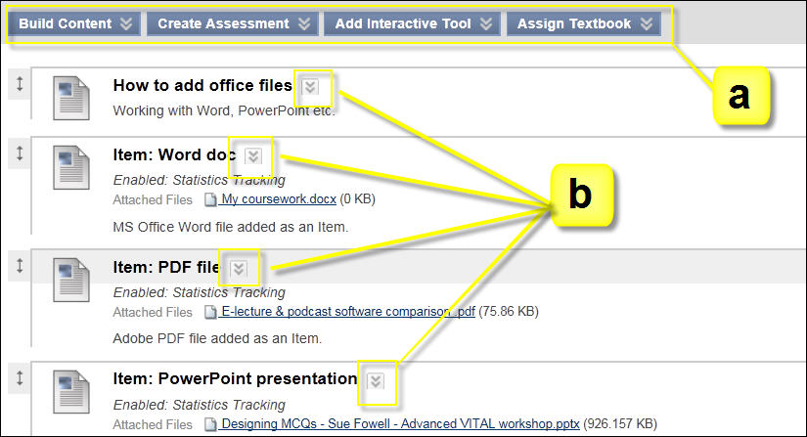

1. The buttons highlighted by a) above contain pop-up menus in which you find links to VITAL’s content creation tools. These are accessed by hovering the mouse over the double downward arrow on each button as shown in the example below.

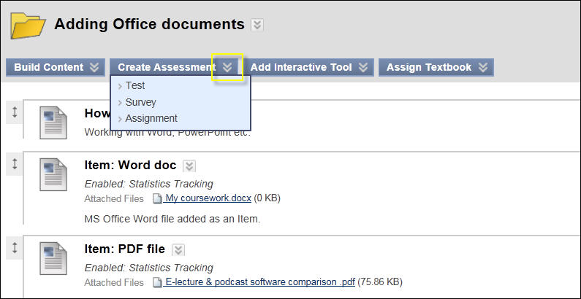

1. The buttons highlighted by b) above contain pop-up menus from which you access the editing and management functions for individual content items, as shown in the example below. This is where you find the Edit, Copy, Delete, Adaptive Release, Metadata, Tracking, User Progress and other tools specific to the individual item where applicable.

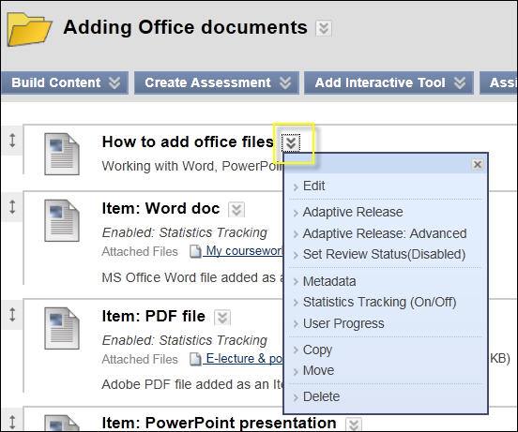

Exercises

1. In your **Personal Test Module** (see step 3) click on **Course Tools** in the **Control Panel** menu to expand the menu for that section.

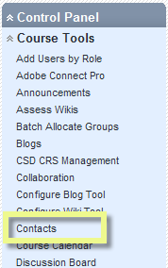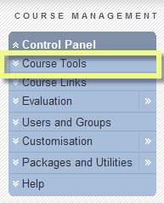

You can then click on one of the tools in the sub-menu list that appears, for example the **Contacts** tool, where you can add contact information of staff teaching the module for the students.

1. To navigate back to the module entry point (usually the ‘What’s New’ announcements page) click on the module title in the breadcrumb trail as highlighted in blue below. In this example the user has been working with the **Send** **Email** tool from the **Course Tools** section of the **Control Panel** menu. The breadcrumb trail shows that they have navigated to the **Send Email** tool page, and then to the **All Users** page for that tool.

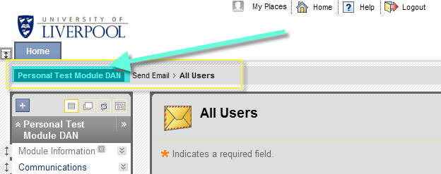

1. Finally, from a module page, click on the **Home** tab, above the breadcrumb trail, to return to your VITAL homepage. (You could also try the ‘**Home**’ icon at the top of the page to return to your homepage.)

Links to other guides

1. The home page and module pages are explained in more detail in the following guides:

* ‘Managing your homepage.’
* ‘Customising your module settings.’
* ‘Customising your module menu.’