**Announcements tool**

**Create and add an announcement to a module**

**Set date/time for announcement to display**

**Send announcement as an email**

**Include module links in announcement**

**Modify/Delete announcements**

**Ideas for using Announcements**

# Overview

The Announcement tool is an electronic notice board that can be used to communicate with students through the ‘What’s New’ section of a module. Use the Announcements tool to create and display any module-related messages to your students there (e.g. changes to lecture times) as in the example below. A basic announcement consists of a title, the announcement text and settings for when to display it to students.

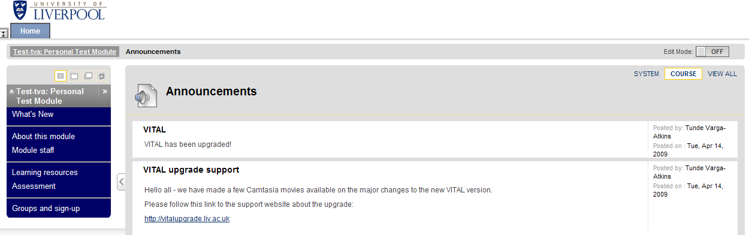

You can also:

* make the announcement permanently visible or set the date and time it appears to students
* send it as an email to all users enrolled on the module (staff and students)
* include a link to any part of the module in the announcement
* include multimedia content and links to external websites in your announcement.

# Create and add an announcement to a module

*When you have finished creating the announcement, click the ‘submit’ button to add it to the module.*

1. 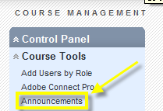In the module where you want to create your announcement, from the **Control Panel** menu, open the **Course Tools** sub-menu and click on the **Announcements** tool link in the list.
2. Ensure **Edit Mode** is **ON**. Click the **Create Announcement** button to access the set-up page.

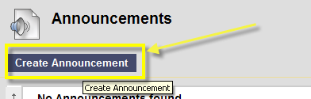

1. Click the **More Help** link at the top of the set-up page for a description of the options and settings you see.

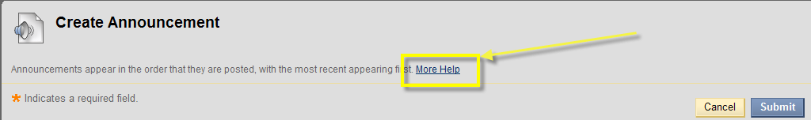

1. The first section is where you enter the announcement title (subject) and message content. The text box WYSIWYG editor lets you format and add multimedia content and links to external web pages.

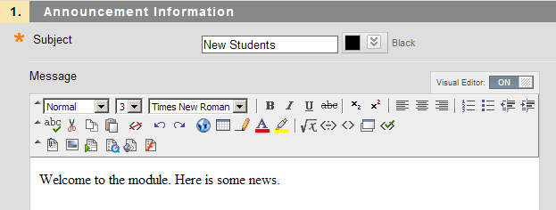

# 

# Set date/time for announcement to display

1. In **Section 2 Options** you can choose the **Duration** for which the announcement will appear to students. You can make the announcement ‘Permanent’ so that it is always visible and appears at the top of the announcements list. Alternatively set date/time restrictions for when messages will be visible (set ‘**after**’ and/or ‘**until**’ parameters).

# Send announcement as an email - *optional*

1. The option ‘**Override User Notification Settings**’ when selected will enable the announcement to be sent as an email to the University email addresses of everyone enrolled onto the module, irrespective of individual email settings.

# Include module links in announcement - *optional*

1. In section 3, the **Course Link** allows you to create a link to any section of the module from the announcement. Click the **Browse** button to open a map of the module and select section or page.

# Modify/Delete announcements

1. To modify or delete an announcement, then with the Edit Mode switched on, go to the ‘**What’s New**’ section to find the announcement, click on downward double-arrow and select **edit** or **delete**. If editing, ensure you click **submit** when you have finished to save your changes.   
   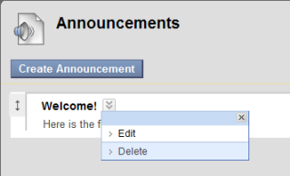

# Ideas for using Announcements

* Module information updates such as new content or changes to lecture times etc.
* Welcome message to the module with links to getting started guides etc.