**Group tool**

Basic steps to create groups

Create a single group

Create a single Self-Enrol group

Create a Manual Enrol single group

Create a group set

Create a Self-Enrol group set.

Create a Manual Enrol group set

Create a Random Enrol group set

Student view of group page

Adding a group or group set to a content area

Adding a group or group set to the module menu

Editing / changing a group

Editing / changing a group set

**Overview**

The Group tool enables online group work, organising students into groups in a module. Each group has its own group area in the module where the group can be given tools such as a group blog, discussion board, email, file exchange, journal, and the Scholar bookmarking tool. Group assignments can also be set-up to which groups submit joint work (group assignments are created **separately** using the Assignment tool – see ‘How to’ guide). Groups are created either singly (one-by-one) or in a set (a number of groups based on one template). A Group Set is the quickest way to create multiple groups sharing the same basic settings. Three different methods of allocating group membership are available, including allowing students to sign up to groups of their own choosing.

See also the ‘How to’ guides for other group management tools:

* The **Batch allocate groups** tool (Control Panel > Course Tools) allows the quick population of groups by uploading a .csv file with students’ usernames and group details.
* The **Sign-up list** tool (a third party tool which integrates with the Group tool) is a specialised tool for managing class sign-ups for events such as seminars, with valuable features such as viewing, printing and exporting group members. See the ‘How to guide’ to the Sign-up list tool.
* *The A****dvanced group management*** *tool is a third-party tool in VITAL which is still being upgraded to the current version. The tool used to provide a quick overview of all the names and group membership in a table. This tool is not currently available.*

# Basic steps to create groups

1. Decide whether to make a single group(s) or a set of groups. Groups can be created by two methods:

* **single** – create each group required from scratch - populated by the module Instructors (manual enrol) or allow students to sign-up to the group (self-enrol).
* **group set** – specify a basic template and the number of copies of this to quickly create a set of groups. In addition to manual and self-enrol there is also the option to get the system to randomly populate the groups.

1. Decide how students are going to be allocated to groups. Both single and group set groups can be populated by:

* **Manual Enrol** – the instructor decides on group membership and allocates students to each group.
* **Self-Enrol** – students can sign up to a group themselves. They see the groups they can sign-up to in their module and choose from there.

Group set groups can also be populated by:

* **Random Enrol** - group membership is randomly allocated between groups by the system. (Random enrolment is not available for single groups)

1. Complete the group settings as described in the sections below for the group type selected.
2. If using Self-Enrol group(s) then you ensure that the sign-up sheets for these groups are readily available to link to from either a content area or the module menu. (If the groups are pre-populated then the group to which each student belongs will appear automatically as shown in the Student view section below. Extra content area or module menu links to the group can also be created.)
3. For instant online help whilst working with the Group tool, click on **More Help** link highlighted below**.**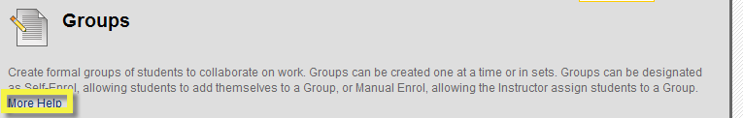

# Create a single group

This section describes how to create the two kinds of single groups: a Self-Enrol or a Manual Enrol group.

## Create a single Self-Enrol group

A Self-Enrol group allows students to choose which group they want to belong to online and sign-up, e.g. for tutorial groups or other kinds of group work.

1. With the Edit mode switched **ON**, go to **Control Panel**, then **Users and Groups**, and click **Groups**.
2. Hover over the **Create Single Group** button and select **Self-Enrol** from the list.

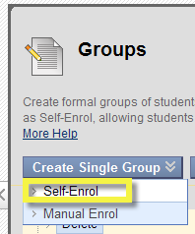

1. A name must be entered for the group. The description text will appear on the group home page (as shown above) and can be used to describe the purpose of the group and any essential information.

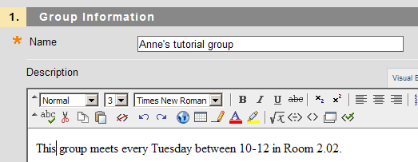

1. Select the **Group Availability** (default **yes**). **Sign-up Sheet Only** means that there is no online group area created for the group just a sign-up sheet. (This could be used as an online tool for organising sign-up lists for seminar groups, special lectures etc.)
2. The setting **Allow Personalisation** in Section 3 (default - enabled) determines whether this group will be able to change the colour schemes and add information modules to the group page.
3. In Section 2 set which tools will be made available for the group to use. (Untick tools not required).
4. In section 4 **Sign-up options,** a name must be given for the sign-up sheet for this group. The description can contain instructions about what the group is for, who can sign up, when, maximum numbers and so on. You can also set a maximum number of members here. This information will be displayed to the student before they decide to sign-up to the group.
5. Tick **‘Show members’** if students should be able to see who else has signed up to the group already before signing up.
6. ‘**Allow students to sign-up from Groups area’** (default **yes**) means that students can sign up to the group from their ‘Groups’ page found via the Tools link in the module if this remains set to yes.

The sign-up list can also be made directly available in a content area which is the easier (and preferred) way for students to find it. This has the further advantage that adaptive release rules can be set for the sign-up lists, i.e. make the group sign-up only available for certain students or at certain dates. See 11 below.

1. Click **Submit** to create the group.
2. Now add the group to a content area (or the module menu) so that students can find it easily and sign-up.

To add the group to a content area, go to section Adding a group or group set to a content area.   
To add the group to the module menu, go to section Adding a group or group set to the module menu.

## Create a Manual Enrol single group

In the Manual Enrol group you decide which students belong to the group before it becomes visible to the students.

1. With the Edit mode switched to **ON**, go to **Control Panel**, then **Users and Groups**, and select **Groups**.
2. Hover over the **Create Single Group** button and select **Manual Enrol** from the list.
3. A name must be entered for the group. The description text will appear on the group home page (as shown above) and can be used to describe the purpose of the group and any essential information.



1. Select **Group Availability** (default **yes**).
2. The setting **Allow Personalisation** in Section 3 (default - enabled) determines whether this group will be able to change the colour schemes and add information modules to the group page.
3. In section 4 **Membership**, add (and remove) members of the group using the right and left arrow buttons highlighted below. To select a member, click on their name in the left hand ‘Items to Select’ box (hold the CTRL button down to select multiple names), then click the right-pointing arrow and their name will be moved to the ‘Selected Items’ box to make your selection(s) belong to this group.

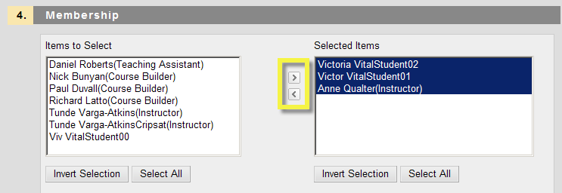

1. Click **Submit**. The group is now listed in your instructor view Groups page. (In the Control Panel expand the ‘Users and Groups’ menu and select ‘Groups’).

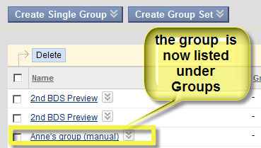

Go to section Viewing group or group sets from MyGroups area to see how students can view and access this group area.

# Create a group set

Use this method to create a number of similar groups quickly. First create the basic template group and then specify how many ‘copies’ of this group are required in the set. Groups created via Group Set will all have the same maximum number of members and enrolment method (set in the template) but the group names, descriptions, tool availability, membership and so on can be edited on a group-by-group basis if required.

For example a group set template called ‘Tutorial Group’ is created and the tutor specifies that 4 groups should be created from this. VITAL then creates four groups ordered numerically (Tutorial Group 1, Tutorial Group 2 ... Tutorial Group 4). The group sets share availability (e.g. dates) and the tools which were enabled for the set, though all such settings as well as names can be changed later.

Three different methods of populating these groups are available: self-enrol, manual enrol and random enrol (detailed in the next three sections).

## Create a Self-Enrol group set.

A self-enrol group set creates a set of groups to which students can sign themselves up to online.

1. With the Edit mode switched to **ON**, go to **Control Panel**, then **Users and Groups**, and select **Groups**.
2. Hover over the **Create Group Set** button and click **Self-Enrol** from the list.
3. A name must be entered for the group set. The description text will appear on the group home pages and can be used to describe the purpose of the groups and any essential information.

Please note that groups within the set are identified by a numeric number so do not use numeric numbers or other identifiers (such as a, b, c) when setting up a group set.

1. Select **Group Availability** (default **yes** – groups available to students).
2. Select the tools that will be made available for the group. (Untick any that are not needed.)
3. Enter the sign-up sheet options (name and description and the maximum number of members).
4. Tick **‘Show members’** if students should be able to see who else has signed up to the group already before signing up.
5. ‘**Allow students to sign-up from Groups area’** means that students can sign up to the group from the ‘Groups’ page found via the Tools link in their module menu if this remains set to yes.

The sign-up list can also be made directly available in a content area which is the easier (and preferred) way for students to find it. This has the further advantage that adaptive release rules can be set for the sign-up lists, i.e. make the group sign-up only available for certain students or at certain dates. See 12 below.

1. In the Group set options section, enter the **number of groups** to be created, e.g. **4** in the example below.
2. Click **Submit** to create the group. Fours groups have been created and are shown in the Groups page.

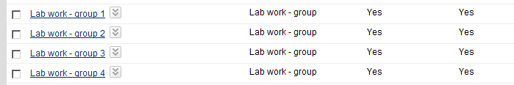

1. Now add the groups to a content area (or the module menu) so that students can find it easily and sign-up.

To add the groups to a content area, go to section Adding a group or group set to a content area.   
To add the groups to the module menu, go to section Adding a group to the module menu.

## Create a Manual Enrol group set

Here the group set groups members are decided in advance by the module Instructor.

1. With the Edit mode switched to **ON**, go to **Control Panel**, then **Users and Groups**, and click **Groups**.
2. Hover over the **Create Single Group** button and select **Manual-enrol** from the list.
3. A name must be entered for the group set. The description text will appear on the group home pages and can be used to describe the purpose of the groups and any essential information.

Please note that groups within the set are identified by a numeric number so do not use numeric numbers or other identifiers (such as a, b, c) when setting up a group set.

1. Select **Group Availability** (default **yes** – groups available to students).
2. Select the tools that will be made available for the group. (Untick any that are not needed.)
3. Enter the number of groups to be created, e.g. **4**.
4. Click **Submit**. The **Edit Group Set** enrolments page opens.
5. Select which types of module users should be available to put into these groups in section **2. Group Set Members Filter Options**.

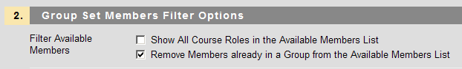

If **Show All Course Roles** is left unticked, only students are shown in the list available for each group. If this option is selected, all module members including instructors and course builders are shown in the list as available for selection.

1. For each group, select the group members. Click to highlight the student name in **Items to Select**, click the right arrow (highlighted below) and the student’s name moves to **Selected Items** and they arenow a member of this group. Hold down the CTRL key to select multiple names.

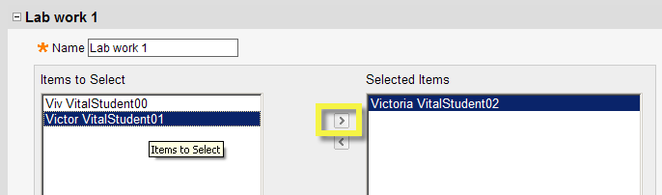

Unless the **Remove Members already in a Group** option (step 8 above) has been un-checked then the students selected will be removed from the list of available students for subsequent groups.

1. Repeat this process to populate the remaining groups. Click **Submit** to finalise and save. The Group Set is created. This page can be returned to to edit and add or remove groups.

## Create a Random Enrol group set

In this type of group set, the system will automatically and randomly populate the groups with students.

1. With the Edit mode switched to **ON**, go to **Control Panel**, then **Users and Groups**, and click **Groups**.
2. Hover over the **Create Group Set** button and select **Random Enrol** from the list.
3. A name must be entered for the group set. The description text will appear on the group home pages and can be used to describe the purpose of the groups and any essential information.

Please note that groups within the set are identified by a numeric number so do not use numeric numbers or other identifiers (such as a, b, c) when setting up a group set.

1. In section **4. Membership** you must select how to **Determine the Number of Groups** to randomly populate. Opt either to specify the **Number of Students per Group**, (enter a number) and then the system will calculate and create the number of groups required based on the size of the class list, select and specify the **Number of Groups** (enter a number)and the system will distribute the class list across this number of groups.

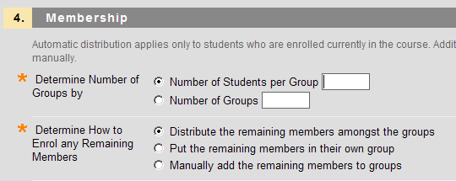

1. Next select how any ‘left-over’ students from the creation and random population of the groups should be enrolled in a group (distribute remaining members across all groups, put remaining members into one group or manually allocate remaining members to groups).
2. Click **Submit**. The random group set is created and is listed under the Groups page in instructor view.

To see the students’ view of the Groups area, read the section Viewing group or group sets from My Groups area.

# Student view of group page

Students see the group(s) to which they belong in the grey **My Groups** panel in the left-hand navigation area, below the module menu. Once students become members of a group, they can access the group page via this **My Groups** menu (a). Once they click into My Groups, the Group page area (b) is shown where students can see the group members, what tools are available for working together, links to any group assignments that have to be submitted and a description of what the group is for and what they are to do. In the example below, two tools, the journal and email, have been enabled for students.

(**a**) (**b**)

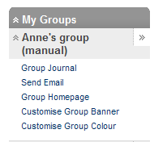 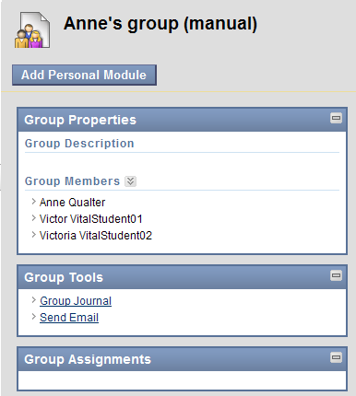

The My Groups will automatically show the groups a student is a member of. For Self-enrol type groups then these will only appear in the My Groups menu when they have signed up to a group. For this reason, in the case of self-enrol type groups, the group sign-up link first needs to be made available in a content area or in the module menu. The next two sections detail each method.

# Adding a group or group set to a content area

This section shows you how to add a Group (or Group set) to a content area for students.

1. Go to a content area in your module (e.g. **Sessions/Resources** or anywhere else where the link the group would best appear). Make sure Edit Mode is switched **ON**.

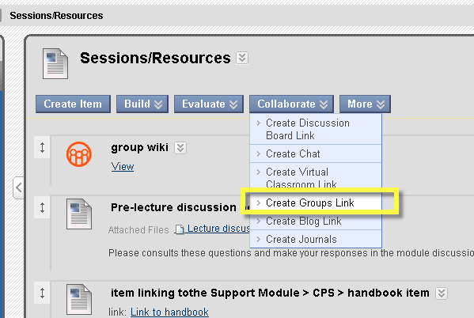needs changing

2. Hover over the blue **Collaborate** button and click on **Create Groups** link.

3. Select the **‘Link to a Group or Group Set’** radio button (Links to the Group page will list all the groups in the module for students.)

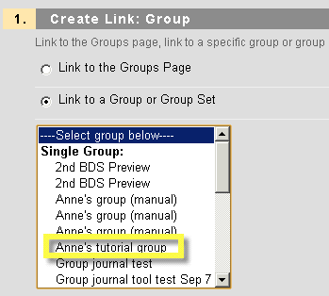

4. Click the name of the group (or group set) from the list that you want to link to (e.g. **Anne’s tutorial group**). Click **Next**.

1. Enter any instructions if relevant and select availability for the link.
2. Click **Submit**. The link to the group has been added to the content area (and if this was a self-enrol group/set, students can find the sign-up lists using this link).

# Adding a group or group set to the module menu

The Groups area (which holds a link to all of the groups created in the module) can also be linked as a menu item in the module menu. To add such a menu item:

1. Go to the module, make sure the Edit Mode is switched to **ON**.

2. Hover over the plus ‘+’ icon at the top left corner of the module menu.

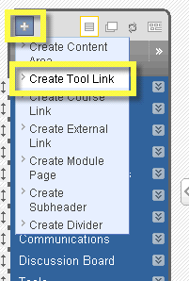

3. Click on the **Create Tool Link** option.

4. Enter a group name, then select **Groups** from the pop-down menu under **Type**.

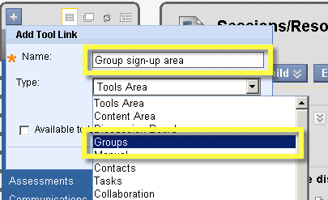

5. Select available to users (tick the box) and click **Submit**. The tool link has been added as the last module item. The page now displays all the groups or group sets in the module for students to see. See for instance the Lab work group set below. Students can click on the ‘View Sign-up- sheet’ to join a group.

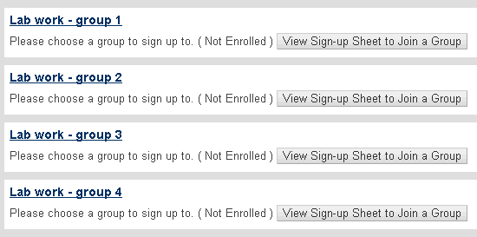

# Editing / changing a group

If you need to change the name of a single group that you created or other details, you can edit the group.

1. Go to **Control Panel,** then **Users and Groups**, click **Groups**.
2. Next to the group name you want to change, click on the downward pointing double arrow.



1. Click **Edit**. (Open will show you the Group Area.) Any changes can be entered here.
2. Click **Submit** to save the changes.

# Editing / changing a group set

If you need to change the name, or other details, across all groups in a Group Set that you created you can edit these centrally without having to edit each group of the group set separately.

1. Go to **Control Panel,** then **Users and Groups**, select **Groups**.
2. Click the **Group Sets** option in the top right hand corner. This will display the group sets only.

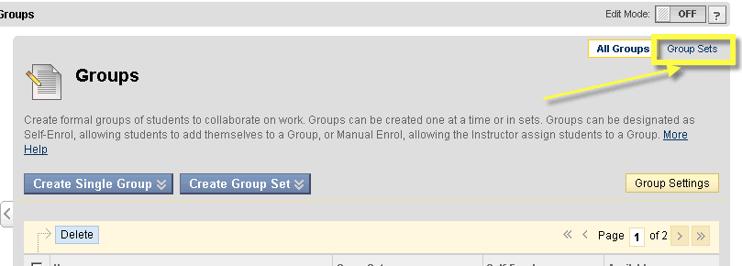

1. Next to the group set you want to change (e.g. Lab work – group), click on the downward pointing double arrow.



1. Select **Edit Set Properties** or **Edit Set enrolments**, depending on the type of information you would like to change. (Open will show you the Group Set Area.) Any changes can be entered here.
2. Click **Submit** to save the changes.