**Email**

Send an email via the Control Panel

Send an email via your VITAL home page

Other places where you can send emails

**Overview**

The email tool in VITAL allows you to quickly send messages to the whole module or to specific groups or individuals in the module. You can also send messages by role, i.e. just to instructors or just to students. The email tool uses the University email addresses associated with each student or staff member. Attachments can also be sent. *Please note that if you send an email to all users, it will send it to all the instructors and all the course builders on the course too.* This guide will demonstrate how you can send emails via Control Panel or using the Send email link from your VITAL home page.

Tip1: Before sending emails to students, you can practise sending emails using your Personal Test Module and enrolling a colleague as a student on your test module.

Tip2: VITAL does not store your email in the module but it does send a copy to your University email account. It is recommended that you organise into separate email folders to keep an easily searchable record of your VITAL emails.

# Send an email via the Control Panel

You can send emails from within the module using Control Panel and Course Tools.

1. 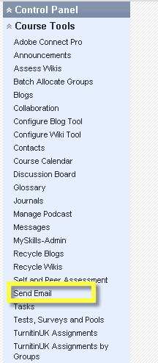In the module for which you want to email users, go to the **Control Panel** and click **Course Tools**.
2. Click on **Send email** (you may need to scroll down the alphabetical list to see it).
3. From the list of available email types, select the most relevant, e.g. email all users, email all groups, email all student users or email select / specific users or group.

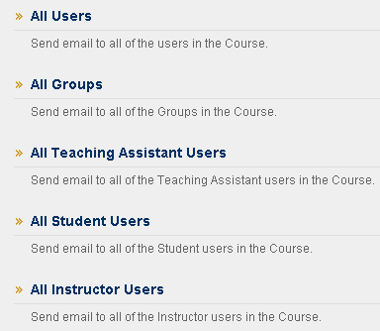

1. In the example below, the **email ‘All student users’** option has been selected.
2. Each student’s name has been copied in the ‘To’ box.
3. Enter **subject** and **message** text for the email.
4. You can attach one or more file if you wish.
5. Click **Submit** to then send the email.

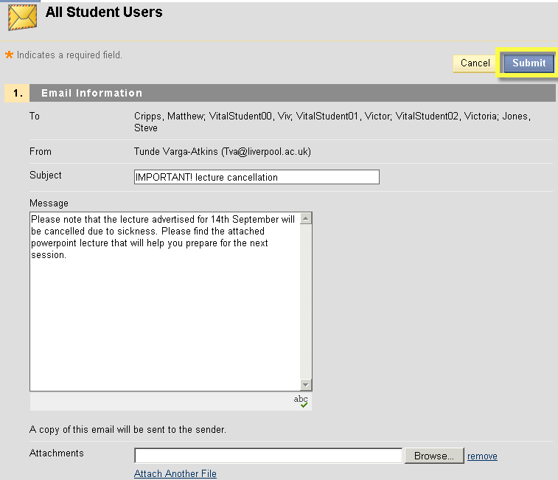

1. After submission, you get a green success message at the top of the screen with the names of the email recipients.

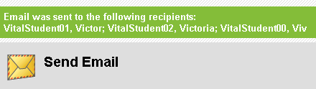

1. This is how the email message looks for the student in Microsoft Outlook:

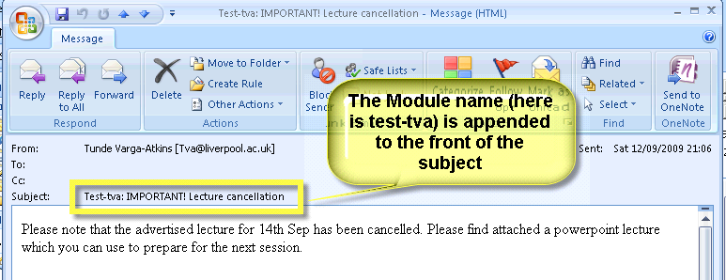

# Send an email via your VITAL home page

Emails can be also sent from your VITAL home page (the page first seen after logging in to VITAL).

1. Find the **Tools** area at the top left side of the VITAL home page and click the **Send email** link.

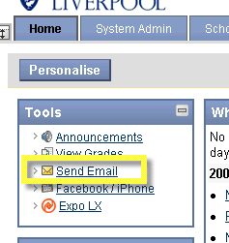

1. Click the module link (e.g. MODU101) to whose users you want to send an email.

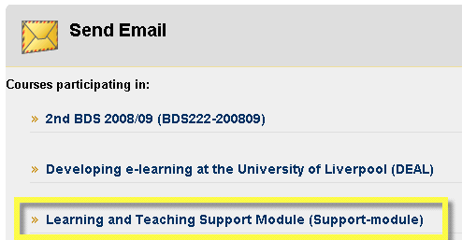

1. Then continue with steps 3-9 in section **Send an email via Control Panel**.

# Other places where you can send emails

There are other places you can send emails to students:

* Grade Centre;
* List All Users;
* Groups (if the email tool is enabled).

If you would like further support on how to send the emails using these tools, contact the Vital Team at [vital@liv.ac.uk](mailto:vital@liv.ac.uk).