**Customising your module settings**

**Access the customisation menus**

**Change module menu colour scheme and style**

**Add a banner image to module entry-point page**

**Change module entry-point page**

**Show/Hide module tools**

**Other customisation settings – Properties, Guest and Observer Access**

# Overview

This guide describes some of the basic settings available through the **Customisation** submenu in the **Control Panel** so thatyou can:

* change the design and colour scheme of the module menu (upper menu at the side of the page)
* add a module banner image to your course entry point page
* change the module entry point (page the student first sees)
* ‘show’ and ‘hide’ course tools for students, instructors, guests etc
* set top-level guest and observer access

(If you want to change the structure of your module – adding sections and so on - then you work mostly through the module menu and this is described in the guide ‘**Modifying your module menu**’.)

# Access the customisation menus

You can access the **Customisation** menu from the Control Panel either by

**a)** clicking the right-pointing double arrow to show the **Customisation** page (highlighted below)

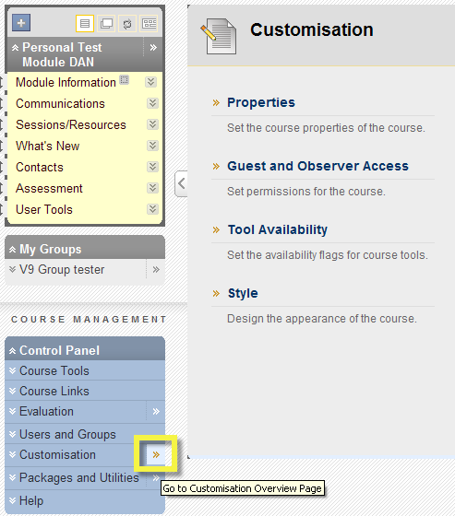

or

**b)** clicking the down-pointing double arrows to expand the submenu as usual and select the relevant section link (shown below).

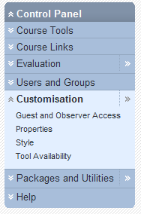

# Change module menu colour scheme and style

1. Select the **Style** link from the **Customisation** menu/page.
2. The **More Help** text andlink (click to open in a new window) at the top of the page describes the settings options available on the page.
3. The section 1 preview window lets you experiment with colours and button styles. The default style you see is text links with a pale background colour. To change the colour of the menu text or background click on the relevant colour button (highlighted below) choose a colour and click **Apply** to see it in the preview window.

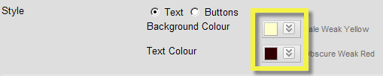

1. To try a button style for your module menu links, click the **Buttons** radio button (default is **Text** as shown above). Then click the **Button Library** linkthat appears to access the full range of styles (described in the **More Help** link and shown below). The preview window shows how the module menu will look to students as the options are selected. **NB.** You cannot change the text colour for buttons, these are preset and some of the patterned buttons have poor text/pattern contrast – exercise caution! Buttons also have a limited number of characters allowed.

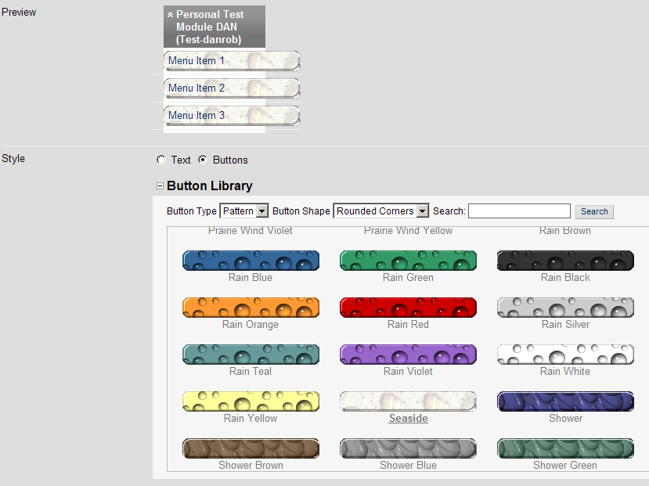

1. If you want to apply the changes you have made to the module menu style then click **Submit**. Press the **Cancel** button if you do not.

# Add a banner image to module entry-point page

You will first need a banner image created either with a graphics software package such as Paint Shop Pro or through MS PowerPoint (see VITAL FAQs to find out how to do this) to upload to your module. The image is best sized between 400 and 700 (width) x up to 150 (height) pixels in size. You can experiment with these sizes. It is best saved as a JPG or GIF file. The banner does not automatically resize in the browser.

1. Select the **Style** link from the **Customisation** menu/page. Section 5 contains a **Browse for Local File** button which you use to locate the banner image on your PC. Click **Submit** to confirm your choice.
2. The banner displays at the top of the module entry-point page only (**What’s New** page by default) as shown in the example below created with PowerPoint. It will not display on other module pages.

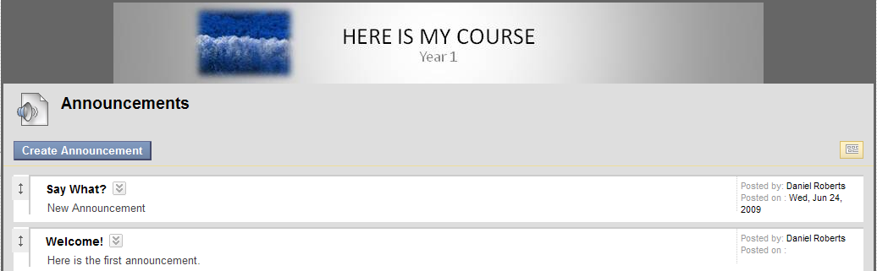

1. If you are not happy with the banner image and want to remove or change it, return to the **Customisation** menu, tick the **Delete this banner** option and click **Submit**.
2. If you change the module entry-point page then the banner will display at the top of the new entry-point page.

# Change module entry-point page

1. To change which page first displays when the module is accessed, from the **Control Panel** menu, select the **Style** link from the **Customisation** menu/page. Section 4 **Select Course Entry Point** presents a drop down list with your module sections. Select one of these to be the new module entry-point. This will be the first page that the student sees when they open this module.

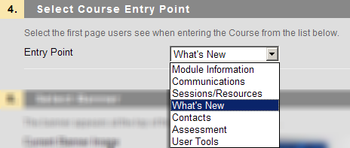

1. Click **Submit** to save your change.

# Show/Hide module tools

If you want to hide or make VITAL tools visible and available for your students. This function is used to make tools available to different groups of users for use in the module or to remove unused tools and so reduce visual ‘clutter’ on the screen. It is good practice to only have tools accessible within a module that you intend to use with your students.

1. From the **Control Panel** menu, select the **Tool Availability** link from the **Customisation** menu/page.

The table below appears with the complete current set of tools available in VITAL and the current visibility of each for four specific user groups. A green tick in a box shows that that tool has been made available for that group and an un-ticked box means it is currently unavailable – these boxes can be ticked and un-ticked to set the tool availability for the groups. A solid grey box means that the tool cannot be made available for that particular group.

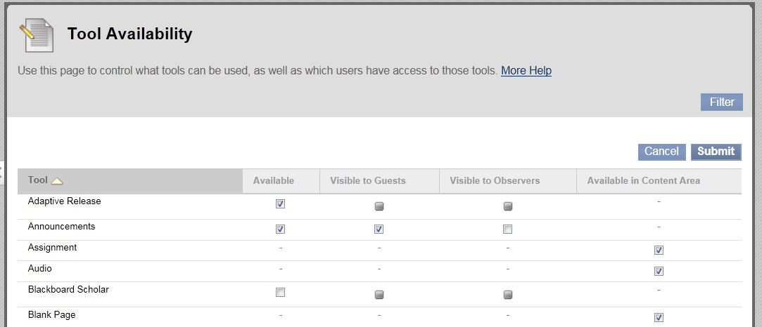

1. Initially the most important views are the first and last columns:

* **Available** – this column shows whether instructors, students and course builders can see and use the tool in this module. If un-ticked (not available) then the tool will not appear to the student and will not be visible in your view of the Control Panel.
* **Available in Content Area** – this column shows whether the tool appears in the content creation dropdown menus (shown below). This option is useful if you want to develop a module using only a few tools and don’t want others displayed when you are working.

1. The ‘**Visible to Guests**’ view sets whether that tool is available to view and use for unenrolled, external users. ‘**Visible to Observers**’ is a specialised role in the system where a user tracks a student’s progress (used for tracking problem students).
2. Save your changes by clicking **Submit**.

# Other customisation settings – Properties, Guest and Observer Access

1. **Properties menu** – These settings contain metadata properties for the module which are dealt with through TULIP and this section should only be changed after discussing what you want to achieve with the VITAL team.
2. **Guest and Observer Access –** This is where you set at the top level whether you will allow guest (unenrolled users) or observer (special student tracking role) access to your module at all.

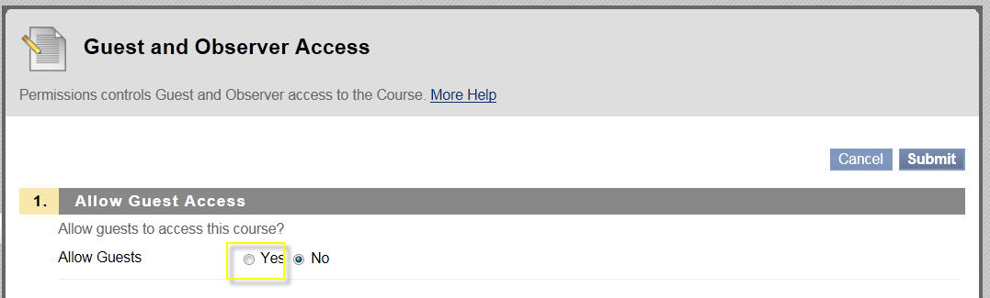

1. You then set which specific sections of your module you will let the guest or observer see via the dropdown menus for individual items on the module menu. The example below shows the menu for the specific section of the side menu bar - select **Permit Guests** to allow access to this section:

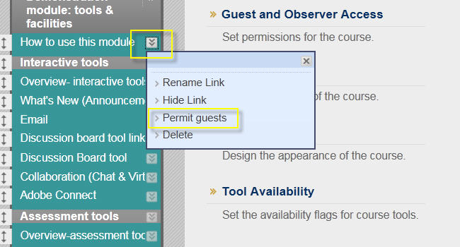

See also the guide **Guest access to VITAL modules** formore information on this subject.