**Adding staff contact details**

**Create a contact profile**

**Organise contacts by folder**

**Overview**

Every VITAL module menu contains a section called Contacts which leads to a page called Staff Information. Click the Create Contact button here to add a profile for each member of staff teaching on module to this page for your students to view. The basic required information to create a contact profile is a name and email address. A profile can optionally include phone number, office location and hours, personal image, link to personal web pages and any other contact notes. Below is an example contact profile as it would appear to students.

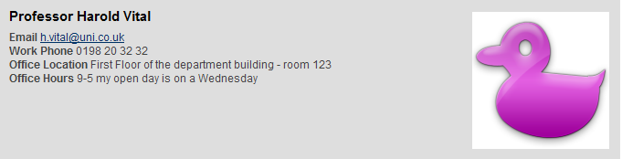

Folders can be created to organise multiple staff profiles, by role on the module for example. (See step 6 below.)

# Create a contact profile

1. There are two places from which you can access the Create Contact tool. In the VITAL module where you want to add staff contact details, with the Edit Mode **ON**,either:

* from the **Control Panel** menu, click on the **Course Tools** menu and select the **Contacts** option here, or
* from the module menu, click on the link to the **Contacts** section.

1. You should now see a page called **Staff Information**, as shown below, which will show all current contacts (if any) and a **Create Folder** button (a) and a **Create Contact** button (b).

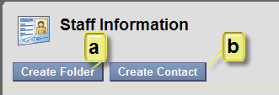

1. Click the **Create Contact** button and complete the set-up page with as many section 1 details as you wish to include (the minimum requirement is that you give an email address and some name information).
2. In section 2 **Options**, set **Make the Profile Available** to **Yes** if you want the contact to be immediately available for students to see. You can edit contacts to change this setting and hide contacts at any time.
3. In section 2 **Options** you can choose to attach an image of yourself. Click the **Browse** button to locate an image on your PC to upload. Images should be no larger than 150 x 150 pixels otherwise they will distort. You can also include a link to a personal website (copy and paste the full address). Click **Submit** when you have finished.

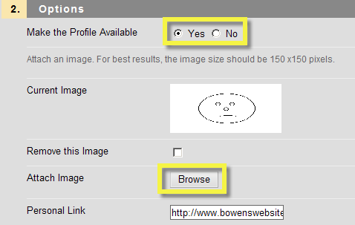

# Organise contacts by folder

1. If you have a large number of staff contacts for a module then you could organise them into folders using the **Create Folder** button. Create the folders first and then create the contacts in each relevant folder. Unfortunately you cannot drag and drop contact profiles into or between folders. The system suggests several categories of folder, namely: Contacts, Teaching Assistants and Guest Lecturers, and you are free to create your own folder titles as well with the **Add text below** option.

