# Course Files tool

Overview

Course Files tool enables you to:

* Quickly copy large numbers of files into a VITAL module.
* Files can be ‘dragged and dropped’ from your computer.
* A file or folder of documents can be linked to more than once within the module.
* Once files are loaded to the Course Files area, you can open and edit them without having to re-load them back into VITAL.
* You can set different permission levels for content. For example you could limited a folder or document so that it is only accessible to instructors and not GTA’s added as course builders.
* Zipped and package files such as websites you want to display within a VITAL module are now added to Course Files.
* You can also copy existing content from your module to you course files. Once files are in the Course Files area, you can download them back to your computer if necessary.

Once file and folders are added to your Module Content area you will need to link to them using the Item tool.

Accessing Course Files within your module

1. From the Control Panel click on the **Files** section:

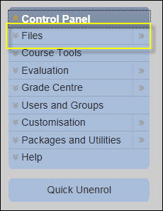

1. Click on the **module code** link. For example:

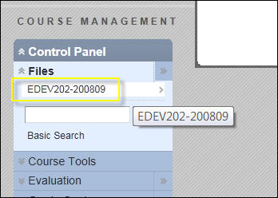

This will open the **Module Content area** for your module. For example:

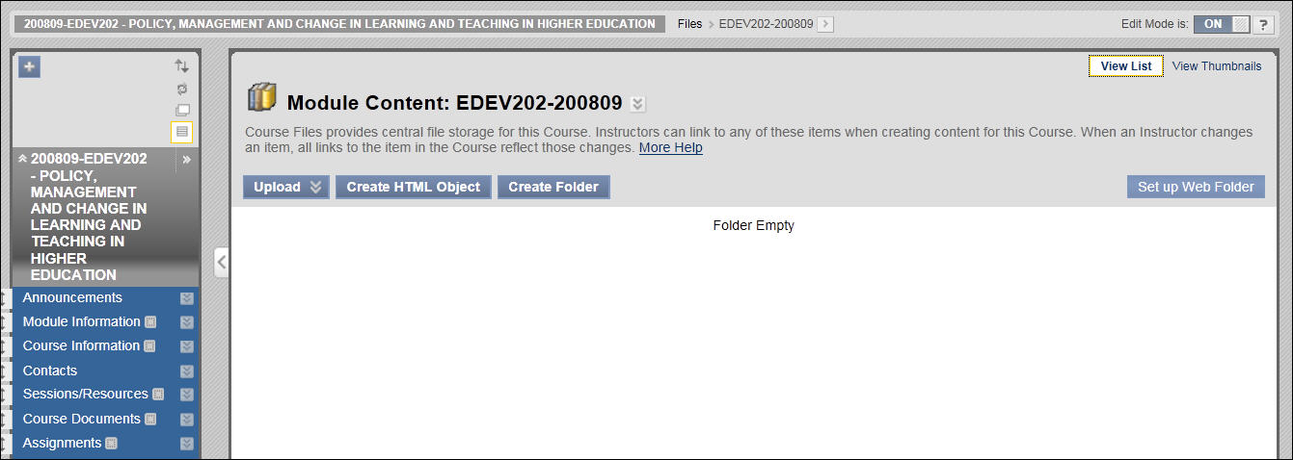

If your module already has content in the Module Content area then this will be displayed automatically. Within this area you can:

* Upload single files from your computer.
* Upload and unpack zipped files.
* Create folders to organise your content.
* Create new html pages directly into the Module Content area.
* Set up a Web Folder which enables to drag and drop files from your computer desktop.

To upload a single document to the Module Content area

1. Click on the **Upload** button and then the **Upload Files** option.

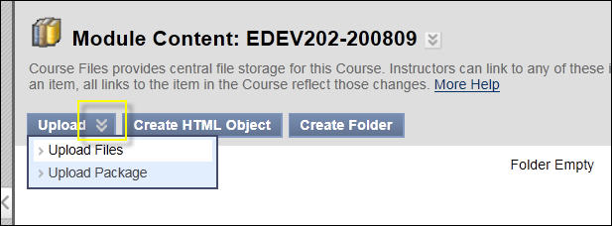

This will open a new page where you can either drag and drop files directly from your desk top or browse and search in the traditional way.

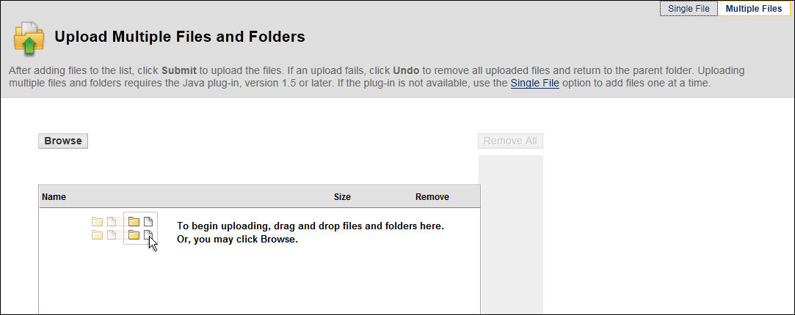

1. Click on either the **Single Files** option:

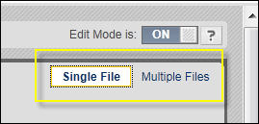

This will open the following page:

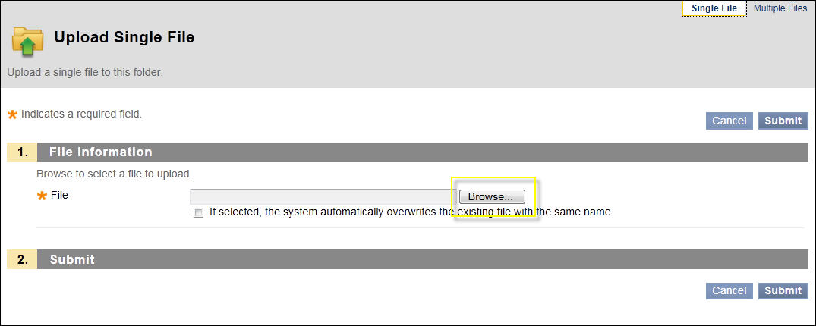

1. Click on the Browse button and select the file form your computer you want to add.
2. Click on the **Submit** button.



This will add your file to the Module Content area. For example:

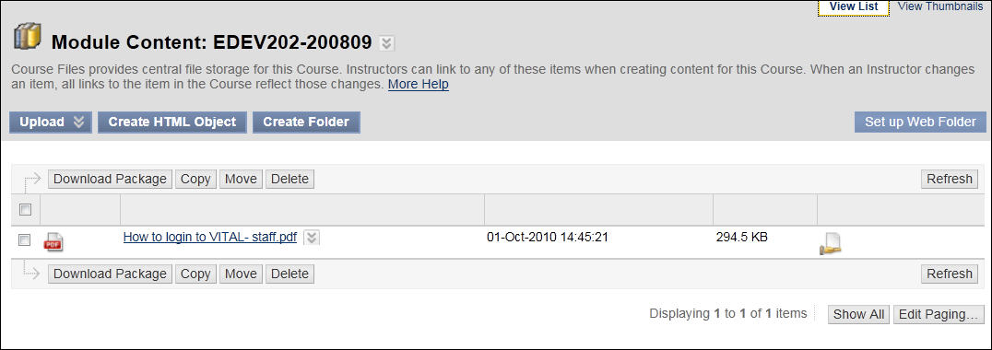

To create a folder within your Module Content area

You can organise your files and documents using folders within your Module Content area.

1. To add a folder, click on the **Create Folder** button:

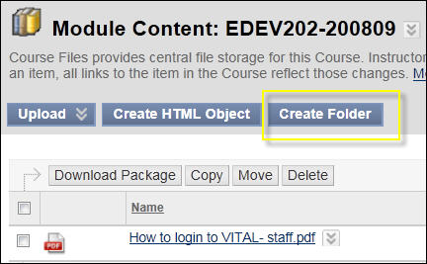

1. Add a **title** for your folder and click on the **Submit** button:

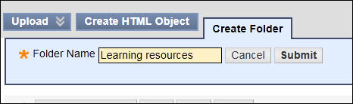

This will add a new folder to your list of documents. For example:

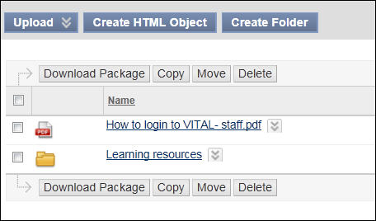

To add a zipped package file

(Before you complete this process you may want to add a new folder as Blackboard does not always add all package and zipped files automatically into a new sub-folder.)

1. From within the Module Content area, click on the **Upload** button and then select the **Upload Package** option:

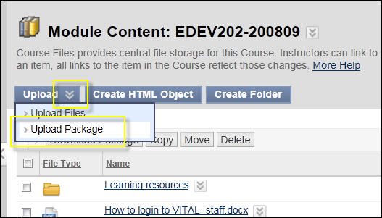

1. Then click on the **Browse** button and locate the zipped files you want to add to your module.

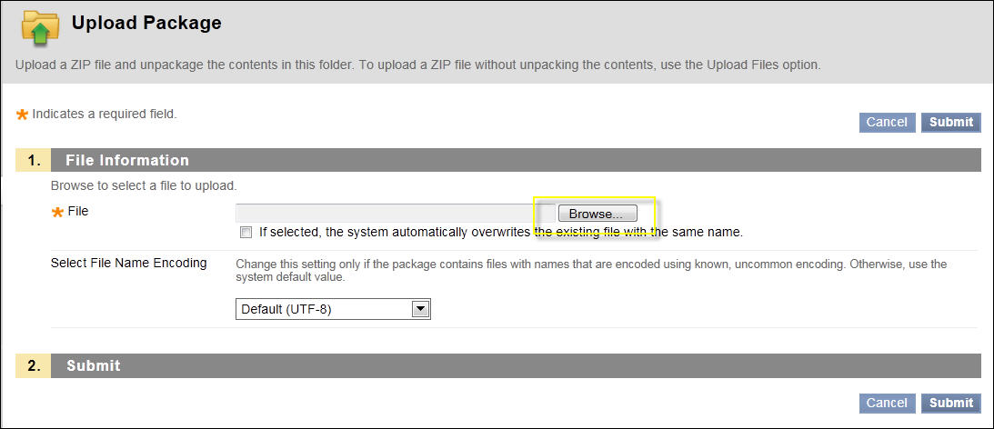

1. Click on the **Submit** button – the files may take a while to load if it is a large number of files in the package. You zipped files have not been added to the module’s Module Content area.

To link to these files within your module, follow the instructions for the **Link Module Content area files & folders within you module** section of this how to guide.

When your browse the Module Content area files, navigate to the sub-folder which you have uploaded the zipped package file and link to the first file of the package for websites and learning objects, this is normally a file named **index.html** or something similar.For example:

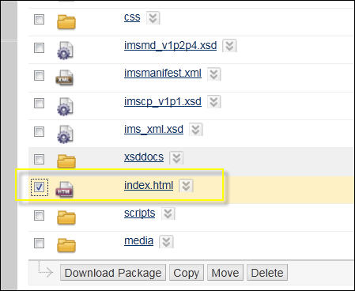

To move, copy and delete files

1. Tick on the file you want to move, copy or delete:

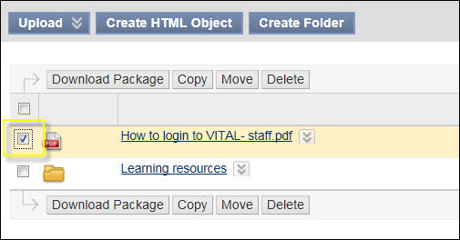

In this example the move function will be used to move the PDF file into the folder.

1. Click on the **Move** button.
2. Click on the **Browse** button and locate the folder you want to move the file to.

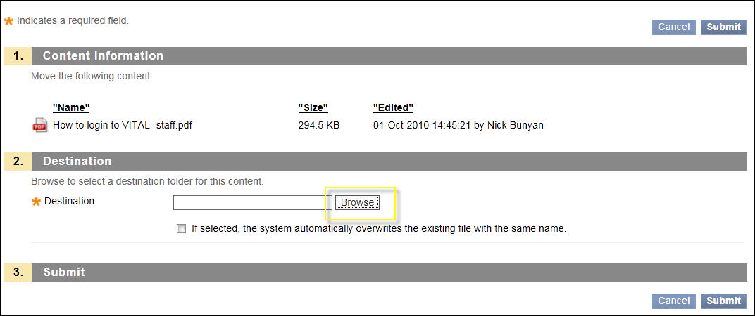

1. Check the folder you want to copy to and click on the **Submit** button.

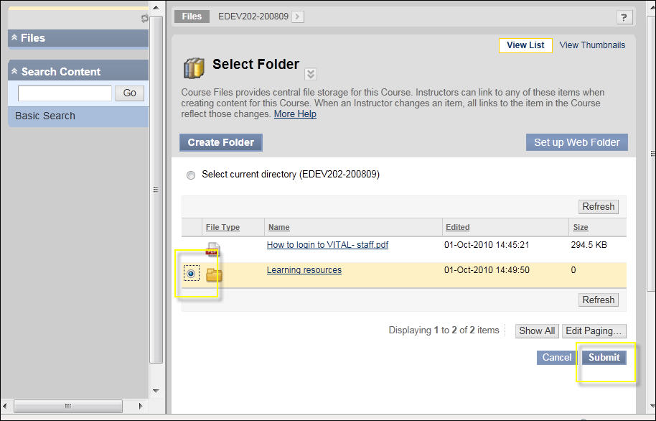

1. Click on the **Submit** button again to return to the main Module Content area. The file has now moved to the selected folder:

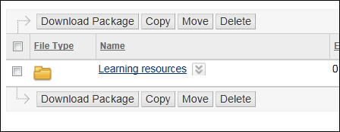

1. Click on the folder to access the file. Notice that the breadcrumb menu at the top of the page will change to show you where you are in the Module Content area.

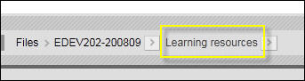

1. Click on the **module code link** to return to the main Module Content area page:

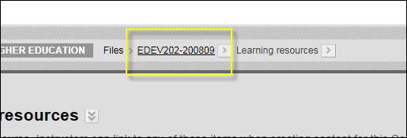

To copy multiple files & folders into the Module Content area

(The following instructions apply to computers with Windows 7 and Internet Explorer 8. Please contact VITAL support if you need assistance with other browsers or operating systems.)

1. Click on the **Set up Web Folder** button:

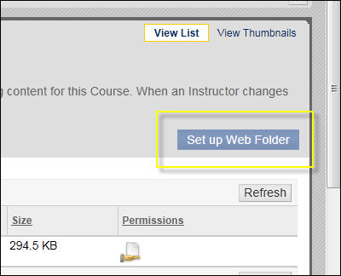

The following page will open:

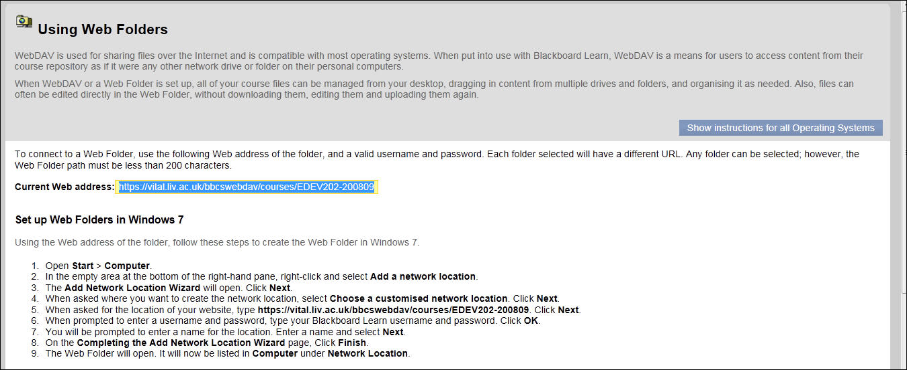

These instructions will enable you to create a permanent link within your computer network to the Module Content area for this module. Once the link has been set up it will enable to access, add, edit and delete documents without logging into VITAL. This is particularly useful if you need to add or edit a large number of documents.

1. Click on the **Show instructions for all operating systems** if you do not have Windows 7 running on your computer:

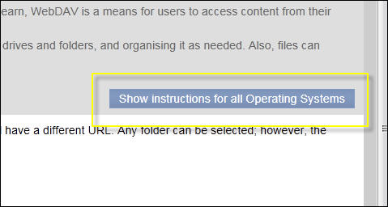

1. In Windows 7, click on your **Windows Explorer** and you will see additional areas added to your **‘Computer.**’ For example:

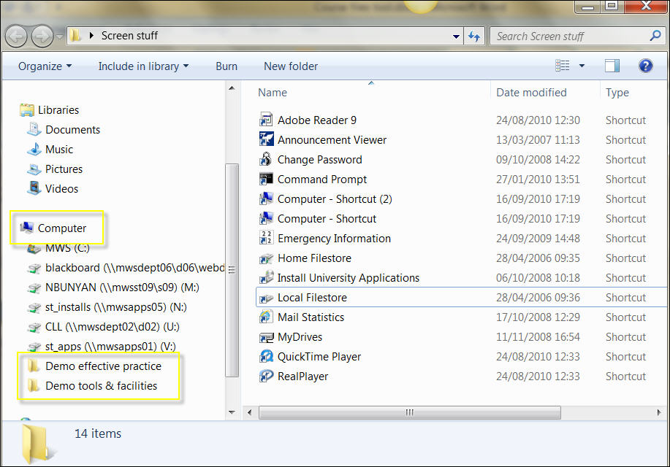

1. Click on the appropriate link and all the files you have in that Module Content area will be listed. For example:

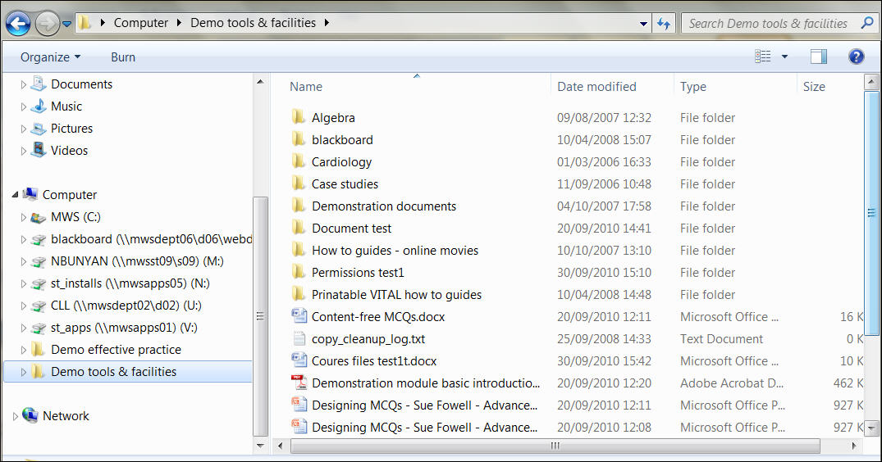

1. Double click on any document to open and edit it. When you save the document any changes will automatically be added to the file in your Module Content area. If this document is linked within your module, then students will be able to access any changes straight away.

Link Module Content area files & folders within you module

In order that students can access and files and folders you have added to your Module Content area, you will need to link to them from within the module. This can be done using the normal Item tool.

1. Go to your module’s **side menu bar** and click on any **Content Area** (E.g. Sessions/ Resources).
2. Click on the **Build Content** button form the top of the screen and then click on the **Item** option:

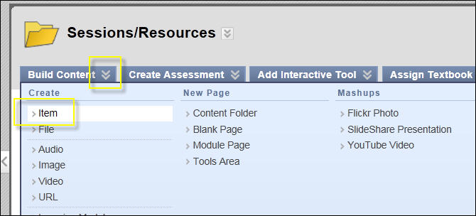

1. Add a **title** and a **description** etc. as you would for a normal document,
2. Scroll down the page and click on the **Browse Course** button:

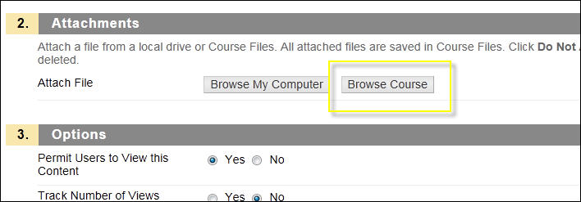

1. Select the **file** or **folder** you want to link to and then click on the **Submit** button:

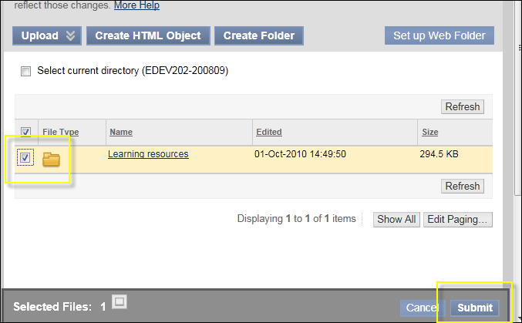

1. Click **OK** on the message box that pop’s up:

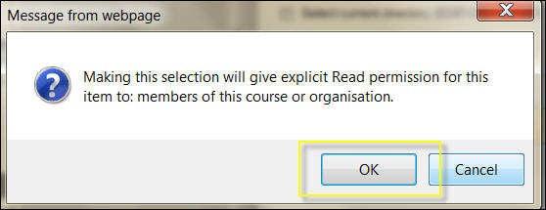

1. This will take you back to the main Item page – click on the **Submit** button:

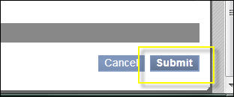

You file or folder will now be linked to your Content Area. For example:

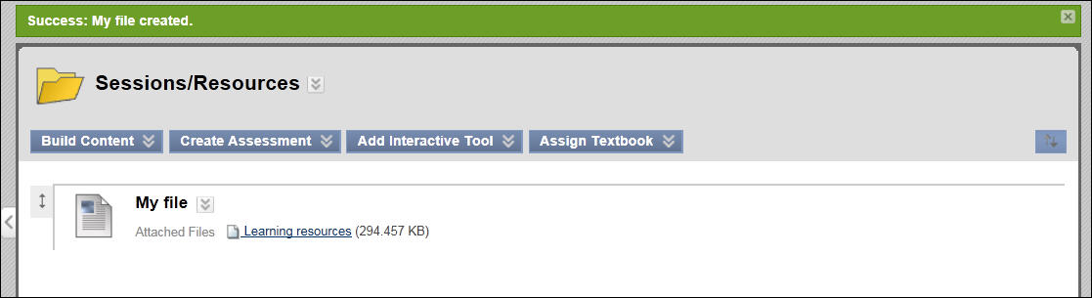

1. Switch the **Edit mode** to **OFF** and click on the link to the file or folder you have just added to check what students will be able to access:

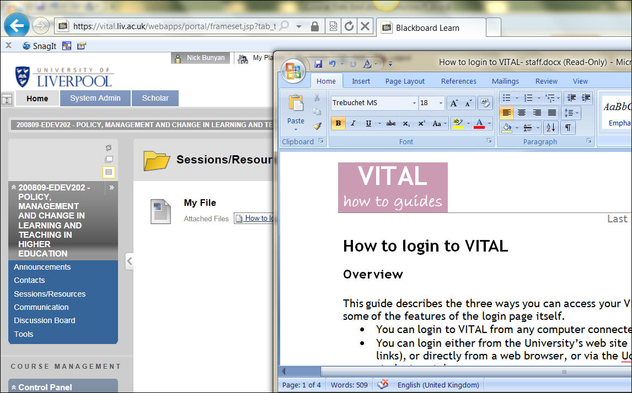

Working with files in the Module Content area

1. Within the main Module Content area page, click on the **down arrow** next to a file and then click on the **360o View** link. For example:

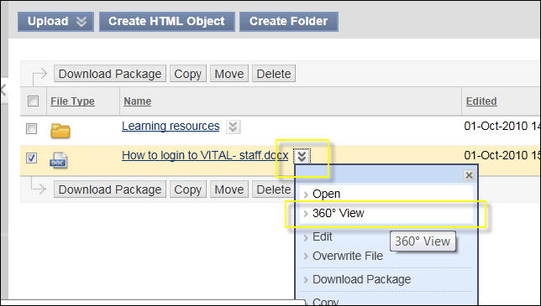

The first **Properties** section contains information about when the file was added, and by whom etc.

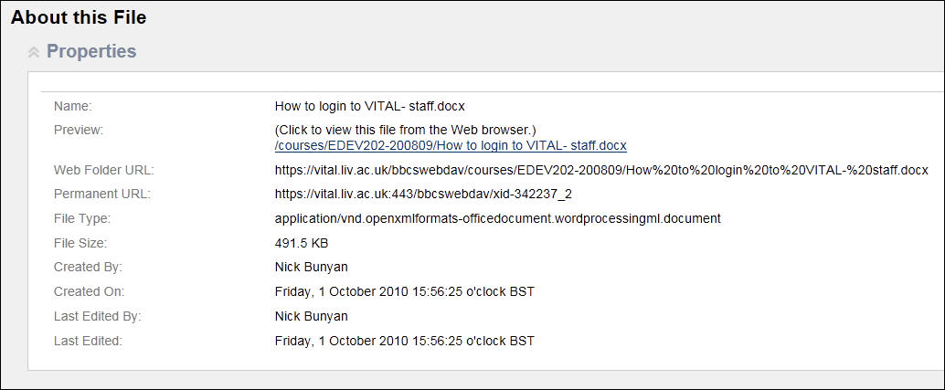

The Permissions section shows you which users within the module have access to read and edit etc. the file. You can for example, limit access to a file of folder to everyone in the module, except instructors. This could be useful if you have GTA’s or admin staff enrolled onto the module but you don’t an them to access this content.

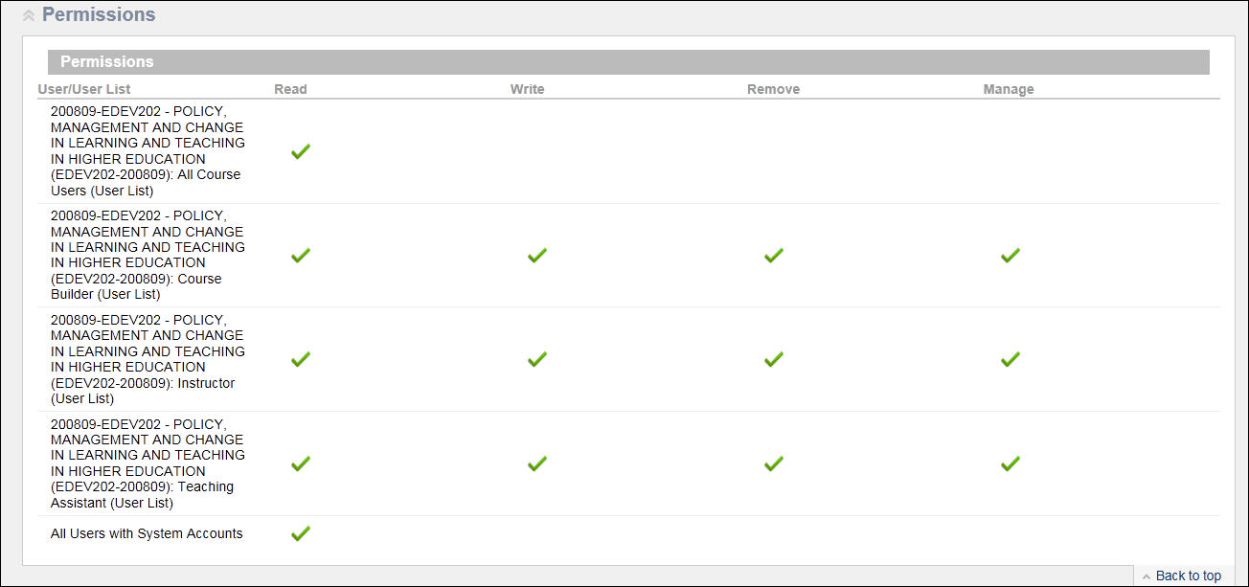

The final section **Links** shows you where in the module this file or folder has been linked.

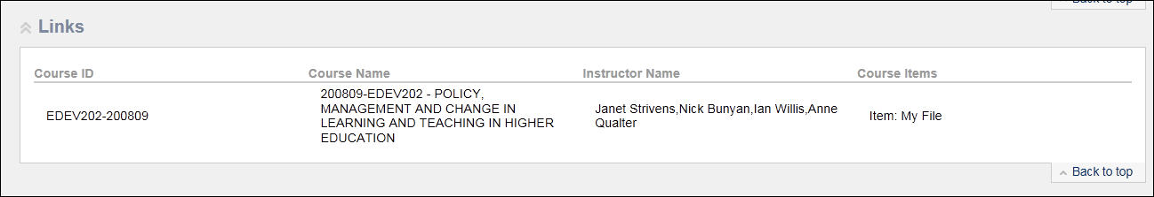

1. Go back to the main **Module Content area** page.
2. To change the permissions for a file, click on the **Permissions icon**:

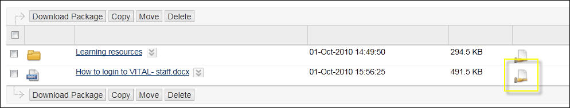

This will open a page listing the users and the level of permissions they each have:

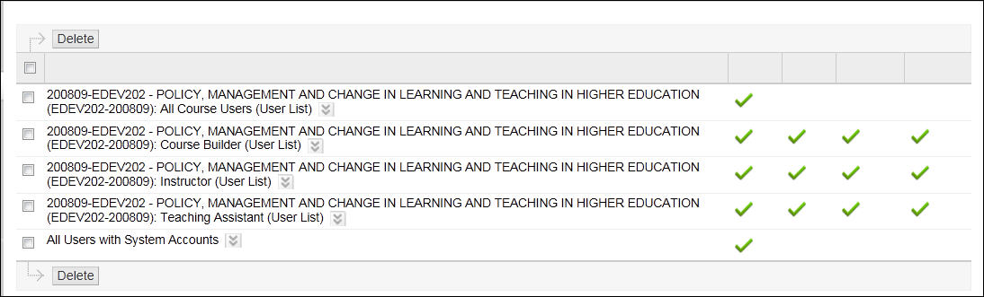

1. Click on the **down arrow** next to each user to change their permissions and then the **Edit** option:

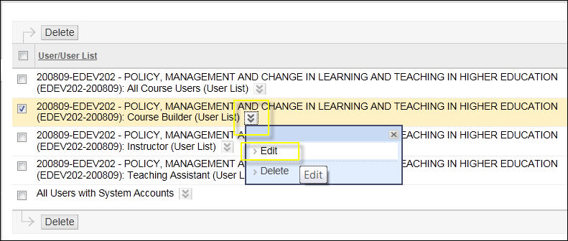

This will open the following window:

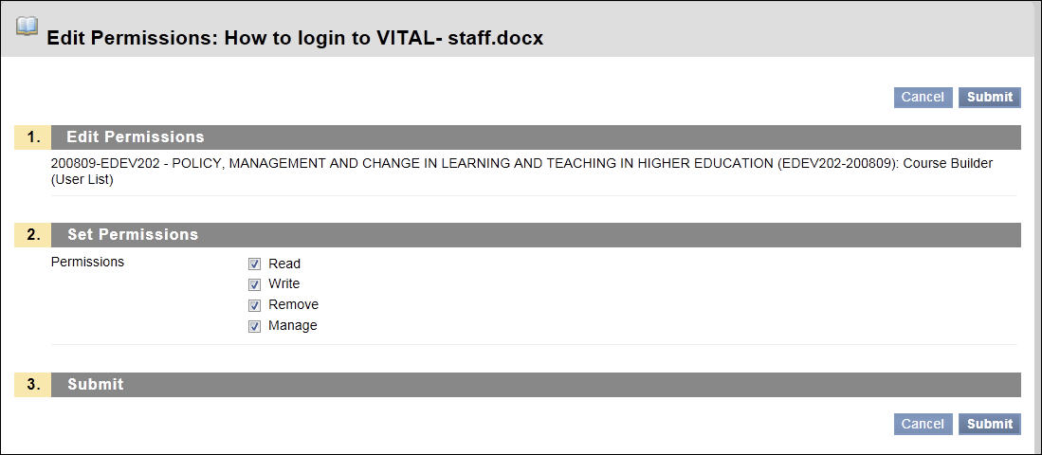

1. Change the permissions as required. Click on the **Submit** button and the **OK** button to return to the main Module Content area page.