**Build content – adding audio files, images, videos and URLs**

**Previously the ‘Adding multimedia files’ guide**

Adding an audio file to the module

Adding an image file to the module

Adding a video file, Flash movie or a YouTube video to the module

Edit/Copy/Delete image, audio or video

Using the text editor to add images, movies, audio or Flash

Things to consider when uploading files

File size and limitations – download times

Who is responsible for copyright?

Accessibility

**Overview**

Audio files, images, video/Flash movies, You Tube videos or weblinks (URLs) can be added to the module’s content area (e.g. Learning resources) using the **Build Content** button. Using this option the file is displayed within the VITAL page.

You can also:

* Add YouTube videos within your VITAL pages using the Create Video > Browse Mashups option.
* Add multimedia files within the WYSIWYG text editor box when using the ‘Create Item’ menu option. In this way, you can easily add more than one file in one go.
* Check the file types you can upload and what settings to use for them using the Contextual Help button when in Create Item.

# Adding an audio file to the module

Currently accepted formats are .aiff, .asf, .moov, .mov, .mp, .wav, .wma, .wmv files.

1. Select a content area where you want to upload the file (e.g. Learning Resources). Make sure the **Edit mode** is ‘ON’. Hover over the **Build Content** button**,** then click on the **Create > Audio** option.

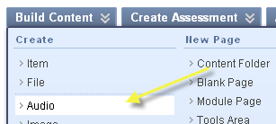

1. Click ‘**More help**’ at the top of the page for information about the types of files accepted and their settings (this will bring up a pop-up window).
2. Click **Browse My Computer** or **Browse Course** to upload or find an already uploaded audio file. (See the Course Files guide for more guidance on this.)

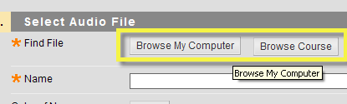

1. Follow the upload steps (e.g. click Open) and the file will be selected and the file name will appear in the ‘Name’ box. Amend this name box if necessary. You can also include a transcript of the audio file.

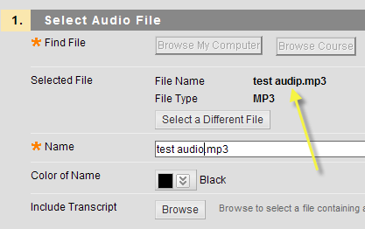

1. Under section 2, set the Audio options. Set ‘**Yes’**, if you want the audio file to autostart or loop, otherwise leave the default, ‘**No’** setting.

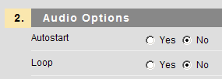

1. Under section 3, set the **Standard options** for the audio file. With ‘**Permit Users to view this content**’, you can set the visibility of the file to Students to **Yes** or **No**. You can also select Yes, to ‘**Track the number of views**’ of this file. Finally, you can select date and time restrictions for students to see this item.

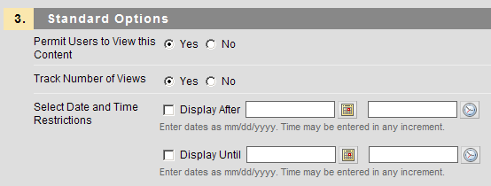

1. Click **Submit**.
2. The audio file has been added on the content area and you can play it using the Play button.

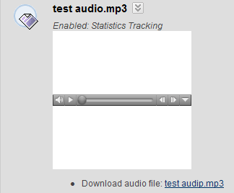

# Adding an image file to the module

*Tip: You should keep the images to sizes (e.g. much less than 600 pixels in width) so that students do not need to scroll the window when they view the image.*

1. Select a content area where you want to upload the file (e.g. Learning Resources). Make sure the **Edit mode** is ‘ON’. Hover over the **Build Content** button**,** then click on the **Create > Image** option.

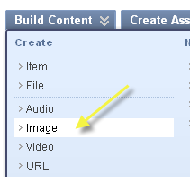

1. Next, click **Browse Computer** to upload a new file or click **Browse Course** to select an already uploaded file.



1. Provide an Alt(ernative) Text and a long description so that students with screen readers can also appreciate the image.
2. Under section 2, **Image Options** you can resize the image if it is too big, for instance. To leave the image sizes as they are, select the Original Dimensions. To customize the image size, click **Custom**.
3. If you clicked Custom, you can enter the new width and height in pixels (e.g. 400 and 300) and set a Border thickness (none, 1-4).
4. You can also enter an Image target URL/weblink for students. When they click on the image, they are taken to the target website (e.g. http://www.liv.ac.uk).

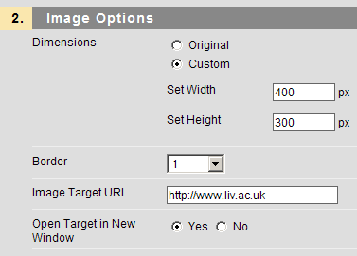

1. Under section 3, set the **Standard options** for the file. With ‘**Permit Users to view this content**’, you can set the visibility of the file to Students to **Yes** or **No**. You can also select Yes, to ‘**Track the number of views**’ of this file. Finally, you can select date and time restrictions for students to see this item.



1. Click **Submit**.
2. The image file has been added on the content area, with the long description displayed below the image.

# Adding a video file, Flash movie or a YouTube video to the module

Currently accepted formats are MPEG/AVI (.avi, .mpg, .mpeg), QuickTime (.mov, .qt) and Flash/Shockwave (.swa, .swf).

1. Select a content area where you want to upload the file (e.g. Learning Resources). Make sure the **Edit mode** is ‘ON’. Hover over the **Build Content** button**,** then click on the **Create > Video** option.

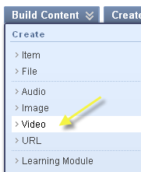

1. Click ‘**More help**’ at the top of the page for information about the types of files accepted and their settings (this will bring up a pop-up window).
2. Click **Browse My Computer** or **Browse Course** to upload or find an already uploaded audio file. (See the ‘Course Files’ guide for more guidance on these.) Use the Browse Mashups > YouTube video option to embed a YouTube video in your module content. (More guidance on Mashups is available in the GGMM guide.)

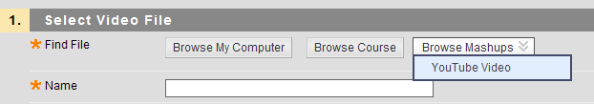

1. Follow the upload steps (e.g. click Open) and the file will be selected, with the file name pre-filled in the ‘Name’ textbox (e.g. test_video.swf). Amend this name if necessary.
2. Under section 2, set the Video options. To leave the video size as it is, select ‘Original’ Dimensions. To customize the size of video screen, click **Custom**.
3. If you clicked Custom, you can enter the new width and height in pixels (e.g. 400 and 300) for the video.
4. You can also set the video to Autostart on display (Yes) or loop (Yes) as well as the quality of the video.

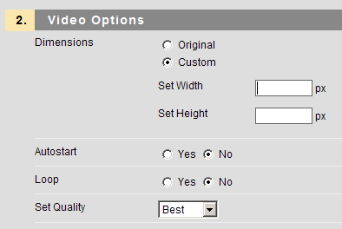

1. Under section 3, set the **Standard options** for the audio file. With ‘**Permit Users to view this content**’, you can set the visibility of the file to Students to **Yes** or **No**. You can also select Yes, to ‘**Track the number of views**’ of this file. Finally, you can select date and time restrictions for students to see this item.



1. Click **Submit**.
2. The video file is displayed on the content area and you can play it using the Play button.

# Edit/Copy/Delete image, audio or video

1. To go back and edit (or copy or delete) the uploaded file’s settings, click the double-arrow after the end of the file name (e.g. test_video.swf).
2. Then select the required menu item e.g. edit to change or modify the file’s settings or descriptions; copy to copy the item and delete to delete it.

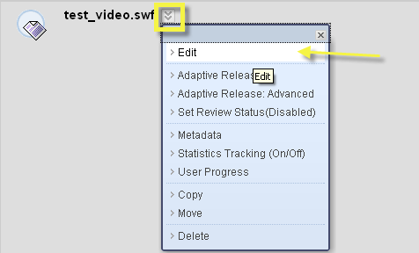

# Using the text editor to add images, movies, audio or Flash

Another way to add multimedia files is via the text editor that appears in Create Item. (This way you can add more than one files in one go.)

1. Select a content area where you want to upload the file (e.g. Learning Resources). Make sure the **Edit mode** is ‘ON’. Hover over the **Build Content** button**,** then click on the **Create > Item** option.

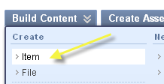

1. Complete the item description, then in the text editor box, click on the appropriate icon to add files (image, movie, QuickTime, audio or Flash). Complete the instructions in the pop-up window and **submit**.

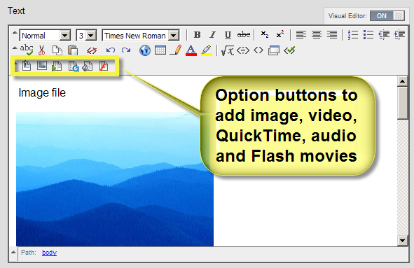

1. Check the preview of the file and click **Submit** again.
2. The multimedia file is displayed on the same page (the example below shows you an image, a video file, a Quicktime movie and an audio file):

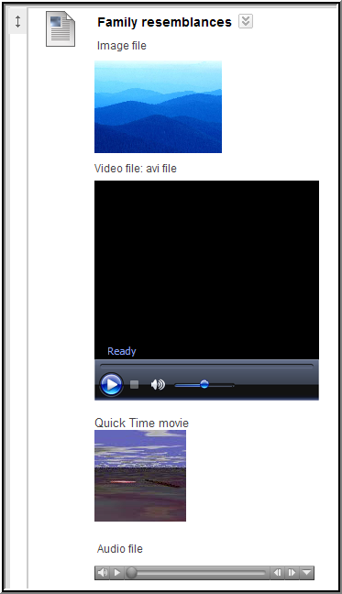

# Things to consider when uploading files

## File size and limitations – download times

In theory, there is no file size limit for adding multimedia files. In practice, not all students and users have fast internet access, so consider the file size. Here is a rough guide of download times for different internet connections:

|  |  |
| --- | --- |
| **Media file size\*** | **Download time** |
|  | |
| **On campus/ halls of residence (100Mbps)** | |
| 1 MB | Negligible |
| 200 MB | 2 minutes 40 seconds |
|  |  |
| **Broadband connection at home (10 Mbps) CHECK at home?** | |
| 1 MB | 1 minute 20 seconds |
| 200 MB | ~ 26 minutes |
|  |  |
| **Dial-up connection at home (56k)** | |
| 1 MB | 2 minutes 28 Seconds |
| 200 MB | 8 hours 4 minutes |

*File sizes are measured in mega bytes (MB), download speeds are measured in mega bits per second (Mbps).

## Who is responsible for copyright?

In short: the person uploading the file to VITAL. Please ensure that copyright regulations are observed when uploading content to VITAL e.g. for content, images and multimedia. As a rule of thumb, anything that the University library has access to and would be available in printed form within the copyright regulations can be scanned in and linked to from within VITAL (e.g. a book chapter). If you are unsure, please ask your subject librarian for further information about copyright (LINK to library website).

## Accessibility

Please ensure that any learning resources you add to your VITAL modules are accessible to the widest range of students. For instance, use a Sans-Serif font on documents (e.g. Arial and Verdana), provide a caption or transcript to accompany images, audio and video files. For further information, see the TechDis web site: <http://www.excellencegateway.org.uk/page.aspx?o=jisctechdis>