# Blog (Campus Pack) tool

Blog (Campus Pack) tool 1

Overview 1

To add a blog to a VITAL module 1

Change the look & feel of a blog 5

Add a new blog post 7

Set permissions for a blog 10

Adding comments to blog posts 11

Receiving alerts from new blog posts 15

Sharing blog posts with other social networking software 17

Tagging blog posts 18

Add interactive widgets 20

Assessing student contributions to a blog 21

Overview

The blog tool can be used to support individual or group student projects or as a communication tool within a VITAL module.

To add a blog to a VITAL module

(Substitute the following action for using Campus Pack Journal if you want to create a provide journal for each student within a module etc.)

1. Login to VITAL and go your module.
2. Select a Content Area e.g. Sessions/ Resources.
3. Set the **Edit Mode to ‘On.’**
4. Click on the **Add Interactive Tool button** and select the **Campus Pack blog link**:

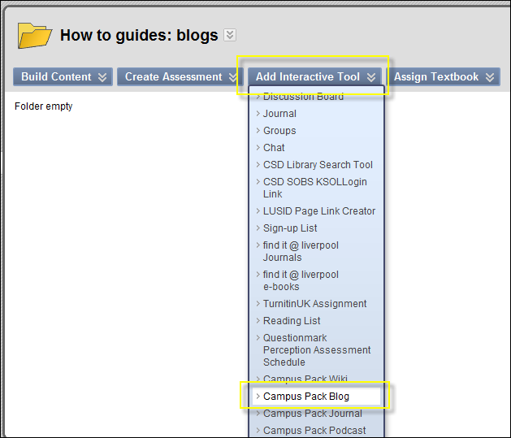

1. Click on the **New** option, and then click on the **Submit button**:

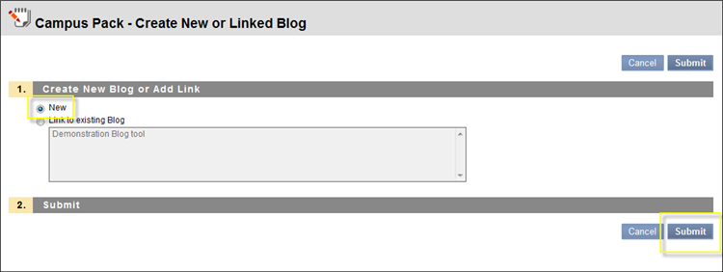

1. Give the blog a **title** and a **description**. For example:

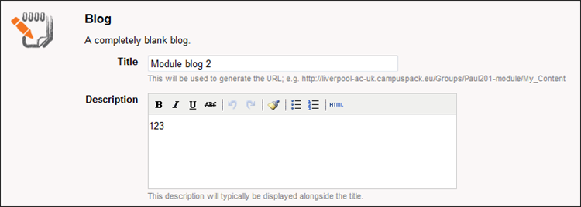

1. **Assignment Type** will let you add a class, group or individual blog. For this exercise, click on the **Class option**:

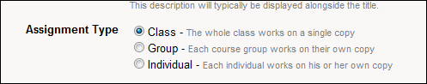

If you want students NOT to be able to see one another’s responses, please select **Individual**.

1. You will also see options to add a column to the Grade Centre – this is a useful option if you want to grade student contributions etc.

Important: you will need to add this option if you intend to assess this blog electronically at this stage as you cannot retrospectively add this option once the blog has been set up.

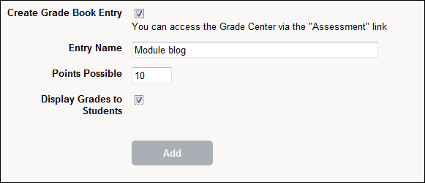

1. Then click on the **Add button** to create the blog.

This will create a blank new blog:

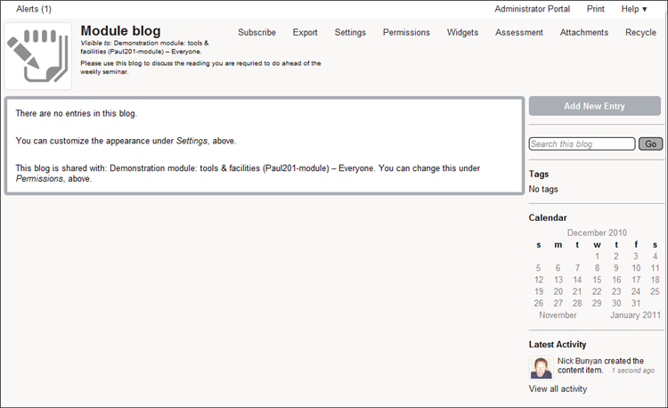

Change the look & feel of a blog

1. Click on the **Settings link** at the top of the blog page:

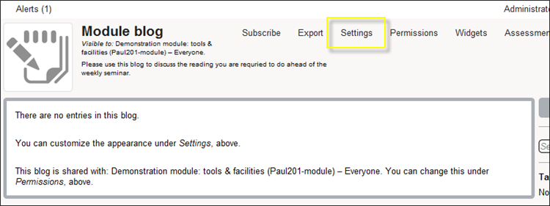

1. Here you can change the title and description created when you set up the blog.
2. To add an image to the top of your blog, click on the **Change Image icon**:

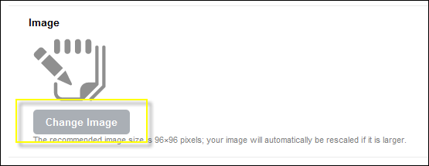

1. Locate and add the image you want at the top of your blog. For example:

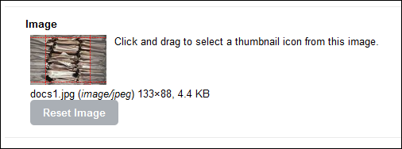

1. To change the blog colour scheme, click on the **Choose Theme option** and then selection from the list of available colour schemes.
2. You can also click on the **Preview button** to check what they will look like before you save any changes:

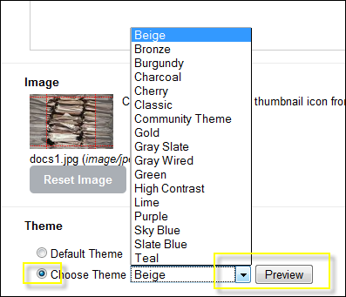

Note: If you are not good with choosing colours, as a suggestion, Beige or Slate Blue is a good basic choice, or Gray Wired or Lime if you want a more contemporary colour scheme.

1. Click on the **Save button**.

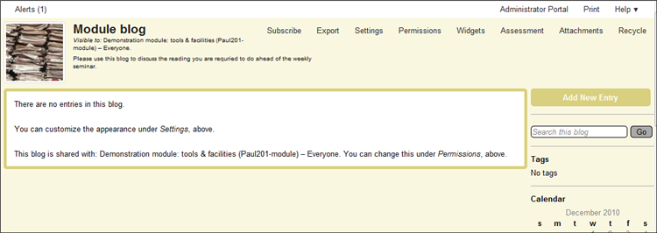

Add a new blog post

1. Click on the **Add New Entry button**:

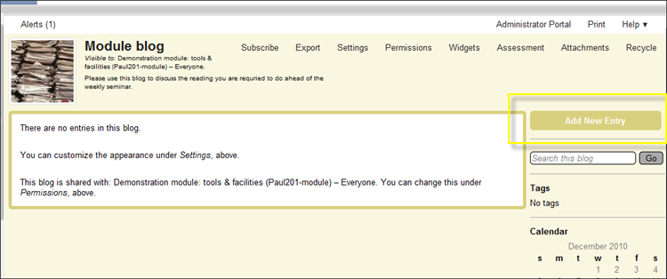

1. Add a **title** for the new blog post (it will default to today’s date) and then click on the **Continue button**.

This will open a new window where you can add your blog post message etc.   
  
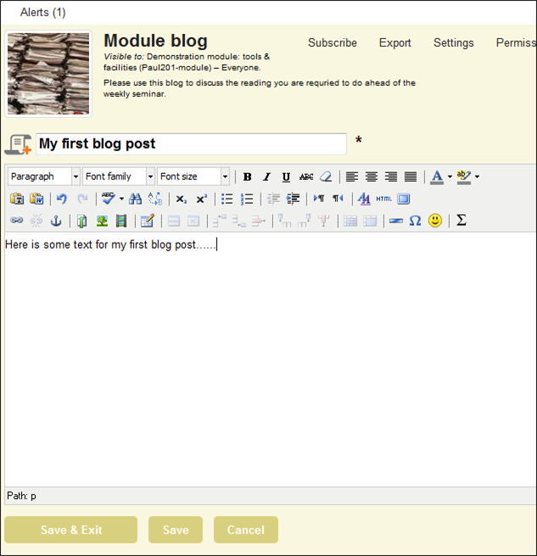

As well as adding text to a blog post message, you have a range of formatting options (similar to a word processor) and you can add images, web links, documents and short video clips etc.

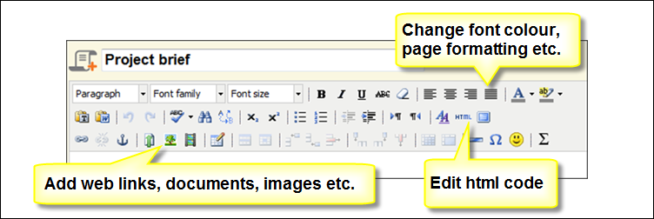

1. If you writing a long message etc. make sure (especially if you are working off campus) after a few minutes that you click on the **Save button** – occasionally this pag4 will ‘time out’ if there is a problem with your Internet connection etc. and you may lose what you have written.
2. Click on the **Save & Exit button** to complete your blog post message.

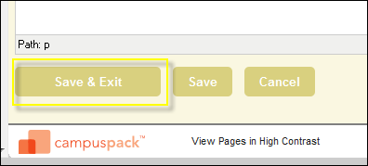

1. To edit or delete a blog post click on the **Edit** or **Delete links** to the top right of the blog post:

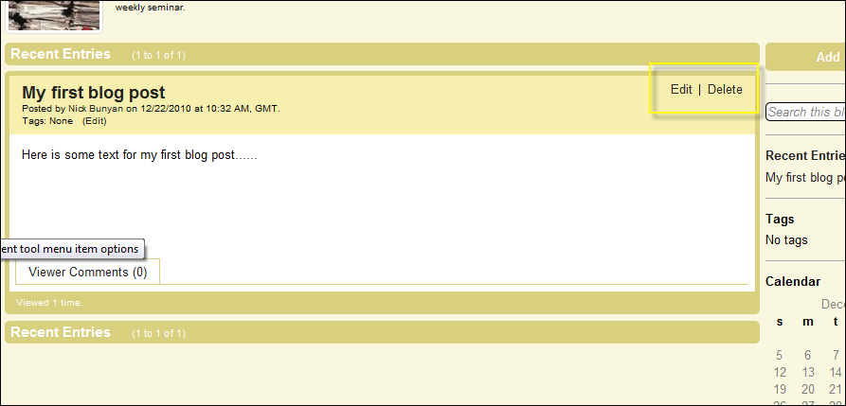

Set permissions for a blog

Blogs can be set with different permission levels for students to access, view other posts, or add comment etc.

1. Click on t he **Permissions link** at the top of page:

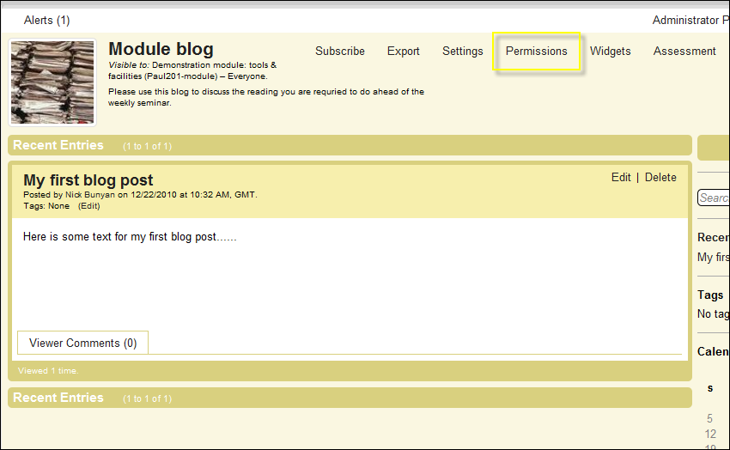

By default, a blog will give automatic access to all students enrolled to the module to have permission to view all messages and add new blog post messages.

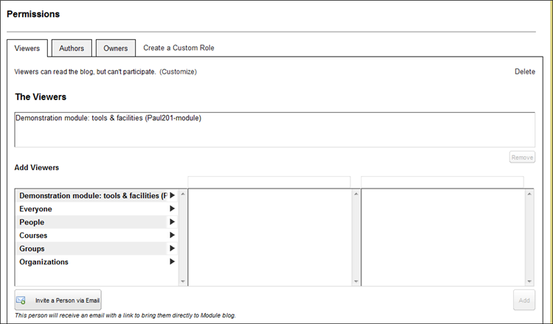

**Viewers** can access the blog and read posts etc. but cannot add new posts.

**Authors** can access, view and add new posts etc.

**Owners** can additionally control how the blog is set up etc. By default, all module instructors will be owners and not any enrolled students.

Additional views or authors can be added to the blog:

The first option (module title) will enable you to add existing groups within your module that you have already created – this is a useful option if you want to create a blog for a specific seminar group etc. Use the VITAL group tools to create a student group first – it should then be accessible from this option.

Adding comments to blog posts

By default, each blog post will have a comment tool attached. Blog viewers will be able to read comments, and blog authors will be able to read and add comments.

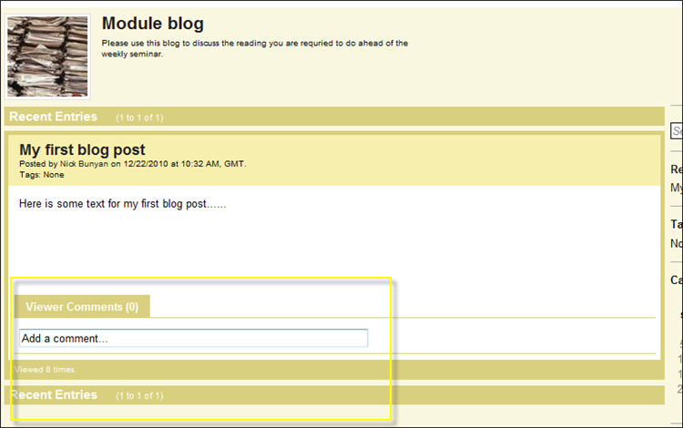

1. Click on the **Add a comment box** to add a comment to the post. For example:

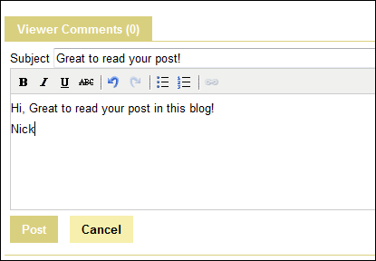

1. Click on the **Post button** to add your comment.
2. Click on the **Edit link** a comment.

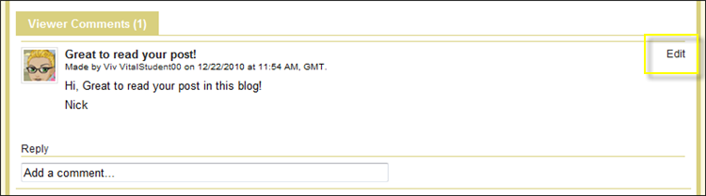

Note: only blog owners can delete comments – if you want your students to be able to do this you need to give them owner permissions.

1. You can also reply to specific comments which will create a simple threaded discussion. For example:

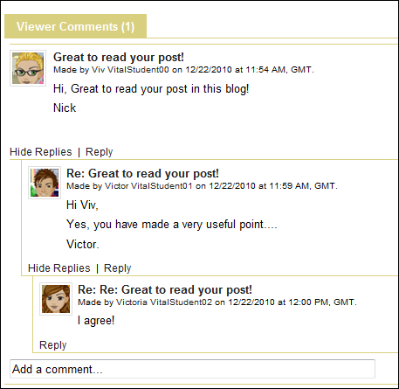

You can also set up the comment tool so for example, you can have private owner only comments attached to a blog post. This facility can be used by module staff for example to make private comments for a blog post that students can read.

1. From the top of the blog click on the **Widgets link**:

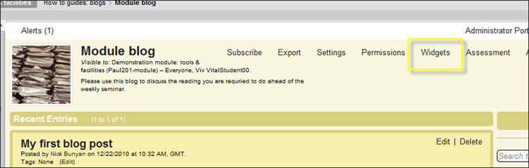

1. Click on the **Available tab**:

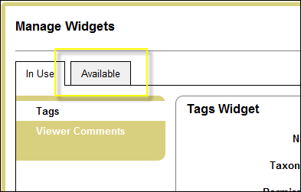

Here you will find a range of ‘widgets’ which you can add to your blog.

1. Click on the **Add button** next to the Owner Discussion option:

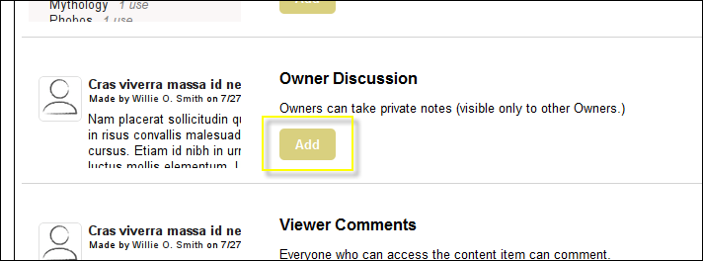

This will add this comment widget to your blog:

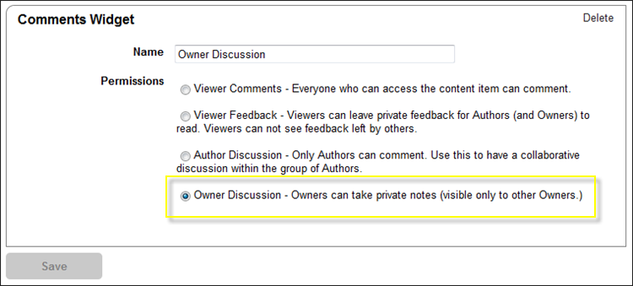

1. Click on the **Finish button**. The private owner only comment option is now available:

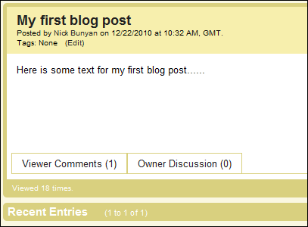

Receiving alerts from new blog posts

Any user enrolled to a blog can receive alerts when new blog posts and new comments have been added by other users. Alert are available in 2 forms – email or RSS alerts.

**Email alerts**

1. To receive email alerts click on the **Subscribe link** at the top of blog page:

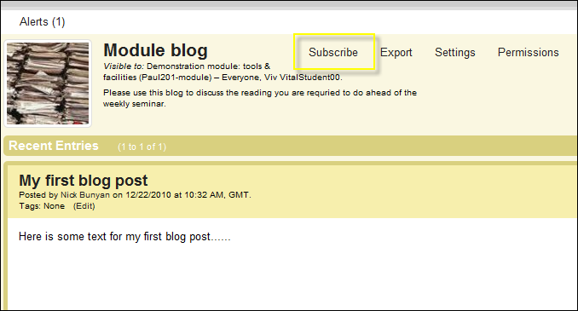

This will open the following page – select the email alert option and click Save:

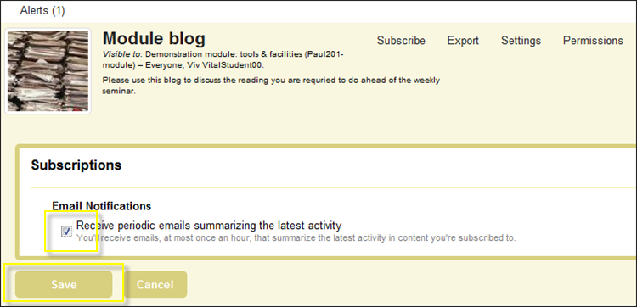

This will send an email alert to your university email account.

**RSS alerts**

To use RSS alerts (you can receive automatic updates to new posts in RSS readers such as Google Reader etc.) you first need to set permissions so that anyone in the world can view the blog.

An RSS link will appear at the top of the blog page:

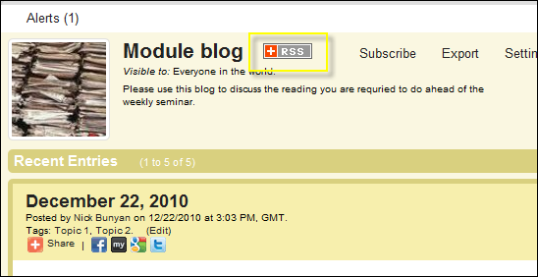

1. Click on the **RSS icon**.
2. Select the Live Bookmarks drop-down menu which RSS service you want to link to:

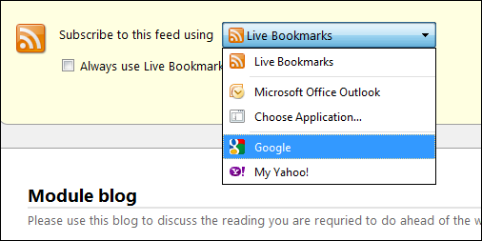

1. Click on the **Subscribe Now button** and follow the onscreen instructions to link to your preferred RSS reader service.

Sharing blog posts with other social networking software

Adding this widget lets any blog post to be shared with other social networking software such as Twitter, Facebook, Delicious etc.

1. Click on the Widgets link at the top of the page.
2. Click on the Available tab.
3. Select the **AddThis widget** by clicking on the **Add button**:

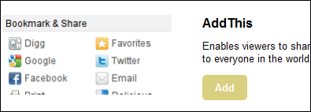

1. Click on the **Finish button**.

With each blog post you will now see a series of icons:

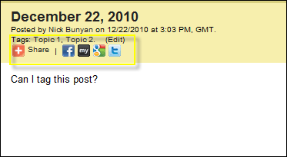

Click on the appropriate icon or the Share icon for a full list of social networking software. You will be prompted to login etc. before you can share your post.

Tagging blog posts

Blog posts can be tagged so anyone accessing the blog can access posts on specific topics etc.

1. To enable tagging, click on the **Widgets link** at the top of the page.
2. Then select the **Available tab**.
3. Scroll down and select the **Author Tags option** and the **Add button**:

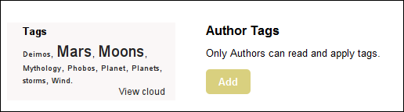

1. Select the ‘Tags – Authors can read and apply tags and Viewers can read them’ if you want anyone with access to the blog to view and search for posts by tags:

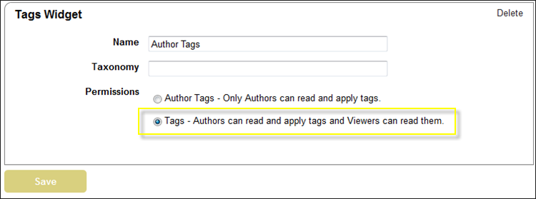

1. Click on the **Save button** and the **Finish button**.

**To add a tag to a blog post**

1. Add a new post and save. Just below the blog title click on the **Edit link** and add text to tag the post – you can add multiple tags using a comma to separate each tag. For example this blog post has been tagged with tags ‘Topic 1’ & ‘Topic 2.’

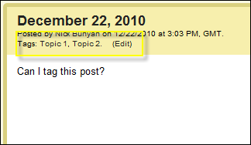

1. Tags are listed from the side menu – click on a tag to list all blog posts with the same tag. For example:

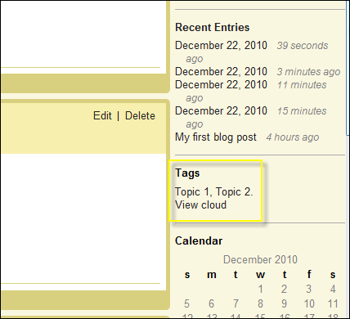

Add interactive widgets

You can set up blog posts to include voting and rating widgets.

1. From the top of the blog page click on the **Widgets link**.
2. Click on the **Available tab**.
3. Scroll down the list of widgets and add either the **Viewer Voting** or **Viewer Ratings** widgets by clicking on the **Add buttons**:

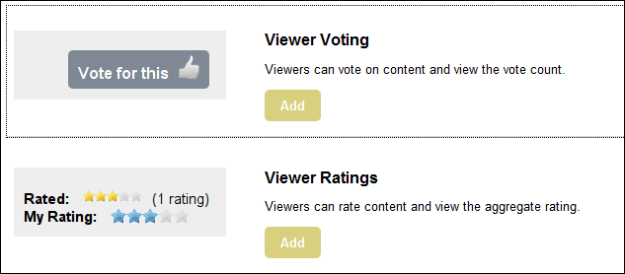

1. Click on the **Finish button**.

All blog post will now have a voting and rating widget for all viewers to use:

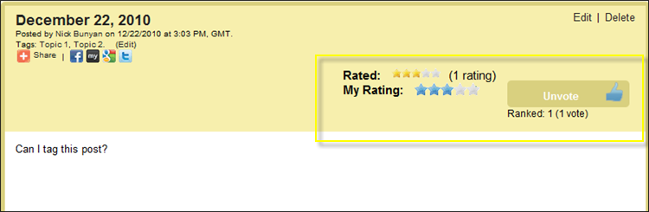

Assessing student contributions to a blog

1. To assess a student contribution to a blog, click on the Assessment link at the top of the blog page:

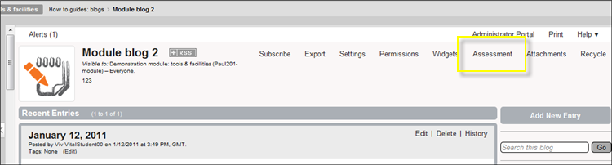

This page will list overall statistics for the blog and list all the users that have contributed. For example:

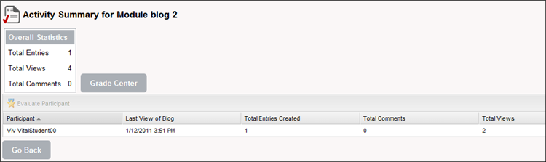

1. To grade a specific student, highlight their name from the list and click on the **Evaluate Participant option**. For example:

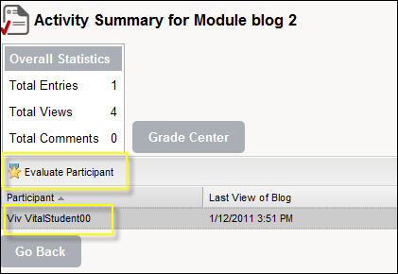

This will open a page which will list all the blog posts entries and comments that have been added by that user.

1. To grade and send feedback to the user, click on the **Edit link**:

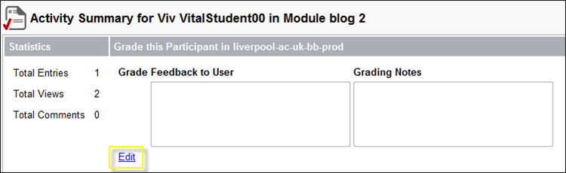

Add feedback information or grade you want to return to the student.

1. Click on the **Submit button** to complete the process.

Note: grades and feedback are also accessible through the module Grade Centre tool.