** Assignment**

Create an assignment – individual submissions

Create an assignment – group submission

Check submissions

Download submissions for printing and offline viewing

A tip for late submissions

**Overview**

The Assignment tool allows you to create a specific assignment item in a module where students submit a piece of coursework electronically. A student submission may consist of one or more files. Every assignment you make will automatically create a corresponding column in the Grade Center, where you can grade and add feedback. Submitted assignments can either be viewed online or printed off in a batch from the Grade Centre. Assignment set-up options include:

* Specify due date and time;
* Specify number of times a student can submit;
* Create Group assignments (one student can submit for the whole group).

See also the related: [ cross-check these]

‘How to’ guide - ‘Turnitin setup and management’ – for assignments where you need to check electronically for plagiarism (*tip - You can still check Assignment work for plagiarism by zipping up all the submissions and uploading them to Turnitin*).

(Student) ‘How to’ guide - ‘How to submit an assignment’ – for the student view of submitting assignments.

# Create an assignment – individual submissions

1. Go to the content area in your module to where you want to add your new assignment (e.g. **Assessment** or **Assignments**).
2. With the EDIT mode switched **ON**, hover the mouse over the blue **Create Assessment** button at the top of the screen, and click **Assignment** from the menu that appears.

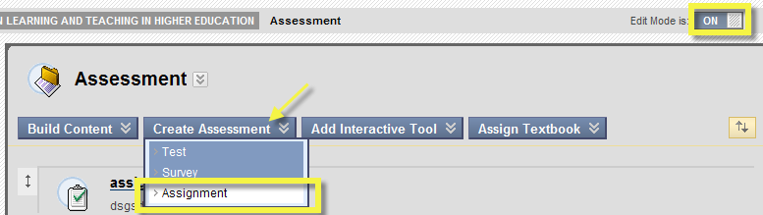

1. You must enter a name for the assignment.

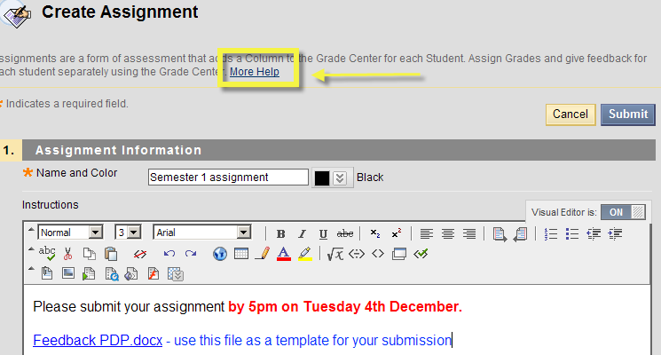

(*Note the ‘****More Help****’ link at the top of the screen – click to open a help page about the Assignment tool in a new window.*)

1. You should enter **Instructions**, which can include document file links, multimedia files, hyperlinks and Flash content. These instructions are visible to the student before they click on the assignment link to submit their assignment, as shown here below.

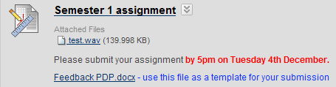

1. In section **2. Assignment Files** you also have the option to attach a file(s) for students to open and download (e.g. marking criteria or assignment instructions) after they have clicked on the assignment link to submit their assignment, as shown here below.

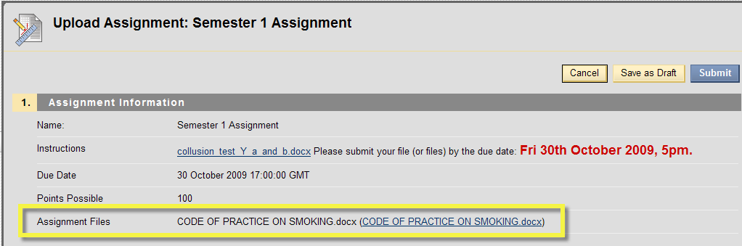

1. To attach a file here click **Browse My Computer (where is Course files button? Bug 30) ,** click **Open** and the file (test.wav) should now be displayed as a link on the page.

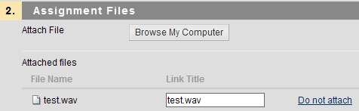

1. Enter **points possible** in section **3.Grading** (e.g. 100 but you can also specify 0).
2. You can also set the number of attempts that you want to allow students for submission. This can be ‘**Allow single attempt’**, **‘Allow multiple attempts’** (unlimited) or a specific number of attempts. VITAL stores the submissions for each attempt which you can access in the Grade Center.
3. You can also set a due date and time using the calendar and clock icons after which students will not be able to submit to the assignment.   
   NB *Make sure that you set the correct time, e.g. AM or PM.*

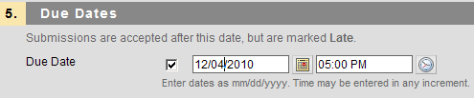

1. Select recipients **‘All students individually’** for an individual assignment.
2. Click **Submit**.

# Create an assignment – group submission

If you are using groups in your module (see ‘How to’ Group tool guide) then you can set a group assignment.

Only one group member needs to submit the assignment on behalf of the group and all members receive one joint mark or grade. Group membership is decided at the point of submission. Anyone added to the group after submission will not receive the grade – unless the assignment is resubmitted. Any member can submit the assignment electronically.

To create a group assignment and once the group has been set up, follow the steps 1-8 in Create an Assignment above, then

9. Select the **‘Groups of Students’** option in the Recipients section to make it into a group assignment.

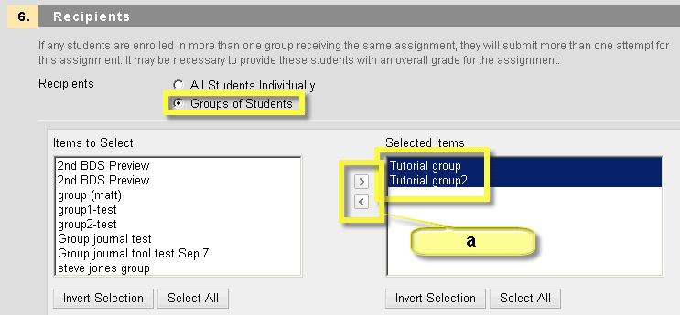

10. From the ‘**Items to Select**’box, click on the group(s – hold down the CTRL key for multiple selections) that you want to be able to submit to the assignment then move these to the right hand side ‘**Selected Items**’ box with the ‘**>**’ icon (‘a’ in the above screenshot). In the example above a group assignment is being set up for two groups.

11. Click **Submit**. The assignment is created in the content area.

# Check submissions

You can check which students have submitted their work, open their submitted files for viewing or printing, and add marks/grades and/or feedback for student’s assignments (which they will be able to view in My Grades) via the Grade Centre.

1. Go to the **Control Panel** and click on **Grade Centre,** then on **Full Grade Center** (if you have not got a customised view).

2. Grade Centre displays each assignment in a column and each student in a row. Find the column for the assignment (e.g. **Test assignment**). Where a submission has been made by a student, a green exclamation mark appears.

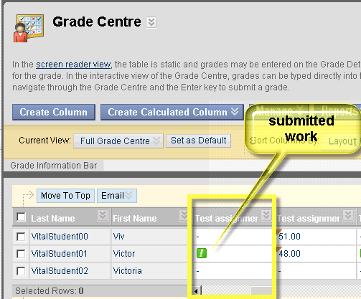

3. To open an individual submission, find the row and column for the assignment, where a submission exists (e.g. marked by a green exclamation mark), and click on the double arrow at the end of the same cell.

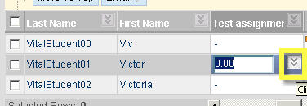

4. This will give you a dropdown menu. Click **View Grade details**.

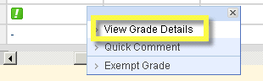

5. From the currently selected **Edit** tab, click the **View attempt** button. You can also edit the grade or allow an additional submission attempt from this screen.

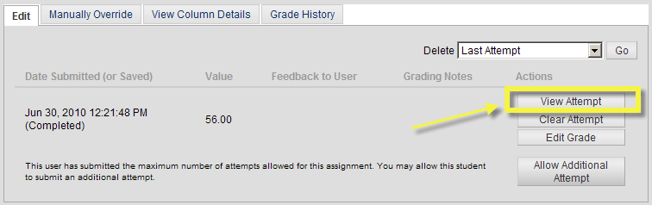

6. From section 2, Review Current Attempt, the student’s submission(s) is the clickable link listed in Attached Files. You can also grade the current attempt here and add feedback to the user, as well as instructor notes (notes not visible to the student), then click **Save and Exit**.

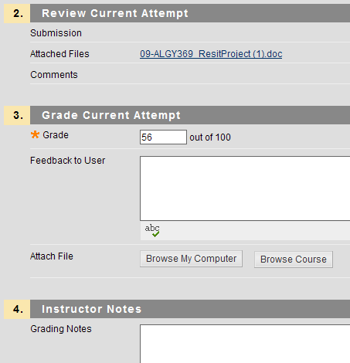[is it worth showing how students will see this feedback ie My Grades – cannot seem to do this on archive system]

# Download submissions for printing and offline viewing

You can download the whole module’s submissions as a zipped file. To download submissions:

1. In your module, click **Control Panel**, then **Grade Centre, full Grade Centre**.

2. Find the column identified by the title of the assignment (, e.g. **Coursework 1**).

3. Click the double arrow next to the assignment’s name, then click **Assignment File Download.**

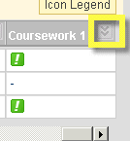 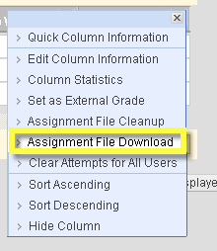

4. Select all the users for whom you want to download the assignment by ticking the box next to their name.

5. Click **Submit**.

6. Click on the **Download assignments now** link.

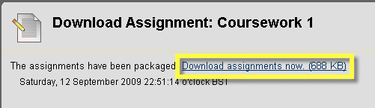

7. Click **Save** to save the zip file on your computer (this may be different in different browsers).

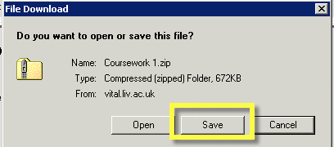

8. Click **Save** again.

9. The assignment title and a student’s username (or their group name if it is a group assignment) is automatically added to each file they submit.

# A tip for late submissions

For late submissions and resits etc. you can set up different assignments with different due dates, and only available to specified students, to make it easier to track student submissions and mark results.