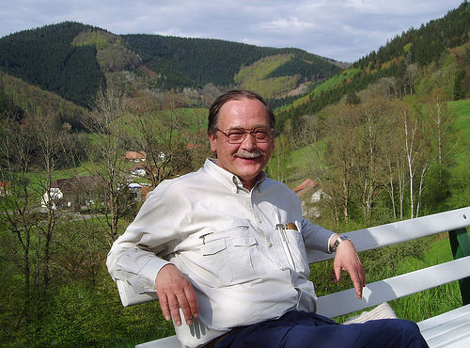

LMS Singularity Day
dedicated to the memory of Ragnar-Olaf Buchweitz
Liverpool, 29 November 2017

Programme
13.30 - 14.30 Eleonore Faber (Leeds)
Noncommutative desingularizations of discriminants of reflection groups
14.30 - 15.30 Alexandr Buryak (Leeds)
Extended r-spin theory and the deformed superpotential of the A-singularity
15.30 - 16.00 Tea/coffee/biscuits, room 304
16.00 - 17.00 Firuza Mamedova (Hanover)
Equivariant indices of 1-forms on varieties
All talks are in room 106.
The abstracts are below.
The event is supported by an LMS Scheme 3 grant.

Abstracts

Eleonore Faber
This is joint work with Ragnar-Olaf Buchweitz and Colin Ingalls. Let G be a finite subgroup of GL(n,K) for a field K whose characteristic does not divide the order of G. The group G acts linearly on the polynomial ring S in n variables over K. When G is generated by reflections, then the discriminant D of the group action of G on S is a hypersurface with a singular locus of codimension 1, in particular, D is a so-called free divisor. In this talk we give a natural construction of a noncommutative resolution of singularities of the coordinate ring of D as a quotient of the skew group ring A=S*G. We will explain this construction, which gives a new view on Knörrer's periodicity theorem for matrix factorizations and allows to extend Auslander's theorem about the algebraic version of the McKay correspondence to reflection groups.
Alexandr Buryak
It is well-known that the parameter space of the miniversal deformation of the A-singularity carries a Frobenius manifold structure. The potential of this Frobenius manifold can be described as the generating series of certain integrals over the moduli space of r-spin curves. This is the simplest case of the Landau-Ginzburg mirror symmetry. I will show that the deformed superpotential of the A-singularity also has a geometric interpretation in terms of a certain extension of the r-spin theory. The talk is partially based on a joint work with E. Clader and R. J. Tessler.

Firuza Mamedova
For a G-invariant holomorphic 1-form with an isolated singular point on a germ of a complex-analytic G-variety with an isolated singular point (G is a finite group) one has notions of the equivariant homological index and of the (reduced) equivariant radial index as elements of the ring of complex representations of the group. During my talk I will show that on a germ of a smooth complex-analytic G-variety these indices coincide. This permits to consider the difference between them as a version of the equivariant Milnor number of a germ of a G-variety with an isolated singular point. The talk is based on a joint work (arXiv:1701.01827) with Sabir M. Gusein-Zade.

