Table S1. PDB codes of the test set of structures
Structures that successfully solved | Structures that were not successfully solved
1EJG 1EW4 1EZJ 1FK5 1G2R 1G6U 1GK6 1GVD 1GXU 1I2T 1J8B 1OAP 1OKS 1OX3 1Q8D 1R6J 1R7J 1RIY 1RW1 1T07 1TGR 1U84 1UJ8 1USE 1USM 1V2Z 1V70 1VBW 1VJK 1WHZ 1WPA 1Y0N 1Y6X 1YIB 1YU5 1YZM 1Z0P 1Z96 1ZVA 1ZZK 2B8I 2C60 2CWY 2D3D 2EFV 2ES9 2F60 2FI0 2FQ3 2FU2 2G7O 2GKR 2GPI 2H9U 2HDZ 2HL7 2HPJ 2I4A 2IGP 2IP6 2JKU 2NML 2NS0 2NUH 2O1K 2O37 2O4T 2OQQ 2OUF 2OVG 2OXO 2P5K 2P6V 2PST 2Q2F 2QFF 2QMT 2QSB 2QVO 2QYW 2RFF 2RHF 2V75 2VC8 2VKL 2YZT 2ZQE 2ZQM 3A4C 3ADG 3B64 3BJO 3BN0 3BRI 3C0F 3CE7 3CEC 3CQ1 3DF8 3E21 3EFG 3F2E 3FBL 3FF5 3FKC 3FMY 3FT7 3G21 3G2B 3GOE 3H01 3H36 3H8H 3HGL 3HRO 3HZ7 3IDW 3IM3 3JTZ 3JVL 3K3V 3KW6 3LAX 3LBJ 3MWZ 3MXZ 3NRW 3OOU | 1EN2 1F94 1GMX 1I71 1IQZ 1J2L 1J8E 1KTH 1KWI 1L9L 1LSL 1LXJ 1M1Q 1MG4 1MK0 1NE8 1NJH 1NNX 1P9G 1PZ4 1RLK 1RWJ 1SBX 1TG0 1TS9 1TTZ 1TUK 1TUW 1U2H 1U3Y 1U9P 1UB9 1UCS 1UOY 1V05 1VYI 1WRI 1XAK 1XBI 1XE1 1XG8 1XW3 1Y9L 1YGT 1Z21 1ZLD 1ZT3 2ASC 2B1Y 2BKF 2BRF 2CBO 2CG7 2CMP 2CWR 2CYJ 2D9R 2E3H 2EA9 2EWH 2EWK 2EWT 2FB6 2FHT 2GYZ 2H8E 2HAZ 2HC8 2HLR 2I5F 2I6V 2IAY 2IVY 2J6B 2J8B 2J97 2NQW 2NSC 2O0Q 2O9U 2OD5 2OOA 2OQK 2PK8 2PND 2PPN 2PY0 2Q79 2QSK 2QTD 2R39 2R4Q 2RH2 2RIL 2UUX 2VQ4 2VSD 2WBX 2WJ5 2WKD 2WUJ 2X3G 2XFD 2XNQ 2YV4 2YVI 2YXF 2ZXY 3A0S 3A38 3AGN 3BN7 3BT4 3BV8 3CA7 3CI9 3CTR 3CW3 3DML 3DQY 3E0E 3E56 3E9V 3EAZ 3EMI 3ENU 3EWG 3EXY 3F14 3F40 3FDR 3FF2 3FFY 3GHF 3GV3 3H9W 3HMS 3HNX 3HQX 3HRL 3I8Z 3IV4 3JSC 3JSR 3JU3 3K0X 3KKF 3KP8 3KZD 3L32 3L4H 3L9A 3LDC 3LE4 3LWC 3LYG 3LYW 3MSH 3N3F 3NBM 3NGG 3NPD 3NX6 3NZL 3OIZ 3OSH 3PHN

Figure S1
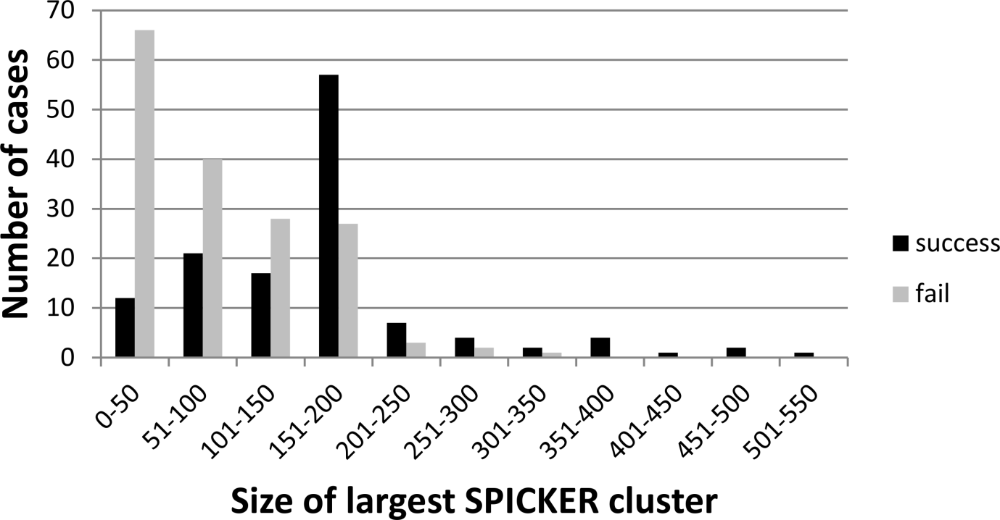
Figure S2
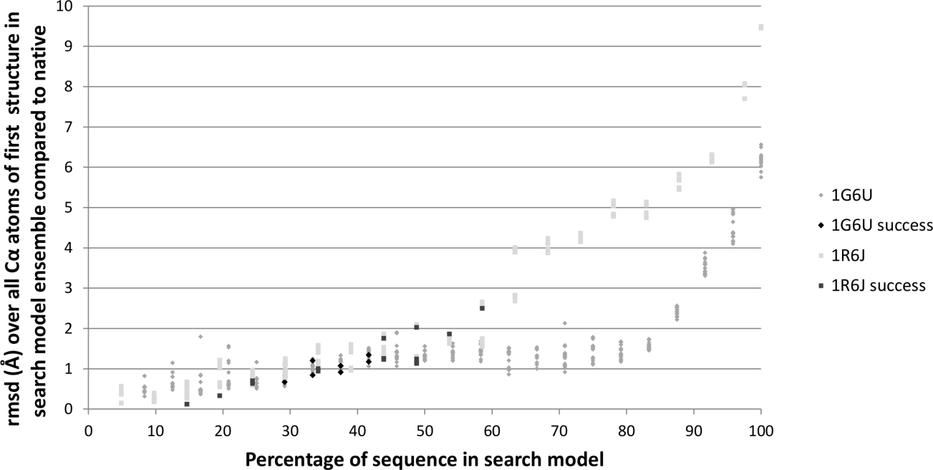
Figure S3
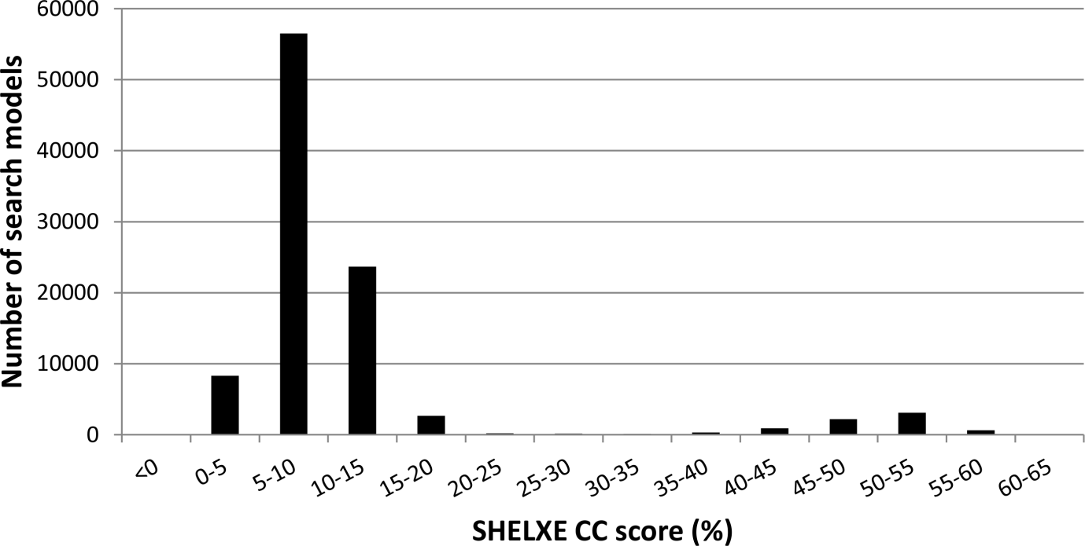
Figure S4
A)
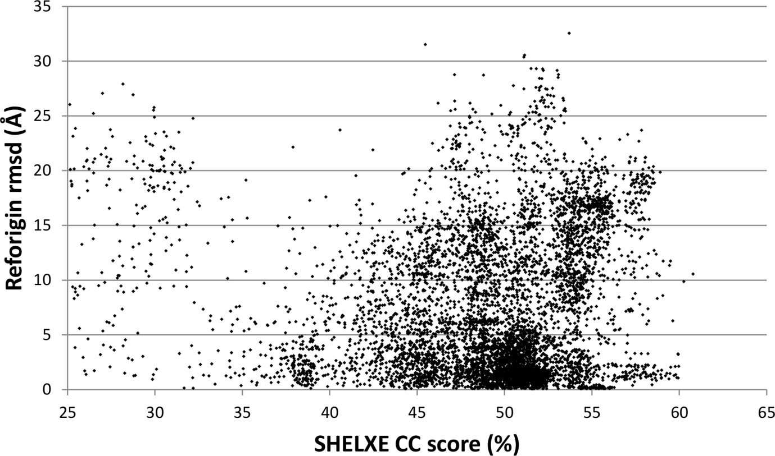
B)
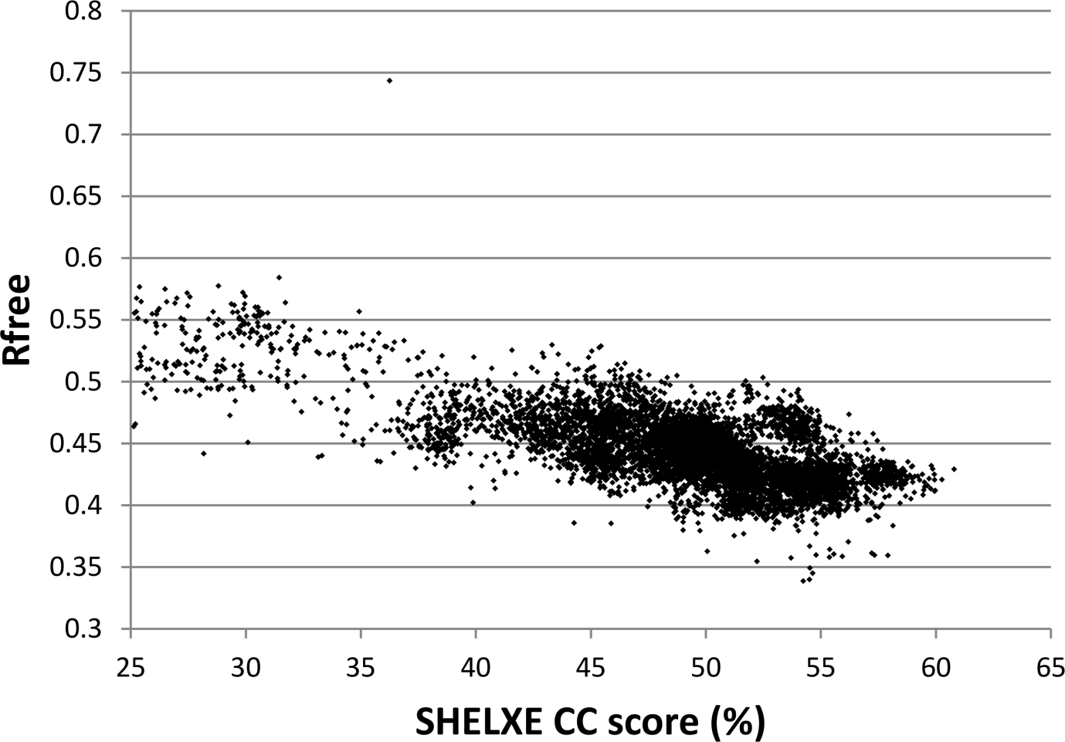
C)
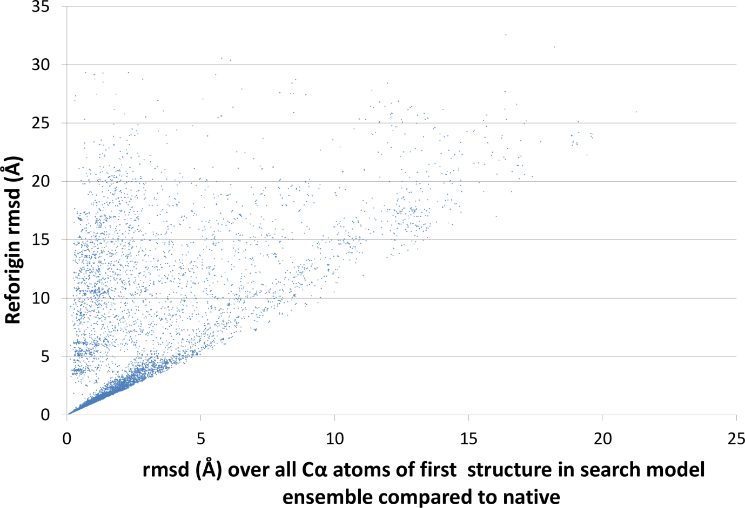

Figure S5

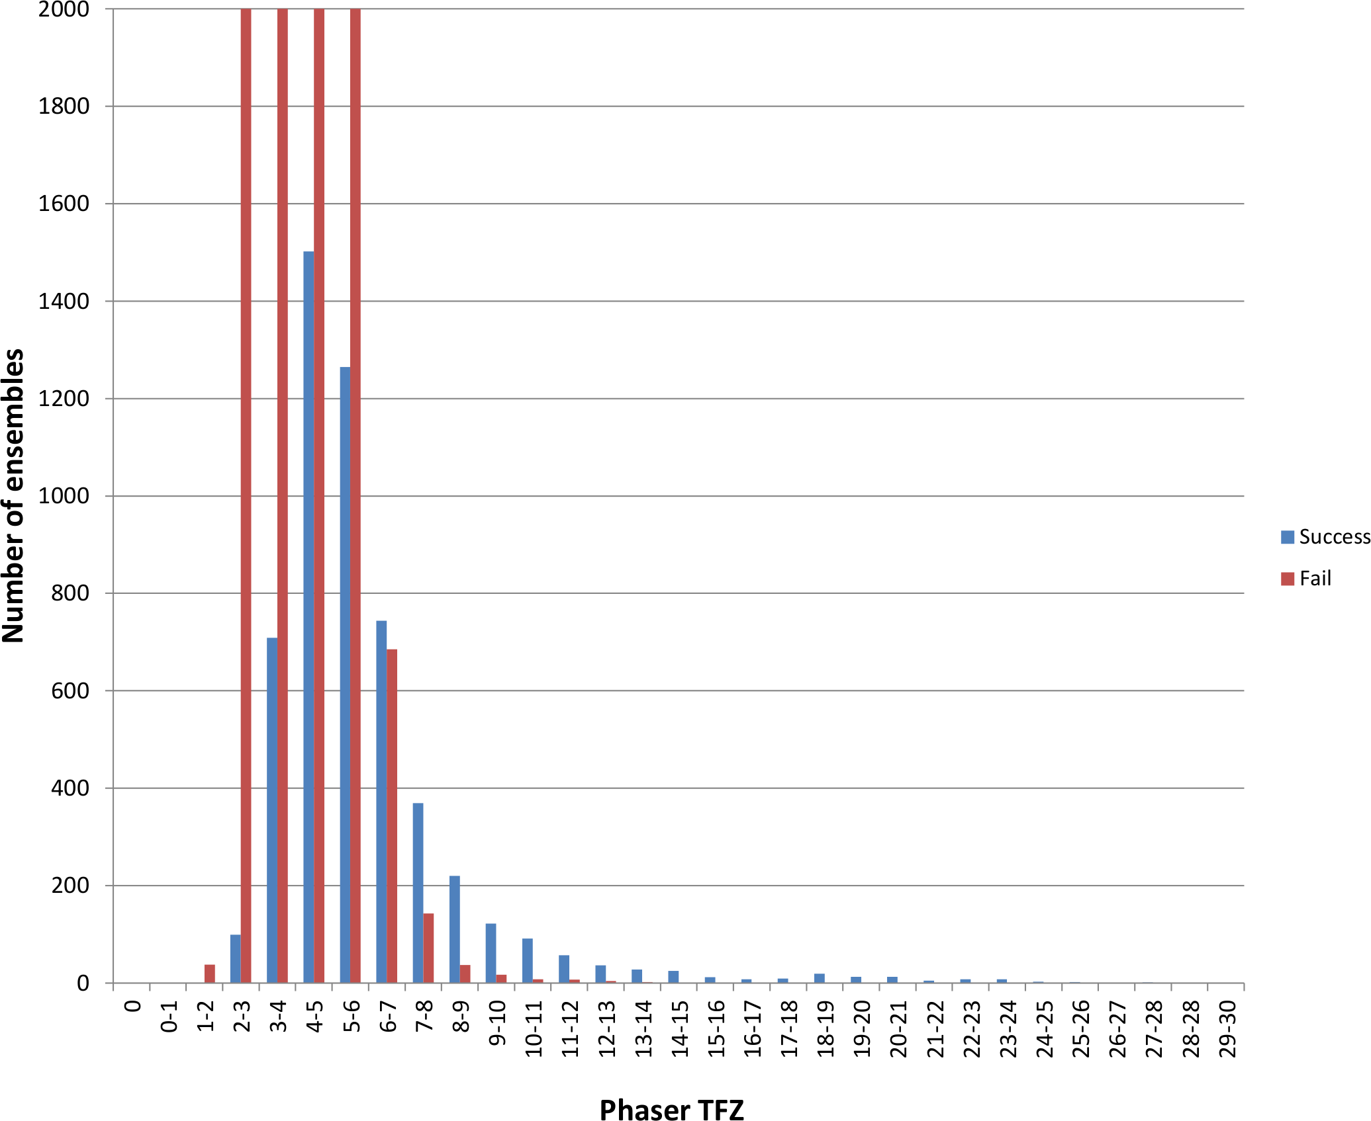
Figure S6
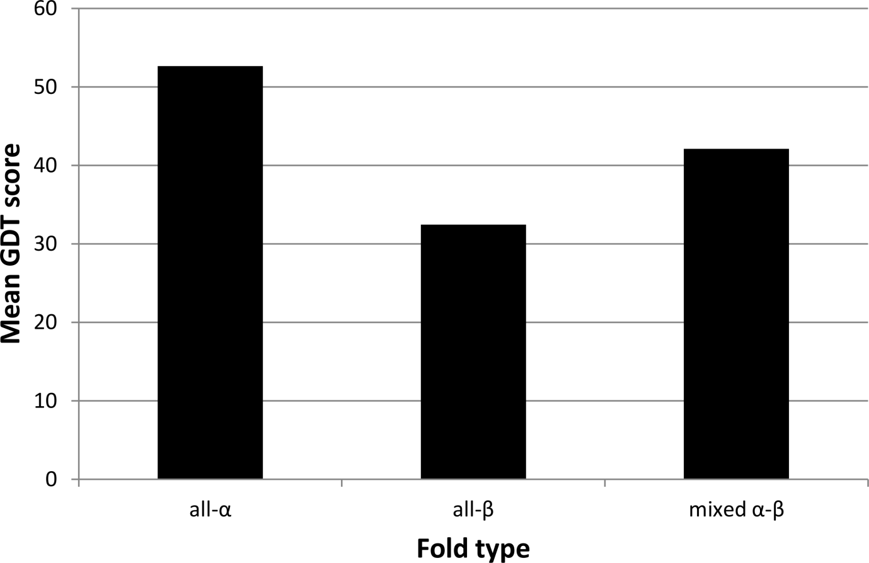
Figure S7
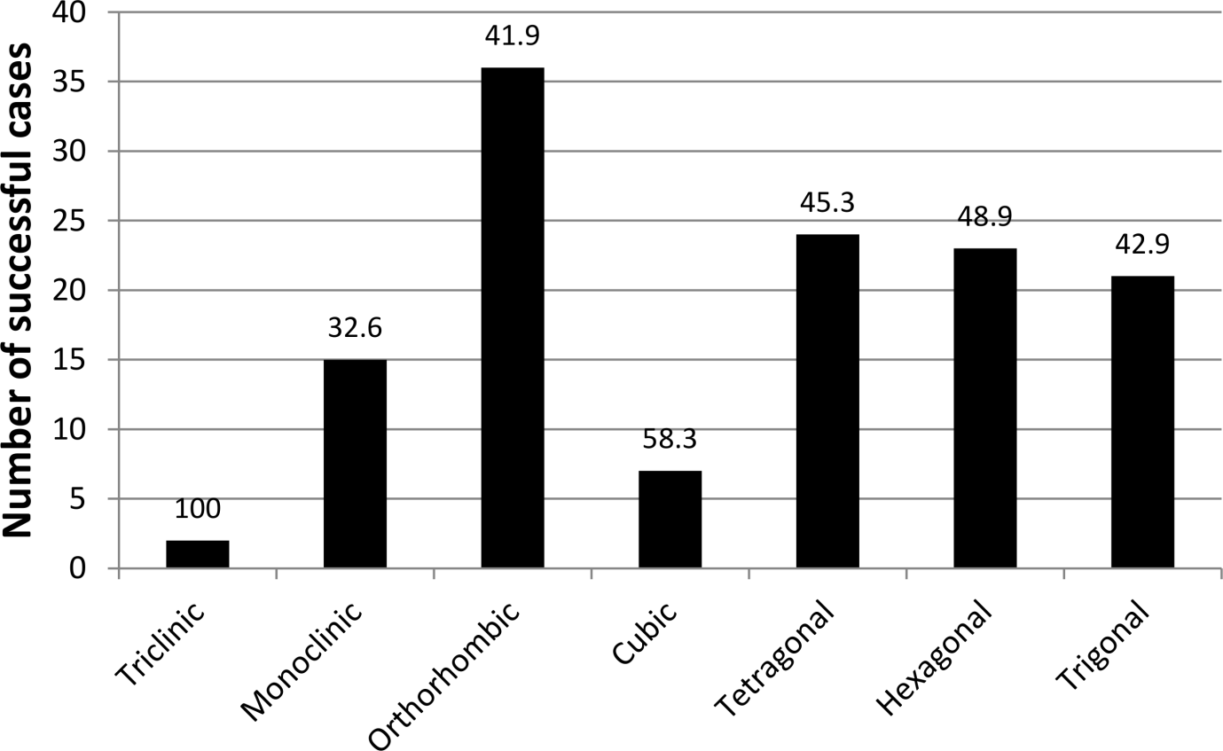
Figure S8
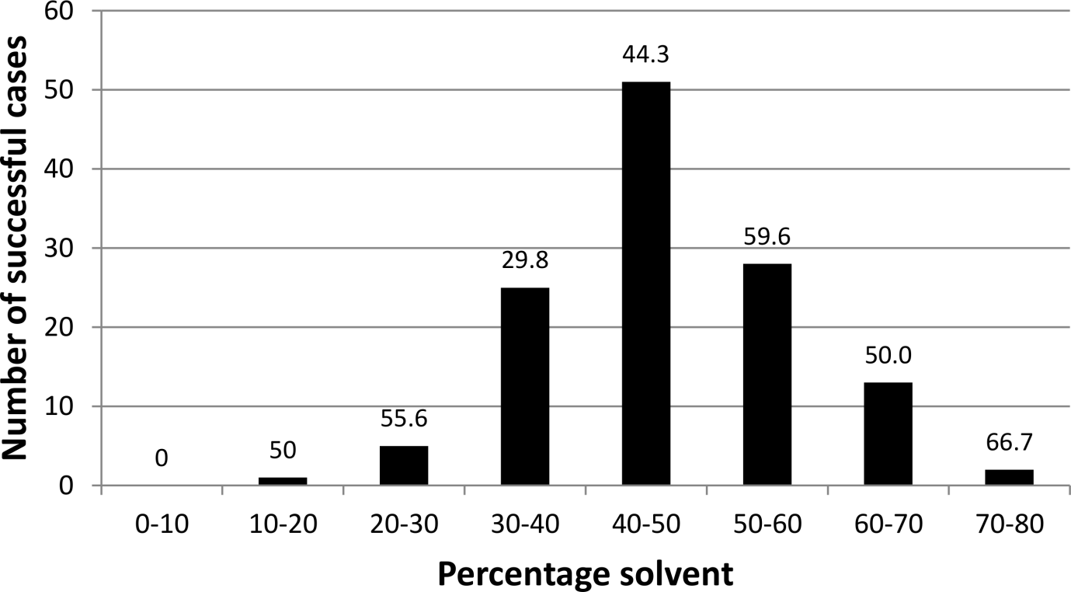
Figure S9
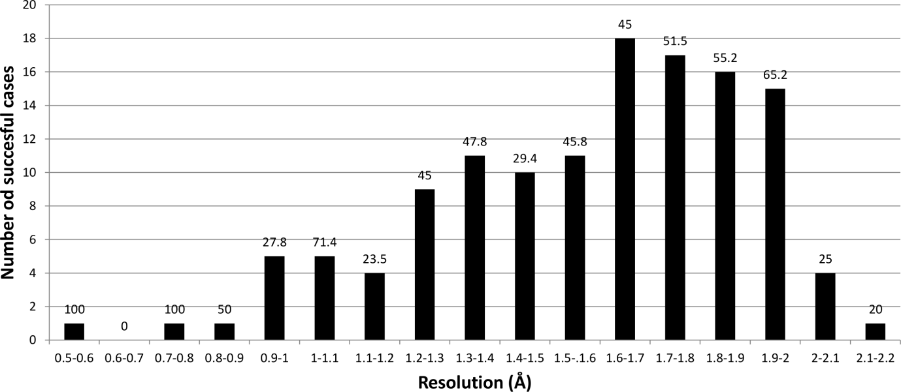
Figure S10
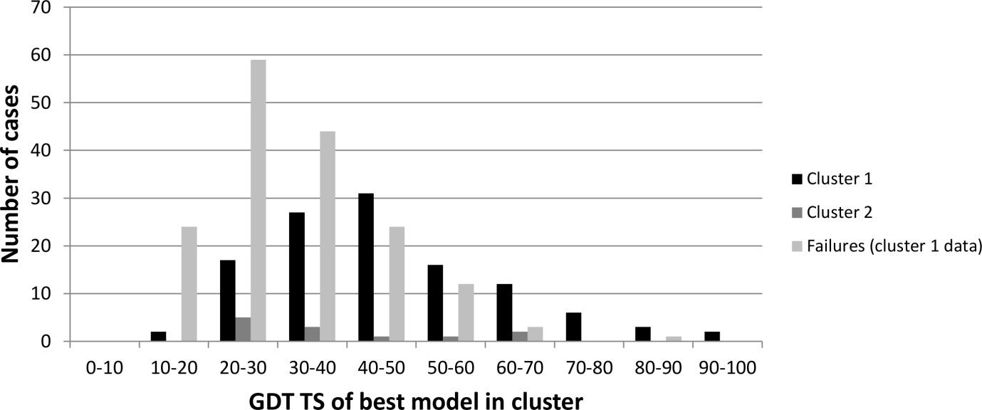
Figure S11
a)
b)
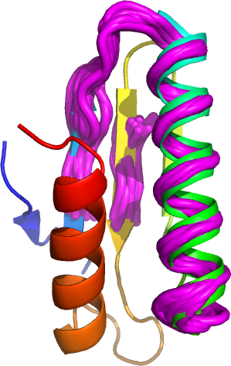

c)

Figure S12
a)
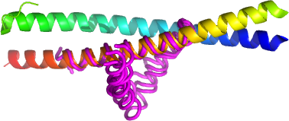
b)
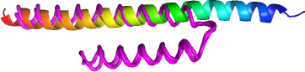
c)
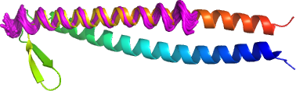
d)
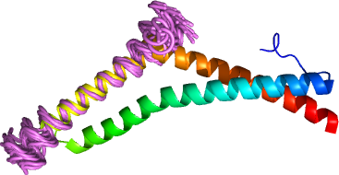
Figure S13
