PORTFOLIO HANDBOOK

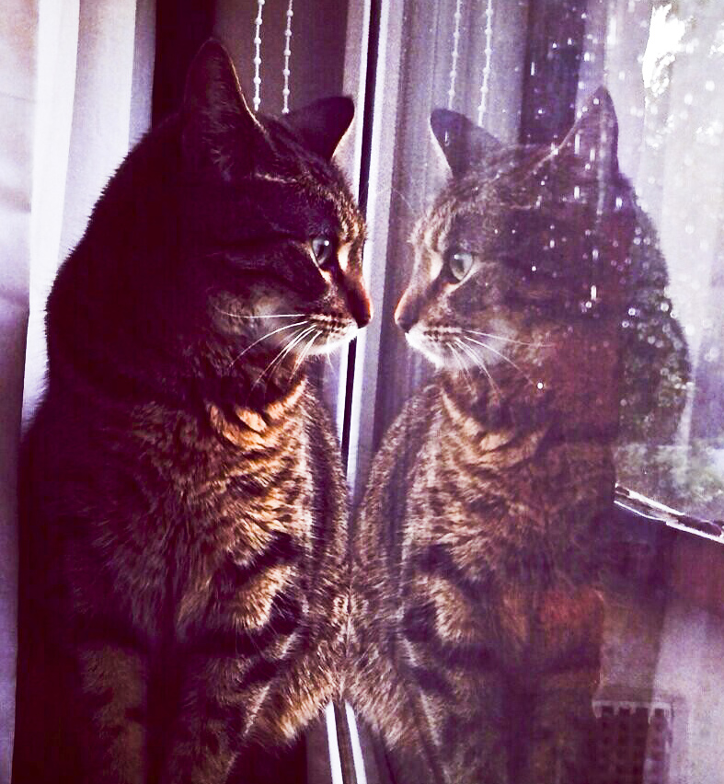

2014/15

2014/15

CONTENTS

Introduction
What is the portfolio and why is it important? 3
Assessment and credit value 3
What is its purpose and audience? 5
What to include in the portfolio 5
Reflection 6

Portfolio platform 7
Building your portfolio 8

Suitable evidence 9
Reflection throughout your portfolio 10
First year – Overview 11 First year – Learning outcomes 12

Second year – Overview 14
Second year – Learning outcomes 14

Third year – Overview 16
Third year – Learning Outcomes 16

Summary 18

Who to contact if you have a problem 18
Bibliography 19
Appendices

INTRODUCTION

What is the portfolio and is it important?
A narrow view of a portfolio is a repository or folder housing work to be marked (or work that has been marked). It can be much more – building it can be part of the learning process itself, with reflection playing a pivotal role.
Assessment of portfolio items involves an unusual mix of assessing both process and product.
What does this mean?
Your portfolio will be made up of:
- tasks set to enable students to achieve specific outcomes (e.g. an essay, literature review, etc) review,
or
(b) evidence that you have selected to demonstrate outcomes have been achieved (e.g. Peer reviews, feedback from presentations, reflective statements, etc)

This mix of activity involves students in evaluative decision making about suitable
evidence, planning to eliminate gaps in their profile and reflecting on learning experiences. It also means that, despite common elements, all portfolios will not look the same or have exactly the same components.

Assessment and credit value
The portfolio focus is not on examination performance and this difference can result in it being deemed less important but, remember, it is credit-bearing and contributes to achieving a passing mark. Learning, Teaching and Assessment Strategies (36) of the BVSc Programme Specification indicates that portfolio ta sks must be submitted for assessment in Years 1-5 of the programme.
Each year of the BVSc programme is worth 120 credits, with the majority assessed by written or practical examination (EMI, SAQ, Integrated, Spot and OSPE).
One sixth of the programme is assessed via the Portfolio and “Other” coursework. “Other” encompasses research skills, literature reviews, pre- project research and the third year research project. This component is worth 20 credits. The following table shows that the breakdown of these credits changes from year to year.
 | YEAR ONE | YEAR TWO | YEAR THREE
Portfolio | 15 | 10 | 5
Research Skills | 0 | 5 | 10
“Other” | 5 | 5 | 5
Total Credits | 20 | 20 | 20

Models cited in relation to Assessment
Bloom's taxonomy is a hierarchical classification of the different objectives that teachers/lecturers set for students - learning objectives. In their review of assessment in veterinary medical education, Baillie, S., et al,(2014) consider Miller’s Pyramid (commonly referred to in the assessment of medical education) as a condensed version of the Bloom model. They have explored a relationship between the two models. Figure 1 represents this relationship, with Bloom’s taxonomy on the right and Miller’s Pyramid on the left.

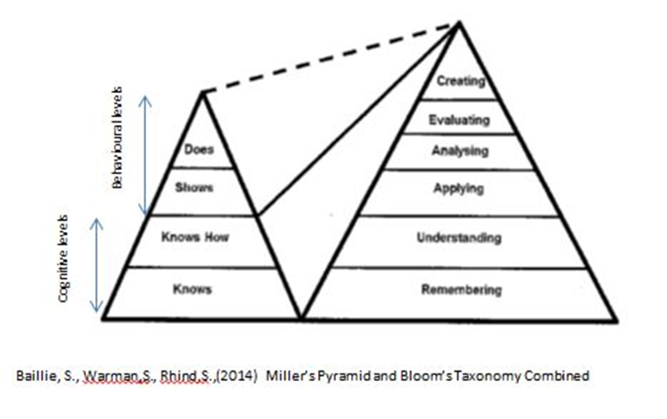
Figure 1:
The authors have mapped the “Knows” and “Knows How” Miller- levels to the six Bloom- levels, “reflecting a progressive contextualization of knowledge as one ‘climbs’ the pyramid”.
The Veterinary portfolio shows a particular emphasis on the “Shows” and “Does” levels but doesn’t overlook the cognitive levels (i.e. what you know is also important!)

What is its purpose and audience?
“If I taught someone to play golf I would not check what they have learned with just a written test. I would want to see more direct, authentic evidence. I would put my student out on a golf course to play”.(Mueller,2005)
Portfolio outcomes and assignments guide students to reflect on their work and to “engage in self-assessment and goal setting” – two of the most authentic skills in real-life situations (Mueller, 2005).
Briefly, your portfolio should demonstrate what you can do.
A really good portfolio is more than box-ticking of completed outcomes. Its reflective content can play a large role in learning and setting up the lifelong learning practice required by a vet in practice or in research. As such, it can tell the story of its owner’s development, reflecting academic and professional development and so could be of interest to external audiences. Sharing a portfolio (or extracts from it) with a potential employer should demonstrate what you can do, how you’d developed and some insight into your decision making and evaluative skills. When interviewing applicants for posts, I’ve always been interested in evidence of what the candidate can do rather than just a polished interview performance and well prepared answers!
The portfolio audience?
Initially, this is the teaching and learning community of the Vet School. In the construction phase, students and staff have access to items that have been submitted but the portfolio will ultimately belong to the student.
A student may review an assignment or outcomes with the lecturer(s) who set specific tasks and you may discuss other outcomes and reflections with your Personal Tutor in a PDP. It can highlight gaps in your profile which will need to be addressed. We expect to be able to tell from your portfolio if you are not meeting outcomes, just getting by or whether portfolio is outstanding. Beyond that, it is harder to predict exactly how your portfolio might be used. As it’s a showcase for how you’ve learned, resolved difficulties and what you can do, it can inform your CV, be sampled by prospective employers or funding bodies…….

What will you put in your portfolio?
Each year of study has specific learning activities that will provide evidence for your portfolio. These activities will often enable you to complete several learning outcomes.
For example: task - literature review; this would normally be set and marked through the Turnitin tool. You would then keep your marked piece of work in your portfolio and this would be your evidence for meeting specific learning outcomes.
Some outcomes are not linked to a specific task. For instance, you might reflect upon an experience (or experiences); consider what you have learned and how to move forward. Your reflection and (or) the goals, targets, etc that arose from it could be evidence for one or more learning outcomes. Selecting evidence to meet outcomes can be very simple but planning to develop and achieve evidence to meet specific outcomes is more complex.
In some situations, alternative evidence may be allowed for portfolio inclusion but this will always entail discussion with staff before you submit it to determine its acceptability.

REFLECTION
Reflection is the thoughtful processing of problems, which often lack structure and there is no single obvious solution. Reflective skills are highly valued in higher education and beyond. Isn’t that just for university and researchers?
Viner (2010) comments
“….my experience of the reaction from the veterinary profession to the term ‘reflective practice’ has been less than positive. Mention the concept to a teacher, or a health professional such as a nurse or a medic, and they embrace it with open arms. But mention it to a veterinarian more than a couple of years out of vet school, and they look at you as if you’re from another planet. It’s not just that they often don’t understand what the term means. They don’t know what it means, but they do know that they don’t want to know what it means! It all sounds too touchy-feely for a busy professional, who is used to rolling up his or her sleeves and getting stuck into the task at hand, rather than pausing for contemplation”.
It might be useful to note that Bradley Viner is a UK vet, owner of five practices and an elected RCVS council member. His thoughts about reflection and the journey to reflective practice support the view that reflective skills have value beyond your time in Vet School. His comments have been included as they echo those of some veterinary students; “I’m too busy to do this as I have (..X…) to do”. Sometimes it takes time for the”penny to drop” that reflection can take you where you need to go more effectively.
This handbook is not the place to consider concepts and practice associated with reflection in depth; there is a first year lecture and a range of other activity that encourages reflective practice. Your portfolio must include reflection - refer to the Building Your Portfolio section, where the minimum number of reflections required is stated. A few really insightful reflective pieces will be better than many scant, shallow ones. The reflective thoughts, conclusions and decisions are steps in development and learning that aid the student. Recording these shines a light on how the student is doing that.

Portfolio platform
This refers to the medium of your portfolio. Some of our students have experience of paper-based portfolios. Veterinary portfolios will be built electronically. An e-portfolio is desirable option for both staff and students to minimise loss, excessive paper usage and to maximise accessibility. The portfolio will be used in PDP sessions.
In 2013-14, VITAL was used for the portfolio and had various “teething” problems. In 2014-15 the School will no longer use VITAL for the portfolio.
The university has purchased Pebblepad, which is purpose-designed e-portfolio software, widely used in universities the UK and internationally. It is also portable – when the student leaves, the portfolio can be taken with them.
The decision has been taken to create an interim portfolio on the M drive. We are monitoring the introduction of Pebblepad in the Medical School and learning from any glitches that they identify. We plan to make the transition from the M drive when we are satisfied that Pebblepad is working smoothly.
The basic Pebblepad format is “What?”
“So What?”
“Now What?”
The portfolio outcomes listed in this handbook are the equivalent of the “What” stage.

First year students will be shown how to set up their M drive and portfolio in the first week of term. Basic formatting, tagging, “work in progress”, privacy and publishing will be addressed and this session will also troubleshoot individual problems.
Second year students will be able to move their portfolios to the M drive.

BUILDING YOUR PORTFOLIO
Construction takes time but there is ample available for completion.
Portfolio building should be simple – match the outcome to suitable evidence! Learning outcomes evolve over time and illustrate development. For instance, it’s reasonable to expect that communication skills in a clinical setting would be more sophisticated and precise in Year 4 than Year 1 for most students.
First year students will have an introduction to portfolio building in a DEVIL session – check the timetable.
Year 1 students will have portfolio management sessions built into time allocated to DEVIL.
Year 2 students: we have made changes to the portfolio component. A portfolio building and management session will be available at the start of term. Subsequently, advice sessions will be available to assist you in managing your portfolio (check VITAL announcements) but these will not be routinely timetabled. For task-specific problems that arise, contact the staff member/team who set the task. For outcome-related issues, if the problem is not resolved through portfolio management sessions or peer discussion, email Margaret Hannigan (Hannigan@liv.ac.uk)

STARTING YOUR PORTFOLIO
The portfolio is built on two essential components – evidence and reflection. Portfolio outcomes to be achieved are derived from different sources; e.g. Programme Specification, RCVS guidance, etc.
Some outcomes are:
- Task-specific: a task was designed for completion of specific outcomes
Failure to successfully achieve the outcomes would require discussion of that item(s with the person who set the exercise and then one of the following:
- repeat the task OR
- complete a similar task OR
- provide alternate acceptable evidence of those outcomes OR
- If appropriate, the student would reflect on what has been learned and how to move forward and record that reflection.

- Not linked to one specific task: the student has to select appropriate evidence from their curricular and student experience to demonstrate these outcome(s) have been met. Good evidence should be provided with as little effort and time as possible. Be careful not to let the evidence gathering become a major task – you won’t have time. Evidence can take various forms and some examples follow.
Suitable evidence
Examples of Direct Evidence.
- Performance being observed by an assessor
- Feedback from a presentation
- Projects or work based assignments
- Personal reports
- Reflecting upon a learning experience
- Minutes of meetings, action plans, progress reports, comments recorded in a PDP
- Internal and external correspondence
- Prior qualifications which relate directly to the units (should be discussed first)
- Product evidence e.g. examples, samples, photographs
- Posters
- Validated self-evaluations
- Peer review evidence (including Web PA, Peermark, etc)
- Your responses to oral or written questions in appropriate format
- Video or authenticated audio files (short clips)
- Brief transcripts
- Countersigned logbooks (or similar documentation)
Indirect Evidence can include:
- Witness testimonies from people within or outside the organisation
- Achievement in related areas
- Attendance on workshop, course or training activity (where deemed appropriate)
- Membership of related committees or outside organisations
Such indirect evidence usually supports or confirms direct evidence but sometimes stands alone.
The BVSc curriculum has formative and summative elements. In general terms, formative assessment is focussed on your development of new skills and knowledge or dusting off ones where you may be a little “rusty”. Summative assessment actually checks what you can do at a given point.
Formative work does count! These items must be included in your portfolio – they just don’t carry a numerical value as summative items will.

Reflection throughout your portfolio
Reflection underpins the learning process: we recognise what we know and understand, align this with new experience and knowledge, process this and this guides us in taking our learning forward. Reflection will play a significant role in your portfolio.
A template (Appendix X) can be used for reflections that are not linked to a task (ie they are not linked to a specific task and instructions). The template is based upon the Pebblepad format and has a simple structure. There is no word limit but, even though your thinking may have no limits, your recording should be concise!
In addition to any task/content-linked reflections, you must provide two reflections per term. One of these will be discussed at your PDP meeting with your Personal Tutor and should focus on your learning or a significant aspect of it.

How should your portfolio look?
There is scope for individuality in each student’s portfolio. There will be common elements (tasks linked to specific points) but each student may pick different evidence to support the other outcomes. An excellent portfolio will not be a clone of other students’ work.
The following pages provide the infrastructure for the student portfolio.
For each year,
- There is an overview of activities that have a link, however small, to the portfolio.
- A list of portfolio outcomes for that year.
  - Outcomes may be task-linked or not.
  - The Evidence/Commentary column can indicate if specific evidence is generated through a task.
  - Where outcomes are not necessarily linked to one task, comments and suggestions for potential evidence may be included. It is deliberate that these are not offered for all outcomes. There are various opportunities throughout the curriculum to provide evidence of these outcomes - the student decides which evidence to use. Wherever a gap or under-performance is identified, this is a stimulus to reflect upon how to address the issue.
Tutors, External Examiners, etc will need to navigate the portfolio so the student should provide appropriate signposting, annotation as required and contextual commentary.

FIRST YEAR- OVERVIEW OF PORTFOLIO-LINKED TASKS
F- Formative S- Summative R- Reflective
Task Name  (Staff Lead) | Format & Mode of Assessment or Scrutiny | Estimated completion time | *Support available? | Exemption available?
SEMESTER ONE
PROF 00 Social Media (F)  C Gray | Group task and presentation
DEV01 Credible information (F)  M Hannigan | Written  Class discussion;  Model answer | 1-2 hours |  | Exemption for graduate applicants (application during Welcome Week).  NB: Assignments still due by deadline
DEV03 Referencing & Avoiding Plagiarism (F)  M Hannigan | Written (submitted via Turnitin) | 1-2 hours (research) + 1 hour
PROF01 Clinical notes/fee structure (F)  C Gray | Written | 2 hours
DEV06 Peer review of essay or article (F)  MHannigan | Individual review, discussion follows in 2/3s and group; Marked to scheme | 1 hour
NSF01 Peer Reviewing EMQs (F)  K Noble | Submitted via Peermark | 4 hours |  | From wk6 semester 1 to wk6 semester 2
DEV07 Peer review of essay (S)  M Hannigan | Written | 1 hour
NSF02 Anatomy workbook challenge – forelimb  F Penrose | -Schematic diagram  -Annotated drawing | 2 hours | Biological drawing workshop
DEV08 Reflective writing (F,R)  M Hannigan | Written  PDP discussion | 1 hour
Statistics (F)  P.Jones | Facilitated groupwork |  | Statistics workshop
SEMESTER TWO
PROF02 Peer evaluation forms for TBL and social media task (S)  C Gray | Written  Submitted via WebPA | 1 hour
PROF 03 Peer role play  C.Gray | Forms assessed during PDP |  |  | 2 forms required: one self- review plus one review of other. Due: Friday 5pm,Wk 12, Semester 1.
Epidemiology (F)  P.Jones | Facilitated groupwork
ID 01 Infectious Disease (S) N.Evans | Poster Presentation
*Support available – this refers to specific, bookable workshops offered as part of DEVIL. A list of workshops will be made available through VITAL. Student requests for additional workshops will be considered. Some themes (e.g. Epidemiology) have built group support into their teaching sessions.
F/S/R | PORTFOLIO OUTCOMES | EVIDENCE/Commentary
 | Use of library
F | Recognising credible sources of information DEV01  - Use framework of indicators to judge credibility of source material  - Identify a spectrum of credible source material from highly credible to poor  - Provide a rationale for decisions made when using above framework |  | Successful completion of task should meet (i) –(iii)
R | Academic Integrity DEV02  Brief personal statement of academic integrity
F | Demonstrate a working knowledge of the Harvard Referencing system DEV03  - Make appropriate Harvard style in- text citations  - Construct a Harvard style reference list/bibliography  - Produce a written discussion of a topic using the Harvard Referencing system  - Comply with a word count |  | Successful completion of task should meet (i) –(iv)
F | Peer review of a given paper DEV04  - Produces a structured review as if the paper were being scrutinised pre-publication  - Makes a judgement on credibility of the material, supported by selected evidence  - Comments on views, discussion, etc., of content with supporting statements.  - If appropriate, suggest improvements. |  | Successful completion of task should meet (i) –(iv)
F | Reflection  (i)Use a reflective framework to consider either overall progress or an aspect of it. DEV05  (ii)Reflection |  | (i)As this reflection should be discussed in your PDP, the notes of discussion (or an extract) might contribute additional evidence.
S | (iii)Reflection  (iv)Reflection
F  S  S  S | Peer Review & Evaluation  Peer Review of EMQs NSF01  Peer evaluation forms for TBL and Social Media task PROF02  (i)Peer evaluation within a practical setting  (ii)Evaluation of a peer’s description/explanation in a practical setting  (iii) Peer Review communication skills in Role Play exercise PROF 03  Evaluate the programme or an aspect of it |  | Peermark (Turnitin)  Web PA software  (iii)Forms provided
S | Feedback  (i)Audit your curriculum for different modes of feedback received  - Demonstrate provision of constructive feedback to another student  - Demonstrate provision of constructive feedback to another student  - Demonstrate provision of constructive feedback to another student  - Demonstrate response to feedback you have received  - Demonstrate response to feedback you have received  - Reflect upon your use of feedback |  | (i)Possible format: Annotated list/ table  (ii)-(iv) Appropriate evidence from different settings (eg. Not all from TBL) and not all written  (v)-(vi) use different situations
S | Communication  Demonstrate effective communication skills with clients
S | Identify a named meeting/group session where you have taken a lead (describe key features)
S | (i)Identify effective contributions you have made to team sessions that lead to a solution or course of action. ID 01  (ii)Identify effective contributions you have made to team sessions that lead to a solution or course of action.  (iii)Describe how you would try to get the best from an unbalanced team |  | (iii)This might be particularly relevant when a team grade is awarded
S | Appraise your strengths and weaknesses in communicating with an audience
S | Identify a short piece of formal writing in appropriate formal or scientific style |  | Examples of this might be a short report, record of practical work.
S | Demonstrate use of non-verbal, non-written communication in an educational setting |  | For example: using diagram/biological drawing for stated purpose
S | Main training a log of professional activity |  | Identify which log you have chosen; is it up to date, filled in appropriately, organised, countersigned, etc.
S | Relate how you have explained an idea/ demonstrated a skill or technique to a peer
F | (i)Demonstrate effective use of IT PROF01 |  | For (ii)- (iii) use different situations [for instance, consider a powerpoint you’ve created, spreadsheet, any professional use of IT, etc]
S | (ii)Demonstrate effective use of IT  (iii)Demonstrate effective use of IT
F | (i)Interpret case study data using a statistical program  OR (if having difficulty with the statistical application) identify the problem(s)that have arisen and summarise the steps taken to resolve the issue(s)  (ii)Describe and explain graphical data  (iii)Structure a verbal (or written) description of graphical data that would enable a peer to reproduce it in graphical form with reasonable accuracy  (iv)Develop a list of key points which would serve as a quick reminder of using R program |  | (iii)as might occur when describing data in a phone call

SECOND YEAR- OVERVIEW OF PORTFOLIO-LINKED TASKS
F- Formative S- Summative R- Reflective
Task Name/  Staff Lead | Format & Mode of Assessment | Approx. completion time | Commentary
LIT 01: Literature review of veterinary school research (F)  Z.Durrani | Submitted via Turnitin |  | Generalised review of all veterinary-related research at Liverpool
NSF 2.1 Peer Reviewing EMQs (F/S)  A Reid | Submitted via Peermark | 5 hours | Questions can be generated from Day 1 (includes formative phase). Final 3 peer-reviewed questions due 30th April 2015
PROF 2.1 Peer Role Play | Forms assessed during PDP |  | Two forms required: one self- review plus one review of other.  Due: Friday 5pm, Wk 12, Semester 1.
PROF2.2 Skills audit (F,S,R)  C Gray | Assessed by C Gray |  | Set Day 1, Semester 1;  Due Monday 9am, Week 12, Semester2
PROF2.3 Risk Assessment  C Gray | Reports - Assessed by C Gray |  | Semester 2
Enterprise Report  K.Mueller | TBC |  | Due 5pm on Day 1, Term3, Semester 2
LIT 02:Literature review of chosen research discipline (S)  Z.Durrani | Submitted via Turnitin |  | Focused review of the research discipline that will form basis of third year research project

YEAR TWO PORTFOLIO OUTCOMES
F | Research Skills  LIT 01  (i)Describe the process by which you identify a research question  (ii)Identify the types of source you would consult for information on a given topic  (iii)Describe how you would use these sources to locate information  (iv)What criteria would you use to judge the credibility of these sources?  (v)Demonstrate the use of a reference manager  (vi)Evaluate the strengths and weaknesses of your research process and reflect upon any need for development .  (vii)Demonstrate use of Harvard Referencing in literature review | (i)-(vi) can be viewed individually or holistically.
S | LIT 02  (i)Identify your chosen area of research  (ii)Outline your research plan  (iii)Review progress at suitable interim stage  (iv)Appraise your research and planning skills upon submission.  (v)Summarise your intentions for your third year research project
S | Academic writing  Select a document you have written to illustrate an appropriate style of academic writing
Professional, Business and Communication Skills
F | Identify and describe an instance where you have employed verbal communication skills to assist a peer with a difficult concept, mathematical problem or equivalent.
S | Identify a situation where you have demonstrated effective skills in communicating with a client | Simulations may be used
S | Appraise your questioning technique in a given situation
S | Maintain a log of professional activity | Ideally this should not be the same as the one you chose in the first year.If it is, it should be substantially developed.
F/S | Peer Review  (i)NSF 2.1 Peer Reviewing EMQs  (ii)Prof2.2 Peer Role Play | (i)Peermark
S | Feedback & Evaluation  (i) Audit your curriculum for different modes of feedback received  (ii)Identify an instance where you have given feedback which you think was particularly effective.  (iii)Demonstrate an effective response to feedback you have received  (vi)Reflect upon your use of feedback from others  Demonstrate how you have evaluated your 2nd year curriculum or an aspect of it.
 | Business Skills
 | Reflect on governing factors of an animal enterprise
 | Demonstrate a business-related skill that you have developed (or showing progress in its development)
 | Epidemiology Exercises TBC

YEAR THREE OVERVIEW OF PORTFOLIO-LINKED TASKS

Task Name | Format & Mode of Assessment | Approx. completion time
PROF 3.1 Calculation of consultation fees
C.Gray
PROF 3.2 Writing referral letter
C.Gray
PH 3.1 Disease outbreak | TBC
PH 3.2 “Essay”? | TBC
PH 3.3 PBL | TBC
PA 3.1 | TBC
Pathology | TBC

YEAR THREE PORTFOLIO OUTCOMES
S | Research Skills  (i)Define title of your Individual Research Project  (ii)Summarise your plan of activity for the project  (iii) Reflect upon progress and future action at appropriate interim stage
S | Academic writing  Select a document you have written to illustrate an appropriate style of academic writing
Professional, Business and Communication Skills
F  S | (i)dentify and describe teaching a skill, technique or process to a peer/student in a year following you  (ii)dentify and describe teaching a skill, technique or process to a peer/student in a year following you  (iii)Describe teaching a skill, technique or process to a peer/student and comment on how successful you were  (iv)reflect upon your strengths and weaknesses in teaching situations
S | Identify a situation where you have demonstrated effective skills in communicating with a client
S | Appraise your questioning technique in a given situation
S | Maintain more than one log of professional activity
F/S | Peer Review  Cite two instances of peer review: one where you have been th e reviewer, the other where you have responded to a review
S | Feedback & Evaluation  (i) Audit your curriculum for different modes of feedback received  (ii)Identify an instance where you have given feedback which you think was particularly effective.  (iii)Demonstrate response to feedback you have received  (vi)Reflect upon your use of feedback from others  Demonstrate how you have evaluated your 3rd year curriculum or an aspect of it.
 | Business Skills
 | Identify a business-related skill that you have practiced and reflect on how you performed
 | Demonstrate how you would structure a referral letter for a given scenario
 | Public Health TBC
 | Pathology TBC
 | Parasitology TBC

Who to contact if you have a problem
Queries about items for your portfolio:
- if your query relates to a specific task, you should always start by speaking to the member of staff who set the task.
- If you need to discuss portfolio outcome further OR your query is generic, m.m.hannigan@liverpool.ac.uk

SUMMARY
- Formative work must be included in the portfolio for full credit to be achieved.
- Portfolio work is credit-bearing.
- A 3 point scale is used for portfolio outcomes not linked to specific tasks (Fail, Pass, Merit). The significance of two pass levels is to discriminate between a minimalist, tick box version and a richer, demonstrative and navigable portfolio.
- Standard university procedures will be applied; examples: (i) a penalty will be applied for work that is not submitted by given deadlines. This shouldn’t be a burden as deadlines are generous.(ii) mitigating circumstances may be applied for
- Task-related deadlines will be announced by lead staff (either in lectures or through VITAL).
- Formative work (first semester) should be in the portfolio by the end of term 1); summative work should be completed before study leave in semester 2.
- The portfolio will be used in the PDP with Personal Tutors. Students should take this into account when making early appointments and ensure that a reasonable amount is complete. It is not expected that students have completed everything for the PDP.
- For non-task-related outcomes, students should identify potential sources of evidence available from their Vet School experience rather than looking for new sources. Where gaps or practice requiring improvement is identified, this is a stimulus to address those points in timely fashion.

Bibliography
Baillie,S.,Warman,S.,Rhind,S. (2014) A Guide to Assessment in Veterinary Medical Education. Version 2. Presented at Vet Ed Symposium, Bristol, 2014
Mueller,J. (2008) Authentic Assessment Toolkit. Journal of Online Learning and Teaching. www.merlot.org[online]. California. http://jolt.merlot.org/vol1no1/mueller.htm [accessed 18th June 2014]

Viner,B. (2010) Success in Veterinary Practice: Maximising clinical outcomes and personal well-being. Chichester, UK. Wiley Blackwell

********

Additional material:
An Australian web interview with Bradley Viner discussing reflective practice:
http://www.smallanimaltalk.com/2013/06/bradley-viner-discusses-reflective.html

Acknowledgements
Cover photograph courtesy of Gabrielle Flude

MH
2014

