FIRE RISK ASSESSMENT – MATHEMATICS BUILDING (INCLUDING OLD OCEANOGRAPHY BUILDING)
Responsible person: University of Liverpool
Address of premises: Maths building
Assessor: Steve Dunkley
Person consulted: Stephen Downing 1st assessment
Date of assessment: May 2017
Date of previous assessment: July 2015
Suggested date for review: May 2019
Relevant fire safety legislation and University documents
Regulatory Reform (Fire Safety) Order 2005
- Code of Practice - Fire Safety
- Code of Practice – Smoking policy
- Code of Practice – Portable electrical equipment safety checks
- Code of Practice – means of escape for disabled persons
- Code of Practice - COSHH
Outstanding action from previous assessments
A fire door in the N stairwell, leading to the basement plant room, was found unscrewed from its hinges. This has been reported to the response desk previously. NOT COMPLETE. Door still off its hinges. Needs to be refixed. FRCS to action
DSC to liaise with Building manager to find new storage area for combustible items currently being stored in main foyer area. Cardboard cages still appear to be stored in main staircase foyer. NOT COMPLETE. DSC to action
DSC to enquire with relevant staff whether they want fire signage and doors closers removed (if fitted). Relevant doors are:
2/004, 2/005, 2/007, 2/009, 2/0182/021, 2/022
Emergency lighting units to be fitted externally above final exit doors from south end lecture theatre (appear to be standard lights only in this area). NOT COMPLETE. FRCS to action

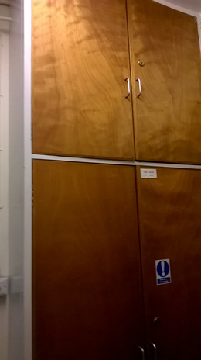
“Fire doors keep locked” signs to be fitted to top cupboard on north stairwell Oceanography building. NOT COMPLETE. FRCS to action

Two single doors leading out from ground floor lecture theatre south side. Lights fitted but unclear if these are emergency lighting units. FRCS to confirm
DSC should speak to Head of School to identify a deputy fire officer that occupies the building
“Fire door keep shut” signs to be fitted on doors 6/007 and 6/008
Additional smoke detectors are required in the following areas:

1m away from door 1/003 (north side)
1m away from doors 3/003 (north side)
1m away from door G/007 (south side)
Photocopier room 4/014
NOT COMPLETE. FRCS to action

FIRE RISK ASSESSMENT REVIEW
All changes to the building layout or the introduction of new processes need to be agreed and reviewed by the Safety Adviser. Fire risk assessments should be amended accordingly and the changes recorded below.
Review number | Date | Changes made | Signature
001 | November 2015 | Minor amendments following request to start reusing the upper penthouse floor | S. D. Dunkley
002 | May 2017 | Formal assessment | S. D. Dunkley

FIRE RISK ASSESSMENT MATHS BUILDING
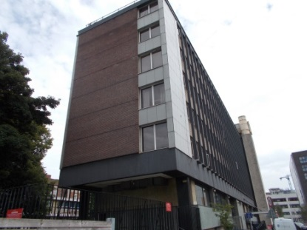
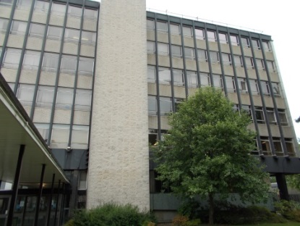
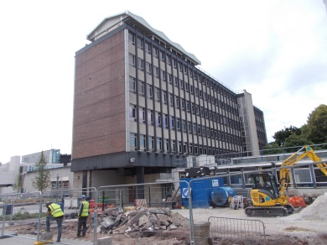
Maths building design and layout
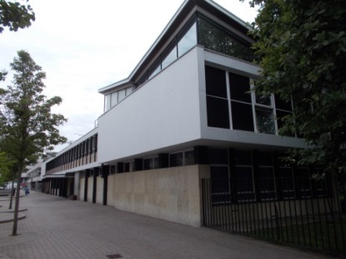
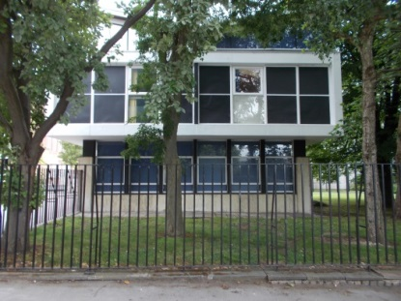
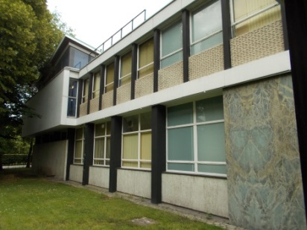
The Mathematics building is located on central campus adjacent to the Stevenson Institute and Student Guild buildings. The area is spilt into two main sections – a large tower and a smaller lower storey building. The smaller building used to be the Oceanography department building but this was subsequently taken over for use by Mathematics staff. Both buildings are now predominantly occupied by the Mathematics department staff however although the back of the lower level building, staff from Student Administration have taken over a small area where they store and issue student prospectuses. The plan is for this to be a short term arrangement until alternative premises can be found. The tower has 11 floors although there are 7 main areas (ground and 6 upper floors). The remaining areas are basement plant rooms and small mezzanine areas between floors. The floor area of the two buildings covers a space of approximately 55 x 40m.
NB – the grassy area in the above pictures have now been built on (a portacabin structure has been placed here and is being used by Student health (who have been moved from the building opposite).

Construction (internal and external)
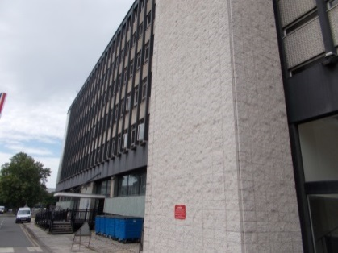
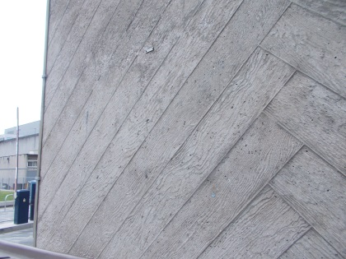
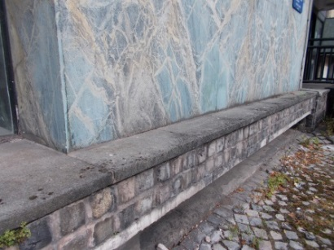
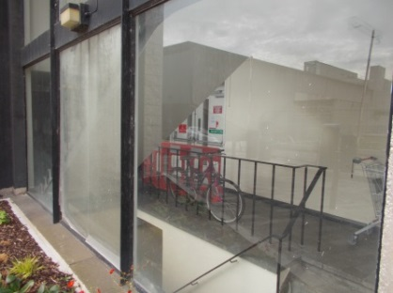
The main tower is constructed from a number of materials but is essentially a brick/metal frame building with concrete, stone and wood panelling fitted across various sections. The building has a significant amount of glazing on the two main sides of the tower. Both buildings have flat roof areas.
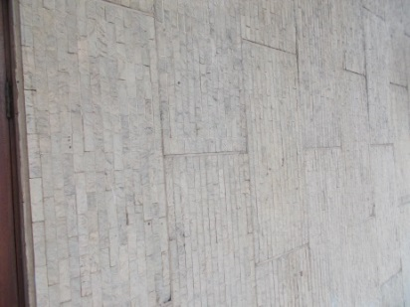
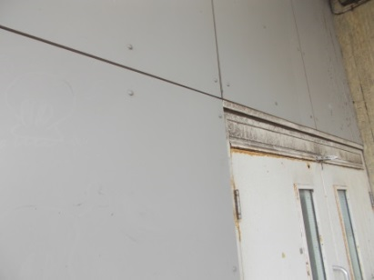
The external materials are visible inside the building in certain areas (e.g. stairwells) but use has also been made of wooden panels and plasterboard to create rooms. False ceilings are evident throughout the building.
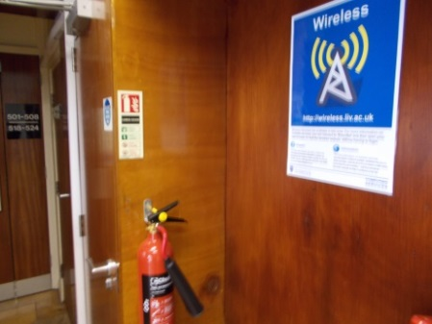
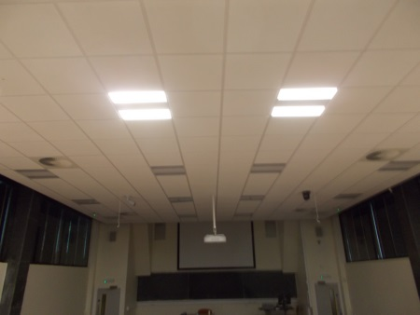

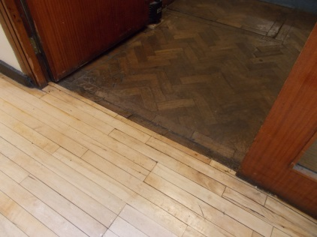
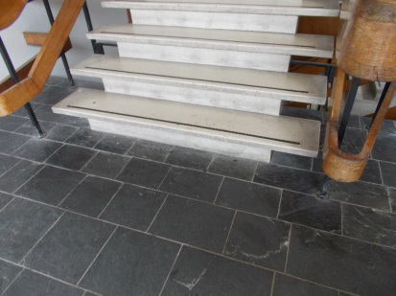
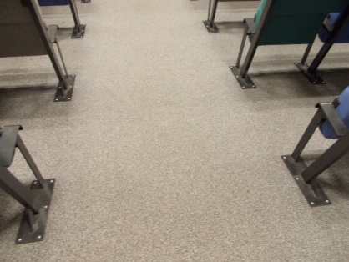
Flooring ranges from carpet in offices to stone, wood block, laminate and stone in other areas and circulation routes.

Occupants
It is estimated that a full building would house between 850 and 900 people. Over two thirds of these would be on ground and first floor levels (where the large teaching rooms and lectures theatres are located). Of this number only about 150 would be staff.
Hours of work tend to follow normal 9-5 Monday to Friday patterns although as is the case with university staff, some academics will work outside of these hours and on weekends. Number in the buildings at these times will be small.
The building is also used for summer schools so students and teachers from outside the University would use the building during normal hours.
Those especially at risk
All staff, students and non-University staff could be at risk if standard fire precautions are not adhered to. Although most of the rooms are offices and teaching areas, the fact that non-University people can use the building means that robust fire precautions are essential. As part of the fire management system, all staff would have been briefed on the general safety arrangements and on the means of escape in an emergency situation as part of their local safety induction. Annual fire refresher training is required for all users of the building (either by addressing the users following the fire evacuation exercise or by providing information/training at a later date). The University requires all areas to carry out fire evacuations at least once a year (normally in the first academic term). According to the fire precautions log book, the last time refresher training was delivered was March 2015. The DSC for the area needs to ensure that refresher training is delivered and recorded in the book.
The last time a fire drill was carried out was February 2017 (again this was not a successful evacuation and took over 10 minutes to complete). If not already done so, his needs to be raised with the Head of Mathematics who must take some positive action to ensure staff and students responds more quickly in future evacuations.
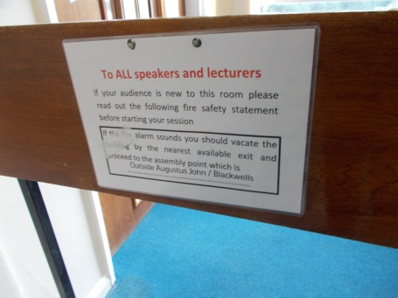
Some of the teaching areas are Orbit bookable. In these areas it is important that those leading session in these rooms remind the occupants of local arrangements. Signs have been displayed by the safety coordinator to remind users about this requirement.

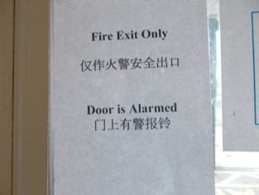
The safety coordinator has commented that a number of foreign students do not seem to appreciate or fully understand the arrangements. To help with this, signs in other languages have been displayed.

Visitors can ensure they are aware of the arrangements by reading the fire action notices located throughout the building. Users should be able to make themselves familiar with fire procedures, emergency contact numbers and the assembly point. It should be noted that there was conflicting information on some of the fire action notices (see below). The DSC should ensure that a consistent message is being given and that only one assembly point is listed.
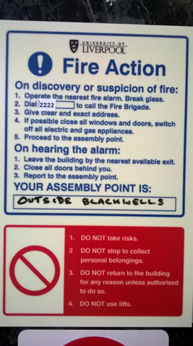
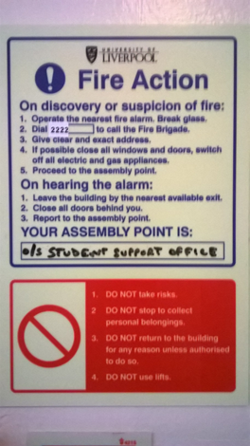

FRCS maintenance staff will access the building as and when repairs are required. As part of their FRCS safety induction, they are asked to familiarise themselves with building safety arrangements they occupy. Other non-university contractors will have been inducted by FRCS (if under their control) or by local staff (if under their control). A generic contractor risk assessment for departments is available if they bring in their own contractors to work on specific departmental equipment.
If disabled staff or students who work or study in this Department start to use the building and they make themselves known to relevant staff, the local Disability coordinator and/or Safety coordinator would be expected to complete a Personal Emergency Evacuation Plan for that individual.
The building is not used for sleeping purposes.
Previous fires/incidents
None.
Main activities in building
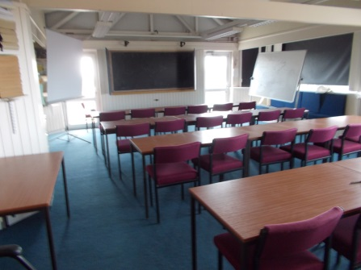
The two buildings are mainly used as staff offices and teaching areas. There are two large lecture theatres on the ground floor and other training rooms on upper floors
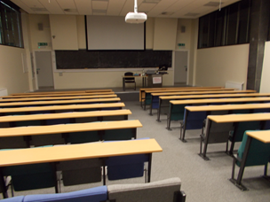
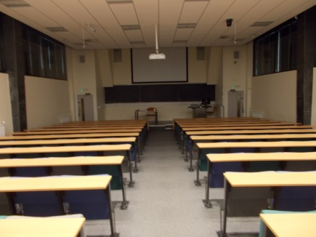
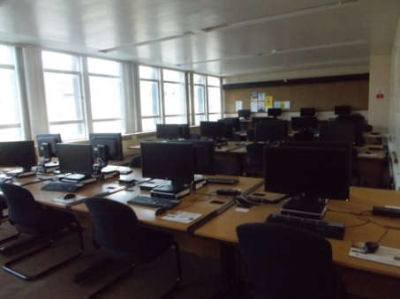
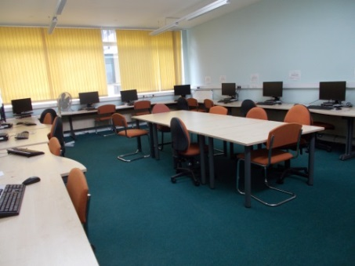
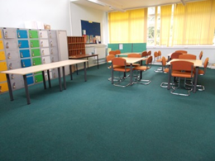
There are general student computer suite and study areas for students to use.
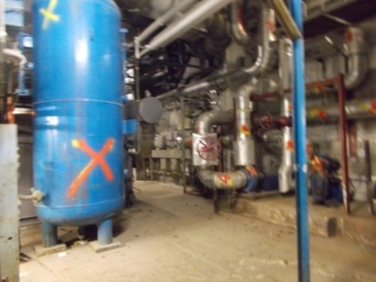
The basement is a restricted area and here there is an old plant room and other services areas.

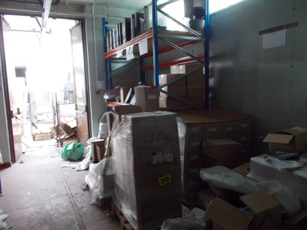
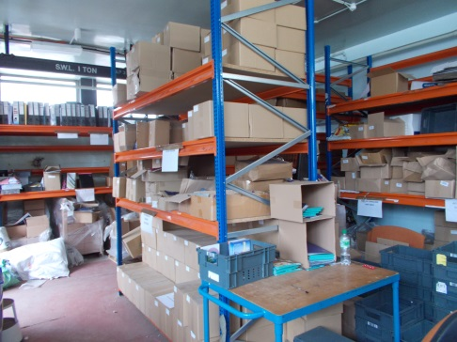

An area is currently being used to store and manage prospectuses. The area opens out into the back yard which is used for large deliveries into this space.
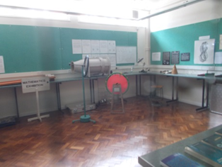
A small number of areas are set aside for demonstrations (e.g. used on open days).

Electrical sources of ignition
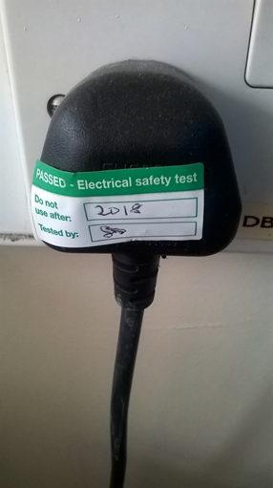
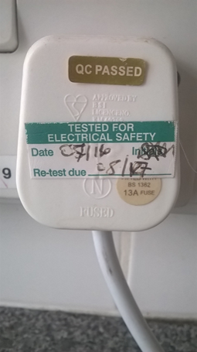
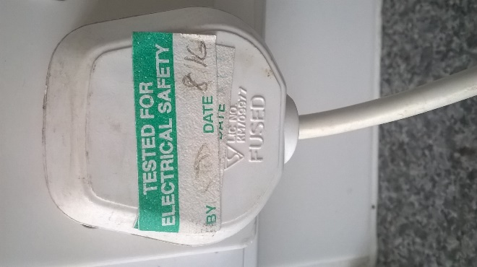

The main electrical installation is checked and maintained by FRCS who keeps the relevant test records. The safety coordinator for the Mathematic building is tasked with ensuring that PAT testing is carried out for all portable electrical appliances in accordance with the relevant University Safety Circular – “Electrical Checks”. There was evidence that a PAT testing regime was in place (tested in 2016).
Generally, cable management was good and there were no significant issues in terms of cables running across areas and therefore liable to damage. No cables were observed running under rugs or matting. No adaptor blocks were seen in use – University policy is that these should not be used and Safety coordinators are asked to remove these if they find any during inspections. No daisy changing of socket boards was observed.
NB – staff computer equipment and associated items like printers are tested every 5 years. In most cases, these are replaced before the need for PAT testing.
Equipment seen as part of the assessment was generally in good condition – no obvious damage was noted on equipment in use.
Any personal electrical equipment brought onto the premises is treated as University owned equipment and is PAT tested like other equipment.
Smoking
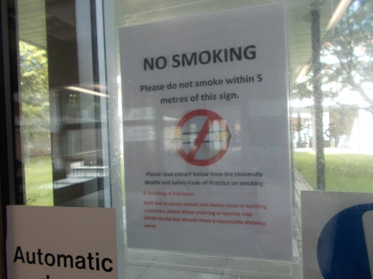
Since September 2012, the University has been a completely no smoking establishment. If staff or students have to smoke, they are asked to do this well away from the main entrances so that others do not have to walk through smoke when entering the building. Signs are displayed indicating this.
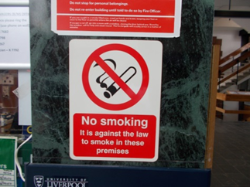
At the time of the assessment, “no smoking” signs were displayed at the main entrances to each block. Additional signs were also seen at various sites around the building.

At the time of the assessment, there was no evidence that people were smoking inside the building.
NB – the code of practice on smoking has recently been updated to include a ban on the use of e-cigarettes in buildings. Safety coordinators have been asked to circulate this information to all staff and students.

Arson
Arson incidents at the University are rare. There have been no recorded arson attempts in or around the building perimeter. One obvious arson target is external waste bins. However, there have been no recorded instances of the bins used by the building being set on fire.
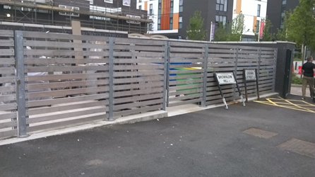
There used to be two main storage areas for bins both near the perimeter of the building. However, since the last assessment a new dedicated bin store set well away from the building has been built.

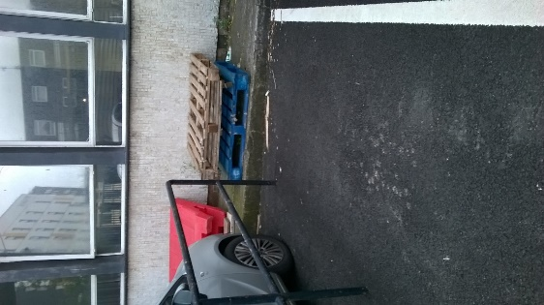
Generally, the perimeter around the two blocks was kept in good order although there were a couple of wooden pallets left near the building opposite the bin store.

NB – following discussions with the Universities insurers, standards have now been set for the placement of skips and the same principles will be adapted and used for external waste bins. This follows on from a recent incident where a skip being used by the Guild refurbishment contractors was overflowing and too close to the building. Although not a major consideration for blocks A and B, coordinators should be aware of the standard for future reference.
Further information can be found on the university A-Z webpages.

Portable heaters and heating installations
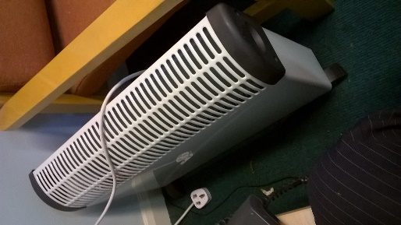
The main heating system is checked and maintained by FRCS. Heating in the building did not seem to be a major issue however there were one or two areas that had portable heaters available for use. The only portable heaters seen in use were the convector type – this is in accordance with University guidance which only recommends the use of convector or oil filled heaters. NB - University Policy states that radiant bar heaters or LPG heaters are not permitted.

Cooking facilities
Cooking facilities are limited to small kitchenettes and tea rooms. Some staff have microwaves and kettles in their offices. There are no electric or gas cookers in the building. In particular:
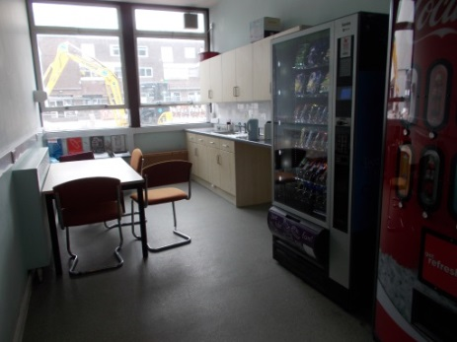
Ground floor tea room – this has a kettle and microwave and a few vending machines.

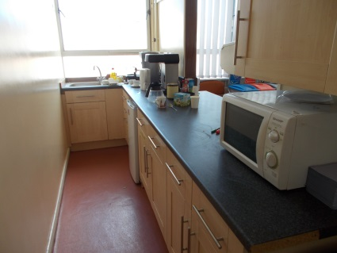
Small kitchenette third floor – includes a kettle, coffee maker, microwave and fridge

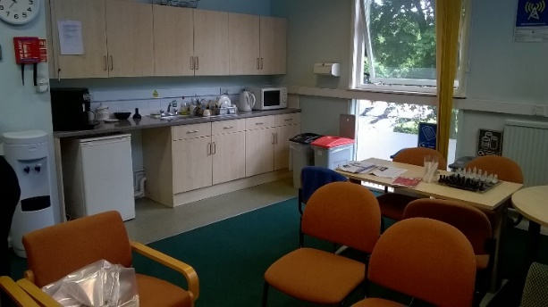
First floor kitchenette/seating area (old Oceanography building)

All were fitted with heat detection and fire blankets.
Lightning protection
FRCS are responsible for managing, maintaining and repairing the lightning protection systems across the University. A dedicated funding stream exists for statutory compliance from which monies for lightning protection can be utilised. Records are held by FRCS and in future will be held on the SharePoint portal.
FRCS are currently reviewing the lightning protection arrangements across site. At present, the aim is to bring up to an acceptable standard all existing lightning protection systems and then review the remaining buildings in the campus to see if additional protection is required on those buildings not currency protected. Lightning protection systems were visible following a walk around the perimeter of the building although it wasn’t clear from the test label when the system was last checked. However, when the last lightning protection risk assessment was completed, lightning protection was not considered necessary for this building.
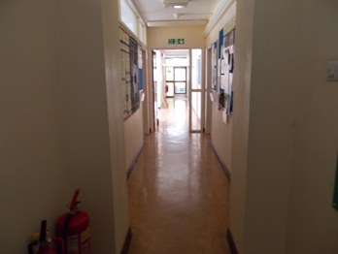
Housekeeping
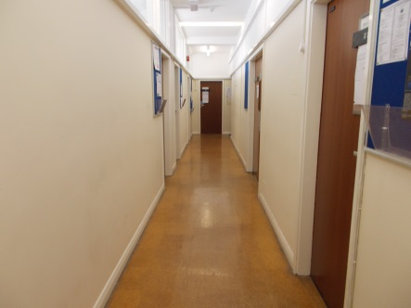
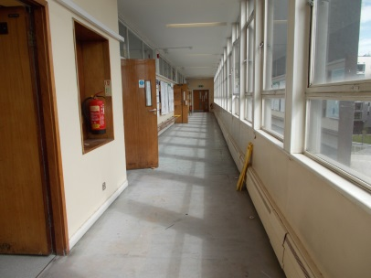
At the time of the assessment the housekeeping standards in most areas were very good. Although not every room was checked, areas seen were kept clear and in good order, particularly corridors and stairwells.
Boards have been left in the north end staircase, ground floor. These need to be removed.
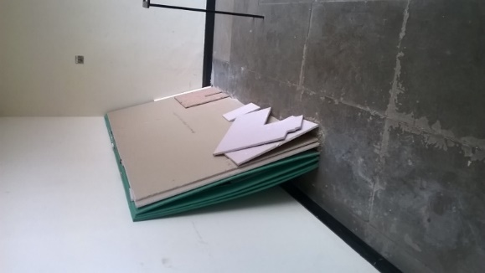

Hazards introduced by outside contractors
Most contractor work is controlled via FRCS. They are responsible for ensuring they have received the University contractor induction and that any assessments and safe working procedures are vetted and authorised. As part of the control measures, contractors are expected to use the standard University signing in book at the main entrance and preferably notify their presence on site to a member of staff.
Any outside companies brought in by the departments to carry out work on specific equipment are the responsibility of the local staff. The university has prepared a generic risk assessment on contractor control which staff in the area are asked to use.
If any hot work has to take place, this will be done under strict controls using the University hot work permit to work system.
Any work that could accidentally set of the fire alarms needs to be managed in accordance with the University Fire alarm isolation policy.
Dangerous/flammable substances
None.
Other potential fire hazards
None.
Means of escape from fire
In most areas, occupants would have an alternative means of escape although there are particular areas where this would not be the case. Specific means of escape from each floor is as follows:
Basement – old plant room now not in use however there are two main staircases down to this area should maintenance staff have to visit – no issues.
Ground – apart from the main entrance there are a further 5 routes leading to outside. Those in the two lecture theatres have alternative means of escape via doors near the front of the theatre. Users of the rooms on the link between the tower and the old Oceanography building also have two means of escape either end of the link corridor.
Staff who deal with the prospectuses also have two means of escape, via a stairwell and doors to the outside.
First floor – on the first floor, the two buildings lose the link corridor and so are separate buildings. In the old Oceanography building the ends of the building only has escape in one direction. Extra detection in the rooms/corridor has been fitted to compensate for the travel distances (slightly excessive). In the tower, one end of the building has escape in one direction. Travel distances are acceptable plus detection has been fitted in all rooms and corridor in this area. The other remaining area has escape in two directions.
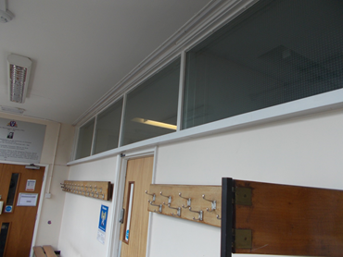
Second floor – most of the offices in the tower have escape in two directions. One end of the building has escape in one direction. As travel distances are close to 18m the space outside the main lecture theatre has been fitted with fire resistant glazing suggested that this route is now protected (a previous assessment in 2003 suggested this as an option for these spaces).
Third floor – as above (2 means of escape for most rooms – protected area for dead end corridor)
Fourth floor – as above.
Fifth floor – as above.
Sixth floor – the sixth floor is only accessible from one stairwell and as a result has a single means of escape in one direction. A fire in this stairwell would normally creating escape difficulties. To address this, a partition has been built on the fifth floor part of the stairwell that now allows users to enter the stairwell and to either use this stairwell or move along the corridor to the stairwell at the opposite end of the building.
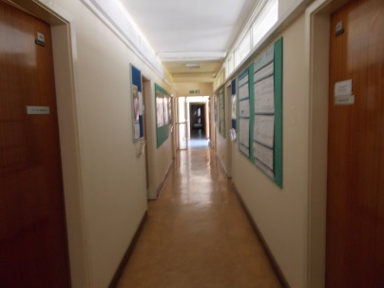
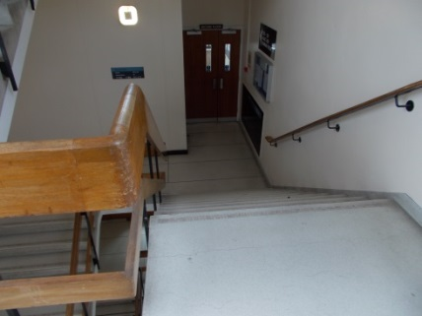
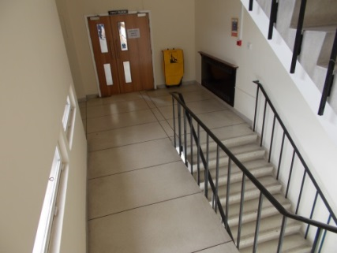
General escape issues

Generally, the escape routes, (i.e. corridors and stairwells) were clear of excessive materials and obstructions.
In accordance with the Fire Service guidance, no waste or recycling bins were being stored on stairwells or dead end corridors.

Efforts were continuing to reduce the amount of combustible materials on stairwells, particularly with the use of noticeboards (see below).
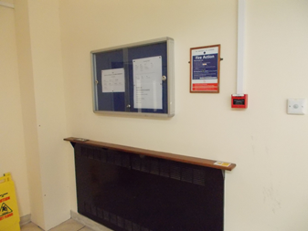
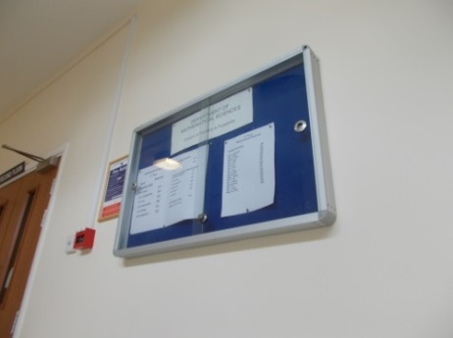

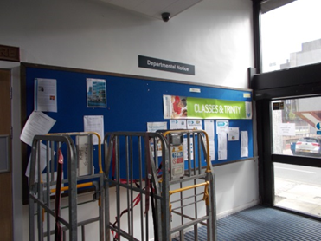
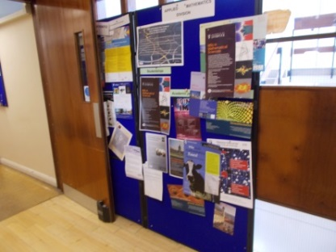

There was still some work to do in other areas particularly the foyer and dead end corridors. Here noticeboards in use were still of the open faced type. As monies become available these should be upgraded to a fire resistant version.
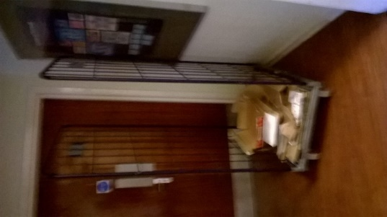
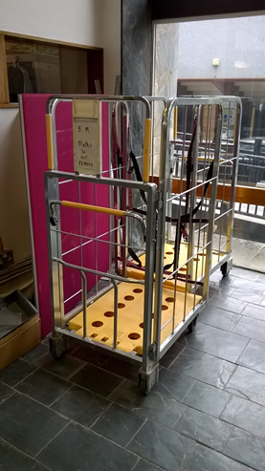
Cages for cardboard were still being stored in the main foyer area. As this is likely to be the main escape route, combustibles in this area should be kept to a minimum. Alternative storage areas for cages containing cardboard should be found. Another cage with cardboard in was found in the stairwell outside the prospectus store area. Those working in this area must be told that cages are not allowed to be stored on the stairwells.

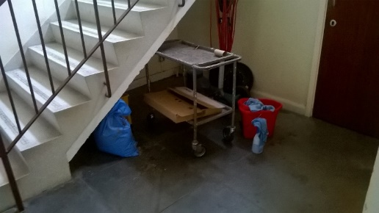
In the old Oceanography building, items were being stored under one of the stairwells. Although most was not combustible, this area should not be seen as a storage place. Escape stairwells should be seen as sterile areas and be kept clear.
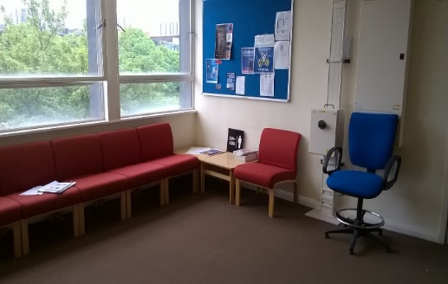
In the main tower, there are parts of the building that have short dead end corridors. These open into small communal spaces (see opposite for example). As a single means of escape, the route should be free from combustibles. Whilst the furniture is likely to offer some resistance in a fire, noticeboards should be class 0 fire resistant and furniture should offer a level of fire resistance.
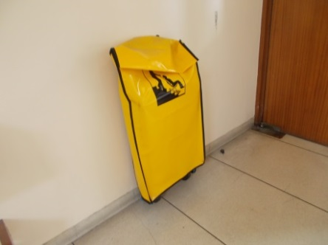
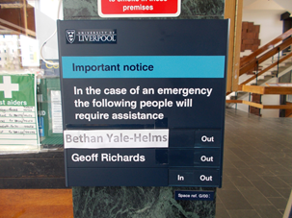

Arrangements are in place to assist anybody with a restrictive mobility issue. Evac chairs are located in the two main stairwells of the tower and a signing in board in in use in the main foyer. A team of people have been trained in the chairs use. The DSC is asked to keep a log of those trained and to ensure that an adequate number of people are trained to cover holidays, sickness, etc. The only task that needs to be completed is to fit directional chair signs on the floors where no chair is located (i.e. on the second and fourth). The signs should direct people up to the nearest chair.
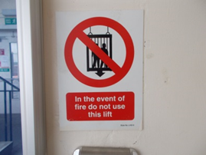
Lifts are not designed to be used in the event of a fire and all are suitably signed.

A number of small office doors with escape in two directions were labelled as fire doors. This does not have to be the case. The following doors could if staff request have the fire signs and door closers removed:
2/004, 2/005, 2/009, 2/018, 2/007, 2/021, 2/022
Noise activated détentes need to be fitted to the following doors:
4/035 and G/021 (old Oceanography building)
Compartmentation and measures to limit fire spread and development
FRCS has carried out a comprehensive fire compartmentation survey and a list of high priority buildings have been identified for further assessment remedial work. Any items identified in the Maths buildings will be address as part of this programme.
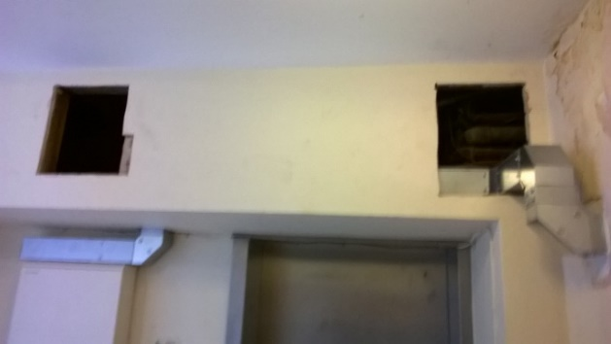
During the assessment, new electrical switchgear had been installed on the north stairwell and some holes were noted. FRCS have confirmed that this equipment will be boxed in with 1 hour fire protection material and locked off.

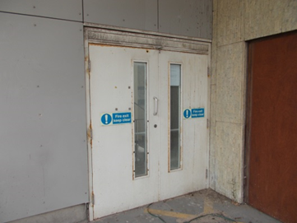
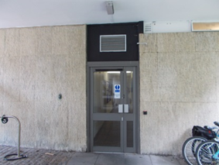
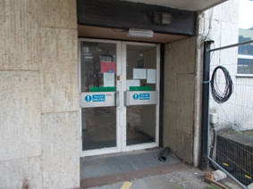
Emergency escape lighting
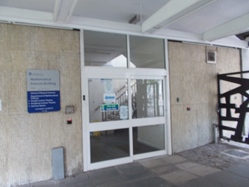

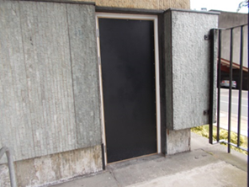
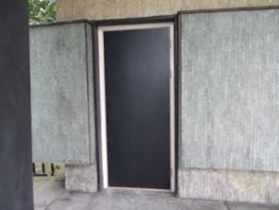
The vast majority of areas were fitted with adequate emergency lighting. This was both on internal stairwells and corridors and on external doors. The only areas were additional lighting was considered necessary was above the doors below (i.e. two single doors out of ground floor lecture theatre (South side) which appeared only to have standard light fittings in the vicinity):

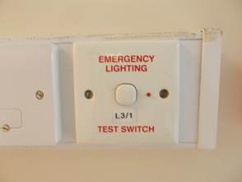
Emergency light test switches are located at various points around the buildings. The DSC is asked to test these at the same time as the weekly fire alarm tests (if there is a light test switch near to the red call point then it should be activated).
Fire safety signs and notices
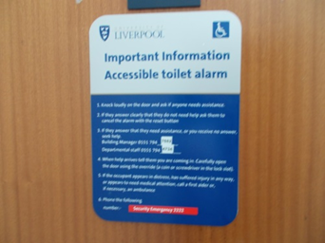
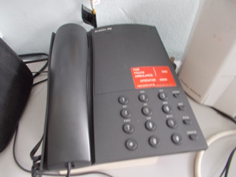
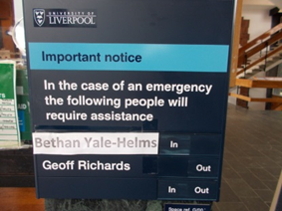
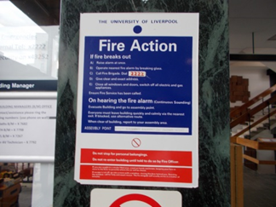
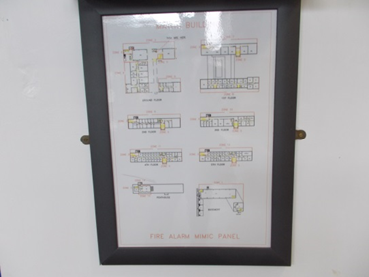
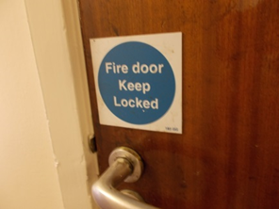
Generally, the standards of signage were good. The panel had a clear mimic diagram to indicate the relevant zones, directional signage was fitted, fire action notices were located near call points and clear mandatory signage was in place for fire doors, etc. Signage for final exit door operation was also fitted and clear. There was evidence of emergency number stickers on telephones and accessible toilets had the standard emergency contact number signs displayed.
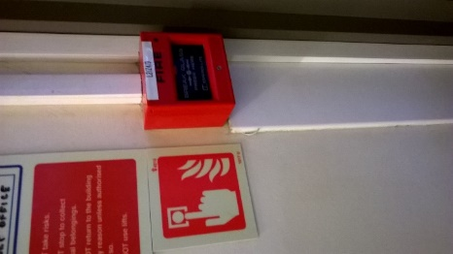
Call point signs have now been fitted near all call points.

The following additional signage is required:
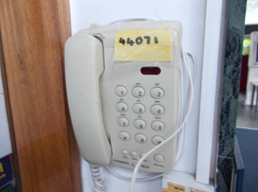
The DSC should check that unless a telephone has a direct emergency number button, all telephones should display the red emergency number sticker.

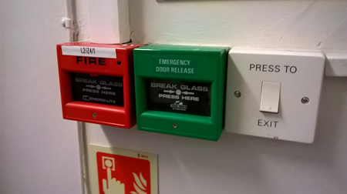
Larger emergency green break glass sings need to be fitted by all emergency door release boxes.

Fit “Fire door keep shut” signs on doors 6/007 and 6/008
Fit “fire door keep shut” sign on door LG004
Means of detecting and giving warning in case of fire
University policy

Automatic fire detection in non-residential buildings is only required for life safety to L4 “enhanced” standard i.e. stairwells, corridors areas of exceptionally high fire risk, or to compensate for a deficiency in some other aspect – unless property protection by AFD is specified for special reasons.

Detection is fitted along corridors, in stairwells and in areas where because of the design of the building (dead end corridors) additional detection is required.

Additional smoke detectors are required in the following areas:

1m away from door 1/003 (north side)
1m away from doors 3/003 (north side)
1m away from door G/007 (south side)

Photocopier room 4/014

There are an adequate number of call points throughout the building (on storey and final exit points). No person would have to travel more than 45m to reach a call point.

There appeared to be an adequate number of sounders in the two buildings. The DSC has not on previous visits or correspondence raised the issue of people not being able to hear the alarm.

Manual fire extinguishing appliances
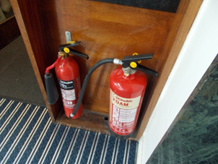
There were an adequate number of fire extinguishers in the two blocks. Normally found in pairs but occasionally as a single unit, they were foam and CO2. It was not considered necessary to provide further extinguishers in the area.
Extinguishers were last tested in January 2017.

NB – if the alarms are sounded, the University policy is not to try and fight a fire but to leave the building immediately. Very few staff have received formal extinguisher training but the policy does allow for people to use the equipment if they have been instructed in their use and the fire is small and manageable.
NB – following discussions with the Fire Service, front line staff (building managers and security staff) are currently undergoing fire extinguisher training.
There are no hose reels in the building.
Access and other issues relating to the emergency services
Access to the Maths tower is via Peach Street. The Fire Service can park directly outside this building. Access to the old Oceanography building would be via Student walk. Although there are bollards at either end of this walk, Security would always be on hand to remove these prior to the Fire Service arrival.
There are no dry risers in the buildings.
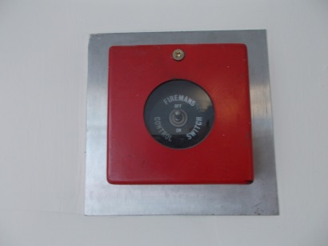
The Fire Service should note that the lift in the North stairwell is fitted with a fireman’s control switch.

Automatic fire extinguishing systems
None.
Procedures and Arrangements
The University of Liverpool’s Code of Practice on Fire Safety asks for:
Weekly alarm tests
Annual fire drill
Annual fire refresher training
The local safety coordinator for the buildings is nominated as the Fire Officer. The deputy is a person located in another building. Ideally this should be someone in the building who can manage and react to day to day issues. The building operates a system of fire wardens to assist in prompt evacuation. The building manager assists in the evacuation drills and weekly alarm testing.
Staff are asked to implement the following monitoring programme:
Weekly | Test the fire alarm system using a different call point in rotation. Log the check in the fire precaution log book.
 | If emergency lighting is testable locally, also activate the emergency lights in the same area as the call point and check that the luminaires in the area work.
 | As part to the cycle of weekly testing, verify the operation of the “green boxes” e.g. maglock-controlled doors they will release door if tested with the plastic key.
Six-monthly | As part of six-monthly safety inspection and monitoring check that all fire doors close properly into their frames.
 | Check that all fire exits open easily.
 | Check that no fire exits are obstructed.
 | Check that all flammables are kept in fire resistant storage when not in use.
 | Check general housekeeping, storage, waste disposal.
 | Monitor that risk assessment (including fire risk assessment) is kept up to date.
Daily | If there are obvious faults relating to fire safety deal with them or report them immediately to the response desk – do not wait for the next weekly or six-monthly check.

The fire alarm signal goes directly to Security control and when carrying out the weekly tests staff are asked to contact Security to ensure the signal was received.
Training and drills
The university requires all areas to carry out an annual fire evacuation test (normally in the first term) and annual fire refresher training. Both are to be recorded in the fire precautions log book.
Testing and maintenance
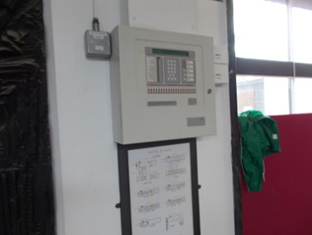
Testing of the fire alarm system and emergency lighting is carried out via FRCS. Records are kept in the fire log book at the entrance to the mathematics tower.

FRCS testing is carried out in accordance with the following schedule:
Emergency escape lighting | Three monthly except in residences and licensed premises or where the failure rate is more than 1% monthly (unless testable by occupant) in accordance with BS 5266-8.
 | Annual full discharge test in accordance with BS 5266-8.
Fire alarm system | 6 monthly in accordance with BS5839, or annually for non-residential non-licensed buildings where the failure rate per item on FM checks is less than 1%.
Individual detectors | Annually.
Firefighting equipment | Annually.  Fire extinguishers in accordance with BS5306-3.  Hose reels and fire hydrants in accordance with 5306-1.
Dry risers | Annually in accordance with BS 5306-1.
Fire dampers | Every 2 years or more if conditions are adverse in accordance with BS9999
Magnetic locks | Annually: verify that the linkage to the fire alarm is working.
Records
All records of maintenance, fire drills, fire training and fire service visits are kept in the fire precautions book in the brown box in the main foyer area.
Overall fire risk assessment – LOW

ACTION PLAN
Action | Responsible person | Priority | Completed date
Fit “fire door keep shut” sign on door LG004 | FRCS | Medium
Larger emergency green break glass sings need to be fitted by all emergency door release boxes | FRCS | Medium
Noise activated détentes need to be fitted to the following doors:  4/035 and G/021 (old Oceanography building) | FRCS | High
Fit directional chair signs on the floors where no chair is located (i.e. on the second and fourth). The signs should direct people up to the nearest chair. | FRCS | Medium
In the main tower, there are parts of the building that have short dead end corridors. These open into small communal spaces. As a single means of escape, the route should be free from combustibles. Whilst the furniture is likely to offer some resistance in a fire, noticeboards should be class 0 fire resistant and furniture should offer a level of fire resistance. | Head of Dept./DSC | High
Storing combustible items under stairwells is not acceptable. Combustible items in the old Oceanography building stairwell must be removed | FRCS/Dept. | High
Cages for cardboard were still being stored in the main foyer area. As this is likely to be the main escape route, combustibles in this area should be kept to a minimum. Alternative storage areas for cages containing cardboard should be found. Another cage with cardboard in was found in the stairwell outside the prospectus store area. Those working in this area must be told that cages are not allowed to be stored on the stairwells. | Head of Dept./DSC/prospectus area | High
Boards have been left in the north end staircase, ground floor. These need to be removed. | FRCS | High
Remove wooden pallets left near the building opposite the bin store. | FRCS | Low
There was conflicting information on some of the fire action notices. The DSC should ensure that a consistent message is being given and that only one assembly point is listed. | Head of Dept./DSC | High

