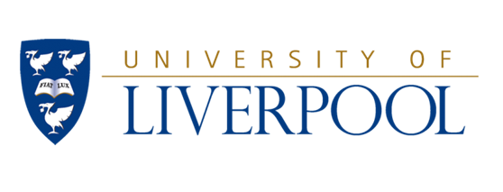

**The Liverpool Royal Infirmary Nurses’ Training School**

**Nurses’ League Travel Award (up to £1,500)**

**Guidance Notes**

**Who can apply for the award?**

The award can be made to assist a registered nurse to engage in work to advance his/her clinical practice, the applicant must have been a Registered Nurse in Merseyside and Cheshire for not less than three years. You are not permitted to apply for the award more than once.

**What can the award be used for?**

The award may be used to support a visit to observe or participate in nursing in any part of the world. However, applicants are responsible for making arrangements for access to their destination site and for securing leave of absence from their employer.

If successful, 75% of the award will be paid in September/October 2016 with the remaining 25% to be paid on submission of a report about the visit to the selection committee for publication in the Nurses League Journal. The visit must be taken and the report presented or submitted by the beginning of May 2017.

**How do I apply?**

You must complete an application form justifying your request by demonstrating the implications and potential benefits to patient care of the selected experience to be undertaken.

To support your application you will need to obtain 2 references, one of which must be from an appropriate nursing manager who is able to support your leave to travel. References must be attached to your application.

Once complete, **return 1 copy of the completed form and references by 12 noon on Tuesday 31st May 2016 to**: *Alan Kelly, University of Liverpool, School of Health Sciences, Directorate of Nursing, Thompson Yates Building, Brownlow Hill, Liverpool L69 3GB, or via e-mail to* [*ajkelly@liverpool.ac.uk*](mailto:ajkelly@liverpool.ac.uk)

Following your application representatives from education and the sponsoring body will make a decision on the award and Interviews will be held mid July 2016 at the University of Liverpool.