ELEC135 Internet Skills
Assignment 2
This work must be submitted by:
Monday 6th November, 2006

You have been asked by a company to produce a web page. The marketing department have produced the text (text.txt) and the graphic designers have produced the various graphics and how they want the page to look.

They want you to write the HTML files which will produce three different page layouts so that they can decide on which one to adopt.

PAGE A
Page A is to look like this:

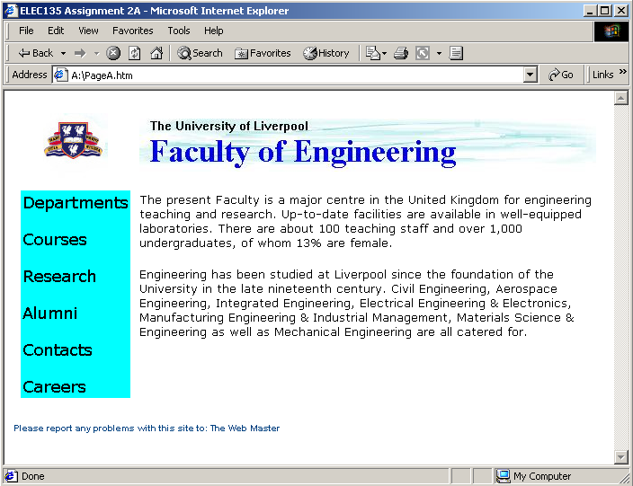

PAGE B
Page B is to look like this:

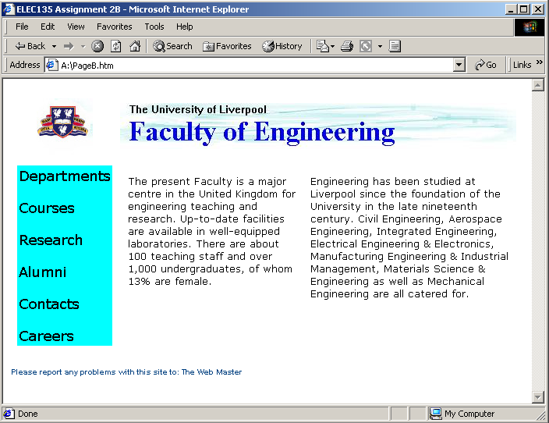

PAGE C
Page C is to look like this:

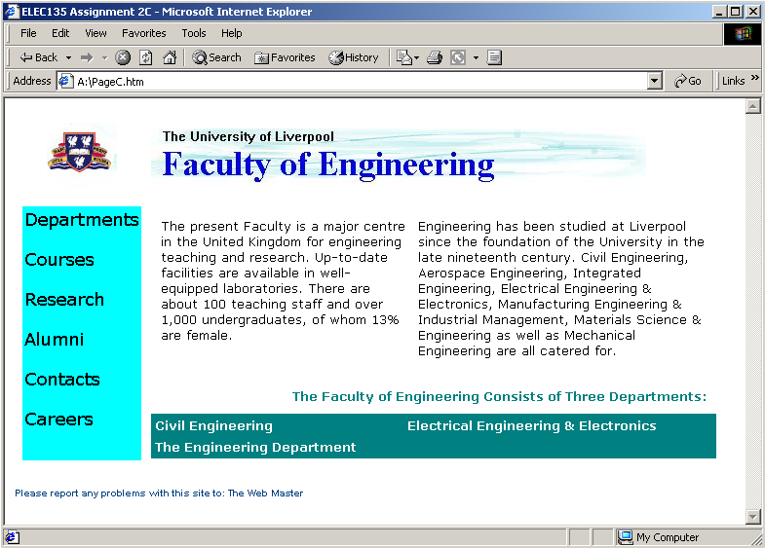

Produce three separate HTML files. PageA.htm, PageB.htm and PageC.htm.

You can see how your finished pages should look and obtain the required graphics and text from the Intranet site:

http://pcwww.liv.ac.uk/eee/elec135/

The bulk of the text is held in a file called “text.txt” (so you do not need to type it in) and the graphics are presented in both GIF & JPEG formats.

TIP: Use Tables !

KEEP ALL FILES ON YOUR M: DRIVE AND MAKE A COPY ON FLOPPY DISK TO BE SUBMITED.

You must not use any web authoring tools such as Word, FrontPage, Hot Metal etc.

Write the HTML code to produce the pages for display in Internet Explorer 6 (the default browser on the University’s systems).

Ensure all HTML tags and attributes are in upper case. For example:
<HTML>, <TABLE WIDTH=”800”>
Not:
<html>, <table width=”800”>

The pages should be produced using a standard text editor such as “The Programmer’s File Editor.” The files should be saved as plain text with a file extension of “.htm” or “.html”

Marks will be awarded for efficient and correct use of HTML and how closely your page resembles the desired output.

Remember:

KEEP YOUR OWN COPY OF YOUR WORK ON YOUR M: DRIVE

Make a copy of your HTML files (and any graphics files) on the floppy disk provided. By keeping a copy of your work on your M: drive you can resubmit if the floppy disk becomes lost or corrupt. Print out each of your pages and the HTML source.

When you have completed the assignment:

CLEARLY LABEL THE FLOPPY DISK AND EVERY PAGE “ELEC135 ASSIGNMENT 2” AND INCLUDE YOUR NAME, DATE AND STUDENT I.D. NUMBER. USE AN ENVELOPE PROVIDED BY THE OFFICE TO KEEP YOUR PRINT OUTS AND DISK TOGETHER.

Submit the floppy disk and print outs on or before

Monday 6th November, 2006

Make sure your work is your own. DO NOT COPY OTHER PEOPLES WORK AND DO NOT LET OTHERS COPY YOUR WORK.

Late work will be subject to penalty as described in the Faculty of Engineering rules and regulations.

