Student Guidelines on Mitigating Circumstances in Relation to Performance in Assessments and Examinations

Please note that this document is for guidance purposes only and the University’s formal policy, arrangements and procedures are contained in the document ‘Policy on Mitigating Circumstances in Relation to Performance in Assessments and Examinations’; therefore, the Policy document takes precedence over these Guidelines

WHAT ARE MITIGATING CIRCUMSTANCES?

Mitigating circumstances are circumstances beyond a student’s control which have affected their performance in assessments (whether an examination, essay, practical or other form of assessment). They may include:

- Illness affecting the student.
- Bereavement.
- Serious illness affecting a close family member.
- Unforeseeable or unpreventable events.

The following will not be regarded as mitigating circumstances:

- Failure to attend an examination due to misreading the examination timetable.
- Events such as holidays and weddings.
- Inadequate planning and time management.
- Having more than one examination on the same day.
- Examination clashes arising from incorrect registration by the student, i.e. examinations scheduled to take place at the same time. (Students are responsible for reporting any examination clashes which occur in their examination timetable to their departmental Examinations Officer and the Student Administration and Support Division so that alternative arrangements can be made.)
- Pressures from paid employment for full-time students. (Students are reminded that the University recommends that they should be employed for no more than 15 hours per week).
- Any event that could reasonably have been expected or anticipated, such as sporting events.

1. REPORTING MITIGATING CIRCUMSTANCES

1.1 Contact your personal or academic tutor

It is your responsibility to report any illness or other mitigating circumstances. Before proceeding with the Mitigating Circumstances procedure it is very important that you contact your personal or academic tutor for advice; this is to ensure that you follow the procedure correctly, and provide the information required.

1.2 Contact your department

Mitigating circumstances are only considered at a few specific times of the year. In the case of coursework (e.g. essays) where you may have experienced mitigating circumstances around the time of the deadline, you should contact your department to discuss the possibility of an extension to the deadline. This will only be granted on the basis of medical grounds or other exceptional circumstances and requires the permission of the Head of Department (or his/her nominee). A valid Doctor’s certificate will be required to verify illness; self-certification is not adequate.

See below for details of the Mitigating Circumstances Process:

THE MITIGATING CIRCUMSTANCES PROCESS

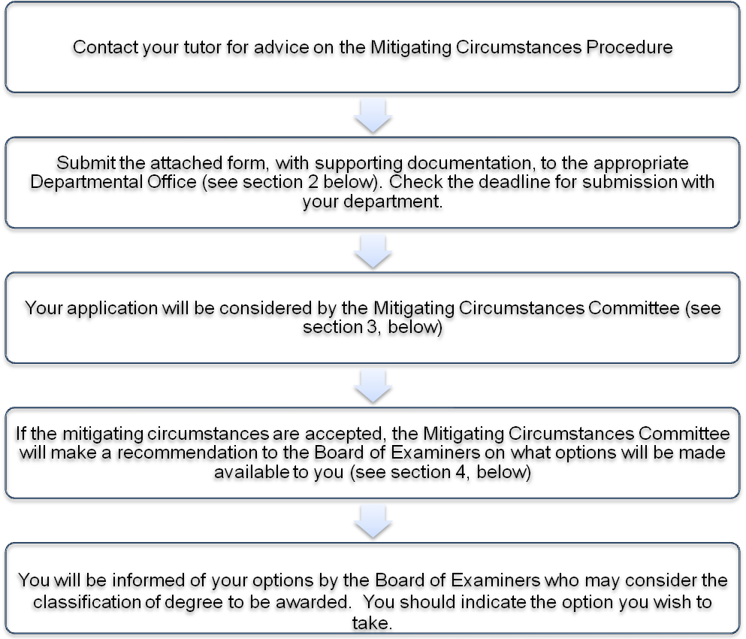

2. COMPLETING AND SUBMITTING THE MITIGATING CIRCUMSTANCES FORM

2.1 Complete the mitigating circumstances form

Any meeting with your personal or academic tutor is only for advice. Following this meeting, you should complete the official form attached to this document and submit it, with supporting evidence, e.g. a medical certificate, to your personal tutor or the Head of the Department/School in which you are registered (in some Departments this might be the Assessment Officer or Board of Examiners). In the case of Combined Honours students, the form should be submitted to the Combined Honours Office; in the case of Joint Honours students, it should be submitted to the Head of Department/School in which you are registered via the Department/School Office. Your case cannot be submitted unless you submit a completed mitigating circumstances form with supporting information.

2.2 Submit the mitigating circumstances form together with supporting evidence

The mitigating circumstances form and supporting evidence must be submitted as soon as possible and normally within 5 days after the events under consideration occur.

While we wish to help you in any way possible, we can only make an accurate decision if we are informed of your circumstances in a full and timely manner. A claim should not be delayed, nor can evidence relating to it be delayed, on the grounds of sensitive personal, family or cultural reasons.

Other than in exceptional circumstances (see section 8 below), it will not be possible for mitigating circumstances to be taken into account after the Board of Examiners meets to discuss the results. You may not appeal against the decision of the Board of Examiners if you have failed to report mitigating circumstances that may have affected the Board’s final decision.

2.3 What supporting evidence is needed?

Supporting evidence must be independent documentary evidence, such as medical certificates, and these must be provided in all cases to verify mitigating circumstances. If the original documentation is provided in a language other than English then independent translation will be sought which may delay the decision making.

Please note that claims will only be considered if they are submitted on the correct form with supporting evidence. Please be assured that all cases will be treated in the strictest confidence.

3. HOW ARE CASES CONSIDERED?

3.1 The Mitigating Circumstances Committee and the Board of Examiners

Once you have submitted your mitigating circumstances claim form and supporting evidence, your case will be considered by the Department’s Mitigating Circumstances Committee before the main Board of Examiners’ meeting.

The Mitigating Circumstances Committee is made up of departmental teaching staff and representatives from the Board of Examiners.

The Board of Examiners is a body made up of the members of teaching staff of the University for your programme of study, teaching staff of other programmes and external examiners. This body considers the ranges of marks for programmes of study and also special cases.

3.2 The Mitigating Circumstances Committee meeting

The Mitigating Circumstances Committee meets in advance of the Board of Examiners and will consider each individual case and seek advice from relevant staff, e.g. academic and personal tutors, particularly when a claim relates to modules taken outside the ‘home’ department, before making a recommendation to the Board of Examiners on whether it considers the mitigating circumstances to be valid. You will not attend the meeting.

The Mitigating Circumstances Committee will take into account the following when considering the claim:

- The seriousness of the circumstances, including the length of time they lasted.
- The documentary evidence provided.
- The amount of work that was affected by the circumstances.
- Whether the mark achieved under the circumstances was inconsistent with those achieved in periods of study unaffected by mitigating circumstances.

The Mitigating Circumstances Committee will apply academic judgement in formulating its recommendations to the Board of Examiners and will always seek to act in the best interests of you, the student. The decisions of the Mitigating Circumstances Committee are not subject to appeal.

If the Mitigating Circumstances Committee decides that your claim of mitigating circumstances is not valid, it will reject it and not make any recommendation to the Board of Examiners. It is therefore important that the Mitigating Circumstances Committee has access to full, frank and fully documented evidence to support your claim.

4. IF MY CASE IS ACCEPTED, WHAT ARE MY OPTIONS?

4.1 After the Board of Examiners

You will be informed of the outcome of your claim after the meeting of the Board of Examiners.

If it is found that mitigating circumstances have affected a student, the Mitigating Circumstances Committee and the Board of Examiners can make recommendations/awards on degree classifications (e.g. First, 2:1 etc). However, the Committee and the Board cannot change individual assessment/module marks; these can only be increased if the examination/assessment is re-taken but you should be aware that this could also lead to a lower mark being awarded (see section 6, below). The recommendations that can be made will depend on your stage of study and the type of assessment affected. If you are given a choice to let a mark stand or to retake an assessment/examination, you will be asked to indicate your choice at this point. You should check carefully below to find the option that applies to you.

4.2 Undergraduate programmes (including clinical programmes), non-final year (e.g 1st and 2nd Year BA Hons; 1st, 2nd, 3rd Year Integrated Masters/ BA Hons with a Year Abroad or Year in Industry; 1st, 2nd, 3rd, 4th Year 5 Year Integrated Masters)

a) Progression to the next year of study

If you have failed or missed an examination/assessment due to mitigating circumstances, and this would prevent you from progressing to the next year of your programme, the Mitigating Circumstances Committee may permit you to re-take the examination/assessment as though it were a first, and therefore uncapped, attempt (see section 6, below).

b) Assessment marks that contribute to your final degree classification

If, in any year of study in which the marks contribute to the final degree classification (except the final year), you have failed or missed an individual examination or assessment but have passed the module as a whole or the mark(s) achieved in one or more of your assessment(s) was/were affected by the mitigating circumstances, the Board of Examiners may permit you to:

either: re-take the relevant examination(s)/assessment(s) with the possibility of improving the mark (see section 6 , below);

or: keep the original mark but the Board of Examiners will take account of the fact that the performance represented by the mark was affected by mitigating circumstances when the degree classification is determined at the end of the final year.

c) Mitigating circumstances that affect a re-sit examination or assessment

If mitigating circumstances have affected a re-sit examination or assessment, the Mitigating Circumstances Committee may recommend that you should be allowed to re-take the examination/assessment again. This may be effected either by allowing you to ‘carry’ the failed credit (normally no more than 15 credits) into the next year of study or to repeat the year. Arrangements to carry failed credit require permission from the Pro-Vice Chancellor for Learning and Teaching on behalf of Academic Committee and may only be granted on discretion to students progressing from year 0 to year 1 and year 1 to year 2 of an undergraduate programme. This will only be allowed in the case of students who have a strong academic record and have provided evidence of mitigating circumstances or other just cause. A strong academic record would normally be evidenced by obtaining an overall module average of at least 50% of passed credit.

The usual rules with regard to marks achieved in re-sit examinations will apply (unless the re-sits are being regarded as ‘first attempts’ on account of mitigating circumstances). When an assessment is re-taken as a ‘first attempt’ all the options available in relation to first attempts will be available to the Mitigating Circumstances Committee and the Board of Examiners i.e. your examination/assessment will be treated as if you had never previously taken the exam. Where the failed credit is ‘carried’ into the next year of study and then re-sat, the Board of Examiners will not take into account the original claim of mitigating circumstances when considering progression or final degree classification.

4.3 Undergraduate programmes, final year

a) Enough assessed work has been completed to determine an award

If mitigating circumstances are judged by the Mitigating Circumstances Committee to have affected the your performance in the final year of an undergraduate programme, the Mitigating Circumstances Committee will decide whether there is enough assessed work to determine that an award should be made.

If the Mitigating Circumstances Committee considers that there is enough work, they will recommend the award which should be made (including the class of the award, if appropriate). You may be offered the option of:

either: accepting that award;

or: of re-taking/re-sitting the missed/affected assessments as a ‘first attempt’ at the next ordinary sitting (see section 6, below)

In considering the award to be made, the Mitigating Circumstances Committee will take account of the extent to which your performance in the assessed work which is available is judged to have been affected by mitigating circumstances.

b) Not enough assessed work has been completed to determine an award

If the Mitigating Circumstances Committee considers that there is not enough assessed work to determine that an award be made to you, or that the learning outcomes of the programme have not been met, they will recommend that you be offered the option of:

either: accepting an aegrotat degree;

or: of re-taking/re-sitting the missed/affected assessments as a ‘first attempt’ at the next ordinary sitting (see section 6, below)

You may only be offered an award (other than an aegrotat award) if you have completed the year of study but missed/failed/performed poorly in assessments; if you have not completed the year of study, you will be required to re-take the year in whole or in part. In degree programmes which have ‘mandatory’ modules or elements, you are still required to achieve a pass in the assessment to be eligible for the degree to be awarded.

4.4 Postgraduate taught programmes

a) Award criteria has been met

If you have met the criteria for the award, the Mitigating Circumstances Committee will recommend that you be offered the option of accepting the appropriate award. Due account will be taken of the mitigating circumstances in determining whether the award should be at pass or distinction level. Alternatively, you may be offered the option of re-taking the affected assessments with the possibility of improving the mark (see section 6 below).

b) Award criteria has NOT been met

If you have failed any of the assessments such that you have not met the criteria for the award, the Mitigating Circumstances Committee will recommend that you be allowed to re-take the failed assessments as ‘first attempts’ (see section 6, below). In exceptional circumstances, the Mitigating Circumstances Committee may also recommend that an award be made notwithstanding any failed assessments.

4.5 Situations where no re-sit opportunity is available

If you have failed an assessment for which no re-sit opportunity is available (e.g. the assessment of practical laboratory work) and as a result fail the module, the Mitigating Circumstances Committee will recommend to the Board of Examiners that you should be allowed to re-take the assessments the following year:

either: by re-taking the year of study;

or: re-taking the assessment while also pursuing your next year of study (see 4.2c above for the rules on the ‘carrying’ of failed credit).

If your performance in an assessment for which no re-sit opportunity is available is judged to have been affected by mitigating circumstances but you have passed the module, the Mitigating Circumstances Committee will consider the impact of the affected mark on your overall results at the end of the final year and will make an appropriate recommendation to the Board of Examiners as to the classification of degree you should be awarded.

5. ASSESSMENT MARKS

A mark can only be increased if you re-take the examination or assessment; however, this may results in a lower mark being achieved. If your claim is successful but you choose not to re-take the examination or assessment, the mark will not be altered, but the Mitigating Circumstances Committee will consider the impact of the affected mark on your overall results at the end of the final year and will make an appropriate recommendation to the Board of Examiners on the classification of your degree.

6. RE-SITS PERMITTED BY THE MITIGATING CIRCUMSTANCES COMMITTEE

If the Mitigating Circumstances Committee has judged that your performance has been affected by mitigating circumstances and you have been given the option of re-taking/re-sitting the missed or affected assessment then you should note the following about re-sits:

(i) You will be permitted one re-sit of each of the examinations/assessments judged by the Mitigating Circumstances Committee to have been affected by mitigating circumstances. This re-sit will be treated as a ‘first attempt’ and will be uncapped.

(ii) If this re-sit itself is then affected by mitigating circumstances, then you may be permitted to re-sit again as an uncapped, first attempt. This will require you to submit a new claim for mitigating circumstances which must be as carefully documented as any prior claim and submitted using the same procedure.

(iii) Following any re-sit that is permitted by the Mitigating Circumstances Committee to be taken as a first attempt that is uncapped, the Board of Examiners will not take into account the original claim of mitigating circumstances when considering progression or final degree classification.

Whenever an examination/assessment is retaken, the mark achieved in the re-take always replaces any previous mark - even when then earlier mark is higher.

7. MITIGATING CIRCUMSTANCES AND ELEMENTS OF ASSESSED WORK

Where elements of the work making up the final mark are missing (for example, coursework) and the mitigating circumstances are accepted, the Mitigating Circumstances Committee will advise on what work must be completed in order that the final mark can be awarded.

Where an assessment or assessments have been missed by a student which total no more than 20% or less of a module’s mark, it is open to the examiner to excuse the student from the assessment without the involvement of the Mitigating Circumstances Committee provided that it is possible for the student to demonstrate the achievement of the learning outcomes of the module through the other assessments/examinations. This still requires supporting documentation from you and will be recorded within the department. The module mark will then be calculated on the basis of the remaining unaffected assessments.

8. MITIGATING CIRCUMSTANCES CASES SUBMITTED AFTER THE BOARD OF EXAMINERS

Mitigating Circumstances which are submitted after the Board of Examiners has met can only be considered if the nature of the mitigating circumstances themselves could be considered to have prevented you from submitting a claim to the Board of Examiners. You should be aware that a claim cannot be delayed, nor can evidence relating to it be delayed, on the grounds of personal or family sensitivity.

Mitigating Circumstances which are submitted after the Board of Examiners may be considered in the following ways:

(i) For first year students cases may be considered at Progress Committee.
(ii) For non-final year students in years which contribute toward their final classification, cases may be considered at Progress Committee. The circumstances may also be considered by their final year Mitigating Circumstances Committee for the purposes of Degree Classification.
(iii) For students in the final year of undergraduate programmes and on taught postgraduate programmes, cases may be dealt with through the appeals process.

9. PROGRESS COMMITTEE AND MITIGATING CIRCUMSTANCES

If you fail to progress in your studies and are referred to Progress Committee, then the appropriate Progress Committee may take into account mitigating circumstances and the findings of Mitigating Circumstances Committees when considering your case.

Further information on Progress Committee can be found here:

http://www.liv.ac.uk/sas/administration/progress_of_students.pdf

Further information on the appeals process can be found here:

http://www.liv.ac.uk/sas/administration/assessment_appeals_ug&pgt.pdf

An aegrotat degree is awarded in very exceptional circumstances where, owing to ill health, a student has not completed enough assessed work to be awarded an honours or non-honours degree and is unlikely to be able to do so in the future. It recognises that the student has undertaken a significant amount element of their programme of study, including assessment, and would have been expected, had they not suffered ill heath, to have completed their programme successfully.

