Updates 23rd September

In purple

This version last updated 14th September

Please use bold blue for the first round of changes.

E-mail updated versions of the document to your work package leader and Andy Morse please.

Minor changes can be communicated by e-mail to your WP leader copied to Andy Morse – but please make the e-mail clear.

Andy is in South Africa from 31st August and is back in the office 14th September. I hope to have some e-mail contact some of the time.

RT6 ENSEMBLES Periodic Activity Report – 1Sep06-31Aug07

Executive Summary

Work performed and results achieved so far

Initial model runs have continued to gain high level recognition. The wider community has continued to recognise the expertise being built within the impacts model integration and views are being sought from outside the project. Cross-cutting initiatives with the downscaling community that yielded a downscaling tool have been further developed over the last year. The three global scale impacts models being further developed within the project are increasingly being recognized as world leaders, LPJ among offline models and Orchidee and JULES among models designed for online coupling to GCMs. The enhancements made to these models specifically for ENSEMBLES, which have focused on the new or improved representation of land management, herbivory and fire, are recognized internationally as ground-breaking.

Expected end results
The anticipated end results are the same as they were in the last two years i.e. RT6 will be able to deliver, for the first time, a comprehensive worldwide probabilistic assessment of the risks to ecosystem services from changes in climate; an assessment of the probability of critical climatic thresholds being reached or exceeding in a future climate from Regional Climate simulation for a range of climate sensitive sectors in Europe; produce an integrated ensemble prediction system using an end-to-end approach with a range of application models driven by state of the art seasonal to decade ensemble prediction systems and to develop the methodologies to allow this system to operate.. The idea end result, and perhaps beyond the scope of this project, will be to show there is not only skill for a range of applications but to show that there is a real utility or value to these predictions

Intentions for use and impact
The intentions for use and impacts are as stated in previous years i.e. RT6 will provide information for the long term planning or response and adaptation to future predicted climate change through a range of sectors in Europe, and will create a prototype of a future operational integrated seasonal forecasting system that could have economic value.

Section 1 - Project objectives and major achievements

1.1 Give an overview of general project objectives, show the project’s current relation to the state-of-the-art
The development of global biosphere models (LPJ, Orchidee, JULES) to represent managed, as well as, natural ecosystems, thus including major crop types, fire and grazing regimes is world-leading. We know of no other project anywhere that has made comparable progress on any of these three areas.
The probabilistic visualization method has been further developed with multiple objectives including a potential for extensive use in ENSEMBLES, and has attracted considerable international interest: including a publication in press is Proceedings of the National Academy of Sciences, and use of the results in the IPCC AR4 Working Group II Report.

For the regional climate impacts models have started to be used and compared with verification data sets. Additional work has been carried out on critical threshold definitions and additional activity has been undertaken for use on extreme event impacts with a subset of the models

For the seasonal to decadal impact modelling the users represent the largest group anywhere in the world working on the integration of application models probabilistically into seasonal scale ensemble prediction systems. As the technology is new many challenges are being faced but all the partners are starting to produce interesting preliminary results using the ENSEMBLES dataset to compliment the work undertaken with DEMETER datasets. The knowledge in the work package is continuing to lead to invitations from other interested research parties to share experiences and insights.

1.2 Summary of recommendations from previous reviews and brief description of how they have been taken up by the project

There have been some minor and constructive recommendations for RT to act upon, identified by the review.
The recommendation to preparation to switch to ENSEMBLES model outputs has been undertaken and the data have been used as they have been made available.

The comment on the challenges on the adaptation to using probabilistic forecasts for impacts groups have continued to be an issue and considerable progress has been made in the last year. Some delays in a project of this complexity are still to be expected. Issues regarding the availability of ENSEMBLES datasets are noted in 1.4 below.

The issue of weighting in the work plan comment which was a comment across a number of RTs is still ongoing and will hopefully be discussed in Prague at the GA.

1.3 Summarise the objectives for the reporting period, work performed, contractors involved and the main achievements in the period
The objectives for global climate change impacts models were to complete the enhanced versions of their respective models including aspects of land management. This has been a primary development point for ENSEMBLES global ecosystem models. Further the organisation of methods for bench marking has been undertaken and a series of benchmark tests carried out for the offline models, and a preliminary climate-change risk assessment (based on currently available climate model outputs) has been performed.

The regional climate change impacts models had objectives to discuss and finalise the approaches of incorporating probabilistic information from regional climate models into application models and methods. To achieve these objective the partners from worked on climate response surfaces for their respective models.

The majority of the seasonal to decadal application models have started to work with the ENSEMBLES pre-production data and all have continued to run with the DEMETER data set.

1.4 If applicable, comment on the most important problems during the period including the corrective actions undertaken
The main concern is the delays in the availability of climate model data (WP6.1 and WP6.2) and this concern in similar in WP6.3 due to the small number of years in the pre-production integration. The bottom line is the impacts groups are ready to go but most have only limited funds to remain active to the end of the project and any further delays in climate model data availability will impact on the amount of analyse that can be undertaken during the lifetime of the project. Partners have been asked to try to manage their remaining funds to maximise the time they can work on the data sets.

Section 2 – RT progress

a) Research Theme objectives and starting point of work at beginning of reporting period

WP6.0: RT6 Coordination
WP6.0 is to organise communication, meetings and report writing and to ensure milestones and deliverables are met.

WP6.1: Global changes in biophysical and biogeochemical processes – integrated analysis of impacts and feedbacks
UNIVBRIS report: The WP6.1 participants were working with enhanced versions of their respective models which included key aspects of land management. This had been envisaged, from the outset, as the principal development goal for global ecosystem models in ENSEMBLES. In addition, a visulaization method had been developed by the UNIVBRIS team to represent probabilistic impacts information derived from models. A paper applying this approach to the IPCC AR4 ensemble (with target variables runoff, fire frequency and biome shifts derived from LPJ) was in press in PNAS. The method was to serve as the starting point for the “preliminary risk analysis”, based on currently available climate model results (RT2a Stream 1), by PIK (ENSEMBLES D6.12).
Thus, with the required tools in place, the time had arrived to refocus attention during year 3 towards model benchmarking against global data sets (ENSEMBLES D6.5). Benchmarking will allow us to quantify the models’ ability to predict present-day patterns of variables relevant to the global carbon cycle. This was seen as the crucial next step, prior to tackling WP6.1’s final aim of quantifying global impacts on ecosystems from the RT2a ensemble—which will be the main goal of WP6.1 efforts during years 4 and 5 of ENSEMBLES.

METO-HC report: No fire model in HadCM3LC climate model.

CNRS report: The Orchidee model developed at IPSL had been implemented in the IPSL AOGCM, and historical and IPCC SRES-A2 simulations had been performed with the coupled climate-carbon cycle IPSL model (LOOP) for the C4MIP ( Coupled climate carbon cycle model intercomparison project). Results had been archived at IPSL/LSCE and used in the the IPCC AR4. A paper describing the C4MIP results had been published in Journal of Climate (Friedlingstein et al., J. Clim, 2006).
In parallel, the ORCHIDEE model participated in the DGVM-2 intercomparison (Sitch et al, submitted).

PIK report: The LPJmL model, including representation of global crop types, grazing land and managed forest (see Deliverable D6.1), as well as a river routing and irrigation scheme, was at a stage suited to conduct global-scale impact analyses.

ULUND report ULUND had completed model development work, and begun scoping work on the implementation of mammalian herbivory in the LPJ modelling framework.

UREADMM report the generalised large-area crop model GLAM had been successfully coupled to the MOSES land surface scheme of the Hadley Centre GCM.

WP6.2: Linking impact models to probabilistic scenarios of climate change
DJF had completed the calibration and testing of the impact model (D6.3, M6.4).

A report “Simulation of spring barley and winter wheat in Europe with the Daisy model” had been prepared. The report describes a calibration of the Daisy model on 10 European experimental data sets. It was investigated if the model could be applied satisfactory for winter wheat and spring barley in different regions of Europe. Pilot areas in Europe had been selected for the simulations and sensitivity analyses. Areas with high agricultural production were chosen. Input data for the simulations has been collected. DJF had bought Joint Research Centre’s (JRC) European Soil Database, Version 2.1.0.0. All necessary soil data for simulations with Daisy is available in the database. Baseline climate data had been delivered by the MARS/STAT database from JRC. Management data had been collected from publications from JRC and from the literature.

Preparation of the sensitivity analyses in the selected pilot areas of Europe had started (M6.6).

FUB had implemented their storm-Loss-Model in an up-to-date GIS-version (ArcGIS9.1).

NOA's work started by contacting major hospitals in Athens in order to obtain admissions data for cardiovascular diseases, which may be related to extreme weather. NOA managed to obtain cardiovascular admissions data from 2 hospitals in Athens and contacts are underway to receive data from one more hospital. The meteorological data used originate from the station of the National Observatory of Athens (in the city centre) and the pollution data from the Environment Ministry.

At the beginning of this period, design and preliminary work for creating hydrological response surfaces had been carried out by SMHI. Initial tests of hydrological models driven with direct data from RCM transient scenarios had also been performed using non-ENSEMBLES results from the RCA3 model on a 50 km grid driven by ECHAM4 global boundaries.

SYKE developed software to carry out sensitivity analyses of their palsa mire distribution models. The sensitivity analyses was completed for some models with final testing of the results still being carried out (Task 6.2.3). Preliminary impact response surfaces were constructed based on the results of the sensitivity analyses (Task 6.2.8) and methods of risk assessment were tested with these response surfaces and probabilistic climate change projections provided by another project in Finland (Task 6.2.9).

UNIK had carried out a European-wide study on the response of annual water availability to changes in temperature and precipitation, calculating monthly discharges under constant T and P changes and aggregating it to long-term means (1961-1990).

WP6.3: Impact modelling at seasonal-to-decadal time scales
UREADMM report: that the GLAM crop model had been run with the DEMETER hindcasts for 1987-1998 to simulate crop yields for west India.

UNILIV: report that the consolidation of malaria model runs with DEMETER data set has been completed.

ARPA report that significant improvement to model routines with the introduction of a numerical soil water dynamics scheme to take in into account capillary rise from the watertable (Task 6.3.2).

JRC report that crop model software has been adaptated and a test was run on Ensembles type data (ten-days to seasonal). The tests using DEMETER downscaled data have continued and now ERA40 downscaled data are expected in order to make further comparisons with results.

Meteoswiss report that winter wind storms are one of the major risks relevant to reinsurance in Europe. s2d model data and forecasts provide a unique data set to investigate these storms in combination with a corresponding reinsurance loss model. The loss model links the reinsurance portfolio and the local vulnerability to the actual meteorological processes.

In the first 2 years, work has been undertaken toward task 6.6.3 which includes: The evaluation of the bias in wind speed and wind gust between the seasonal forecasts and ERA40. We have focused on the comparison of extreme events and have started to assess if there is a need of a downscaling for the requirements of the user model. Both, ERA-40 and the ECMWF seasonal forecast model exhibit very similar wind climatologies. There are no apparent major biases in the forecast data however, more work needs to done concerning bias as a function of lead time. Previous studies have shown that ERA-40 wind data can be used with the loss model.

b) Progress towards objectives – tasks worked on and achievements made with reference to planned objectives, identify contractors involved

WP6.1: Global changes in biophysical and biogeochemical processes – integrated analysis of impacts and feedbacks
UNIVBRIS report: The PNAS paper was published as:
Scholze, M., W. Knorr, N.W. Arnell and I.C. Prentice (2006) A climate change risk analysis for world ecosystems. Proceedings of the National Academy of Sciences 103: 13 116-13 120.
This paper has attracted considerable international interest, especially from Working Group 2 of the IPCC. It is cited in the 2007 Report of Working Group 2.
UNIVBRIS took a lead in developing the WP6.1 benchmarking activity for D6.5. We organized a meeting at the 2006 General Assembly which defined the strategy to be adopted (model versions, data sets and analysis tasks), and subsequently maintained close contact with the other modelling groups involved. As the lead group in the UK NERC-QUEST programme, UNIVBRIS also developed plans for a QUEST-funded (> 1 M Euro) project called CCMAP (Carbon Cycle Modelling, Assimilation and Prediction) which, among many other objectives, will provide more comprehensive benchmarking information on the WP6.1 models during the next two years. Although details are still being worked out, it is likely that this project will start in 2007 and will be able to provide valuable additional information for WP6.1.
It was previously realized that the completion date of the model benchmarking for offline and online model runs (D6.5) would need to be extended to 31 August 2007 from its original date six months previously. The offline benchmarking work for D6.5 is now close to completion at the time of writing and expected to be complete in September 2007. UNIVBRIS has secured the co-operation of METO-HC in assisting co-ordination of the final steps of the offline analysis.
The online modelling work will follow similar protocols and will use some of the tools developed for offline modelling. However, this component of D6.5 cannot be realized until after the RT2a ensemble is made available, so the completion of delivery of D6.5 is unavoidably delayed until we have access to the RT2a ensemble.
UNIVBRIS also continued to work on LPJ development, with a view to including a module in LPJ representing the interaction between vegetation dynamics and mammalian herbivory. This interaction is increasingly recognized by the dynamic global vegetation modelling community as important (a) for the analysis of the impacts of climate change on pasture and rangelend ecosystems and (b) for the correct prediction of biomass and carbon cycling in savannas and grasslands. Modelling herbivory is also important for more realistic analysis of fire regimes, because of the strong fire suppression that results from intensive grazing in regions (e.g. Central Asia) where current models appear to overpredict both area and biomass burned.
Additional funding has supported the continued development at UNIVBRIS of the new fire dynamics component of LPJ, called LPJ-SPITFIRE. QUEST supported a meeting at Bristol which compared several fire models, including the one developed through ENSEMBLES by METO-HC as well as LPJ-SPITFIRE, and a further planning meeting to create a blueprint for a mammalian herbivory module in LPJ. Two papers have been submitted describing, respectively, data-model comparisons between LPJ-SPITFIRE and the JRC’s global remotely sensed burned-area product, and between LPJ-SPITFIRE and several regional, ground-based data sets. A paper on the theory of grazing systems is in preparation: a key conclusion is that hervbivore populations can, as long suspected, sustain grassland productivity at a higher level than would occur in the absence of herbivores. Finally, a new collaboration has been established involving Andrew Illius at the University of Edinburgh, building on the scoping work carried out in ENSEMBLES by ULUND, to develop the new LPJ herbivory module. This module will include six herbivore functional types. It will be globally applicable, with the main benchmarks being plant biomass and herbivore type and populations in different regions. It is expected to be complete during the lifetime of ENSEMBLES.

METO-HC report: The first stage of fire model implementation within HadCM3LC has been completed. This model uses near-surface temperature and dew-point temperature and top-layer soil moisture to derive a fire risk index, and combines this with a prescribed ignition rate and a function of windspeed and bulk density of the fuel in order to estimate burnt area within a climate model gridbox. The model shows spatial and temporal patterns of fire behaviour which are plausible when viewed at the global scale, but a number of significant regional biases are seen. This are largely due to biases in the climate model, but biases in the vegetation (itself simulated within the climate model) are also likely to affect the result, as are some of the assumptions made in this simplified model. The current version of the model is a useful first step towards the construction of a preliminary integrated climate-ecosystem-fire model which will be used to explore the behaviour of the coupled system in parallel with developments of a more sophisticated representation of fire (D6.6).

The Met Office has contributed to the development of the protocol for offline benchmarking the LPJ, JULES and Orchidee ecosystem models and a report describing this offline work is expected to be complete by 30 September 2007 (D6.5, M6.7) building on the blueprint developed by UNIVBRIS and drawing on contributions to the modelling and/or data-model comparisons made by CNRS, PIK and ULUND.

CNRS report:
The ORCHIDEE model has been evaluated against historical data for both the C4MIP coupled simulation and for the oflline ORCHIDEE simulation, where the model is forced by observed atmospheric CO2, historical climate from the Climate Research Unit, East Anglia, and historical land use.
The benchmark evaluation of the model consist of :
- Simulated atmospheric CO2, comparison with the NOAA/CMDL network. The ORCHIDEE model is able to reproduce the seasonal cycle, the interannual variability and the long term trends at most of the observing stations (figure 1),
- Simulated carbon budget at the continental scale, comparison with the state of the art atmospheric CO2 inversions,
- Simulated net atmosphere-land CO2 fluxes (NEP) and Gross photosynthesis (GPP) at some well documented forest sites (FLUXNET),
- Simulated historical continental run-off, comparison with the Labat et al (2004) database
- Simulated trends in Leaf area index (LAI) in the Northern hemisphere, comparison with the NOAA/AVHRR Lai products over the last 20 years (figure 2).

.
The SPITFIRE model (initially developed for the LPJ framework) is in the process of being implemented in the ORCHIDEE model. Offine simulations are being performed in order to numerically test the ORCHIDEE-SPITFIRE coupling.

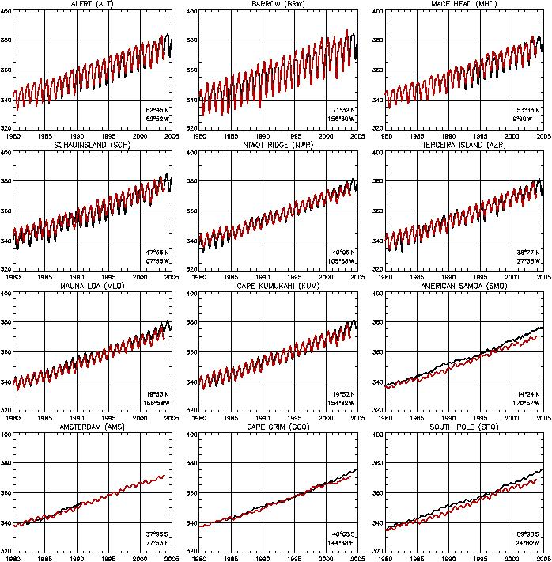

Figure 1. Simulated (red) vs. observed (black) atmospheric CO2 at major NOAA/CMDL atmospheric CO2 stations.

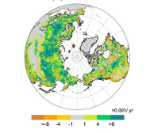
(a) (b)
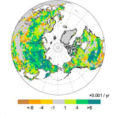

Figure 2. (a) Observed, and (b) simulated distribution of growing season LAI trend in the Northern Hemisphere.

PIK report: A concept has been developed and applied for a global risk analysis under climate change (Deliverable 6.12). Results presented in D6.12 were derived by forcing offline the LPJmL global impact model with outputs from the RT2a Stream 1 ensemble. The scope of this analysis is a quantitative investigation of terrestrial biospheric changes expressed in terms of a set of multidimensional risk metrics, computed at 1° spatial resolution for several 30-year time slices for a limited selection of the RT2a climate scenarios and emission trajectories.

Based on average annual values for 1971-2000 (reference period) and 2071-2100 (scenario) of net primary production (NPP), vegetation carbon, soil carbon, runoff, evapotranspiration and the fractional coverage with plant functional types, several risk metrics were calculated as the difference between the above time slices. These risk metrics capture the following processes: 1) vegetation structural adaptations to change as a function of woodiness, leaf phenology and leaf morphology; 2) biogeochemical adaptations as a function of carbon stocks, carbon fluxes and above vegetation structural changes; 3) hydrological changes as a function of changes in runoff, evapotranspiration and soil water storage; and 4) basic processes that underlie these changes, including water limitation of NPP and fire frequency.
The resulting values are mapped globally, demonstrating the risk of change under the various scenarios chosen and using the different risk metrics separately and in combination. The results, which demonstrate pronounced regional differences as well as differences between distinct scenarios, are reported in D6.12. This preliminary analysis will be extended in a later stage of the ENSEMBLES project to a more comprehensive analysis, which will include more climate scenarios (as available from RT2) as well as results from ORCHIDEE and JULES in order to additionally demonstrate the uncertainty stemming from different impact models (D6.17).

b) Benchmarking of offline models for D6.5
For the benchmarking study (Deliverable 6.5), a historical (20th century) has been performed with LPJmL, using the following global forcing data: 1) A combination of several land use datasets including the fraction of cropland up to 1992 (Ramankutty & Foley 1999), the distribution of crop types from Leff et al. (2004), an approximation of managed grassland (Klein Goldewijk & Battjes 1997), and area equipped for irrigation (Siebert & Döll 2005); 2) climate (monthly fields of temperature, precipitation, wet days, cloud cover) from the CRU TS2.1 dataset (Mitchell & Jones 2005); and 3) annual atmospheric CO₂ concentrations (source: http://www.cnrm.meteo.fr/ensembles/public/results/results.html).

ULUND report: ULUND has provided a modelling protocol for comparing modelled NPP with data from the Ecosystem Model-Data Intercomparison (EMDI) project., for D6.5,
ULUND has also carried out a literature search on different approaches for modelling herbivore physiology and population dynamics. For mammalian herbivores of different size, e.g. goat, cattle, wildebeest, and elephant, sufficient information on main processes and parameter values was found.
Further, ULUND has led an evaluation of CO₂ effects on forest NPP predicted by LPJ (in co-operation with PIK and UNIVBRIS). The model accurately reproduces the magnitude of the NPP enhancement observed at four Free Air CO₂ Enrichment (FACE) experiments located in temperate climates. A global application of the model suggests that the response found in the experiments might also be representative of the average response of forests globally. However, the model predicts stronger NPP enhancement in tropical forests (~35%) and weaker in boreal forests (~15%), suggesting that currently available FACE results may notbe sufficient for a global assessment across all types of. A paper describing these results is now in press in Global Change Biology.

UREADMM report: A coupled crop climate model was used to examine the possible impacts of climate change on crop productivity, including crop-climate feedbacks, for a temperate cereal (wheat) and tropical legume (groundnut) crop when represented within the land surface scheme of HadAM3. When integrated with sea surface temperatures (SSTs) and CO₂ concentration representative of a present-day climate the crop simulations are in agreement with observations. Under climate change both the spatial extent of the crop growing region and the simulated crop yields change and are related to changes in important crop growth processes. The impact of crops on the climate was examined and shown to have just as large an impact as climate change alone in some regions. A full report has been prepared.

WP6.2: Linking impact models to probabilistic scenarios of climate change
DJF has during this period primarily worked on construction of impact response surfaces for selected impact models of crops, soil carbon and nitrogen (Task 6.2.8, D6.7, M6.12, M6.13). DJF has also contributed to application of preliminary results from the Ensembles Prediction System to impact models for estimating risks of extremes and risks of impacts (Task 6.2.11). Preliminary sensitivity analyses have been conducted and a method to construct impact response surfaces was tested. The Daisy model was used to simulate winter wheat yields and nitrogen leaching for selected climate grid in Europe. The probability of exceeding a threshold of 10 and 20% reduction in crop yield compared to baseline was calculated. Also the probability of exceeding a threshold of nitrogen leaching larger than 25 kg N/ha was calculated. The predicted climate change and especially the change in precipitation is variable for different part of Europe. Sensitivity analyses were made for climate grid from Denmark and south Germany. The analysis indicates that the seasonal distribution of precipitation may be important for the resulting response surfaces and the probability of exceeding thresholds in crop yield and especially nitrogen leaching.

FMI's work during this year has focused on two major issues: first the work with forest fire risk assessment has continued and secondly the systematic estimation of climate extremes like drought and excess rainfall.

During the reporting period FUB continued on improving the Storm-Loss-Model in order to calculate loss data in better correlation with insurance data. Therefore, sensitivity tests concerning the variation of the threshold for loss have been performed and also a new dynamic approach for damage calculation has been implemented. Further, the loss-model has been modified to work based on RCM output. Subsequently the model has been applied to a first set of ERA40-driven RCM simulations at 50km resolution.

NOA are working to relate admissions data to extreme weather and air pollution events. Work is underway to find statistical relationships between these parameters to enable transfer function creation. Up till now, the research has indicated that when meteorological variables and indexes are used, correlation between them and hospital admissions is low but significant at the 99% level. The cold period of the year seems to be the dominant factor in the association. When pollution data are used, scatter plots indicate a low association pollutant levels with admissions but reveal a clear relation with met data:
Ozone shows a positive correlation with temperature and with global horizontal radiation
Ozone shows a negative correlation with relative humidity.

SMHI performed hydrological model simulations to produce impact response surfaces to changes in annual temperature and precipitation for selected river basins within Sweden and for the total Baltic Sea basin. Testing of different approaches to incorporate seasonal temperature and precipitation change into the response surfaces were included. Preliminary seasonal response surfaces were produced for selected impact thresholds. These are preliminary as we cannot know in advance what the seasonal patterns of climate change produced by the climate models will be. Analysis of the sensitivity of different hydrological regimes to seasonal versus annual response surfaces was conducted. We contributed to the report for deliverable 6.7. SMHI participated in the joint ENSEMBLES/AMMA meeting on climate fluctuations and trends in West Africa. This was part of the overall strategy to build up cooperation on climate modelling and impacts analysis between these two EU-financed projects.

SYKE has evaluated preliminary response surfaces of area change suitable for palsa mires with probabilistic climate change projections from the Hadley Centre's perturbed physics experiment. Computer programs have been refined to evaluate the response surfaces with joint probabilities of regional temperature and precipitation changes. New versions of the response surfaces have been created incorporate the annual cycle of temperature changes. This included an analysis of the projected cycle of monthly temperature changes based on GCM simulations. A preliminary probabilistic analysis of winter wheat yield in Europe has been carried out with probabilistic climate change projections from the Hadley Centre's perturbed physics experiment.

Since a change in temperature and precipitation, which is constant throughout the months and years is very unlikely in reality, there is the need to examine the impact of seasonal changes of T and P on water availability. UNIK started therefore a first approach to this task with a variation of T and P during the summer months (JJA), only, and constructed response surfaces for 18 river basins throughout Europe. First results proof that the impact of seasonal variations have to be examined further because basins that showed a weak response under a constant change showed a strong response to the seasonal change and vice versa.

WP6.3: Impact modelling at seasonal-to-decadal time scales
JRC report: for Task 6.3.2. Crop model runs have been undertaken, at JRC-IPSC, using observed data and DEMETER hindcasts, results were presented in Lund (Sept 2006). A new version of the Crop Model called Crop Growth Forecast Model running on Ensembles forecasts type data (from ten days-to-seasonal forecasts for the time being) was finalised and is running in test mode.

Some internal trials on the sensitivity of the crop model were performed under different scenarios built as follows:
Temperature increase of +2°C, +4°C and +6°C (as compared to the 1975-2005 average), without and with CO2 variation (560 and 706 ppm). The remaining climatic parameters were derived from our climatological database using the average daily distribution of the last 5 years. The crop model was modified in terms of crop parameters to take into account the CO2 concentration changes. We are active today to collect PRUDENCE data (A2 scenarios, DMI) and transforming them in order to be injected into the crop model.
Task 6.3.3 We are in contact with Cantabria University in order to have ERA40 dowscaled data to be used to run our model in order to compare related crop yield results with those obtained with DEMETER dowscaled data and our “perfect” forecasts.
For the continuation of JRC work within this workpackage (task 6.3.5) we need now as input the Ensembles Climatic Scenarios.

Meteoswiss report: The progress in this WP strongly depend on progress/results in WP5.5 of the same partner. We have contributed to tasks 6.3.2, 6.3.3 and to milestone 6.9.

Contrary to that which was expected based on the results in the year 2 PAR, we found significant biases in the wind gust (WG) parameter of ERA40 and ECMWF system 2 s2d data. This led us to use a field that was independent of the surface parameterisation schemes, namely the 850hPa geostrophic wind speed. See our report for WP5.5 for more details.

We undertook work towards task 6.3.3 which included a number of different approaches to selecting wind storms (WS) and calibrating s2d WS with the operational WS dataset of Swiss Re. Again, see our report for WP5.5 for more details.

We have made a contribution to task 6.3.2 by assessing the associated reinsurance losses between various wind storm datasets based on the Geostrophic Wind Speed (GWS) from ERA-40, DEMETER, ECMWF system 2 and ECMWF system 3 at 850hPa derived from the Geopotential (GP). The WS datasets were applied to a Swiss Re European portfolio using the Swiss Re loss model. In figure 1 we present an example of a tier 3 validation of wind storm climatologies for ERA40 (figure 1a) and DEMETER (figure 1b) data.

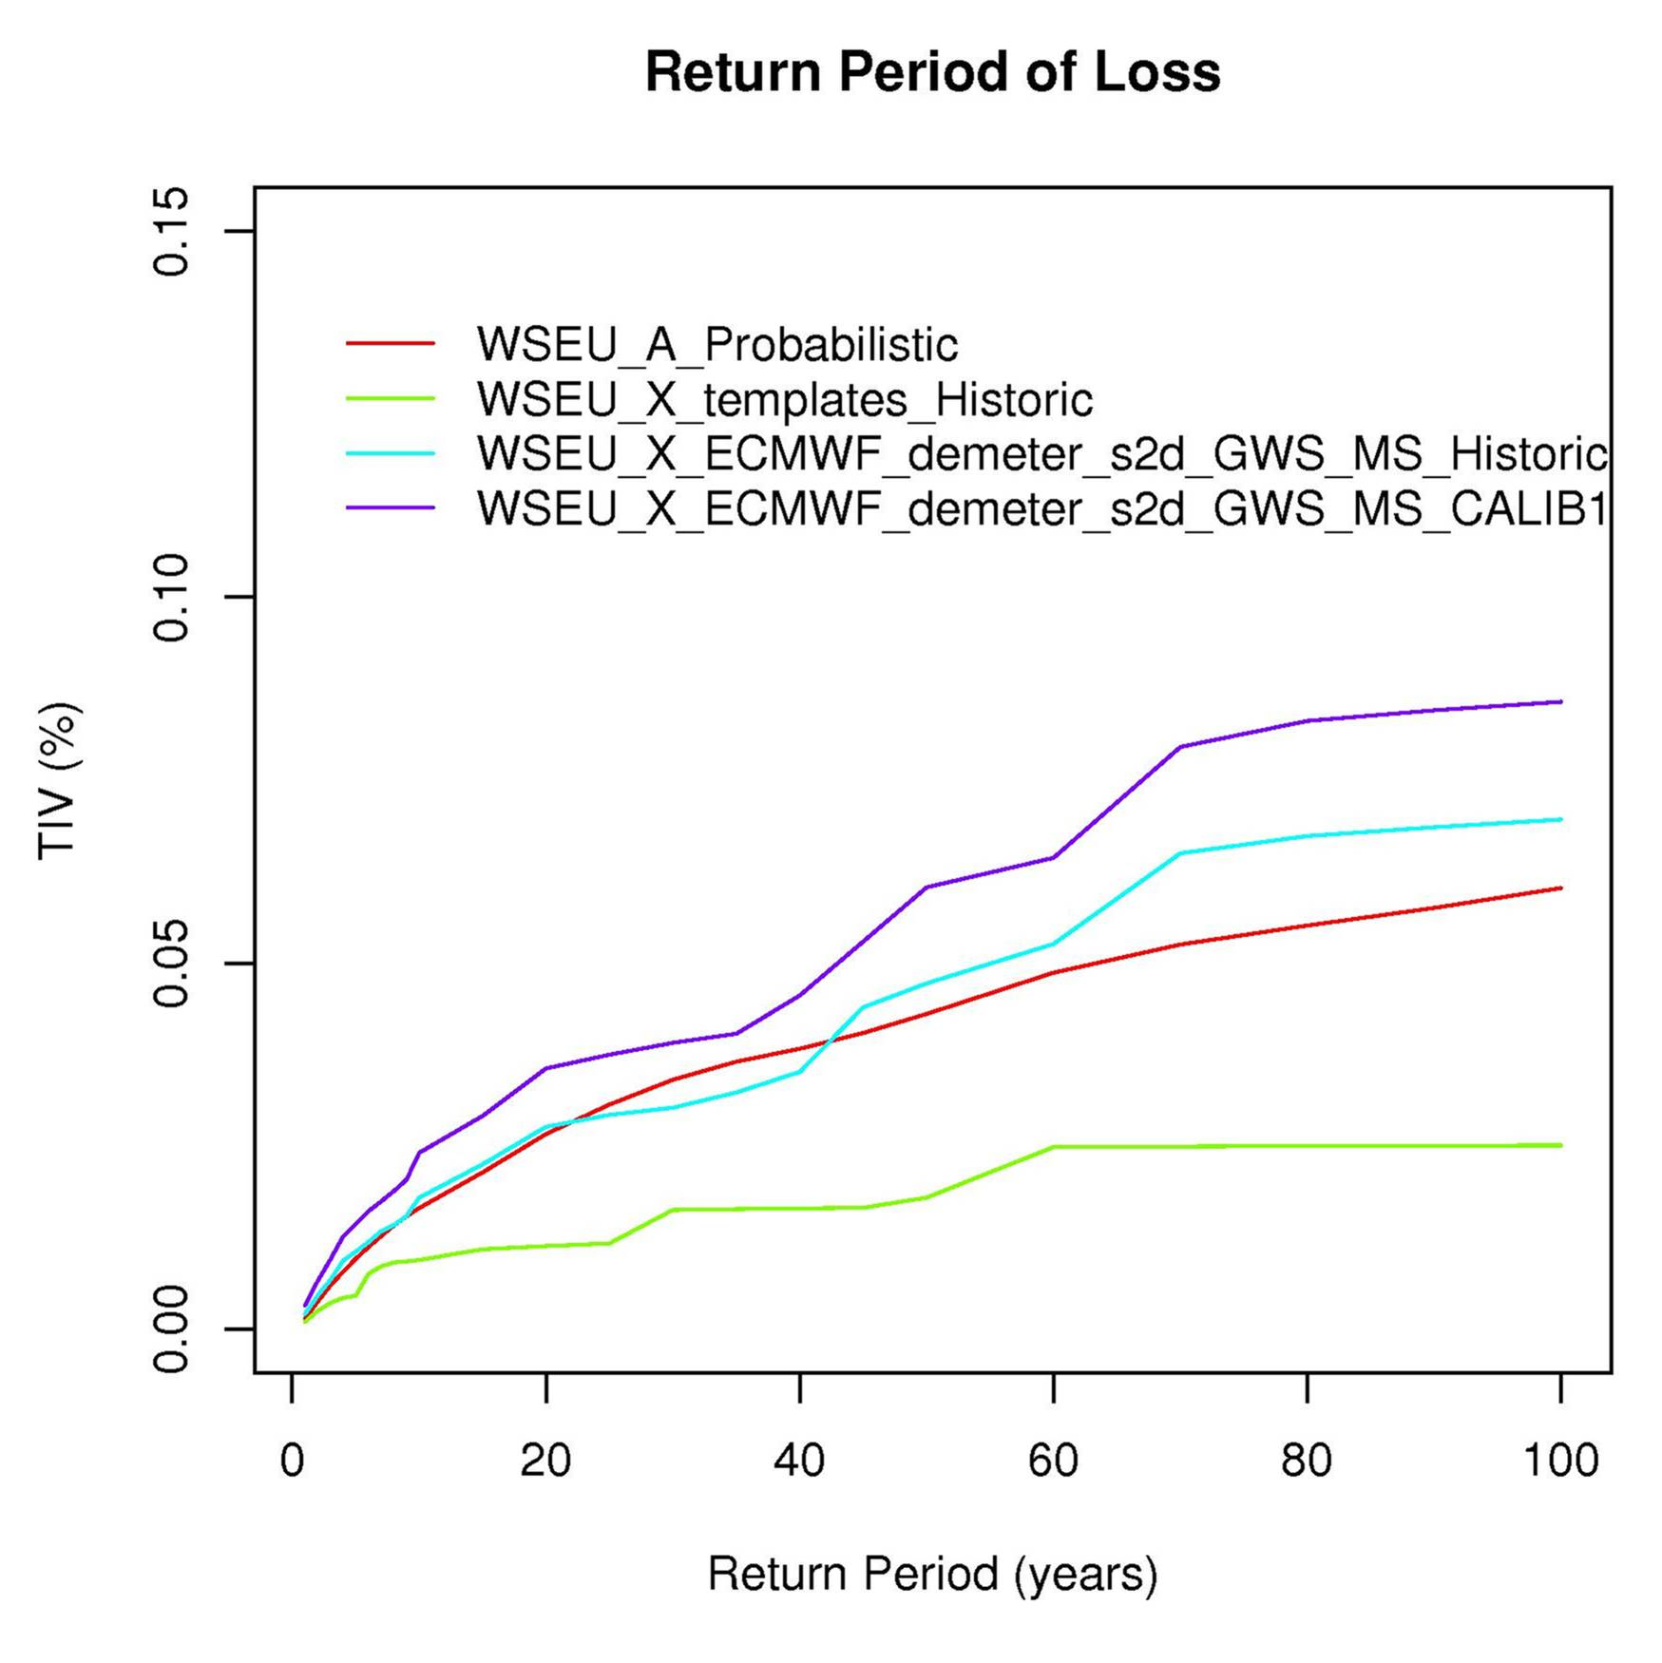
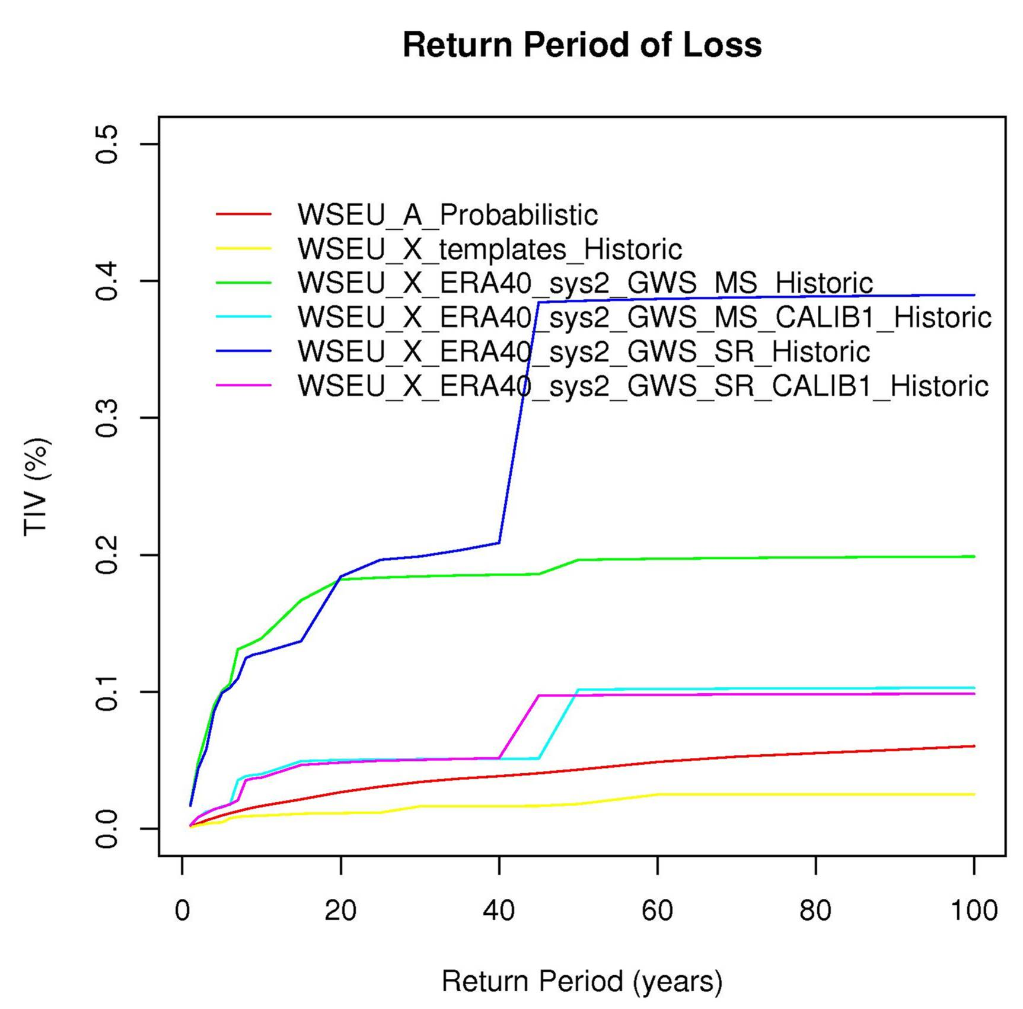
a) b)

Figure 6.3.1: Examples of the return period of loss (Total Insured Value, TIV, %) between the current operational wind storm Swiss Re datasets (WSEU_A_Probabilistic, red line in a) and b)) and calibrated ERA40 (pink line in a)) and calibrated DEMETER (purple line in b) wind storms respectively. The insurance portofolio used in this figure does not reflect the actual SwissRe market share.

In summary, we have shown that GWS is a viable alternative to using WG for the purposes of assessing wind related losses in the Swiss Re loss model. The GWS has the advantage that it is independent of surface process parameterisations which have been shown to be troublesome; however it is generally a smoother field and therefore we loose some regional details in each wind storm. Further work will continue improve the calibration of s2d data with ERA40 data. Once an optimal calibration procedure is in place we will apply the technique to other ENSEMBLES datasets and then look to the potential predictability of WS.

EDF report:

Two studies have been done during the reporting period

- The first one concerns spatial downscaling , using large scale geopotential fields (ERA40 & DEMETER) to predict local precipitations over 48 French basins. The goal was 1) to estimate the quality of the quantitative seasonal forecasts of precipitations at the local scale obtained by downscaling and 2) to determine if it is possible to obtain a useful and valuable information for watershed management.

- The second one consists in using the UC/INM web portal for statistical downscaling (Task 6.3.3) to downscale DEMETER System 2 and ENSEMBLES Stream 1 seasonal hindcasts over local stations in France.

The study concerning the SVD method for precipitations forecasts is finished and has been summarized in a paper submitted to the International Journal of Climatology :

The web portal for statistical downscaling has been used to downscale the DEMETER System 2 and ENSEMBLES Stream 1 hindcasts (Task 6.3.5). The first analysis made (on DEMETER hindcasts) show that, on average, the RMSE and ACC of the downscaled temperatures allow an improvement of ~30% compared to raw hindcasts. This work was partly presented at the Workshop on Seasonal Predictions of the World Climate Research Program, Barcelona, Spain, 4-7th June 2007. When the analysis are finished, a synthesis paper will be written and submitted for publication..

The DEMETER downscaled hindcasts will now be used in a statistical model to predict electricity demand over France (Task 6.3.2). Results should be available in late 2007, and will be synthesized in a paper.

ARPA report: Validation of the new numerical soil water dynamics scheme allowing to take into account capillary rise from the watertable (Task 6.3.2) with good results presented at the 10th national conference on agrometeorology (Tomei et al., 2007).

Observed data for daily maximum and minimum temperature and precipitation of Emilia-Romagna are being compared with Ensembles stream 1 s2d output from three global models (ECMWF, MetOffice, MeteoFrance) and one regional model, LEMM. The latter is the seasonal dynamical downscaling experiment (regional forecast) performed by INM using RCA model, as part of RT2B activities (Task 6.3.5).

Downscaling is carried out using the interactive web portal for Climate Models data access and Statistical Downscaling set up by the Spanish Grupo Mixto de Investigación en Meteorología Aplicada, Universidad de Cantabria - Instituto Nacional de Meteorología (http://grupos.unican.es/ai/meteo/ensembles/). In particular predictors used from ECMWF 40 years Reanalysis (ERA40) are:Geopotential-500-00, Temperature-850-00, Specific humidity-850-00. Observations in our area from the ECA dataset are predictands (Task 6.3.3)

Task 6.3.2 New developments in the Criteria modelling software system are being carried out for effective management of the many Ensembles input data, model runs and output analyses needed for the project. A new software interface for visualization of downscaled data and comparison with observations was devised and implemented

Up to now we downloaded rainfall forecasts for 1991 and 1992 using global models. The following table shows absolute and relative departures from observed data of median forecast cumulated rainfall resp. 1, 2..., 5 months after run start in four runs.

Cumulated Rainfall | 1 Month |  | 2 Month |  | 3 Month |  | 4 Month |  | 5 Month
Cumulated Rainfall | mm * | % ** | mm | % | mm | % | mm | % | mm | %
1991 - Summer | -23.11 | -22% | -39.16 | -23% | -12.10 | -7% | 34.69 | 18% | 5.93 | 2%
1991 - Winter | -45.13 | -33% | -0.99 | -1% | -6.46 | -3% | 29.19 | 13% | 95.16 | 40%
1992 - Summer | 29.58 | 77% | 23.32 | 24% | 35.65 | 27% | 33.99 | 19% | 80.64 | 40%
1992 - Winter | 55.75 | 563% | -31.99 | -21% | -2.53 | -2% | -0.69 | 0% | -3.16 | -1%
* Median forecast – observed
** (Median forecast - observed) / observed

LSE report Tutorial on the use of the emtool (a matlab ensemble interpretation toolbox) given at ECMWF (part of Task 6.3.6)

UREADMM report: We have started to work on the weighted DEMETER ensembles. Different methods of exploring the weighting of the forecast ensemble have been developed, including post-hoc weighting using the application results (Task 6.3.4).

UNILIV report: Task 6.3.2 Has seen further development of both West Africa and southern Africa malaria models runs with the DEMETER data set.

Task 6.3.3 Downscaling work for Africa has not yet been possible due to lack of target data. Work on issues of forecast model bias have been continued with effective methods developed to deal with biases in temperature forecasts. Pan African malaria models runs with 20 years of 63 members have been undertaken using the Liverpool MAP2 cluster

Pan African tier-2 plots
a) | b)
c) | d)
Figure 6.3.2 Tier-2 Brier skill score (BSS) for upper tercile event, DEMETER-driven LMM forecasts minus BSS for “spin-up only” control run (where positive). DEMETER with 63 ensemble members for 1980-2001 using bias-corrected temperature and uncorrected rainfall to driven LMM against ERA-40-driven LMM incidence for a) February 2-4; b) February 4-6; c) May 2-4; and d) May 4-6. Only high variability grid points (CoV>0.5 for ERA-40-drven LMM) are shown. By subtracting control run skill any influence of rainfall during the LMM spin-up period on the apparent skill of the DEMETER forecasts is removed. The February forecast at 2-4 months shows some skilful grid points scattered across the grid in western, southern and eastern Africa. By months 4-6 (part (b) of the figure), the skill has reduced further although there are still a few skilful grid points in Sudan, Ethiopia, South Africa and West Africa. For the May forecast, the main areas of skill for months 2-4 (part (c) of the figure) lie along 10ºN although there are a few skilful grid points in other locations. At months 4-6 for the same forecast (part (d) of the figure) this region of skill has nearly all disappeared but a few skilful grid points remain in other regions of the grid.
a) | b)
c)  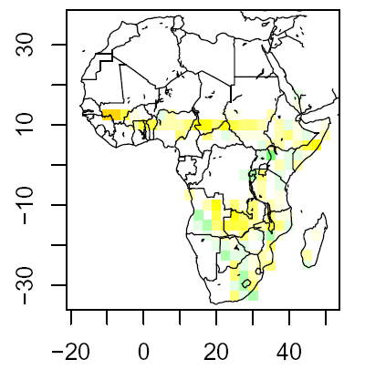 | d)  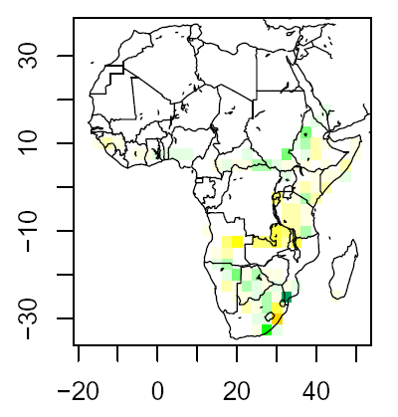

Figure 6.3.3 Tier-2 Brier skill score for upper tercile event, DEMETER-driven LMM forecasts minus BSS for control run (where positive). DEMETER with 63 ensemble members for 1980-2001 using bias-corrected temperature and uncorrected rainfall to driven LMM against ERA-40-driven LMM incidence for a) August 2-4; b) August 4-6; c) November 2-4; and d) November 4-6. For the August forecast shown a) and b), there are only a few skilful grid points at 2-4 and even fewer at 4-6. The highest number of skilful grid points is found for the November forecast months 2-4 in part (c) of the figure where the region of skill at about 10º N extends across from Mali to Sudan, together with areas in Angola, Zambia, Ethiopia, Somalia, South Africa and Mozambique. At months 4-6, however, the only remaining strongly skilful grid points are in Zambia, Angola and South Africa. The region of skill in West Africa in part (c) of the figure corresponds to skill in predicting anomalies in incidence at the very end of the LMM season.

Work currently being carried out by the ENSEMBLES team at IRI (Ruiz, Connor, et al. in press):
Task 6.3.2 A variety of (climate sensitive) malaria transmission models have been incorporated into a Multi-Malaria-Model framework and runs initiated with differing initial starting conditions. To analyze the overall transmission dynamics and the skill of mathematical models to represent malaria incidence, the following six actual epidemiological situations are currently under consideration: (ES1) Hwange District in rural Zimbabwe; (ES2) Kapsabet locality in Nandi District, Kenya, (ES3) Kisii District in the highlands of Western Kenya; (ES4) Nuquí municipality, on the rural lowlands of the Colombian Pacific Coast; (ES5) El Bagre municipality, on the Cauca River floodplain region, rural lowlands of the Colombian Caribbean Coast; and (ES6) Chobe District in Botswana lowlands. The model outputs will be analysed in terms of their probability distribution and skill in capturing malaria transmission in these varying locations.
For each epidemiological situation, several steps are conducted to determine the magnitude of the exogenous variables of the multi-model ensemble. These steps include: (a) the analysis of demographic census, to estimate the total populations at risk in rural and semi-rural areas; (b) the analysis of epidemiological time series (historical positive malaria cases for the prevalent type(s) of infection), to determine current conditions, malaria prevalence, major type of infection, initial conditions, etc.; (c) the analysis of vector population dynamics, to determine the primary vectors incriminated in malaria transmission and their feeding/resting behavior; and (d) the analysis of climatic time series, to detect the role climatic conditions play in malaria transmission dynamics on each study site. Analysis of these datasets also includes the estimation of changes in mean and variance, as well as the detection of the presence of significant trends in historical time series. Simulations include: (a) base scenarios; (b) experimentation-validation-analysis, including instability cases and sensitivity to initial conditions; (c) changing climate scenarios, to assess the effects of global warming and local climatic changes on malaria transmission; and (d) stability analysis.

c) Deviations from the project work programme, and corrective actions taken/suggested: identify the nature and the reason for the problem, identify contractors involved

WP6.1: Global changes in biophysical and biogeochemical processes – integrated analysis of impacts and feedbacks
Offline model benchmarking for D6.5 is subject to a slight additional delay, about one month, due to the unavailability of key participating scientists during August. (The work is expected to be completed by 30 September 2007). However, online benchmarking (and therefore delivery of D6.5) is further and unavoidably delayed, because it depends on the provision of the RT2a ensemble. Online benchmarking of impacts components of these models (including vegetation models) will be undertaken once the historical simulations have been completed by RT2a

WP6.2: Linking impact models to probabilistic scenarios of climate change

Deliverable 6.7 has been slightly delayed. However, this in itself is not expected to affect the remaining project period, which will be more dependent on the timely delivery of GCM and RCM results.

The SMHI WP6.2 workplan for the remaining project period is pushed forward approximately six months. This is in accordance with discussions at the WP6.2 meeting in Helsinki, April 2007, where it was decided that, where possible, workpackage activities should be postponed due to expected delays in receiving outputs from the climate models.

WP6.3: Impact modelling at seasonal-to-decadal time scales
EDF would like noted that they have provided and still provide more than was agreed in the contract. AS WP/RT leader I am happy to support this observation.

ARPA: We would like to use our local observed data as predictands, but it is not clear which format is needed to upload data in the interactive web portal (no documentation available).
Another relevant problem is the limitation of our account, which allows to create forecast outputs only for a single season and a single model at a time; this leads to a continuous repetition of the procedure, and produces a huge amount of output files which have to be subsequently aggregated. No replies to our messages in this respect was obtained from the Spanish group. No deviation from the project work programme up to now but there is a risk of delay in the near future if the above issues are not addressed. This matter is being looked at and will hopefully be resolved before the report deadline

UNILIV: There have been no deviations but there has been no one in post on the project for the last year and the nationally funded research student who works for a substantial proportion of their time on the project was on maternity leave for 6 months and has returned on a 0.5 basis.

The absolute usefulness of the 10 year pre-production runs will be limited due to the small number of years and thus will limit the ability to verify threshold events.

Section 3 – Consortium Management

3.6 Co-ordination activities and communication

All RT6 work packages and WP6.0 held successful and productive WP meetings during the GA in Lund. A shorter RT6 meeting was held to discuss future direction of impacts work in integrated EU projects.

Considerable effort has gone into establishing links with AMMA which have been sycessful. UNILIV WP6.3 representing the integration of the impacts communities were part of the ENSEMBLES team that presented at the AMMA TTC kick-off meeting in Bamako, Mali.

WP6.1 is continuing to benefit from synergies with other projects and activities. Foremost among these are: (1) the UK NERC programme Quantifying and Understanding the Earth System (QUEST), which is led by Colin Prentice (PI at UNIVBRIS); (2) The EU research training network GREENCYCLES.

WP6.2 held a meeting in Helsinki in April 2007…lead to report …

Links with EUROLIMPACS has been maintained and a number of important affiliated partners have been introduced to the project through RT6.

Appendix 1 "Plan for using and disseminating the knowledge":

Only list papers that list the project

Papers

Bondeau, A., Smith, P., Zaehle, S., Schaphoff, S., Lucht, W., Cramer, W., Gerten, D., Lotze-Campen, H., Müller, C., Reichstein, M., Smith, B. 2007. Modelling the role of agriculture for the 20th century global terrestrial carbon balance. Global Change Biology 13, 679-706.

Piao S L, Friedlingstein P, Ciais P, Viovy N., 2007, Recent climate trends in the northern hemisphere and their impact on vegetation growing season and productivity. Global Biogeochemical Cycles, in press..
Piao S L, Friedlingstein P, Ciais P, Ducoudré N, Labat D, Zaehle S. , 2006, Climate and land use changes have a larger impact than rising CO_2 on global river runoff trends. Proc. Natl. Acad. Sci. USA. in press.

Piao S L, Friedlingstein P, Ciais P, Zhou L, Chen A., 2006, The effect of climate and CO2 changes on the greening of the Northern Hemisphere over the past two decades. Geophysical Research Letter, 33, L23402, doi:10.1029/2006GL028205.

Scholze, M., W. Knorr, N.W. Arnell and I.C. Prentice (2006) A climate change risk analysis for world ecosystems. Proceedings of the National Academy of Sciences 103: 13 116-13 120.

Challinor A.J., Wheeler T.R., Craufurd P.Q., Ferro C.A.T. and Stephenson D.B. (2007). Adaptation of crops to climate change through genotypic responses to mean and extreme temperatures. Agriculture, Ecosystems and Environment, 119, 190-204.
Donat, M., Leckebusch, G.C., Ulbrich U., 2007: Changing European circulation types in a greenhouse gas climate and their relation to the occurrence of extreme wind storms - a multi model ensemble approach, Geophysical Research Abstracts, Vol. 9, EGU2007-A-07039, 2007. http://www.cosis.net/abstracts/EGU2007/07039/EGU2007-A-07039.pdf
Leckebusch, G. C., U. Ulbrich, L. Fröhlich, and J. G. Pinto, 2007, Property loss potentials for European midlatitude storms in a changing climate, Geophys. Res. Lett., 34, L05703, doi:10.1029/2006GL027663.
Leckebusch, G.C., B. Koffi, U. Ulbrich, J. Pinto, T. Spangehl, S. Zacharias, 2006: Analysis of frequency and intensity of winter storm events in Europe on synoptic and regional scales from a multi-model perspective. Climate Research, 31, 59-74
Leckebusch, G.C.; Ulbrich, U.; Fröhlich, L.; Pinto, J.G.; Donat, M., 2007: European storms and their property loss potential under enhanced greenhouse gas concentrations – a global and regional climate model analysis, Geophysical Research Abstracts, Vol. 9, EGU2007-A-06477, 2007. http://www.cosis.net/abstracts/EGU2007/06477/EGU2007-A-06477.pdf
Pinto, J.G., E.L. Fröhlich, G.C. Leckebusch, and U. Ulbrich, 2007: Changing European storm loss potentials under modified climate conditions according to ensemble simulations of the ECHAM5/MPI-OM1 GCM. Nat. Hazards Earth Syst. Sci., 7, 165–175, 2007.
Pinto, J.G., U. Ulbrich, G.C. Leckebusch, T. Spangehl, M. Reyers, S. Zacharias, 2007: Changes in storm track and cyclone activity in three SRES ensemble experiments with the ECHAM5/MPI-OM1 GCM. Climate Dynamics, DOI 10.1007/s00382-007-0230-4.
Olesen, J.E. (2006). Reconciling adaptation and mitigation to climate change in agriculture. In Boutron, C. (ed.) From regional climate modelling to the exploration of Venus. ERCA - volume 7. Journal de Physique IV France 139, 403-411.
Ulbrich, U., J.G. Pinto, H. Kupfer, G.C. Leckebusch, T. Spangehl, M. Reyers, 2007: Changing Northern Hemisphere Storm Tracks in an Ensemble of IPCC Climate Change Simulations. Submitted to J. Climate

Benito Garcia-Morales, M. and Dubus, L. 2006 : Forecasting precipitations for hydroelectric power management : how to exploit GCM’s seasonal ensemble forecasts ? Int. Journal. of Climatology. (submitted and in revision)

J Bröcker, LA Smith (2007) Scoring Probabilistic Forecasts: On the Importance of Being Proper Weather and Forecasting 22 (2), 382-388

Marletto V., Francesca Ventura, Giovanna Fontana, Fausto Tomei, 2007. Wheat growth simulation and yield prediction with seasonal forecasts and a numerical model. Agric. For. Meteor. 147(1-2): 71-79

Tomei F., Antolini G., Bittelli M., Marletto V., Pasquali A., Van Soetendael M., 2007. Validation of the Criteria water balance model (in Italian, extended abstract). AIAM 2007, 10th Agrometeorology national meeting, Calabria, 29 May – 1 June 2007, Abstract book, 66-67.

Presentations

Only include major presentations (if you wish).

Fronzek, S. and T.R. Carter (2007). Probabilistic assessment of climate change impacts on subarctic palsa mires and yield of winter wheat in Europe. ENSEMBLES WP6.2 meeting (Helsinki, Finland, 4/2007)
Fronzek, S. (2007). Methods of climate change impact assessment: The case study of subarctic palsa mires. Research seminar in environmental sciences, University of Helsinki (Helsinki, Finland, 1/2007)
Fronzek, S. (2006). Response surfaces of palsa mires and probabilistic climate change projections. WP6.2 meeting at the ENSEMBLES General Assembly (Lund, Sweden, 11/2006)
Graham, L.P., 2007. ENSEMBLES (RT6) - Evaluating the impacts of climate change on hydrology and water resources. AMMA Workshop on impacts of climate fluctuations and trends in West Africa. Bamako, Mali, 26 February –1 March 2007. SMHI, oral presentation, 30 countries, 100 participants.
Graham, L.P., 2007. Transient simulations of future runoff to the Baltic Sea for the 21st century. In: Isemer, H.-J. (ed.), Proceedings from the Fifth Study Conference on BALTEX. Kuressaare, Estonia, 4–8 June 2007. SMHI, abstract of oral presentation, 20 countries, 150 participants.
Graham, L.P., 2007. Climatic change in the Baltic Sea Area. Climate Change – Adaptive Management within the Baltic Sea Drainage Basin, World Water Week in Stockholm. Stockholm, Sweden, 12 August 2007. SMHI, oral presentation, 25 countries, 50 participants.
Olesen, J.E. (2006). Water resources and climate change: impacts on agriculture in Europe. In: Moren-Abat, M., Quevauviller, P., Feyen, L., Heiskanen,, A.-S., Noges, P., Solheim, A.L. & Lipiatou, E. (eds.) International workshop on climate change impacts on the water cycle, resources and quality. Brussels, 25-26 September 2006. Scientific and policy report. European Commission, Climate change and natural hazards series 8. EUR 22422. p. 81-85.
Wetterhall, F., Graham, L.P., Andréasson, J., Hellström, S-S., Rosberg, J., 2007. A rainfall-runoff model´s sensitivity to extreme events. Proceedings from the XXIV IUGG General Assembly. Perugia, Italy, 9–13 July, abstract of oral presentation, 50 countries, 2000 participants.

