Resurgence of the Sea Lamprey in St Marys River, Laurentian Gt Lakes
Twenty years ago, nothing much survived in the polluted waters of the St. Marys, the massive waterway that connects Lake Superior and Lake Huron. Over the past couple of decades, however, water quality and habitat have improved dramatically as a result of more stringent pollution control. As a consequence, the river is now ideally suited to the survival of larval sea lamprey.
The Sea lamprey, a primitive eel-like fish native to the Atlantic Ocean, was first noticed in Lake Ontario in the 1830s and spread to the rest of the Great Lakes system, probably through the shipping canal around the Niagara Falls in the early 1900s. The sea lamprey feeds on the body fluids of other fish, clinging to its victim with a sucker-like mouth and rasping though the scales and skin with a sharp tongue. Sea lamprey prey on all species of large Great Lakes fish and are so destructive that only one in seven fish attacked will survive. Each sea lamprey can kill in the region of 20kg of fish during its life as a parasite.
By the 1950s, sea lamprey had helped bring the Great Lakes fishery to the brink of collapse. Virtually every fish caught had a lamprey wound; some bore the scars of 10 or more attacks.
Confronted with the negative impact of this invading parasite, the governments of Canada and the United States agreed to create the Great Lakes Fishery Commission as a mechanism for cooperative bi-national fishery management. Its first task was to find a way to control the sea lamprey.
In 1958, after testing almost 6,000 compounds, scientists discovered the "magic bullet" that would control lampreys without causing too much damage to other wildlife - TFM (for 3-trifluoromethyl-4-nitrophenol) The selective lampricide TFM has subsequently been the mainstay of a 40-year campaign that has reduced Great Lakes sea lamprey populations by 90 per cent and helped to bring about the resurgence of a $6 billion a year sports and commercial fishery.
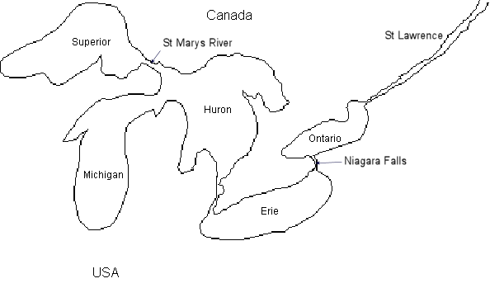
Fig 1 The North American Great Lakes
Unfortunately, the ‘happy ending’ for control efforts has been marred somewhat by the problems of the St. Marys River which now produces more sea lamprey than all Great Lakes tributaries combined. The St Marys is not a normal river, but the outflow from Lake Superior containing a massive flow of water.
They migrate from the river into Lake Huron and northern Lake Michigan where in this area, the adult sea lamprey population is now almost as large as it was before control efforts started four decades ago. Today more fish are destroyed by sea lamprey than all other causes combined, including natural causes and sport, tribal and commercial harvest.
"The St. Marys River experience has taught us that the sea lamprey will always be a significant threat to the Great Lakes fishery if controls are relaxed," said Mark Gaden, of the Great Lakes Fishery Commission. In reality, it wasn't so much a case of controls being relaxed as controls being defeated by the river's tremendous size and flow. "The St. Marys is 25 times bigger than the biggest river we've ever treated," said Gaden.
Larry Schleen, who works for Canada's Department of Fisheries and Oceans (DFO) as manager of the Sea Lamprey Control Centre in Sault Ste. Marie, adds, "Our projected costs indicated that application of ten to 12 million dollars in lampricide would likely have a pretty dramatic effect on larval populations. However, other methods of control are much more cost effective."
So the Commission and its partners, including the DFO and Ontario's Ministry of Natural Resources, set about developing an alternative strategy. Scientists used a deepwater electro-fishing device to determine larval density and distribution. With the help of global positioning and mapping technology, larval "hot spots" were recorded and targeted for control.
Granular Bayluscide, a slow dissolving lampricide particularly suited to the deep waters of the St. Marys, is being applied by helicopters to these hot spots to kill sea lamprey larvae on the river bed. In 2000, Bayluscide was applied to about 800 hectares of the river.
As part of an integrated strategy to reduce dependency on chemicals, the Commission has also entered into partnership with Great Lakes Power and the U.S. Army Corps of Engineers to build sea lamprey traps on the St. Marys River. The trapping program has the dual benefit of removing spawning adults from the river and supplying males for the Sterile Male Release Program. Sterilized males - 26,000 of them in 1999 - were released into the river where they compete as aggressively as normal males, wasting the spawning potential of their mates.
Results so far indicate that the integrated control strategy now being implemented on the St. Marys eventually will reduce sea lamprey numbers in Lake Huron and northern Lake Michigan by an impressive 85 percent, bringing populations into line with other parts of the Great Lakes system. Scientists predict a corresponding dramatic rise in the spawning potential of lake trout and other species.
Meanwhile, the GLFC and its partners maintain a regular TFM treatment schedule in about 250 Great Lakes tributaries while research continues into reducing lampricide concentrations and developing alternative, non-chemical control measures.
"It's generally agreed among the scientific community that we will never rid the Great Lakes of sea lamprey," said the GLFC's Mark Gaden. "The sea lamprey factor will always be a consideration in every decision that's made about the Great Lakes fishery.
"But the current suppression level of 90 per cent is consistent with the objectives of provincial, state and tribal management agencies. More importantly, it's allowed them to undertake restocking and other rehabilitation measures with confidence that all their work won't be destroyed by sea lamprey. It's a level we can all live with, and that's a major success."

