Persistent organic pollutants: Pesticides, PCBs and dioxins
Industrial society has put thousands of organic compounds to use this century, often in large quantities. In the 1960s it became increasingly obvious that certain persistent organic chemicals had found their way into the natural environment in large quantities. Some of them have caused significant environmental issues with animals exposed to them displaying symptoms of illness or injury.

The risk of a stable compound causing biological effects increases if it is capable of bioaccumulation, i.e. of being stored in living tissue. Stable organic compounds that are fat-soluble are usually able to bioaccumulate. Fat-soluble pollutants can accumulate in fatty tissues of living organisms in concentrations many times higher than in the surrounding environment. Predators may accumulate certain persistent pollutants in even higher concentrations than their prey, a phenomenon known as biomagnification. The very highest concentrations of toxins in living organisms are usually found in mammals and birds that feed on fish or other aquatic animals. Biomagnification also occurs in the terrestrial fauna, although concentrations there are consistently lower.

Many aromatic hydrocarbons are both fat-soluble and persistent. If these compounds become halogenated (i.e. if their hydrogen atoms are replaced by chlorine, bromine or other halogens), their stability and their solubility in fat both tend to increase yet further. In some cases toxicity also increases. The majority of well-known persistent organic pollutants thus belong to the category halogenated aromatic hydrocarbons.

Three main categories of substance
Some of the "classic" environmental poisons – such as DDT, toxaphene, chlordane and hexachlorocyclohexane (HCH) – are insecticides. These have been deliberately dispersed over agricultural land. Their use has gradually been phased out in UK and other industrial nations, but some of these agents continue to be used elsewhere (in the tropics, for example). Substances of this kind remain present in the general environment, including substances never used in this country.

Industrial chemicals never intended for dispersal outdoors can also leak into the environment. PCBs (polychlorinated biphenyls) are the best-known example; other compounds of this kind are polychlorinated naphthalenes (PCNs), chloroparaffins and brominated flame retardants. Some stable industrial chemicals are no longer manufactured. The use of PCBs has been gradually banned completely in UK and many other countries. It has been found to be more difficult to replace some other chemicals with less hazardous substitutes. The use of brominated flame retardants continues almost unabated for this reason.

A third category of persistent organic pollutants occur mainly as by-products of various manufacturing or combustive processes. These include hexachlorobenzene (HCB), polycyclic aromatic hydrocarbons (PAHs) and dioxins. To a limited extent many of these compounds can also be formed naturally, but anthropogenic emissions have now declined substantially thanks to a number of steps that have been taken.
These notes are given as an introduction only – they are NOT intended to be comprehensive

The Organochlorines

The DDT group
The first pesticide to really pose environmental problems because of persistence was pp'DDT or dichlorodiphenyl - trichloroethane which was first synthesised in 1874 but whose insecticidal properties were not discovered until 1939. 1.1'- (2,2 dichloroethenylidene) bis (4-chlorobenzene) or pp'DDE is the principal breakdown product of pp'DDT and often the residue at highest concentration in contemporary environmental samples and is even more chemically stable than its parent compound. pp'DDD - (1,1'-2,2- dichloroethylidene, also known as TDE) one of the metabolic products from the breakdown of pp'DDT but has also been used as an insecticide in its own right. op'DDT and op'DDD are contaminants of the technical mixture, op'DDE is a breakdown product of the contaminants in the technical mixture. There has been no authorized use of DDT in the UK since 1983 under the 1986 Control of Pesticides Regulations (Harding, 1988). EEC provisions require an EQO of 0.025µg/l (annual mean) for DDT in all waters and a standstill provision applies to concentrations in sediments (DoE,1989). Use of technical DDT still continues in some les-developed parts of the world.

A reduction in the relative amount of DDT to DDE in environmental contamination was be expected and observed during the 1970s and 1980s because the use of DDT in its major applications in agriculture has been progressively phased out between the late 1970s and 1984. The reduction has been shown in seals from NE England (Law et al. 1989), cetaceans and pinnipeds in the North Atlantic (Aguilar, 1984) and Guillemots and Herring from the Baltic (Ollson and Reutergårdh, 1986).
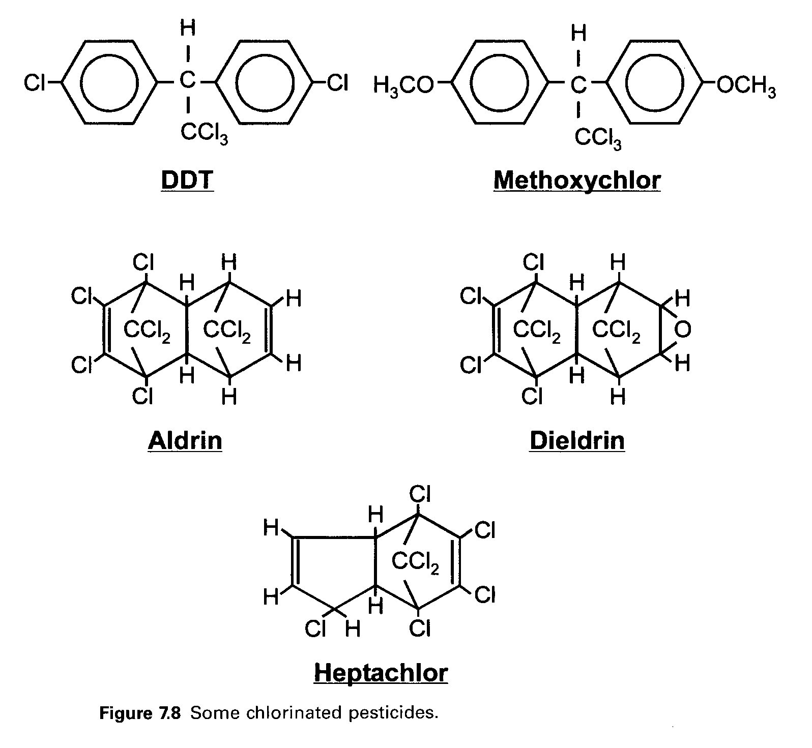

Chlorinated cyclodienes -
The 'drins' (aldrin, isodrin, endrin and dieldrin) belong to the chemical family of chlorinated napthalenes or cyclodienes and were widely used in the UK as contact insecticides from the 1950's with a decline in use since the1970's. These are amongst the most toxic and persistent of all pesticides. Aldrin and dieldrin are stereochemically related, aldrin being rapidly metabolised to dieldrin and isodrin to endrin. Chlordane in technical form is a mixture of variously chlorinated dicyclopentadienes. The cis- isomers are by far the more toxic. Both isomers of pure chlordane are dehydrogenated and epoxidised to oxychlordane (which is analogous to dieldrin). Of the 'drins', endrin is the most toxic both to fish and mammals with an oral LD50 to rats of 10mg/kg body weight compared to 100 mg/kg for Dieldrin and 113 mg/kg for DDT (Mellanby, 1967). All approvals for products containing dieldrin in the UK ceased in March, 1989 although a few remaining uses of aldrin in agriculture were allowed to continue until the end of 1992 (DoE, 1989).

Hexachlorocyclohexane -
There are 8 isomers of hexachlorocyclohexane (HCH) also known as benzene hexachloride (BHC), formed by different spatial arrangements of the chlorine atoms on the benzene ring. Commercial HCH contains a mixture of these isomers. The gamma - isomer of HCH (the 99% pure form of which is commonly known as Lindane) is the only one of eight isomers to have appreciable insecticidal qualities. The technical material from which Lindane is prepared contains only about 13% of the gamma form, some 68% of the two alpha stereoisomers and small quantities only of the beta and delta isomers.

Pentachlorophenol (PCP)
Pentachlorophenol (PCP) is a synthetic organochlorine compound manufactured in large quantities and used primarily as a wood preservative. PCP and its derivatives are extremely cost- effective biocides and have also been used as algicides, bactericides, fungicides, herbicides, insecticides and molluscicides. The major use of PCP in the UK has been as a preservative of wood, paints, paper, textiles, rope and leather. (HMSO, 1974). Production of PCP in the UK ceased in 1978 (Economic Intelligence Unit, 1981). Although it breaks down fairly rapidly in the environment, its use has resulted in widespread contamination of the aquatic and terrestrial environment. In a study in British Columbia of freshwater and marine sites receiving PCP's in the effluents from wood treatment industries, PCP's in the sediment ranged from not detected to 500 µg/kg dry weight (Environment Canada, 1979). Technical grade PCP contains trace quantities of the lower chlorinated phenols and more significantly will also contain PCB's , PCDD's and PCDF's. The thermal decomposition of PCP is one of the major sources of PCDDs and PCDFs in the environment (Crosby et al ., 1981). Low oxygen conditions are unfavourable for the biodegradation of PCP giving it a half life of 10-70 days in flooded soil and almost zero degradation in sediments (WHO, 1987).

Organophosphorus Pesticides
Over 100 organophosphorus insecticides are currently manufactured. They are all esters, amides or thiol derivatives of phosphoric or phosphonic acid. Most organophosphates are practically insoluble in water, lipophilic and relatively non-volatile. One exception is the volatile OP, dichlorvos, which was first manufactured under the tradename "Vapona" when it was sold as impregnated cellulose or resin strips to be used as household fumigants although it has recently come to prominence under the trademark Nuvan, used to control parasites on cultured salmon. In contrast to the organochlorine compounds OP's are unstable and reactive compounds which are hydrolysed and oxidized in the environment to non-toxic phosphoric or phosphonic acids (WHO,1986) although some environmental residues can be detected.

The average half-life of these compounds in soil varies from a few hours for dichlorvos to several weeks for parathion and up to several months for fenamiphos (Bayer,1971). Degradation is faster in the light. The half life of fenitrothion is two days in lake water, under illumination, compared to 50 days in the dark (Greenhalgh et al ., 1980). Malathion and parathion have been identified in Rhine river sediment samples in the Federal Republic of Germany at trace levels of 0.01-0.1µg/kg (Midwest Research Institute,1975). In the USA. National Soil Monitoring Programme (1970-1972), malathion was detected in cropland soil at levels between 0.08-0.19 mg/kg in several US states (Carey et al ., 1978, 1979) and at levels of < 0.01-0.02 mg/kg in soil from farms in Ontario, Canada (Harris et al., 1977). Parathion was detected in the surface soils (0-15 cm) of apple and sweet cherry orchards up to a maximum of 0.021 mg/kg, and in soils from farms in south-western Ontario at between 0.01-0.03 mg/kg (Harris et al ., 1977). OP's, being lipophilic, are stored in the fat of the exposed organism, but are readily hydrolysed and bio-transformed and normally will be excreted within days. There is no evidence of prolonged storage or bio-accumulation in natural food chains (WHO,1986). There have been many cases of acute poisoning and even death due to accidental spillages of pesticide on the skin and clothing but the exposure of the general public occurs through the consumption of foodstuffs incorrectly treated or harvested prematurely.

Polychlorinated Biphenyls (PCBs)
PCBs or polychlorinated biphenyls are a group of chemicals consisting of 209 individual compounds. PCBs were widely used as a fire preventive and insulator in the manufacture of transformers and capacitors because of their ability to withstand exceptionally high temperatures. They are complex mixtures of chemicals (100 – 130 in the average environmental sample) which were used (and subsequently released as ‘technical mixtures’ named in various ways which indicate how chlorinated they are : Arochlor 1042, Arochlor 1254, Arochlor 1262). Each component has its own chemical and toxicological properties. They are difficult and expensive to unambiguously analyse.

PCBs were introduced in 1930 as a non-flammable, chemically inert fluid. There use increased for approximately 40 yrs. Unfortunately, their properties of chemical and thermal stability which gave them industrial utility made them very refractory in the environment so that they became ubiquitous in the environment. Since they are toxic and potentially carcinogenic with the ability to bioaccumulate and magnify up food chains they have caused considerable environmental problems. They were actually discovered by Jensen in 1966 as an interference during the analysis of DDT in Swedish environmental samples.

PCBs were banned in new uses by the USEPA in 1979, with a complete ban in 1984. They are classified as a probable human carcinogen by numerous national and international health-protective organizations, such as the EPA, The Agency for Toxic Substances and Disease Registry (an arm of the U.S Public Health Service) and the World Health Organization. Research also links PCB exposure to developmental problems.

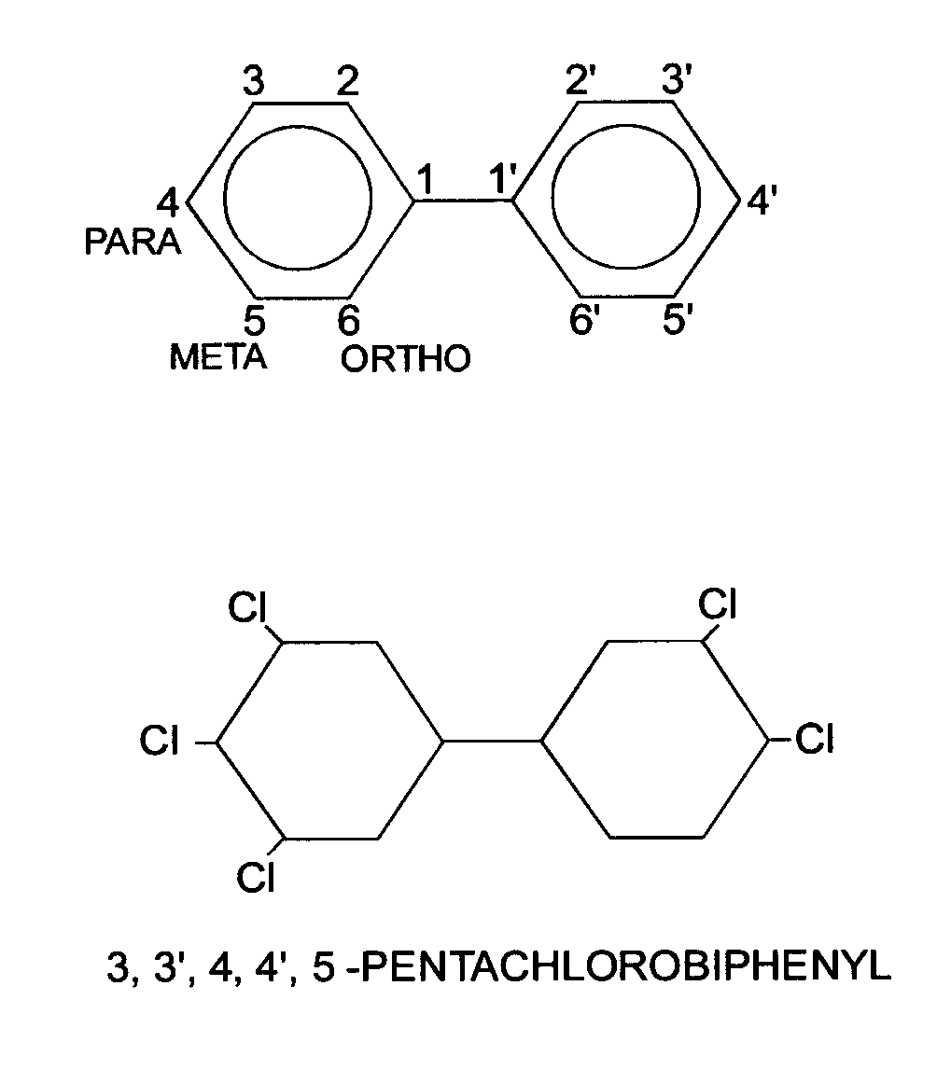

Dioxins and Furans
Dioxins (polychlorinated dibenzo-para-dioxins, or PCDDs) and furans (polychlorinated dibenzofurans, or PCDFs) are a group of toxic chemical compounds which are inadvertently generated and released into the environment as by-products of various combustion and chemical processes. Due to their toxicity, tendency to bioaccumulate, and persistence in the environment, dioxins and furans have been the subject of ongoing public health and environmental concern. Despite existing controls, they are distributed widely in the environment, sometimes at levels which may pose risk. For example, dioxins/furans have been the cause of numerous fish consumption advisories in the Great Lakes region, and the U.S. Environmental Protection Agency (EPA) has recently estimated that the risks for the general population based on dioxin exposure could be as high as the range of a 1 in 100 to 1 in 1,000 increased chance of experiencing cancer related to dioxin exposure (USEPA, 2000b). In response, various local, state, regional, and national efforts are focusing on achieving further reductions in dioxin contamination.

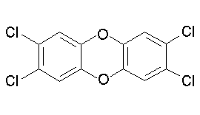
2,3,7,8 TCDD - Tetrachlorodibenzo dioxin

Reading
For More Info: - see course website : http://pcwww.liv.ac.uk/aquabiol/BIOL367_Web/

