BIOL 272
DERELICT AND CONTAMINATED LAND

General Background

The origins of derelict land vary widely, ranging from quarries and industrial buildings to sewage farms and military bases. However the problems associated with this wide array of land types are often remarkably similar.
The official definition of derelict land is, 'land so damaged by industrial or other development that it is incapable of beneficial use without treatment' (DoE, 1995). However, this definition excludes areas which are currently in use, areas awaiting development and land requiring planning permission before any restoration is permitted. The following two definitions have subsequently been created to cover such sites (DoE & Uni. Liverpool, 1986). The first, neglected land, covers land which though capable of some beneficial use is at present not cared for, untidy and in a condition detrimental to the environment. Operational land was used to describe those parts of land within a current development which are not realising their full potential and are detrimental to the environment.

As the latter two categories are not included in the governmental survey of derelict land (DoE, 1995) the overall picture of total 'wasteland' in Britain is often distorted. There is an estimated 110,000 hectares of wasteland in urban England and Wales alone, which is an equivalent of 5% of the area of urban Britain. However the total area of officially derelict land in Britain is just 39,600 hectares, with 34,566 hectares justifying reclamation, (DoE, 1995). When considering these figures, one must be aware of how they are generated. The term justifying reclamation is used for land considered by the local authority to 'justify reclamation in terms of its overall derelict land strategy'. Land considered by the local authority not to be sufficiently obtrusive or dangerous to warrant money being spent on it, would not have been included.
In addition the problems of carrying out a comprehensive derelict land survey and of maintaining the register should not be underestimated. The impact of derelict land on land values, despite the grant aid such status attracts, may also be a contributing factor affecting derelict land statistics. Depressed areas wishing to attract investment may be reluctant to head the national league table for derelict land. The contaminated land register, known as the Section 143 register, proposed by the Environmental Protection Act 1990, was subsequently abandoned by the Environment Act 1995 following a consultation document (DoE/Welsh Office, 1994). These proposals were highly controversial and demonstrate the sensitivity of such registers.

Distribution of Derelict Land
The regional distribution of derelict land in England is/shown in Figure 1. Certain regions contain far greater concentrations of derelict land than/others due to the industrial heritage of the region. For example, the South West has the largest area of derelict rural sites due to its long history of china clay mining. Rural dereliction is generally a result of the mineral extraction industries, whereas in urban areas derelict land tends to be created by general industrial dereliction.

The size of derelict sites varies widely from a small corner plot to hundreds of hectares; the average site size being 3.8 hectares. The majority of derelict sites, 83% are less than 5 hectares in area, however, the sites larger than this account for 72% of the total area of derelict land, (DoE, 1995).

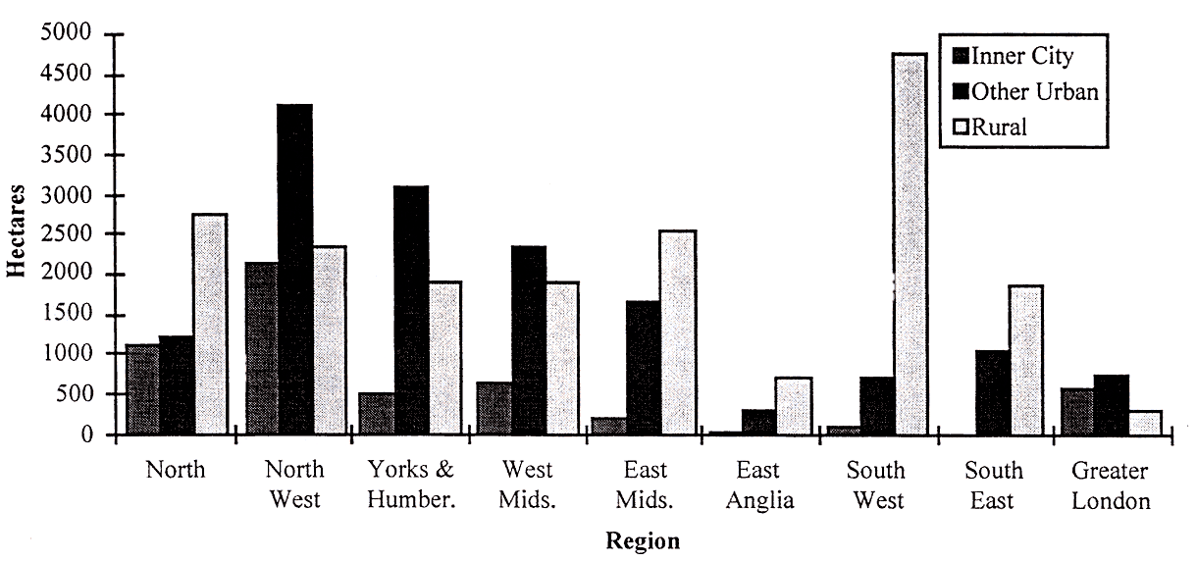
Figure 1. Regional distribution of derelict land by type.

Derelict land is currently being produced at a rate estimated at 1,716 hectares per year (Handley, 1995). Despite substantial reclamation activity, the stock of derelict land is not decreasing in line with reclamation. Over the period 1988-93 a total of 9,500 hectares was reclaimed (DoE, 1995); yet this only resulted in a 2% decrease in the total of derelict land, whereas the area justifying reclamation had risen from 31,600 hectares to 34,566 hectares, a rise of 7%. These small decreases in the derelict land stock despite land reclamation efforts, is due to two major factors. The continual production of derelict land and the re-entry of previously reclaimed derelict land back into the dereliction cycle (see Figure 2).
The degradation of soft end use reclaimed land back into dereliction can be due to a range of factors the most common being inappropriate engineering of the original reclamation process poor management, a lack of consideration of a site's specific physical and chemical composition or the failure to apply basic ecological principals during landscaping.
Hard end use reclamation schemes, such as industrial construction and housing, may revert back to derelict land as a result of economic, social, managerial or political problems; these are often unforeseeable whilst reclamation is taking place. In addition, 9,500 hectares were reclaimed in 1988-93 yet only 88% of this was bought back into beneficial use (DoE, 1995). This implies that 1,100 hectares have officially been reclaimed yet are not being used. This is a typical scenario of hard end use restoration; land is prepared for building and so officially reclaimed but there is no development to be built and so the area remains un-used.
.
Figure 2. represents the cycle through which land can pass from dereliction to a reclaimed siteand then re-enter the derelict state.

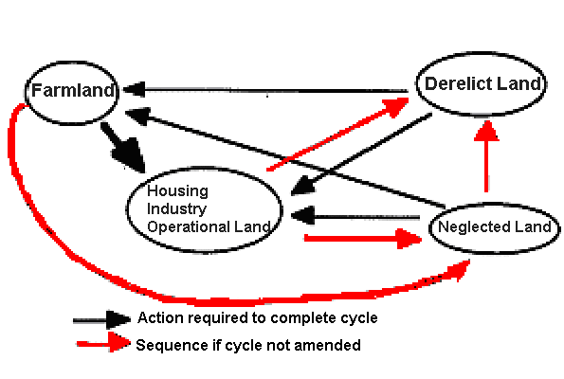
Amenity and Conservation Land

