Marine Fisheries – Over-exploitation and mis-management?

Lecture by Dr Rick T Leah

Introduction

World fisheries remain very important for human food supply (and Britain’s in particular). However, the industry is in crisis, fish stocks are virtually all over exploited and society seems unable to deal with the problem. The problem seems to be getting worse day by day.

Aims and Objectives

To explore the problems and issues involved in a VERY contemporary problem of the depletion of a resource, to highlight how we are all part of the problem and to examine some management options.

Reading and Background

You are strongly recommended to follow this subject by linkages and information provided on the course website http://pcwww.liv.ac.uk/aquabiol/BIOL202_Web/Overfishing/Overfishing.htm

And to use excellent sites provided by the Guardian Newspaper plus various activist organisations ( whilst bearing in mind the potential for mis-information)
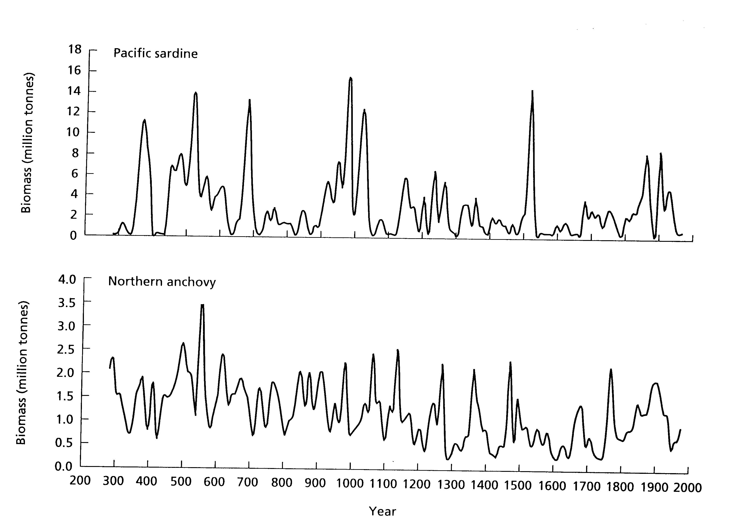
Variation in Fish Biomass – Coastal California – from scales in sediments

